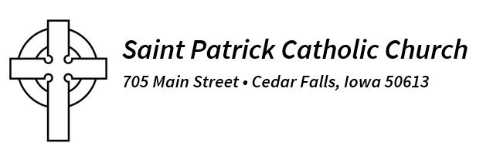
Nov. 15, 2025
Dear Parishioners:
How quickly is the 2025 Jubilee Holy Year coming to a close. The Catholic Church in 2025 celebrated the 2,025th anniversary of the Incarnation of our Lord. The concept of “Jubilee” has its origins in the Book of Leviticus (chapter 25) as a special year of reconciliation, pilgrimage, and coming home. Pope Francis designated the 2025 Holy Year as a time to renew ourselves as “Pilgrims of Hope.”
Many of us are also familiar with the Archdiocese of Dubuque embarking on the Journey in Faith process. The Archdiocese of Dubuque is putting together a pastoral plan that will sustain parish life for the next 25 years. By July 2026, all parishes will be clustered with nearby parishes to create new pastorates. The goal of these new pastorates consists of revitalizing parish life and adapting to the priest shortage and the ongoing changes in our culture. If you have not offered your thoughts and comments to the archdiocese regarding the Journey in Faith process, there is still time. Go to the Journey in Faith website at www.dbqjourneyinfaith.org to learn more about the Journey in Faith process and click on the Feedback Form button on the page to submit your comments before Nov. 21.
The Journey in Faith process will insist that all priests can only say three Masses on a weekend. Given that mandate, we will only be offering three Masses here at St. Patrick Church in Cedar Falls starting in July 2026. This mandate suggests that parking will be at a premium starting in July 2026. One of the main reasons that St. Patrick Church purchased the Baptist Church property in 2023 was to increase parking in and around the parish. Our parish started the Foundation for the Future campaign in April 2023 to pay off the loan from the Archdiocese of Dubuque for the property, as well as to fund both immediate and upcoming essential needs for the parish. At the end of this campaign, many essential needs -- among them church and school parking lot repairs, a new heating and cooling system for the school, and a new roof for the school -- will be paid for or available when those needs arise.
We have good news today to share with you in these final months of our Foundation for the Future campaign. As of today, we have collected $1,318,916 in monies received and pledges, which is nearly 90 percent of our $1.5 million goal. We have paid off our $927,000 loan to the Archdiocese of Dubuque.
Where is the Finance and Pastoral Council taking us at this point in our Foundation for the Future campaign? To address the issue of lack of parking, the Finance Council and Pastoral Council are looking at bids to create a parking lot on the green space where the Baptist Church once stood. Our goal is to start pouring the concrete parking lot in the Spring of 2026.
We continue to ask for additional gifts to bring our Foundation for the Future campaign to a successful completion. We still need approximately $180,000 in gifts. Please consider helping us before the end of the year with your generous gifts. By doing so, we will find ourselves prepared for the new Mass schedule in July 2026. We are not only anticipating fuller Masses next July, but also an influx of parishioners from other parishes who will be looking to receive the Sacraments of the Church here in Cedar Falls due to reduced Masses in their parishes.
Our parish continues to operate out of a position of strength and not weakness. That is primarily due to the wonderful parishioners who show up week after week, not waiting to take but to give of themselves to the mission of Christ and the building up of God’s Kingdom here on Earth.
Sincerely,
Fr. Ivan Nienhaus

