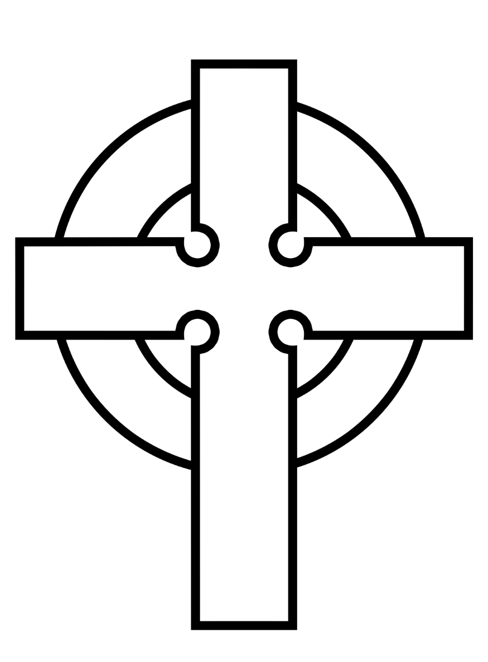
Saint Patrick Catholic Church
705 Main Street • Cedar Falls, Iowa 50613

Dear St. Patrick parishioner:

Thank you for your generous support and ongoing participation in the parish life of St. Patrick Church and School here in Cedar Falls. In 2022, the Parish Council took the initiative to purchase the vacant lot where the old First Baptist Church once sat on Seventh Street. In 2023, our parish launched a $1.5 million capital campaign. This campaign included paying off a $900,000 loan from the Archdiocese of Dubuque that covered the purchase cost of the new property. The remaining $600,000 is designated for the construction of parking spaces on that lot, along with money designated for a new roof for the school, upgrades to the heating and cooling system at our school, and parking lot repairs.
We recently received permission from the Archdiocese of Dubuque to go ahead and construct the parking lot on the vacant site of the old First Baptist Church. The cost of this new parking lot is $280,758. This parking lot – the cost of which will be fully covered by our successful capital campaign – will give us 46 additional parking spaces. Starting in July of 2026, additional parking will be needed, as our parish will be providing only three Masses per weekend versus our current four-Mass schedule. Fewer Masses will suggest that our lack of parking will only be exacerbated. A reduced Mass schedule was a decision made by the Journey in Faith core team in Dubuque, not your pastor or parish council.
Today, our Foundation for the Future campaign stands at $1,410.000. Our three-year campaign that started in 2023 is scheduled to be completed in April of 2026. We still need $90,000 to successfully complete our capital campaign.
This last week I donated a $5,000 gift to St. Patrick Parish to help finish our campaign on a positive note. I am asking each family to consider matching my gift on or before April 30, 2026. We need to begin construction in a timely manner so that it will be ready by July 1, 2026, when we will have a reduced Mass schedule. Will you help us complete our Foundation for the Future?
The decision that our Parish Council made in 2022 to purchase the old First Baptist Church property due to our lack of parking is becoming even more providential with the restructuring of parish alignments that will begin on July 1, 2026. The final phase of our Foundation for the Future capital campaign is a test of our commitment and faithfulness to

Phone: 319-266-3523 Fax 319-266-2179 www.saintpatrickcf.org

the future of our parish. The Parish Council had a vision in 2022 to help make sure our parish had the necessary foundation for continued success and faithfulness to the Gospel. Completing our capital campaign now is not just a financial milestone; it is a statement of our parish’s integrity and vibrancy. Let us cross the finish line together and turn our shared vision into reality.
St. Patrick Parish here in Cedar Falls time and time again has successfully navigated the never-ending changes in our culture and in the church. We have been blessed with incredible parishioners who have kept us in the forefront of parish vitality, faithfulness, and church ministry. Thank you for your gifts to complete our Foundation for the Future campaign. We will have a parish celebration to mark the end of our successful campaign on May 3, 2026.

Sincerely,
Fr. Ivan Nienhaus

Phone: 319-266-3523 Fax 319-266-2179 www.saintpatrickcf.org

