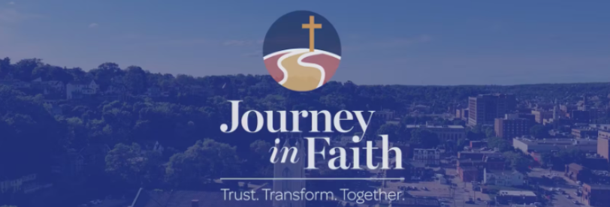
Dear Brothers and Sisters in Christ,
About a week ago, we celebrated the great Solemnity of Pentecost. We were reminded that the Holy Spirit has always guided the Church through moments of excitement and change. The same Spirit who united people from many places into one Church continues to call us together today as one family of faith, sharing one mission in Christ.
In that spirit of unity and trust, I introduce the Interim Mass Schedules for each pastorate. The plan is to implement these interim schedules from July 15, 2026, through January 15, 2027. To access the interim schedules for your pastorate, please click the button below. Each pastorate has a one-page graphic listing all daily and weekend Mass times.
These interim schedules will be evaluated throughout the next six months and adjusted as needed. Please be patient and grace-filled as we allow the proposed schedules time to take effect. The schedules were created with great care and with input from each parish’s leadership. Recognizing that these changes may be difficult for some, please approach this transition with understanding, flexibility, and a shared spirit of unity.
As we continue moving forward together, may we remain focused on our shared mission and on the joy of celebrating the Eucharist together.
Walking with you on this Journey in Faith,
Archbishop Thomas Zinkula

