RURAL COMMUNITY HEALTH CENTER RUCHC NGO NABARANGPUR ODISHA PROJECT-ACCESS TO CLEAN WATER BY DRILLING 15TUBEWELLSYEAR2025- FUNDED BY HAVE CANADA -
2025

acw
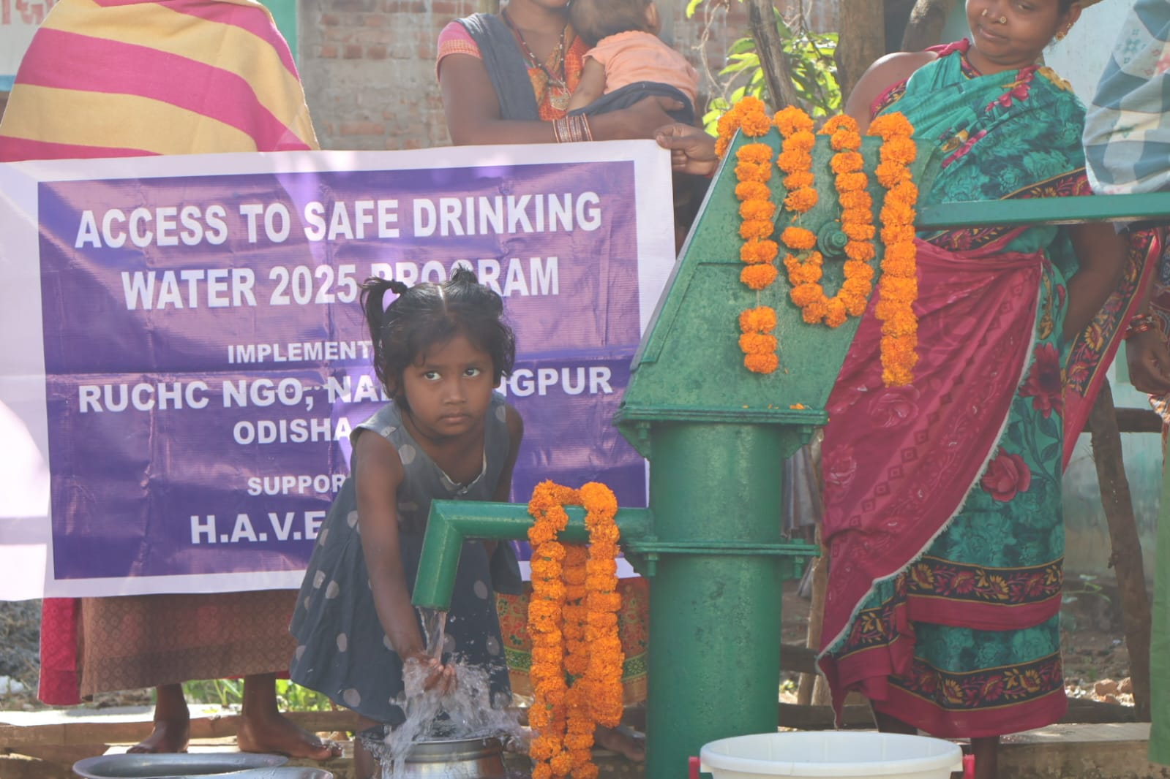
RUCHC NGO

RURAL COMMUNITY HEALTH CENTER RUCHC NGO NABARANGPUR ODISHA

PROJECT-ACCESS TO CLEAN DRINKING WATER BY DRILLING 15TUBE WELLS

YEAR 2025-FUNDED BY H.A.V.E. CANADA
------------------------------------------------------------------

From the Desk of the President……………
This Annual report comprises of details of activities taken by RUCHC in provision of Safe drinking water, community health, social justice, women’s empowerment and sustainable rural development related to overall social, economic, political, cultural and intellectual development of total human being of this most back word district of Orissa.

Since the water health sanitation and the development need in our target area is far greater than the resources available with RUCHC particularly where people are living in a dismal state of chronic crises, it becomes necessary to carefully consider how existing resources were to be spent. A number of different solution and decision were taken for the improvement of overall situation, which is recorded in this document.

I wish to extend my sincere thanks to HAVE committee Canada, all sponsors, RUCHC staff, management and committee members, villagers who are our partner in development, legal advisor of RUCHC for their unstained support, encouragement and co-operation around the year.

Ms. Nishita Dandsena
President, RUCHC, Nabarangpur
Odisha, INDIA

Nabarangpur District Profile

The district (area: 5,294.5 sq km) is situated in the southwest corner of Orissa, bordering Koraput district. Most of the land is forested. The district is located at an average elevation of 1,876 feet. The city of Nabarangpur is the district headquarters. Roughly equal to the nation of Bahrainor the US state of New Hampshire. This gives it a ranking of 390th in India (out of a total of 640).Nabarangpur has a sex ratio of 1018 females for every 1000 males. Nabarangpur’s borders stretch in the north to Kalahandi district, in the west to Jagdalpur district in Chhattisgarh, in the east to Kalahandi and Rayagada districts, and in the south to Koraput district.

- In 2021, over 2 billion people live in water-stressed countries, which is expected to be exacerbated in some regions as result of climate change and growth.
- In 2022, globally, at least 1.7 billion people use a drinking water source contaminated with faeces. Microbial contamination of drinking-water as a result of contamination with faeces poses the greatest risk to drinking-water safety.

- Safe and sufficient water facilitates the practice of hygiene, which is a key measure to prevent not only diarrhoeal diseases, but acute respiratory infections and numerous neglected tropical diseases.
- Microbiologically contaminated drinking water can transmit diseases such as diarrhoea, cholera, dysentery, typhoid and polio and is estimated to cause approximately 505 000 diarrhoeal deaths each year.
- In 2022, 73% of the global population (6 billion people) used a safely managed drinking-water service – that is, one located on premises, available when needed, and free from contamination.

These 15 tube wells project had significantly enhanced access to safe drinking water through sinking tube wells thus supplying clean water to the community and improving health and sanitation.

EXPECTED BENEFITS
- Increased access to safe drinking water for people and livestock
- Reduced communicable disease morbidity and prevalence
- Improved living standards
- Community capacity building on hygiene promotion and sanitation

- General economic empowerment of the area that is currently dry and poorly developed
- Reduced poverty levels

The women will be relieved of the problem of trekking for long distance in search of water for household

- Accessibility: Water and sanitation facilities must be physically accessible and within safe reach for all sections of the population, taking into account the needs of particular groups, including persons with disabilities, women, children and older persons.
- Affordability: Water services must be affordable to all. No individual or group should be denied access to safe drinking water because they cannot afford to pay.
- Quality and safety: Water for personal and domestic use must be safe and free from micro-organisms, chemical substances and radiological hazards that constitute a threat to a person’s health. Sanitation facilities must be hygienically safe to use and prevent human, animal and insect contact with human excreta.
DESCRIPTION OF VILLAGES
SL.NO | VVVILLAGE | POPULATION | STATUS | SPONSORED PLAQUES | MAINTENANCE | DEPTH OF DRILLING IN METERS
1 | Jetuguda | 360 | 1 Tubewell | IN LOVING MEMORY OF  JOSEPH AND HAZEL O'RIELLY  SPONSORED BY: LUCILLE AND DERRICK HARTY, GAMBO, NL, CANADA | Water Groups form by RUCHC & Gram Panchayat | 40 mt
2 | Sindhiguda | 240 | 1 Tubewell | IN WONDERFUL MEMORY OF A GREAT HUMANITARIAN  MARY HOLLOWAY  WALKER: JANET HOUNSELL, GLOVERTOWN, NL, CANADA | Water Groups form by RUCHC & Gram Panchayat | 45 mt
3 | Jampadar | 680 | 1tubewell | SPONSERED BY ANGIE AND SCOTT GREEN AND FAMILY | Water Groups form by RUCHC & Gram Panchayat | 45mt
4 | Doaliguda | 360 | Dugwell | SPONSORED BY GRADES 4, 5, AND 6  GLOVERTOWN ACADEMY  GLOVERTOWN , NL, CANADA | Water Groups form by RUCHC & Gram Panchayat | 50 mt
5 | Bataguda | 520 | 1 Tubewell | IN MEMORY OF GRAHAME WELLS AMAN WHO MADE OTHER SMILE | Water Groups form by RUCHC & Gram Panchayat | 48mt
6 | Podaguda | 480 | 1 Tubewell | SPONSERED BY KEGEL HEATING AND COOLING JOHN 4:13-14 | Water Groups form by RUCHC & Gram Panchayat | 50mt
7 | Kairamundi | 200 | 1tubewell | SPONSERED BY KEGEL HEATING AND COOLING JOHN 4:13-14 | Water Groups form by RUCHC & Gram Panchayat | 39 mt
8 | N.Anchala | 1200 | 2Tubewell | SPONSERED BY ROXANNE JACQUES | Water Groups form by RUCHC & Gram Panchayat | 40 mt
9 | Old Anchala | 900 | 1Tubewell | SPONSERED BYCANADENSYS AEROSPACE INC | Water Groups form by RUCHC & Gram Panchayat | 55 mt
10 | Mohali | 120 | Pond | SPONSERED BY DENTISTRY IN THE HIGHLANDS | Water Groups form by RUCHC & Gram Panchayat | 38 mt
11 | Nuaguda | 80 | Open well | SPONSERED BY ROTARY CLUB OF HALIBURTON | Water Groups form by RUCHC & Gram Panchayat | 35 mt
12 | Singoguda | 450 | 1 Tubewell | SPONSERED BY CANADENSYS AEROSPACE INC | Water Groups form by RUCHC & Gram Panchayat | 39 mt
13 | Banbhugam | 180 | 1 Tubewell | SPONSERED BY TD WEALTH, PAUL MORSE | Water Groups form by RUCHC & Gram Panchayat | 40 mt
14 | kupia | 800 | 1Tubewell | SPONSERED BY RIDGEWOOD FORD | Water Groups form by RUCHC & Gram Panchayat | 55mt
15 | Champia | 1700 | 2Tubewell |  | Water Groups form by RUCHC & Gram Panchayat | 45mt

- Access to clean, safe water isn't an end, it's a means.
- We know that when a well is installed for a village, girls return to school. Women begin small businesses. Men are no longer too sick to work. Fields are watered and food supply becomes more reliable.

- Health returns and children grow up to be productive members of their community. The cycle of poverty is broken. Lives change.
- With safe water nearby, women are free to pursue new opportunities and improve their families’ lives. Kids can earn their education and build the future of their community.

1 JETUGUDA

Clean water is a fundamental necessity for sustaining life on Earth. Its availability is essential for various activities, including drinking, sanitation, agriculture, and industrial processes. Despite its significance, many regions worldwide face challenges in accessing clean water due to pollution, inadequate infrastructure, and climate change.

This village has a population of 360 people which is situated in the remote inaccessible forest area where drinking water, communication, electricity, health, education facilities are not available which affects their livelihood since most of them are daily wages laborer or small farmers. They have one old tube well when it goes defunct People had to walk some distance in the hilly forest area to collect water from the nearby seasonal brook which gets dry in summer. Some time they get attacked by wild bears and animals, some of them were seriously injured and lost their lives. Not only it causes water borne disease but precious time and energy lost that can be used to earn wages to improve socio -economic condition.
An application was given to RUCHC, after the survey and village meeting was conducted here we explained importance of safe drinking water, its social and economic advantage, group formation, waste water management, etc to the villagers. A successful tube well is drilled in the centrally located place and waste water will be used for kitchen garden which will economically benefit the villagers and also increase their productivity by saving their precious time earlier wasted in fetching water

People are thankful to LUCILLE AND DERRICK HARTY, GAMBO, NL, ..

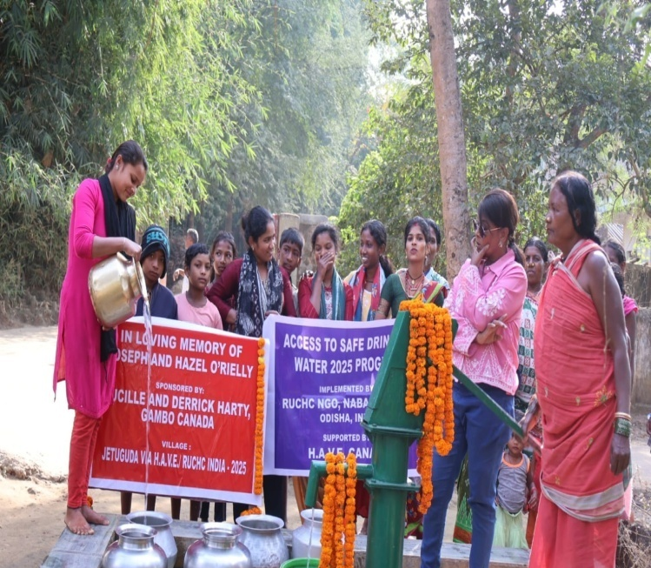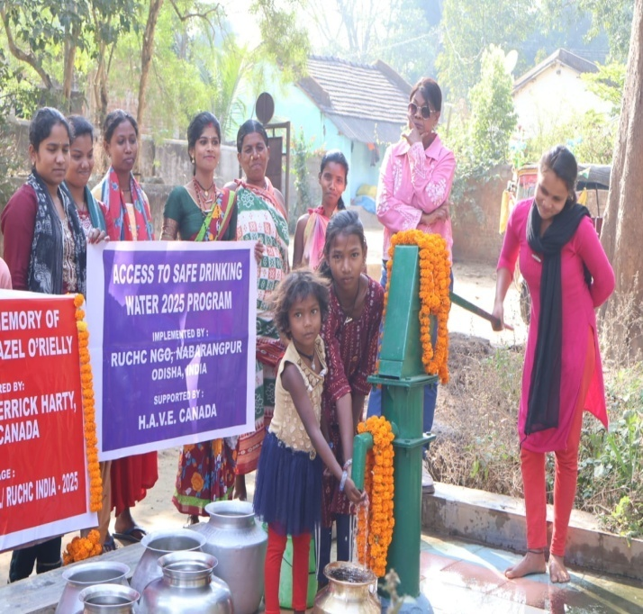

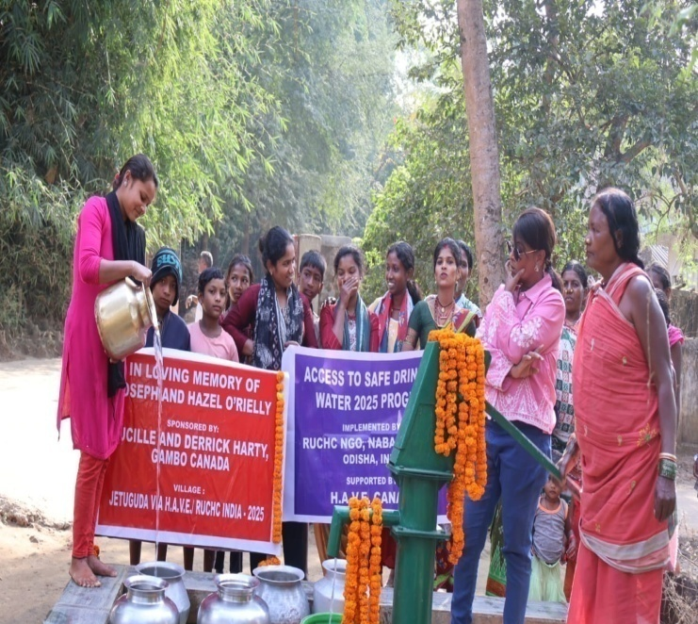
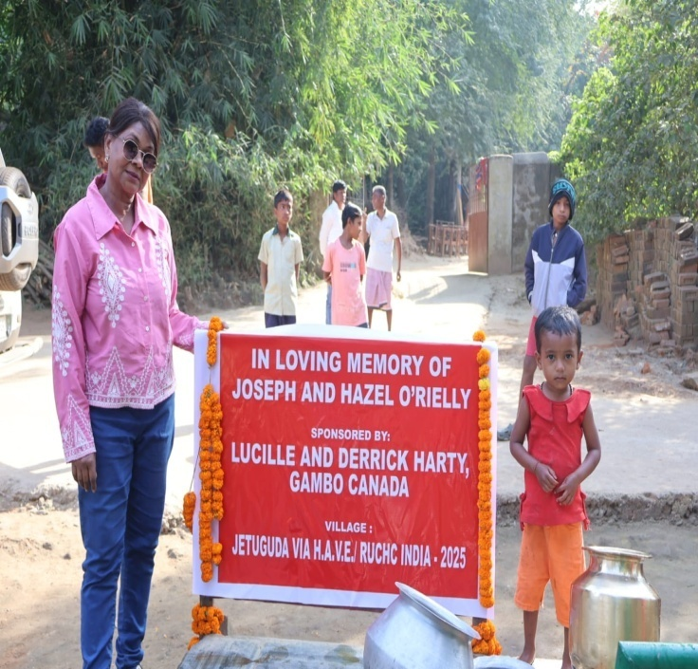

2 SINDHIGUDA

The Importance of Clean Water
Clean water is vital for maintaining human health and preventing waterborne diseases. Additionally, it plays a crucial role in food security and economic development, particularly in agricultural societies. Moreover, clean water sustains ecosystems, supporting biodiversity and ecological balance.

This village has a total population of 240 people. It has got 1 tube wells which is not sufficient to meet the domestic and drinking water need of the people. Often people face small squabbles and quarrels over a pot of water which disturbs village harmony. Waiting in the long queue for a pot of water, ruins productive time to work in agriculture field as a daily wage laborers which affects their earning pattern. Therefore, against this background RUCHC decided to drill a tube well in the village sindhiguda. A survey was done and a centrally located place was selected by villagers themselves to drill a tube well. A village meeting was held to explain community responsibility to manage and maintain tube well. A successful tube well was drilled in the centrally located place where waste water can be use for growing vegetable which will bring extra income to the users of the tube well.

People are thankful to WALKER: JANET HOUNSELL, GLOVERTOWN, NL, CANADA

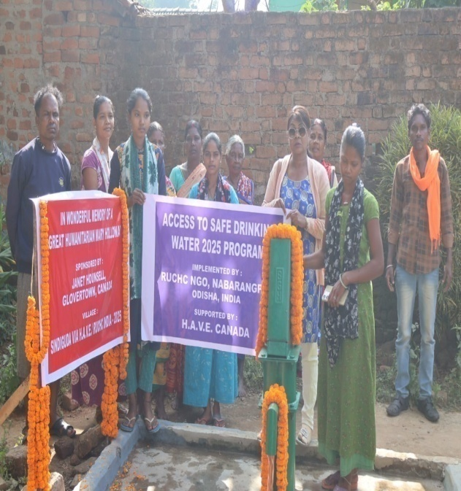
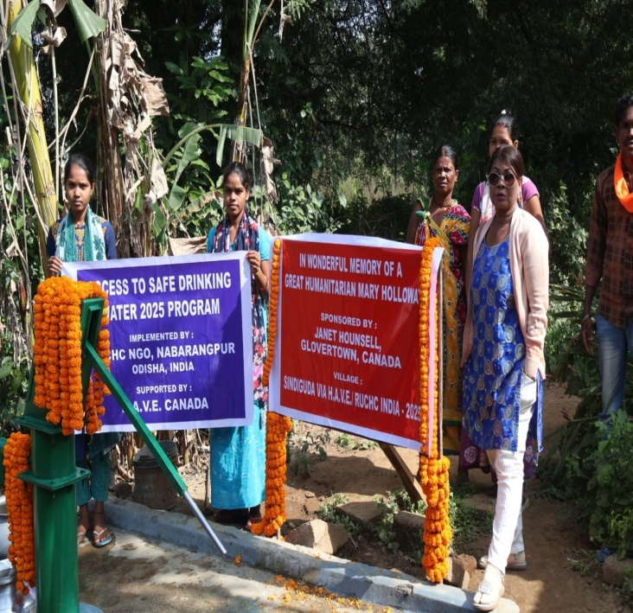

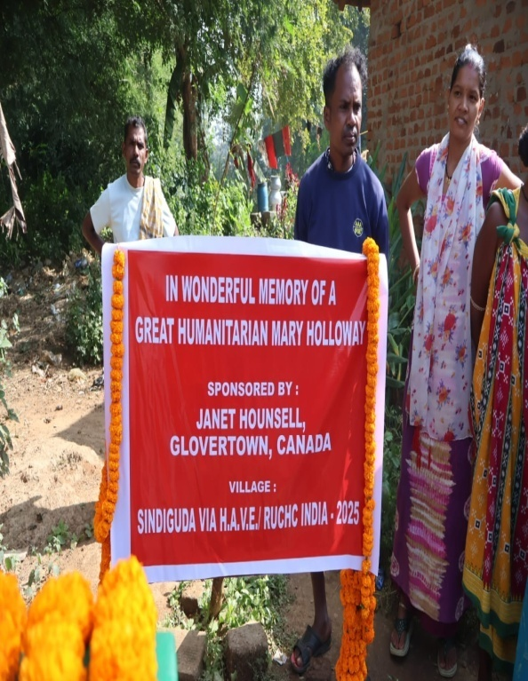
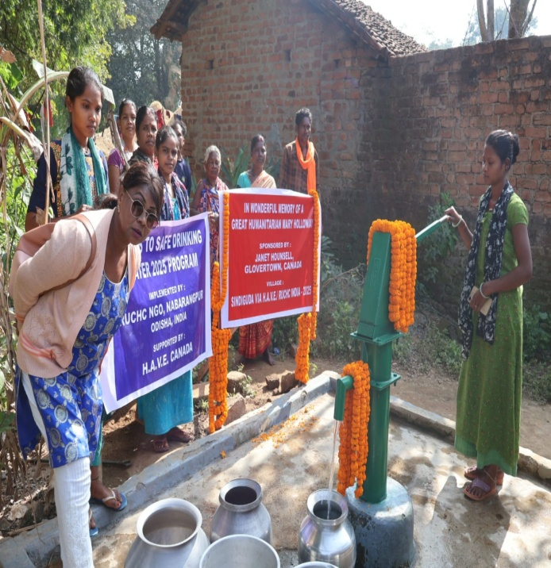

3.DOLAIGUDA

Population growth, urbanization, and industrial activities contribute to water pollution and scarcity. Inadequate wastewater treatment and agricultural runoff further degrade water quality. Climate change exacerbates these challenges, leading to unpredictable precipitation patterns and droughts. These are the Challenges in Ensuring Clean Water.

This village has a population of 360 people. It has got no tube well. People walk some distance in the hilly forest area to collect water from the nearby seasonal brook or they are forced to get water from paddy field contaminated with pesticides, which causes water borne diseases and affects the livelihood since most of them are daily wages laborer or small farmers. An application was given to RUCHC office after the survey and village meeting where we explained importance of safe drinking water, its social and economic advantage, group formation, waste water management, etc to the villagers. A successful tube well is drilled in the centrally located place and waste water will be used in good plot for kitchen garden which will economically benefit the villagers and also increase their productivity by saving their precious time earlier wasted in fetching water.
People are thankful to GRADES 4, 5, AND 6
GLOVERTOWN ACADEMY GLOVERTOWN, NL, CANADA
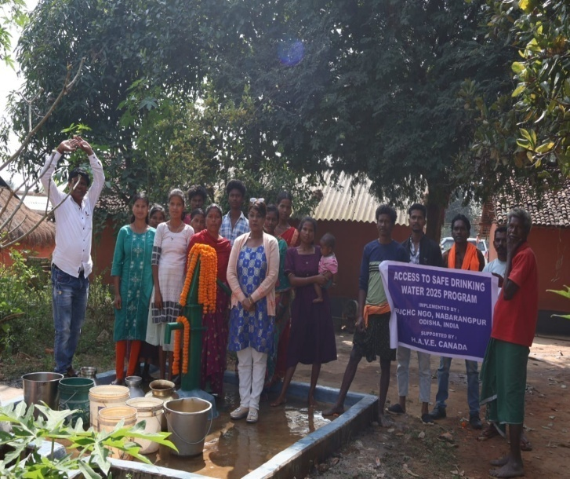
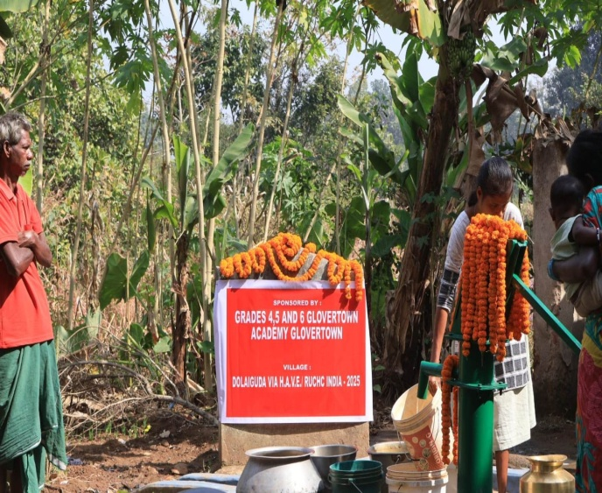

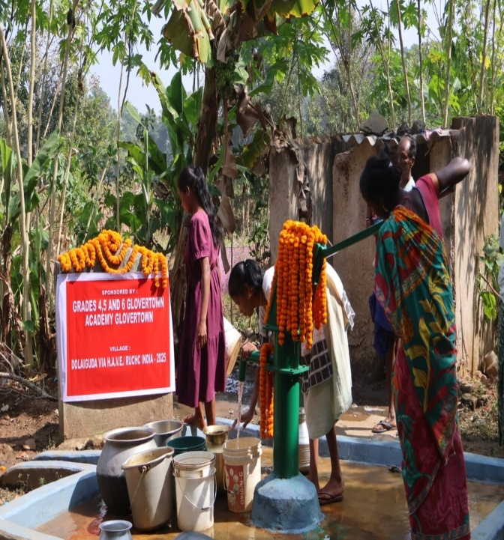
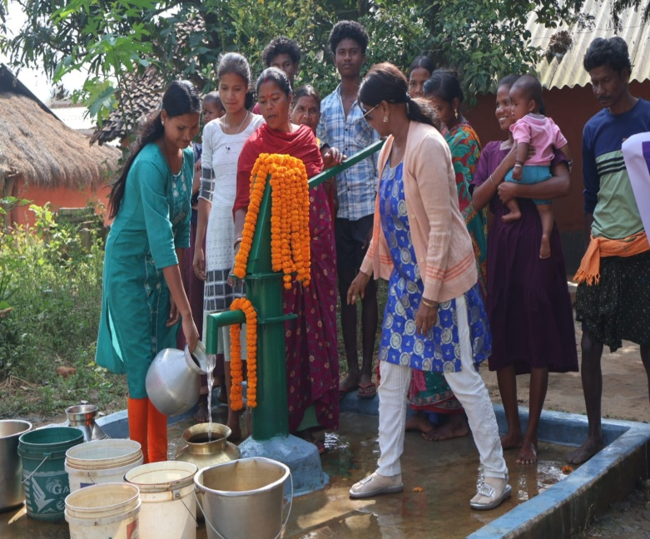

4.PODAIGUDA

Implementing robust water management practices, such as wastewater treatment, watershed protection, and water conservation, is essential. Investing in infrastructure development and technology innovation can enhance access to clean water. Moreover, promoting public awareness and community involvement is crucial for sustainable water resource management.

This village has a population of 480 people. It has got 1 tube well. If it goes defunct villagers walk miles in search of water or forced to get water from paddy field contaminated with pesticides, which causes water borne diseases. An application was given to RUCHC office, after the survey and village meeting where we explained importance of safe drinking water, its social and economic advantage, group formation, waste water management, etc to the villagers. RUCHC’s objective is for integrated development in the village based on safe drinking water which will provide benefit of the development at the local level. A successful tube well is drilled in the centrally located place and waste water will be used in good plot for kitchen garden which will economically benefit the villagers and also increase their productivity by saving their precious time earlier wasted in fetching water.
People are thankful to KEGEL HEATING AND COOLING JOHN 4:13-14

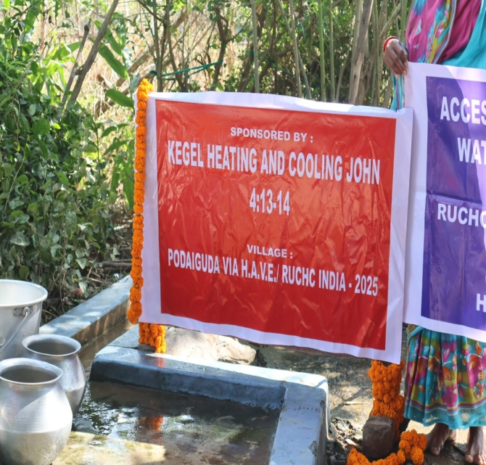
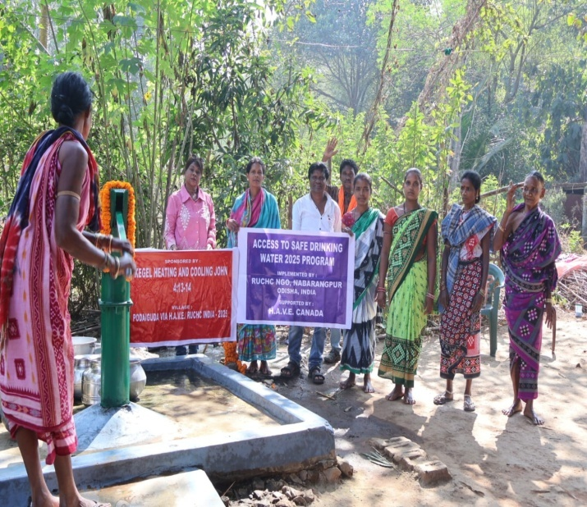

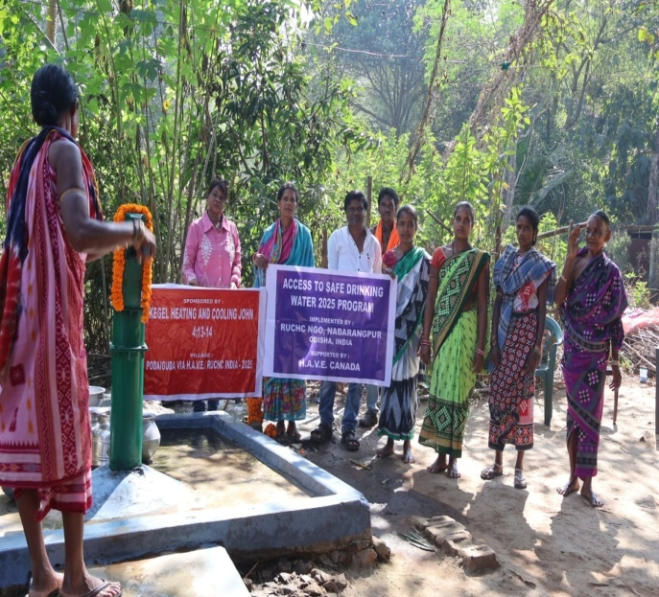
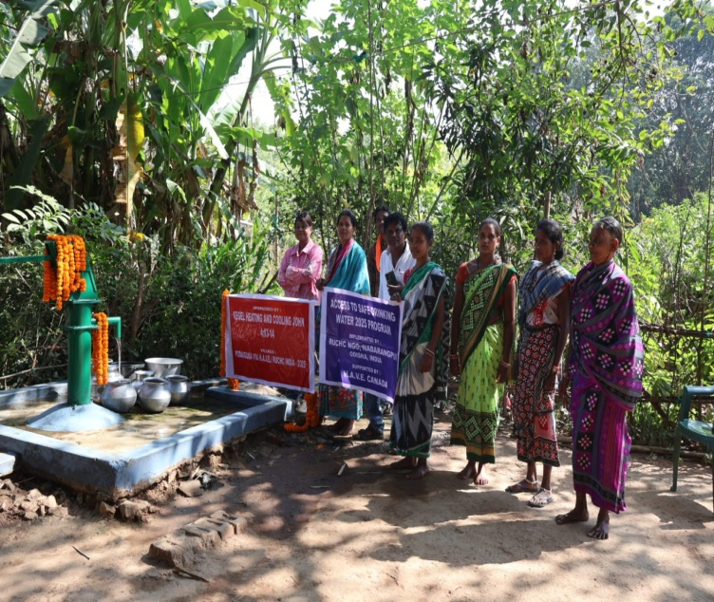

5 KAIRAMUNDI

Clean water is a precious resource that is indispensable for human well-being and environmental sustainability. Addressing the challenges of water pollution and scarcity requires coordinated efforts at local, national, and international.

This village has a population of 200 people. It has got open well. Women are forced to walk miles in search of water which affects their livelihood since most of them are daily wages laborers or small farmers. An application was given to RUCHC office, after the survey and village meeting where we explained importance of safe drinking water, its social and economic advantage, group formation, waste water management, etc to the villagers.. A successful tube well is drilled in the centrally located place and waste water will be used in good plot for kitchen garden which will economically benefit the villagers and also increase their productivity by saving their precious time earlier wasted in fetching water.

People are grateful to KEGEL HEATING AND COOLING JOHN 4:13-14

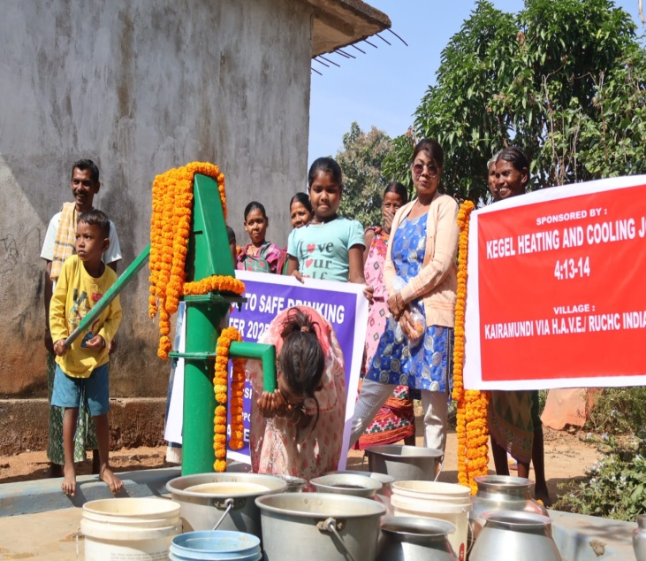
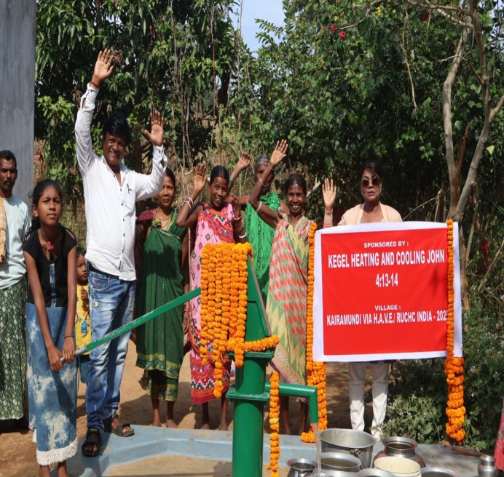

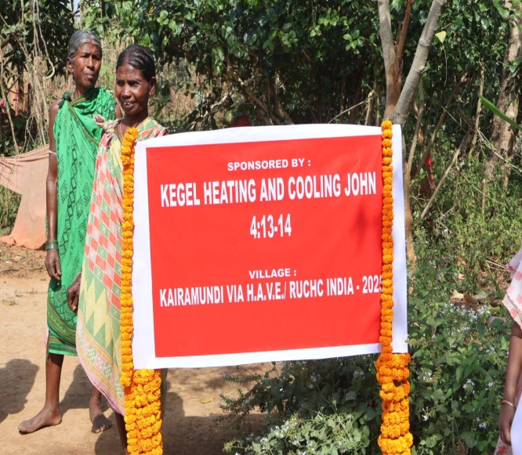
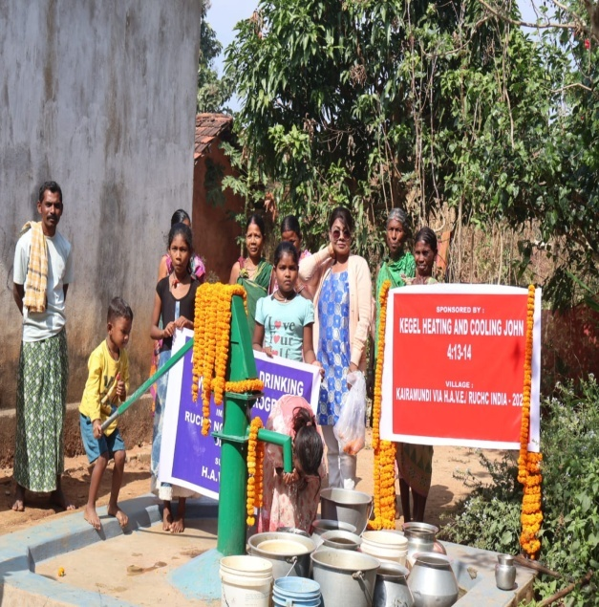

6.MOHALI

The water supply for each person must be sufficient and continuous to cover personal and domestic uses, which comprise water for drinking, washing clothes, food preparation and personal and household hygiene. There must be a sufficient number of sanitation facilities within or in the immediate vicinity of each household, and all health or educational institutions, workplaces and other public places to ensure that safe sanitation standard is maintained.
This village has a population of 120 people. It has got 1 pond If it goes dry in summer villagers walk miles in search of water or forced to get water from paddy field contaminated with pesticides, which causes water borne diseases. An application was given to RUCHC office after the survey and village meeting where we explained importance of safe drinking water, its social and economic advantage, group formation, waste water management, etc to the villagers. RUCHC’s objective is for integrated development in the village based on safe drinking water which will provide benefit of the development at the local level. A successful tube well is drilled in the centrally located place and waste water will be used in good plot for kitchen garden which will economically benefit the villagers and also increase their productivity by saving their precious time earlier wasted in fetching water.
People are thankful to DENTISTRY IN THE HIGHLANDS
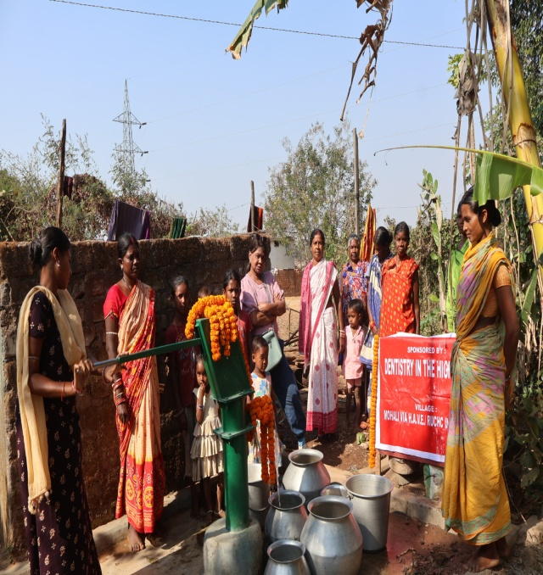
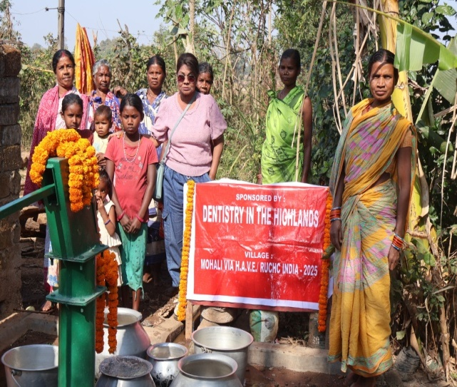

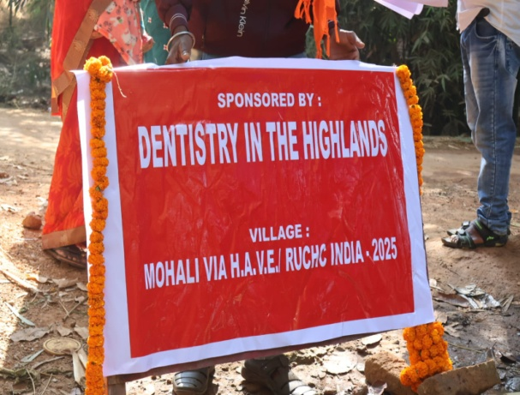
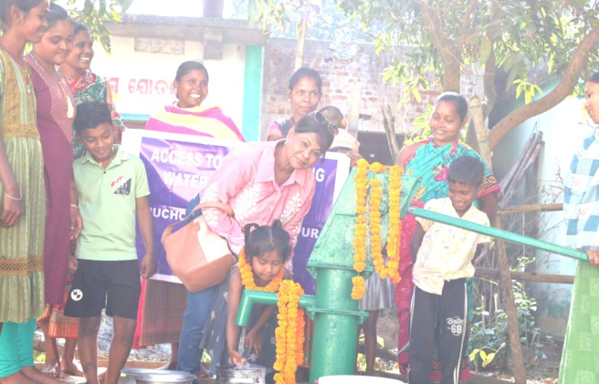

7 NUAGUDA

Population growth, industrialization, and pollution pose significant challenges to ensuring clean water for all. Inadequate infrastructure and poor water management exacerbate the problem, especially in developing countries. Climate change further intensifies water scarcity and pollution, making it imperative to implement effective water conservation and purification strategies
The village has a population 80 people and it has got no tube well. It is a cut off and remote area inaccessible by Road. People live by river side which flows down 4 km from the village walking to meet their water need which causes diarrhea epidemic in rainy seasons and year out malaria; it leads to many deaths in the village. Under the circumstances people approached, RUCHC for a tube well. After a village survey and meeting villagers were motivated to make route for the drilling truck to come in and a successful tube well was drilled in the centrally located place which will meet the drinking and domestic water need of the villager and also help prevent many waters borne diseases. RUCHC has motivated each village for income generation activities like kitchen garden around tube well using waste water which will help them immensely
. The community is thankful to ROTARY CLUB OF HALIBURTON
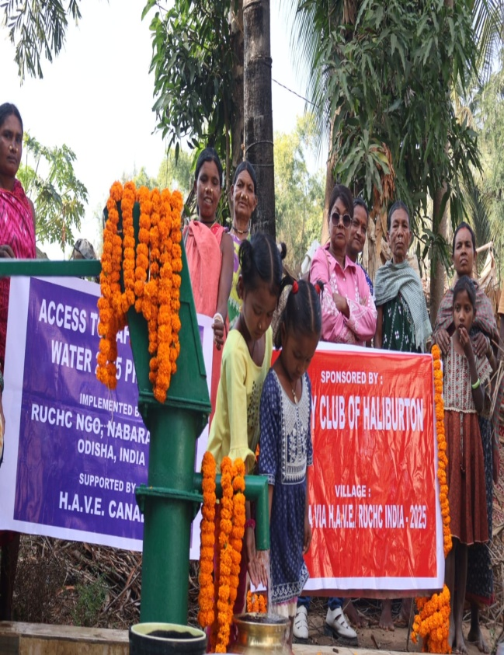
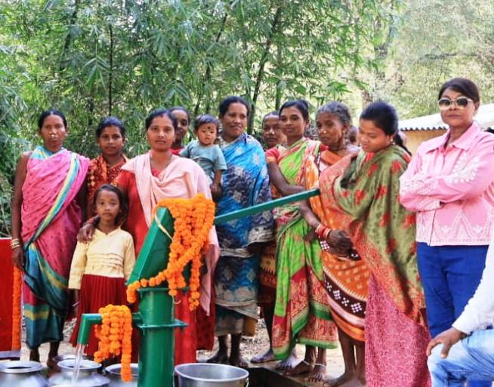
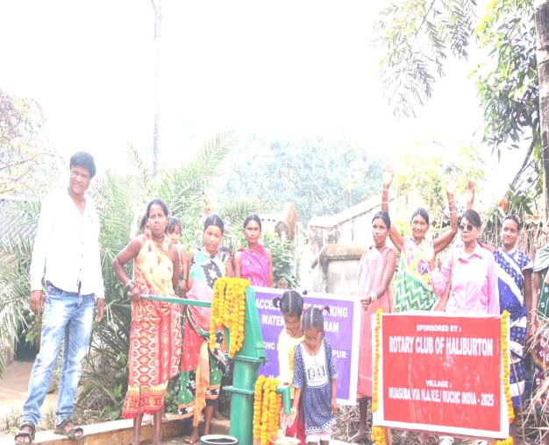
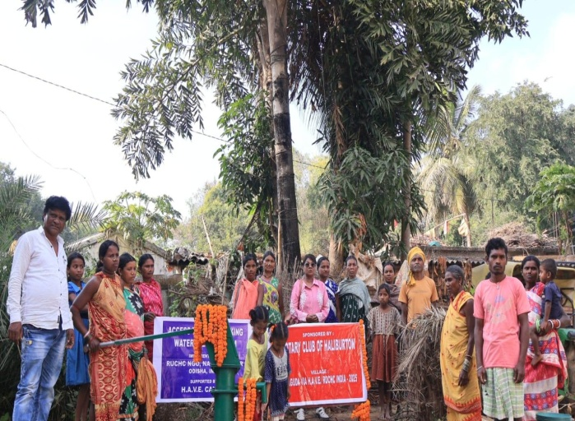

8 BANBHUGAM
Access to clean, safe water isn't an end, it's a means.
We know that when a well is installed for a village, girls return to school. Women begin small businesses. Men are no longer too sick to work. Fields are watered and food supply becomes more reliable. Health returns and children grow up to be productive members of their community. The cycle of poverty is broken. Lives change. With safe water nearby, women are free to pursue new opportunities and improve their families’ lives. Kids can earn their education and build the future of their communities.

This village has a population of 180 people. This village has1 tube well if it went dry in summer villagers are forced to fetch water from nearby seasonal brook which causes water borne diseases and affects the livelihood. RUCHC, s objective is for integrated development in the village based on safe drinking water which will provide benefit of the development at the local level. An application was given to RUCHC after the survey and village meeting where we explained importance of safe drinking water, its social and economic advantage, group formation, waste water management, etc. to the villagers. A successful tube well is drilled in the centrally located place and waste water will be used in good plot for kitchen garden which will economically benefit the villagers and also increase their productivity by saving their precious time earlier wasted in fetching water
Villagers are grateful to TD WEALTH, PAUL MORSE
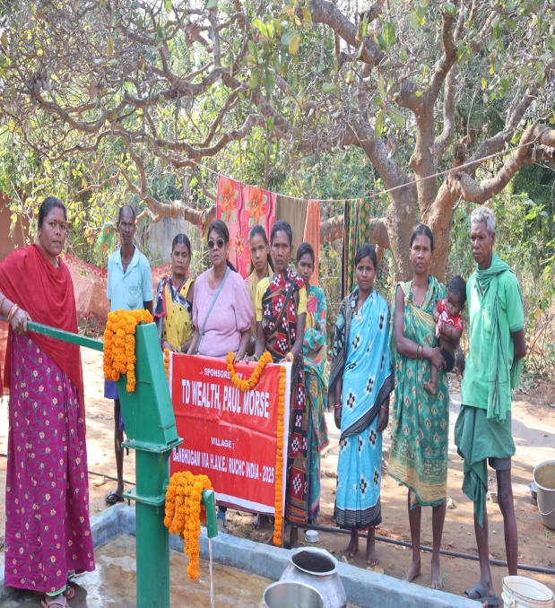
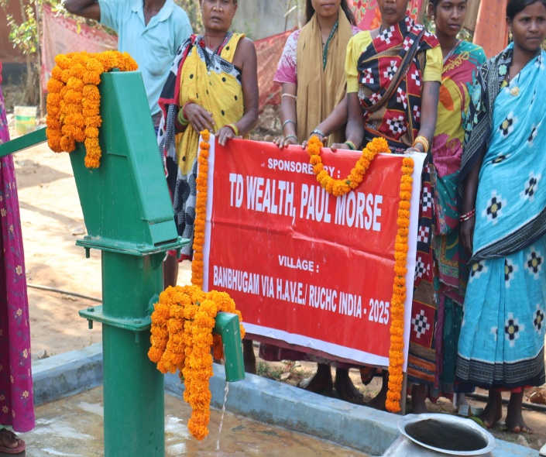
.
This well is sponsored by

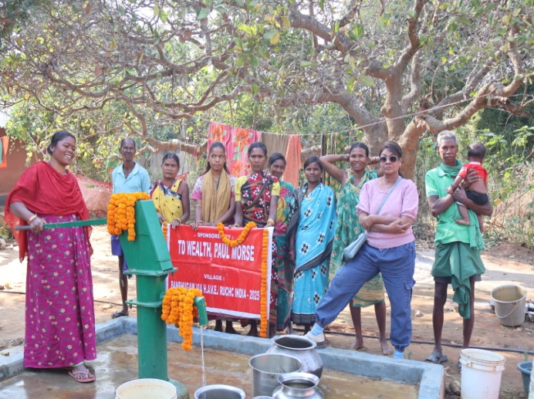
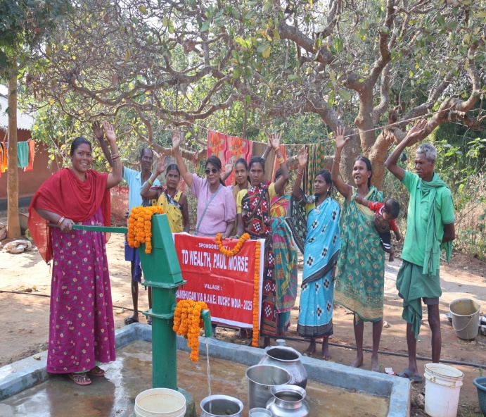

9 KUPIA
clean water is indispensable for human health, environmental sustainability, and economic prosperity. Efforts must be made at local, national, and global levels to ensure equitable access to clean water for present and future generations. By addressing the challenges and investing in sustainable water management practices, we can safeguard this precious resource and promote a healthier, more prosperous world.
.
The village has a population 800 people and it has got 2 tube wells which is not sufficient to meet the water needs of villagers. Under the circumstances people approached, RUCHC for a tube well. After a village survey and meeting villagers were motivated to make route for the drilling truck to come in and a successful tube well was drilled in the centrally located place which will meet the drinking and domestic water need of the villager and also help prevent many waters borne diseases. RUCHC has motivated each village for income generation activities like kitchen garden around tube well using waste water which will help them immensely.
Villagers are grateful to RIDGEWOOD FORD

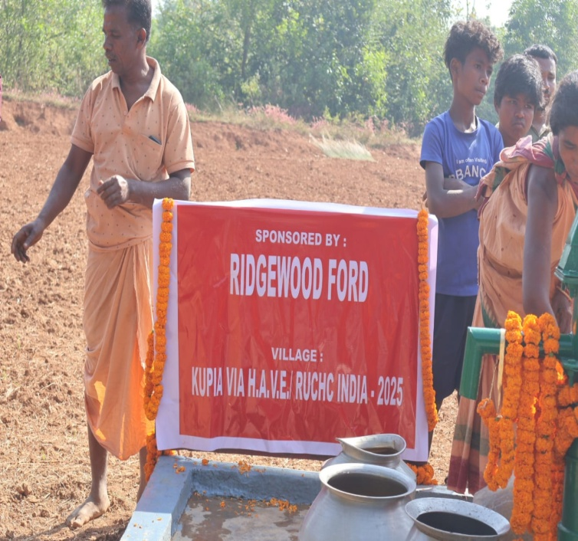
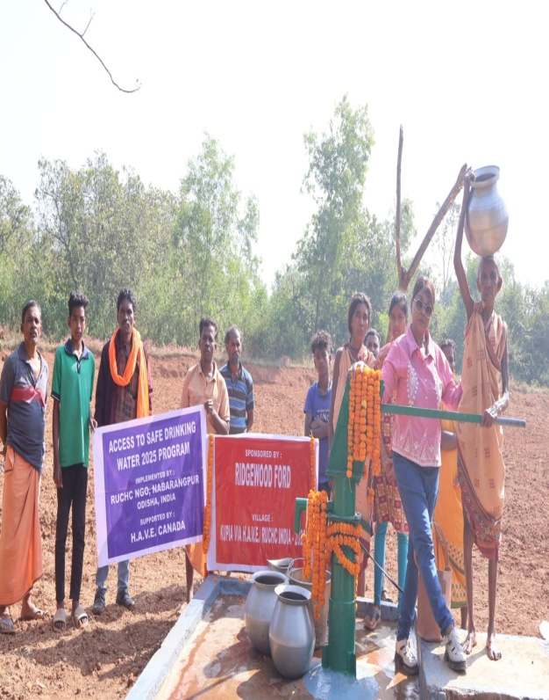

10 JAMPADAR

Water is a very essential for mankind. The United Nations suggest that each person needs 20-50 liters of water a day to ensure basic needs of drinking, cooking and cleaning. It was also endorsed by the Indian National Water Policy 2002, with the provision that adequate Safe drinking water facilities should be provided to the entire population both in urban and in
Rural areas. The provision of clean drinking water has been given priority in the Constitution of India, in article 47 conferring the duty of providing clean drinking water and improving public health.

This village has a total population of 680 people and it has got 1 tube well in one of the streets of the village but one particular street resided by lower class tribal has no tube well. Caste discrimination, over dependence on existing tube well used to create many problems in the village for domestic and drinking water need of people. So, the people approached us for a tube well. A village meeting was held explaining the importance of water management, tube well maintenance, and uses of waste water, etc. After a survey a successful tube well was drilled in a centrally located place which is sufficient to meet the water need of one particular street deprived of safe drinking water. The waste water is going to be used by water group for cultivation of vegetables which will bring extra income in the family.

Villagers are grateful to ANGIE AND SCOTT GREEN AND FAMILY

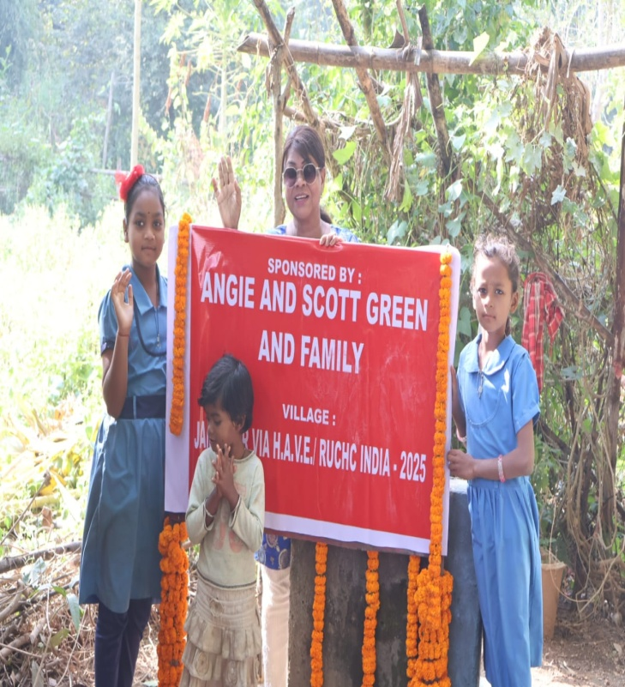
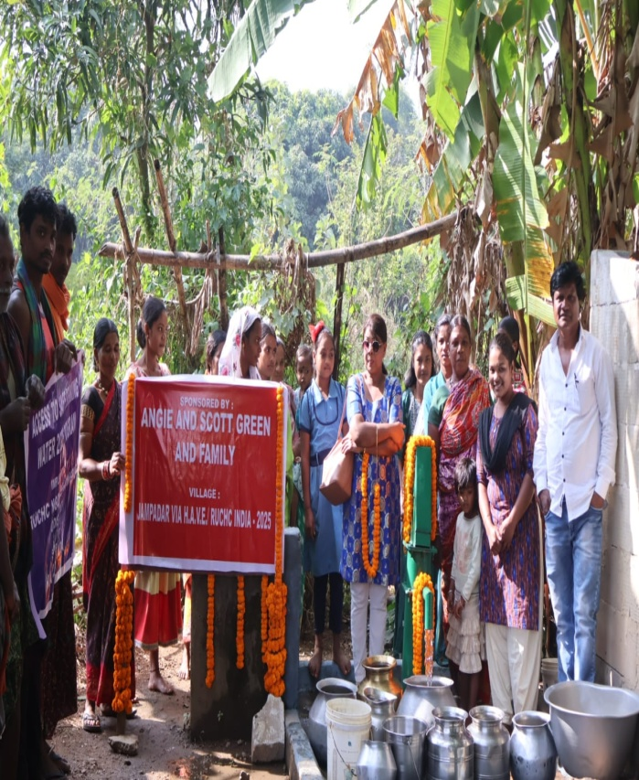

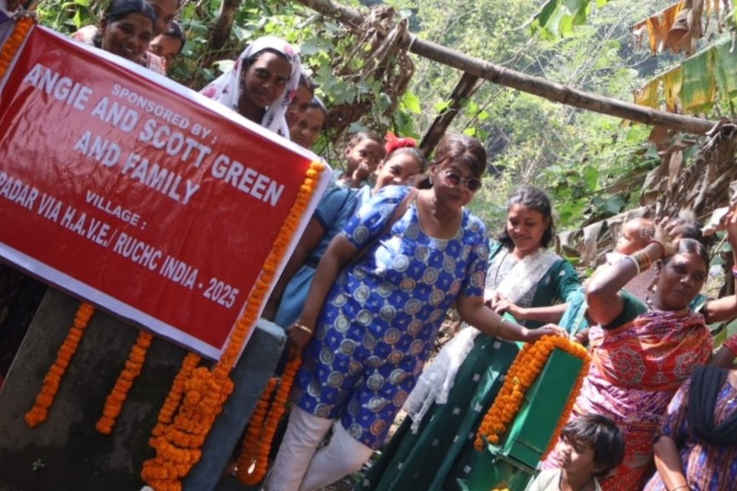
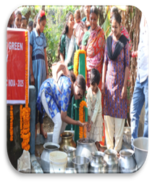

11. OLD ANCHALA

The country has 75.8 million people, of its 1.25 billion populations, without access to clean water, report by WaterAid, water and sanitation nonprofit headquartered in London, says- The majority of those people come from impoverished communities–living on around $4.31 a day–and are forced to collect dirty water from open ponds and rivers or spend most of what they earn buying water from tankers, consequently, millions of people get insufficient or poor-quality water. In India, about 140,000 children die from diarrheal diseases each year, after using dirty water, the report says. Without this, already overburdened communities bear the added stress of healthcare costs, loss of school days and reduced time for income-generating activity.
This village has a total population of 900 people and it has got 1 tube well in one of the streets of the village but one particular street resided by lower class tribal has no tube well. Caste discrimination, over dependence on existing tube well used to create many problems in the village for domestic and drinking water need of people. This village is RUCHC’s operational area for many years. So, the people approached us for a tube well. A village meeting was held explaining the importance of water management, tube well maintenance, and uses of waste water, etc. After a survey a successful tube well was drilled in a centrally located place which is sufficient to meet the water need of one particular street deprived of safe drinking water. The waste water will be utilized for growing vegetables which will help users to raise some income.

People are grateful to CANADENSYS AEROSPACE INC.
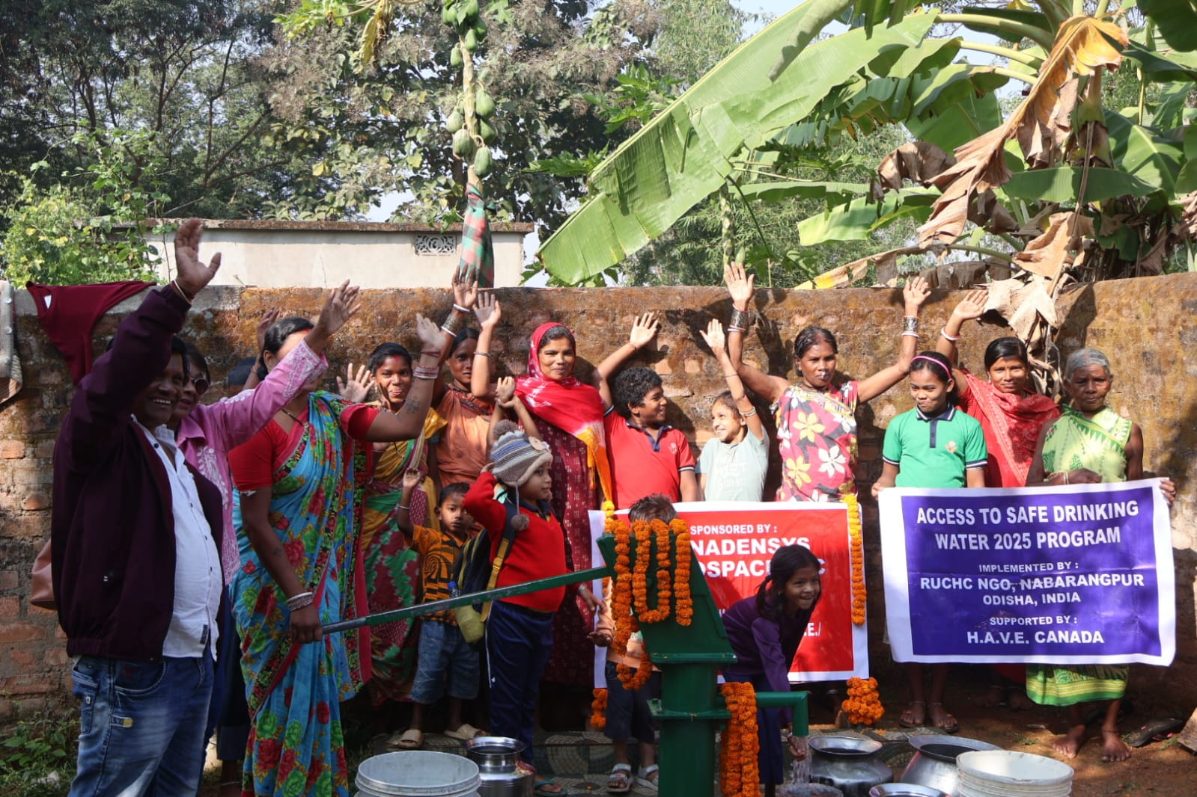
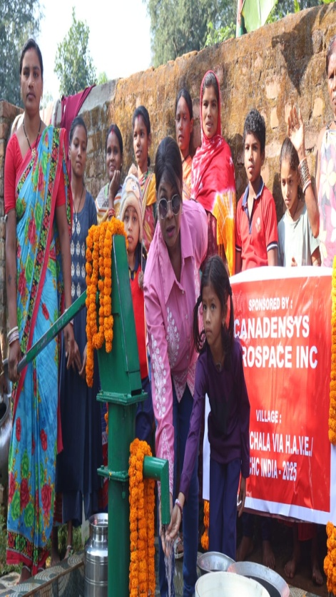

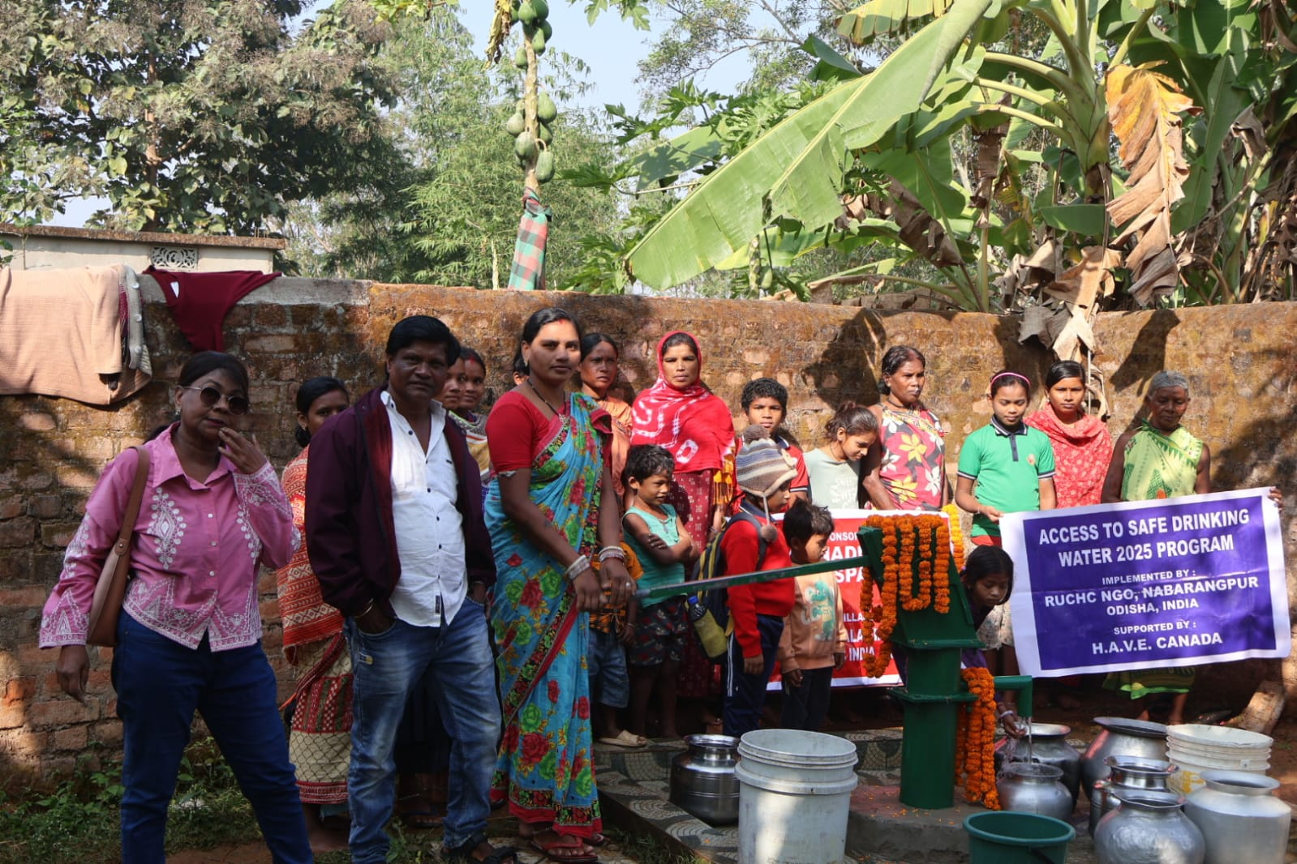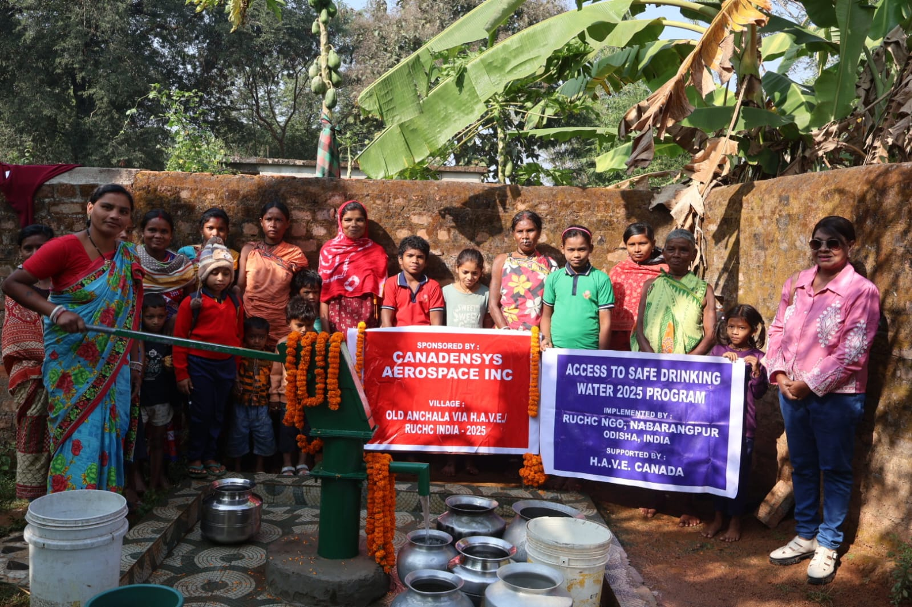

12.SINGOGUDA
Through time, early societies understood the importance and need for water and planned their lives around it. Civilizations were born and lost on account of water. Today, we have the advantage of this knowledge and we still fail to value it and plan our societies around it. Water supply in India has two principal sources, namely water from rivers and groundwater. However, the rivers are shrinking because of pollution and industrialization, while the population keeps growing, pushing us towards an enormous water deficit
This village has a population of 450 people and by nature it is remote inaccessible and cut off from basic amenities like school health, electricity, road, water, etc. This village has only 1 Tube well which is not sufficient to meet the water need of people. People have approached the Block Office many times but it fell on deaf ears. It is operational area of RUCHC where we do community health. This village was brought to our notice by a staff and a village meeting was called to explain the importance of safe drinking water uses. Its management and waste water uses. A survey was done and a successful tube well was drilled in a centrally located place. Waste water will be used for kitchen garden to raise extra income to the users.

People are grateful to CANADENSYS AEROSPACE IN

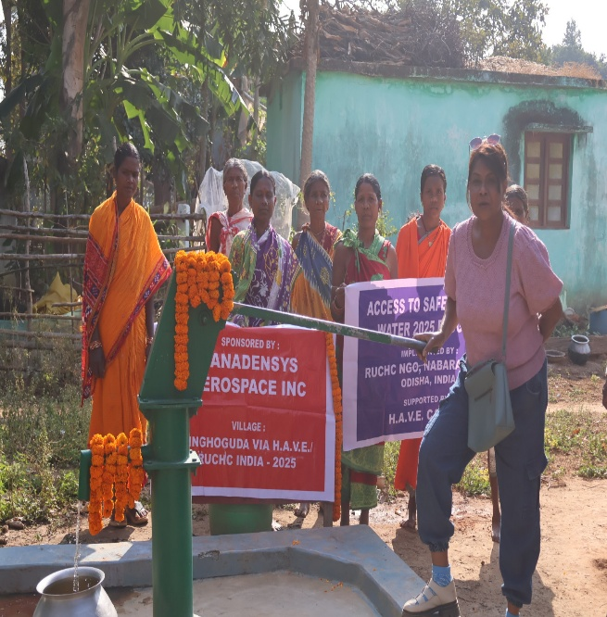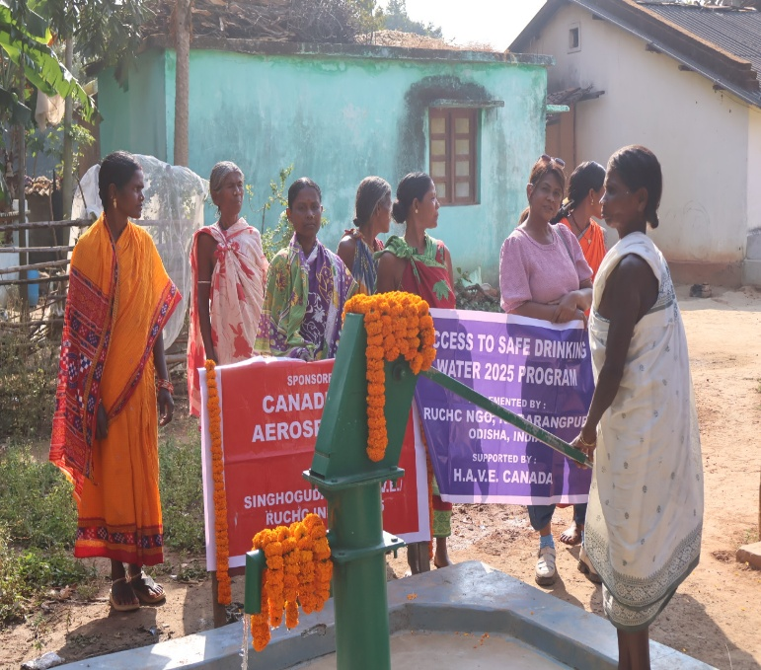

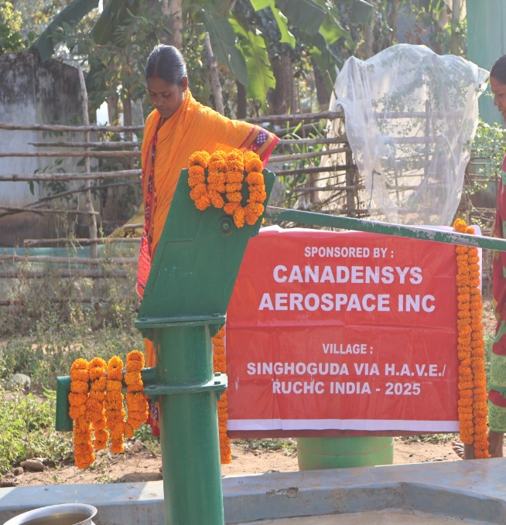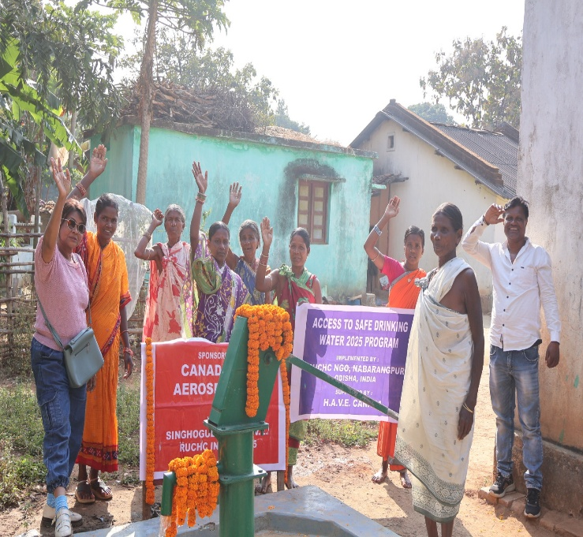

13. BATAGUDA.

In the past 100 years, the world’s water usage has increased at a rate twice that of population growth. Access to clean water affects individual health and is a significant factor in controlling the spread of infectious disease, and water access is also vital to the livelihoods of millions of people who rely on a consistent water source for agricultural or pastoral use.

This village has a total population of 540 people and it has got 1 tube well which is not sufficient to meet the water need of people. Over dependence on existing tube well used to create many problems in the village for domestic and drinking water supply. A village meeting was held explaining the importance of water management, tube well maintenance, and uses of waste water, etc. After a survey a successful tube well was drilled in a centrally located place which is sufficient to meet the water need of community deprived of safe drinking water. The waste water will be utilized for growing vegetables which will help users to raise some income.
Villagers are grateful to Grahame wells family.

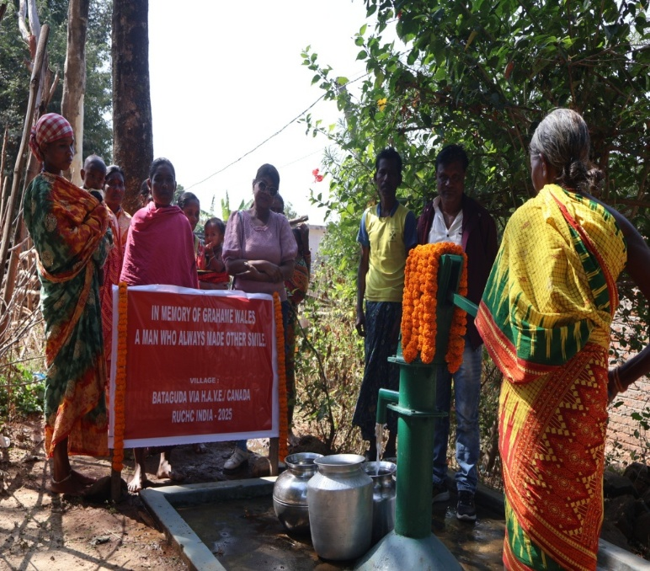
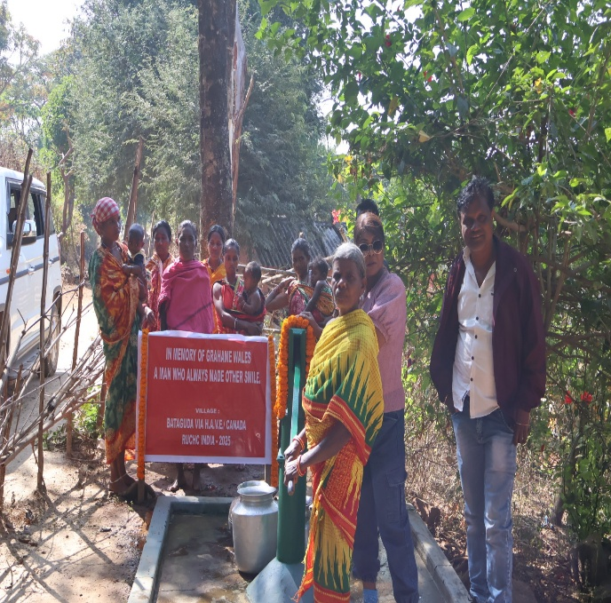
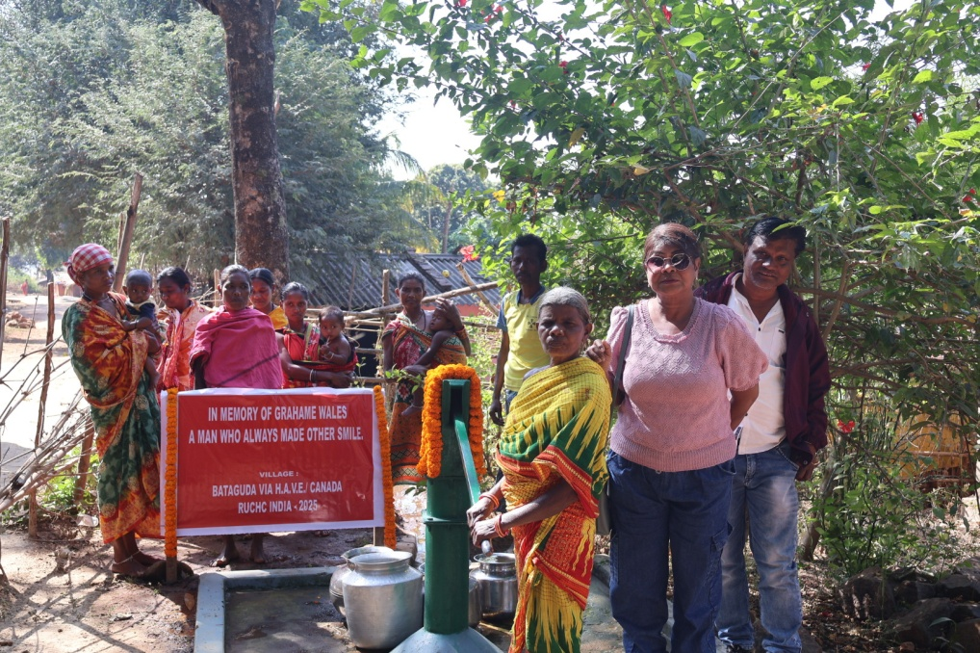

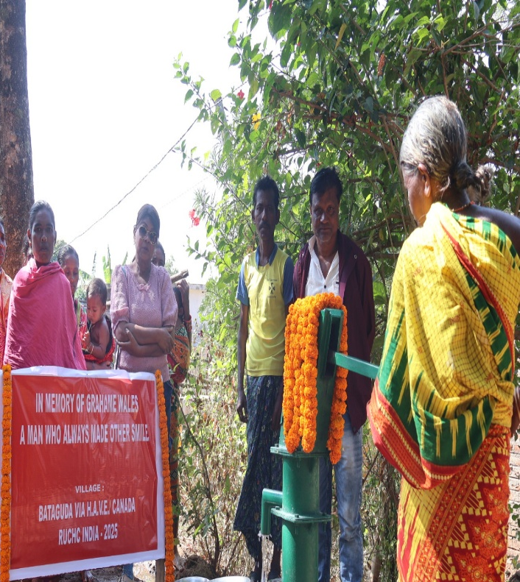
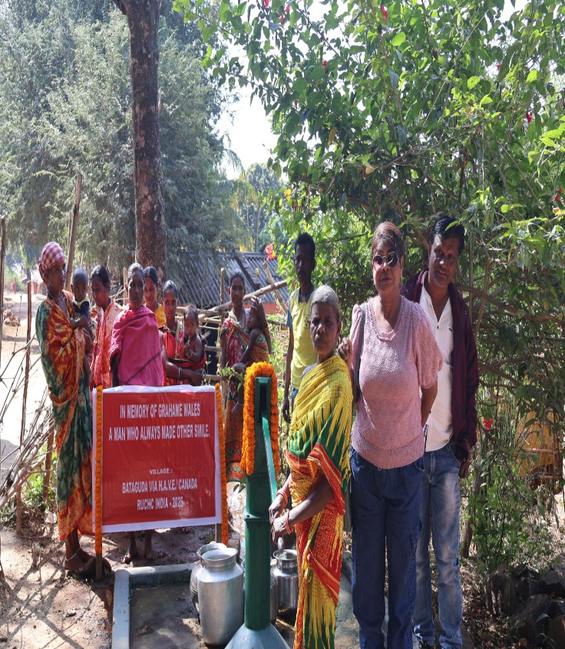

14 NEW ANCHALA

For millions of people a shortage of clean drinking water is a reality they must face every day. Sometimes they simply do not have enough; in other cases, the available water is contaminated. In developing countries, poor water quality is the leading cause of health problems. 80% of all illnesses in developing countries are caused by polluted water. It is estimated that 2 million people die from these illnesses every year.

This village has a population of 1288 people and it has 1 tube well. It is difficult to search the water and food for the people of the village. They have approached the Block head quarter for a tube well in the village but their application did not bring any fruit. Under the circumstances people approached, RUCHC for a tube well. After a village survey and meeting villagers were motivated to make route for the drilling truck to come in and a successful tube well was drilled in the centrally located place which will meet the drinking and domestic water need of the villager and also help prevent many waters borne diseases. RUCHC is motivated each village for income generation activities like kitchen garden around tube well using waste water which will help them immensely.

The villagers are grateful to ROXANNE JACQUES

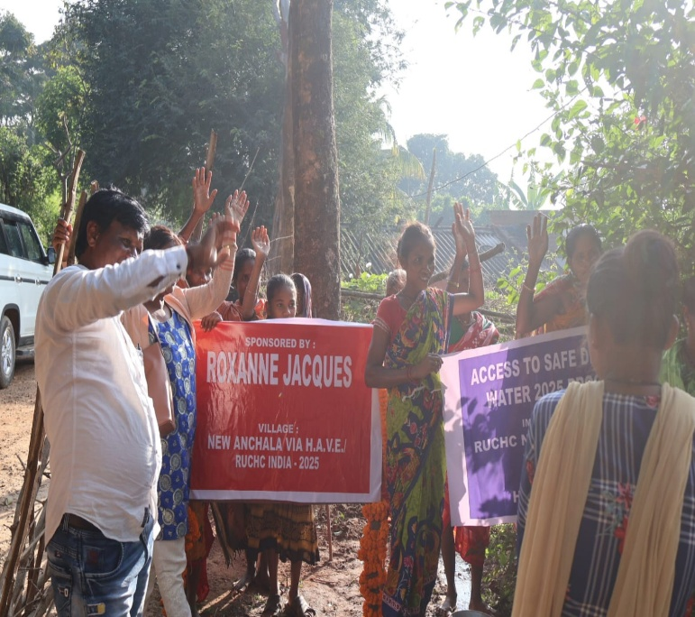
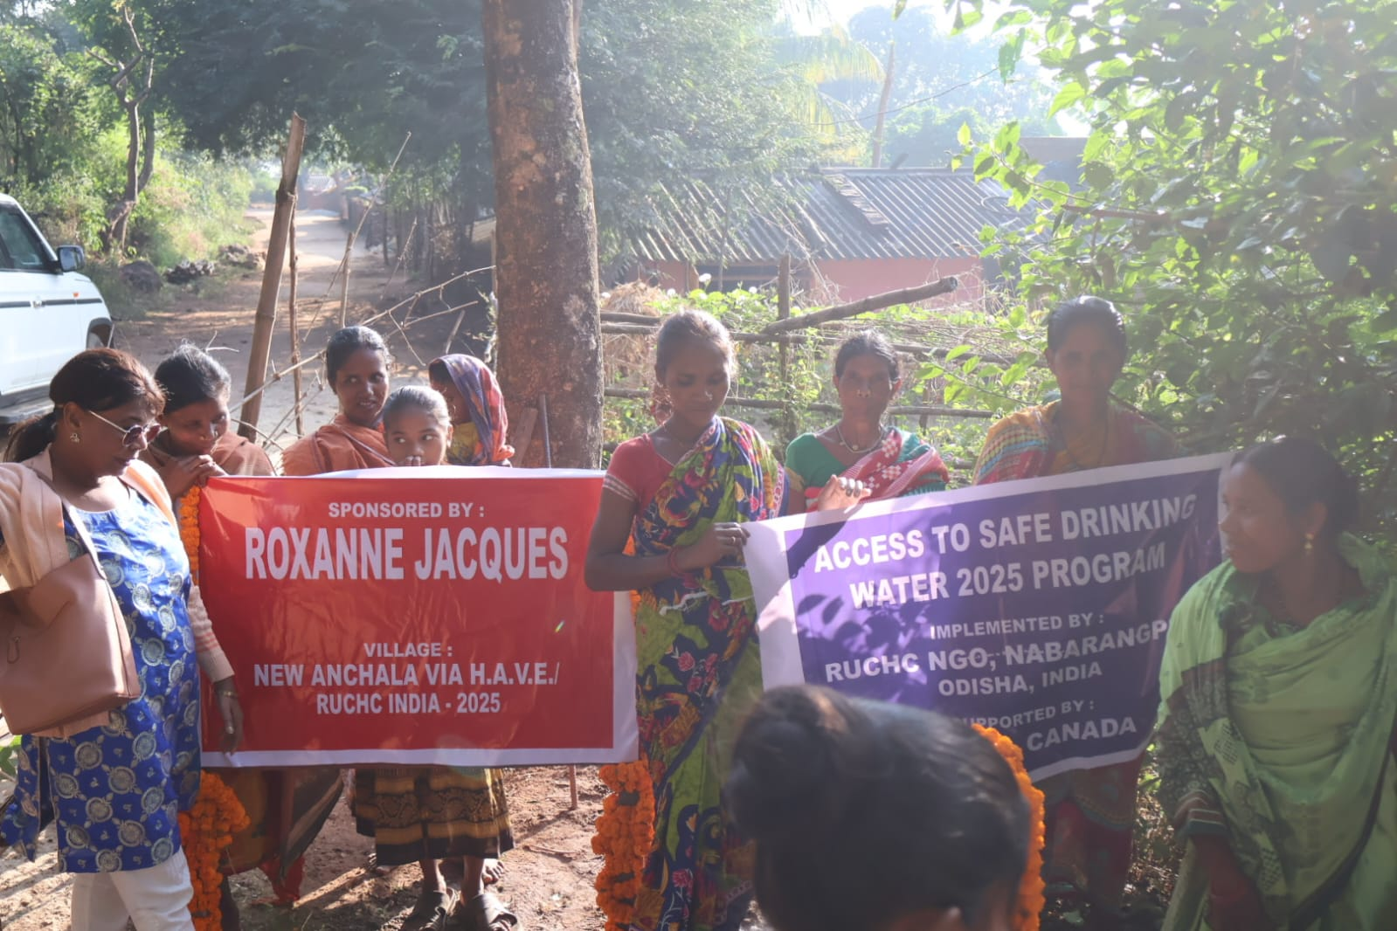

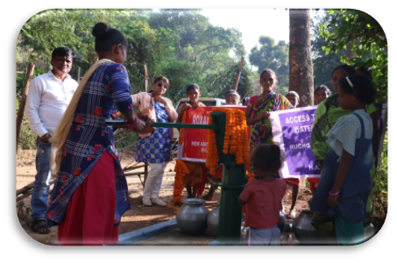
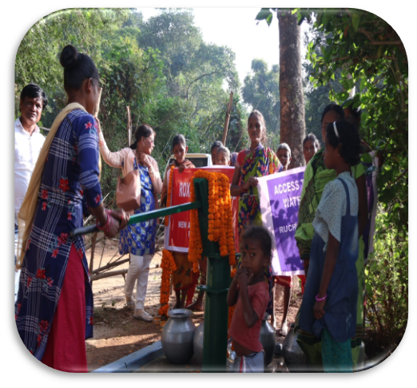

15 CHAMPIA

it has got 1 tube well. This is not sufficient to meet the need of people also in case the existing tube well is not in working condition people had to walk miles to another village to get a pot of water; under the circumstances villagers approached RUCHC for a tube well. After a village survey and meeting, villagers were motivated to make route for the drilling truck to come in and a successful tube well was drilled in the centrally located place which will meet the drinking and domestic water need of the villager and also help prevent many waters borne diseases. RUCHC has motivated each village for income generation activities like kitchen garden around tube well using waste water which will help them immensely

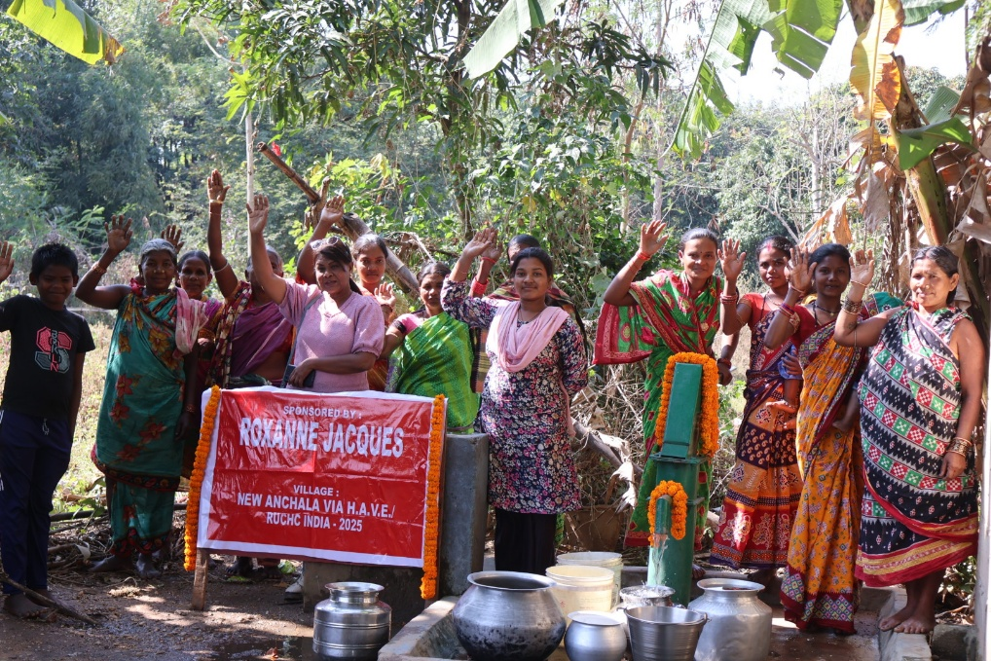
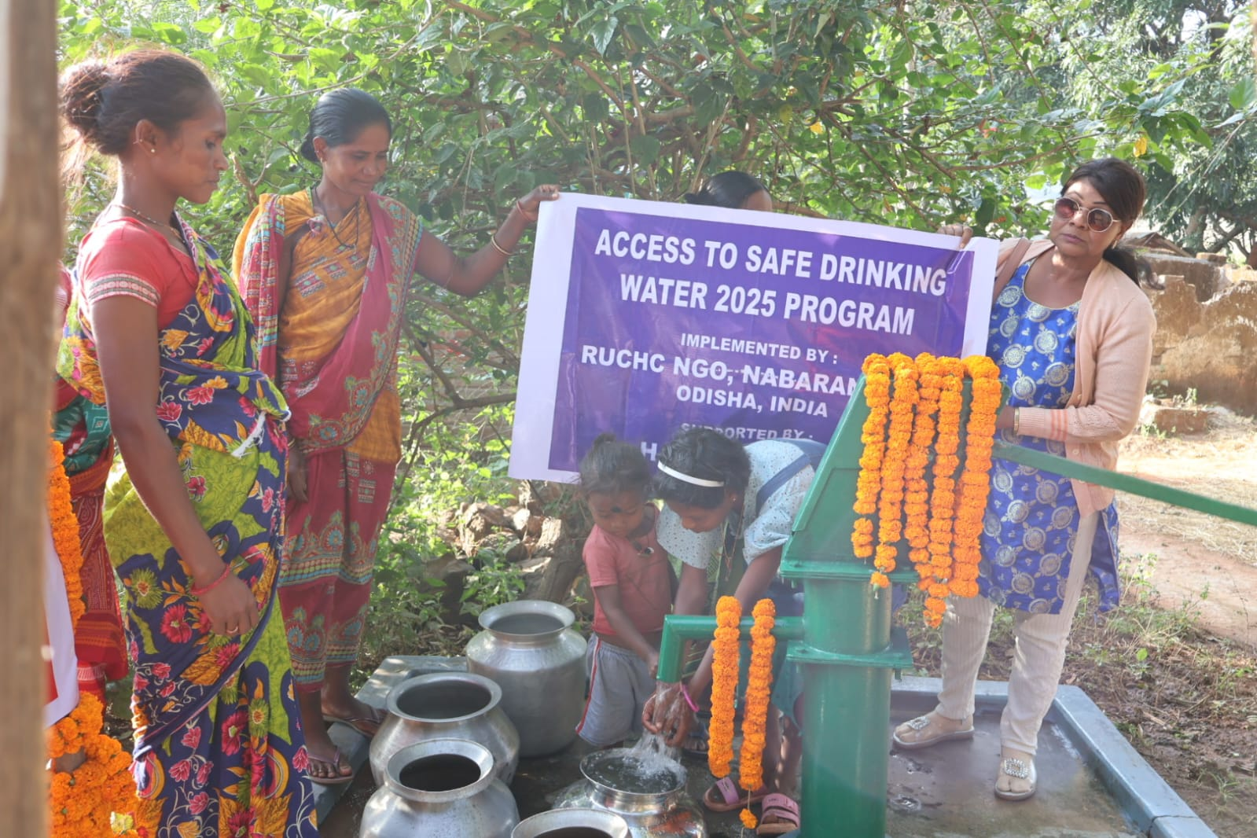

Acknowledgement

Progress in social change cannot be possibly measured in some mathematical formula. It takes time to see the fruit of a development effort. We have tried our best with all our mind, heart and hand to transform a little segment of our society to extend possible. There are successes as well as failure in our effort. We have learnt from our failures and have been encouraged by our success. Keeping society where the people in general and the poor and needy in particular can live happily with justice and peace and realize the joy of liberated and developed life

Last but not least I do extend my sincere gratitude to the HAVE CANADA, sponsors & walkers Rural water And Sanitation department GOI, District Administration, villagers, board members, Staffs and volunteers for their honest commitment and their co-operation in all my endeavors, which added new and genuine inspiration to RUCHC and particular to me to strengthen our will to help people liberate themselves from social and physical pain.

Ms. Nishita Dandsena
President, RUCHC, Nabarangpur
Odisha, INDIA

