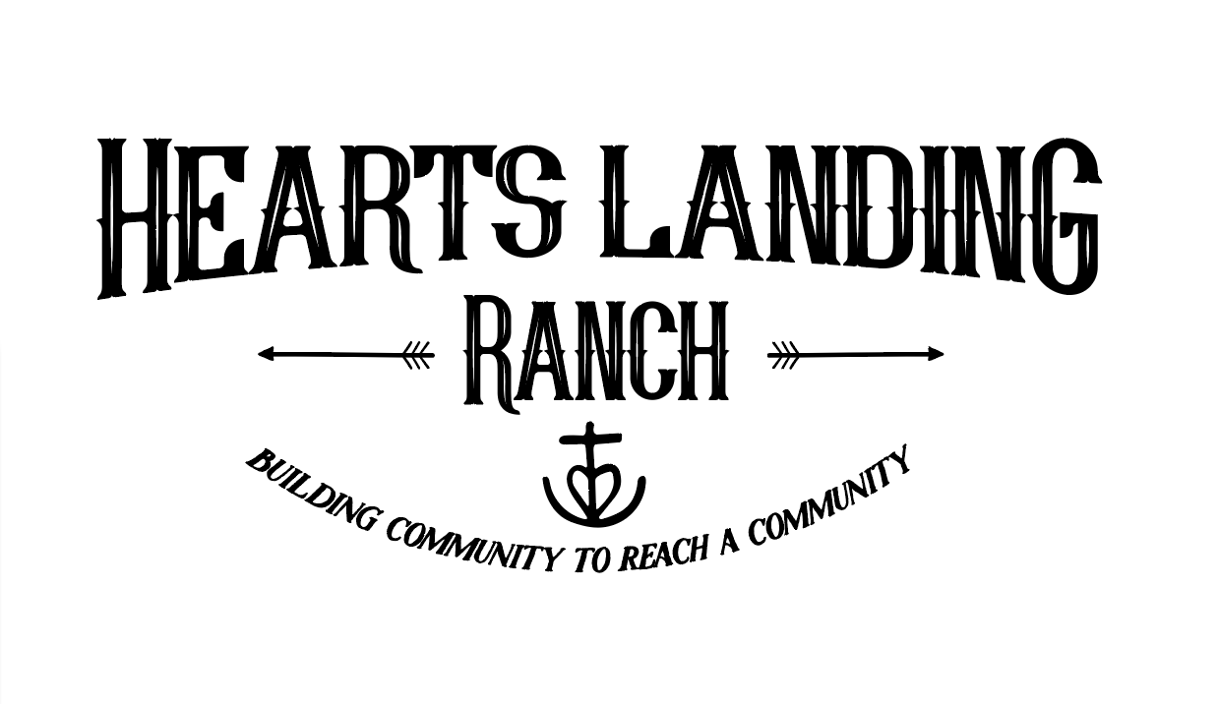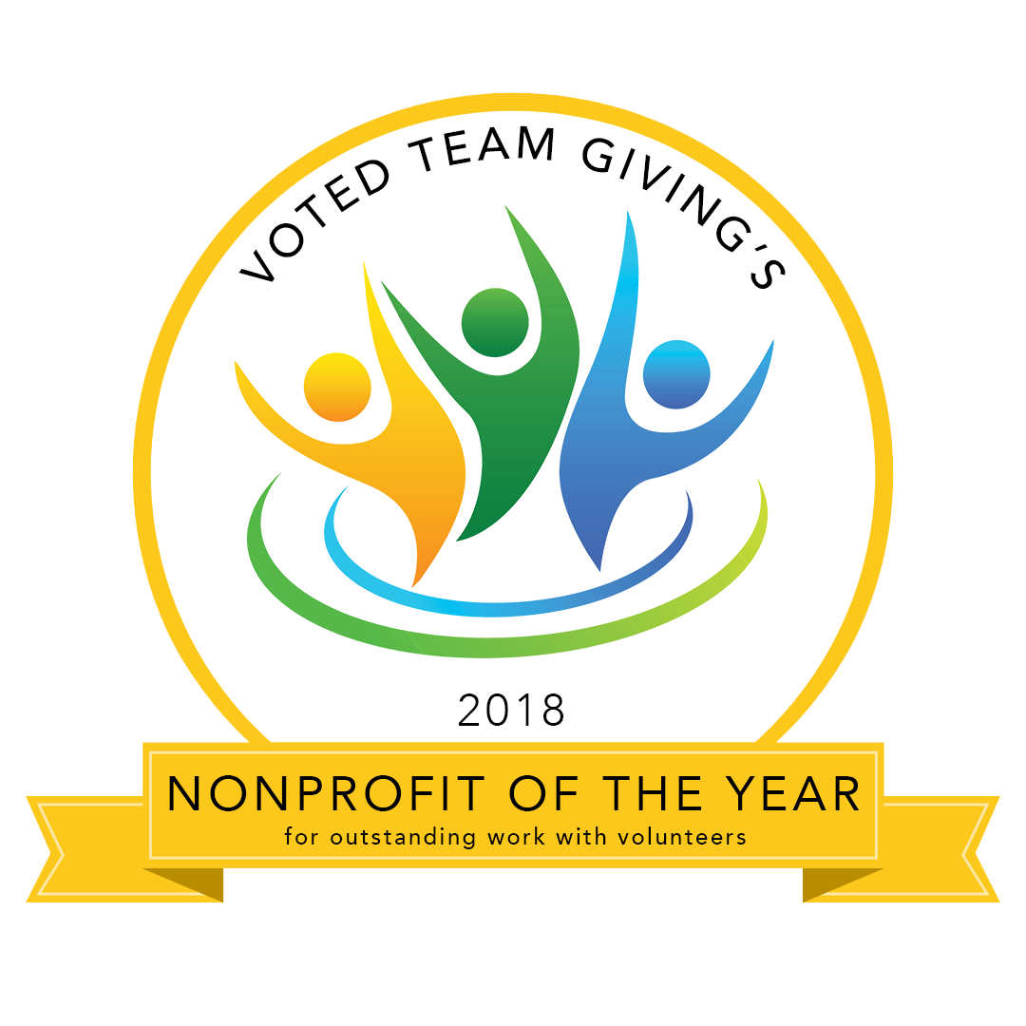
Restoring Lives Thru Rescued Horses

Equine-Assisted Psychotherapy or Equine-Assisted Learning
ADULT SESSION REQUEST FORM

This application is for:

__ Individual Female __ Individual Male __Marriage and/or Couples Counseling

__Parent and Child __ Family __ Other (Please explain): _____________

General Information: Date of application: ___________

Full Name: ___________________________________________ DOB: _______________

Email: ____________________________________________ Cell: ____________________

Address: ____________________________________________________________________

City: _______________________________ State: _________ Zip Code: _____________

Marital Status:

__ Single __ Married for _____ years __Separated for ______ years
__ Divorced for _______ years __Widowed for ______ years __ Living together for _____ years

Occupation: ________________________ Work Phone #: ________________________

Spouse/Partner: _________________________________ DOB: ___________

Email: ___________________________________________ Cell: ____________________

Family Member: _________________________ Relation: ____________ DOB: _________

Family Member: _________________________ Relation: ____________ DOB: _________

Family Member: _________________________ Relation: ____________ DOB: _________

Please describe your family environment and interactions.

Medical History:
Emergency Contact Name: ____________________________ Relationship: _____________

Emergency Primary Phone #: ________________ Emergency Secondary #: _______________

Primary Doctor: ___________________________ Doctor’s Phone: ____________________

Allergies? If yes, please list: _____________________________________________________

Insurance Provider: _________________________ Phone #: _________________________

Group #: __________________________________ Medical #: _______________________

Have you taken, or are you now taking, any prescription medications for mental health issues?

__ Yes __ No If yes, Prescribed by whom? _________________________________________

List Current Prescriptions:
RX: ______________________ Condition: ____________________ First Started: ___________
RX: ______________________ Condition: ____________________ First Started: ___________
RX: ______________________ Condition: ____________________ First Started: ___________
I authorize the exchange of Confidential Information with my child/ward(s) medical and mental health contacts provided. *Please also sign the attached ROI form to indicate with whom consent is given.
Signature: __________________________________ Date: __________________

Counseling History:
Have you ever consulted a counselor, psychotherapist or psychiatrist before? __ Yes __ No

Name of Therapist: ____________________________ Practice Name: _________________

Dates seen (from when to when): ___________ Reason: _____________________________

Are you currently, or have you ever been, a danger to yourself or others? Y/N? Please describe:

____________________________________________________________________________

____________________________________________________________________________

Please list your goal(s) for therapy, and why you believe HLR would be a good fit:

____________________________________________________________________________

____________________________________________________________________________

___________________________________________________________________________

Other:
How did you hear about Hearts Landing Ranch? ______________________________________

If you were referred, please provide the contact person’s information so we can thank them:

Name: _________________________ Agency/Company: _______________________________

Phone: ________________________ Email: _________________________________________

What is your religious background? ________________________________________________

Any other comments or information to better help us understand your situation and goals?

_____________________________________________________________________________

_____________________________________________________________________________

_____________________________________________________________________________

Please rate yourself honestly in the below areas 1-5 (1 being the least applicable, 3 neutral, 5 most applicable in the specific characteristic)

___Social interaction ___Content ___Team player
___Creative ___Angry ___Authority (does well with)
___Outgoing ___Honest ___Responsible
___Physically active ___Helps others ___Timely completion of chores
___Interaction with animals ___Happy ___Fully completes tasks
___Attentive ___Positive self-esteem ___Detail oriented
___Academic ___ Depressed ___ Motivated
___Mechanical ___ Anxious ___ Hard working
___Musical ___ Peer pressured ___ Intimidated by others

Our Heart and Your Requirements for Participation
The heart of our Equine Session Program is to provide a place for individuals, horses and families to experience hope, healing and encouragement. This is accomplished by inviting individuals to come just as they are and actively engage in the activities
Healing and breakthroughs are possible, but expect that it takes time and effort. To start, we like to see clients for 8 weeks, with an assessment at roughly 4 weeks to determine next steps. Mental Health is an invisible wound, and emotions and trauma cannot be seen in the same way as a broken leg. In the same way, sometimes in EAP, “doing the work” doesn’t always feel or look like “doing the work”. Most often, our brains betray us.
We expect that participants want to be here and are willing to work towards their goals. This includes taking personal responsibility for choices, including showing up on time; and baring a health emergency, giving at least 48 hours’ notice of cancellation.

When participants are under 18, we ask a parent/guardian to remain on site while we are in session with your child(ren). There is a designated waiting area, with comfortable seating, near the arena. You also are welcome to wander the large garden (with raised beds, located past the house/driveway) or some people choose to wait in their car. Please respect privacy and do not sit on the paved patio around/next to the house. Please also keep in mind the privacy and concentration of those participating in sessions.

Session Components
Equine Session activities are dependent on treatment goals, and can take many unique forms. The basics, however, will always be the same for an Equine-Assisted Psychotherapy (EAP) Session, which would include an Equine Specialist (ES), a Mental Health Professional (MH) and horse(s).
Equine-Assisted Learning (EAL) may also be available, and would be implemented with an Equine Specialist and horse(s), without a mental health specialist. This may be an option, for example, if someone needs to work on life skills such as communication, perseverance, or boundaries.
Working with horses: The majority of participants who come to Hearts Landing Ranch are drawn to the Ranch because of the horses. While some of the Sessions will include learning to correctly handle, groom, wash, round pen and even assist “vet” horses, Session Plans are geared toward developing person growth and helping to build a bridge of understanding through the pain or difficulty an individual may be experiencing, not to become an accomplished horseman/horsewoman or rider. If you would like riding or horsemanship specific training, talk to us and we can make a recommendation.
Disclosure and Consent Statements
Statement of Faith
​Hearts Landing Ranch is a faith-based organization. Although the ranch is not associated with any particular denomination, we are founded upon Christian principles and values. It is through Christ Jesus' grace, forgiveness and transformation that we have hope and new life. It is our greatest joy and honor to live out our faith in action by serving children and families of all backgrounds with the same loving grace that has been freely given to us.

Clothing & Equipment Requirements & Recommendations
- Shoes/boots with closed toes and closed heels are required. Leather boots are recommended for greatest protection. (Sometimes, we have extras on hand). No steel-toed boots should be worn for safety reasons.
- Nothing is permitted to be hanging down around the neck or tied around the waist while working around the horses
- Sessions are Rain or Shine. Come prepared. Sacramento weather is HOT in the summer and winter is ever changing; layered clothing is always a good idea.
- We recommend that individuals bring their own hat, water bottle, snacks and sunscreen.
Safety Rules
  - Children may not be unattended.
  - Children may not run or play loudly.
  - Dogs are not allowed to be brought onto Hearts Landing Ranch property.
  - The session areas, barn, or horse areas are not open to parents, family members, caregivers or visitors without prior permission.

Possible Reasons for Participant Discharge
  - Fees are not paid as originally agreed.
  - The participant has reached all of his/her goals.
  - The participant misses scheduled appointments without prior cancellation. (You will be charged for the time, if proper notice of 72hrs is not given).
  - The participant’s inability to follow directions is interfering with progress toward goals.
  - The participant is uncontrolled and/or participates in inappropriate behavior that constitutes a safety risk to him/herself, staff, volunteers, and/or horse(s).

Cost
The cost of an Equine-Assisted Psychotherapy (EAP) session is $175 per person group rate (with a minimum of 3) or $300 for a private session. We are private pay, and can accept credit card, check, Venmo, PayPal, cash or HSA. If you have medical insurance, a portion might be covered through your mental health professional. We are not set up to bill insurance directly. Fees must be paid out of pocket. All those who have insurance to assist with this fee are expected to handle payment for services and bill their insurance company themselves. We are willing to provide receipts needed to do so. It is your responsibility to see that all fees are covered. If you will be filing to your insurance, it is IMPORTANT that you realize that we must assign a diagnosis, and that diagnosis will permanently be on your medical record. We strive to keep the tuition fee as low as possible through vigorous fundraising efforts conducted throughout the year, as well as through the help of scouts, and local businesses and churches who have committed donations, and volunteer hours. Financial assistance in the form of a scholarship is available to a limited degree for those who qualify. Please inquire about the sliding scale if payment is not possible without assistance. Payment in full is required at the beginning of each session, and scholarships must be secured ahead of time. Due to the high level of program activity, we are not able to offer refunds, make-ups for missed sessions, or carry a balance over from one session to the next.
If you are unable to keep your appointment, please give 72 hours notice. Unless there is an extreme emergency, we will charge for your session if 72hrs of notice is not given. You will be charged the full fee if no notice is given.
If you are in the position to give further, consider planned giving through Mandatory IRA disbursements, Owner Advised Funds, Stock Options and Estate Planning. We encourage you to talk with family and friends who are passionate about giving back. Many companies also match employee donations. Hearts Landing Ranch is an approved Benevity nonprofit.
Photo Release
Regarding the use and reproduction by Hearts Landing Ranch of any and all photographs and any other audiovisual materials taken of me for promotional printed material, educational activities, exhibitions, or for any other use for the benefit of the program. (Initial your response):
I consent to and authorize ___________ I do not consent to nor do I authorize: ____________
Confidentiality Policy
Confidentiality is defined as “told in secret or private relations; trusted.” Any information in regards to the participants (clients) at Hearts Landing Ranch must be held in strict confidentiality. It is critical that we respect each individual. Confidentiality is considered one of the most basic responsibilities of our facility. In failure to abide by this policy, the quality of the services we provide may diminish and result in legal ramifications.
I have read and understand Hearts Landing Ranch’s Policy of Confidentiality and agree to abide by the same.
Signature for Confidential Policy: ____________________________________________________________

Social Media Agreement
Hearts Landing Ranch appreciates clients’ enthusiasm in sharing the growth and experiences from being part of this program. However, we ask that you consult with Hearts Landing Program Director before taking any video or pictures of a session, as well as prior to posting sessions online and/or referencing Hearts Landing (including on Facebook, Instagram, YouTube, Twitter, Vine, etc.). For those who do not know our work, some of the therapeutic exercises may be taken out of context. Also, not everyone in our program is open to sharing their personage on social media.
I agree to request permission from the Hearts Landing Ranch Program Director before taking personal photos or videos and agree that no pictures or videos may be posted online of any sessions that contain another individual that I may capture or be featured in and/or before referencing Hearts Landing Ranch.
Signature for Social Media Agreement: ______________________________________________________

Thank you for taking the time to thoroughly fill this form out and provide a transparent and complete assessment.

NOTE: Please make sure that the above form is complete. Incomplete forms will only delay the admission process or void it completely. If you have any questions, please feel free to refer to our website www.heartslandingranch.com or call us at 279-529-8279.

Please send completed forms via email to: heartslandingranch@gmail.com

Demographic Data Form
Notice to Applicants - Completion of this Form is Voluntary.
The purpose of this Data Form is to provide statistical data being requested when Heats Landing Ranch applies for grant money…which helps the Ranch provide services to more people. The data you provide on this form will be kept confidential and used solely for statistical purposes. Completion of this form (pages 7 & 8) is optional and voluntary.
Date: _____________________ Name: _______________________________________________
Voluntary Self-Identification of Ethnicity, Race, Age Range, and Gender
Race/Ethnicity: (Please Select One)
- Hispanic or Latino – A person of Cuban, Mexican, Puerto Rican, South or Central American, or other Spanish culture or origin regardless of race;
- White (not Hispanic or Latino) – A person having origins in any of the original peoples of Europe, North Africa, or the Middle East;
- Black or African American (Not Hispanic or Latino) – A person having origins in any of the Black racial groups of Africa;
- Native Hawaiian or Other Pacific Islander (Not Hispanic or Latino) – A person having origins in any of the peoples of Hawaii, Guam, Samoa, or other Pacific Islands;
- Asian (Not Hispanic or Latino) – A person having origins in any of the original peoples of the Far East, Southeast Asia, or the Indian Subcontinent including, for example, Cambodia, China, India, Japan, Korea, Malaysia, Pakistan, the Philippine Islands, Thailand, and Vietnam;
- American Indian or Alaskan Native (Not Hispanic or Latino) – A person having origins in any of the original peoples of North and South America (including Central America), and who maintains tribal affiliation or community recognition; and
- Two or More Races (Not Hispanic or Latino) – All persons who identify with more than one of the above five races.
- Other: (Please specify) _____________________________________________________________
Age range:
- Under 12
- 12-17
- 18-24
- 25-34
- 35-44
- 45-54
- 55-64
- 65-74
- 75 and older
Gender:
- Male
- Female
- Transgender
- Decline to state
- Other (please identify): ____________________________________________________________
Voluntary Self-Identification of Education and Employment Status
Are you Bilingual? Yes No If yes, what language___________________________________________
Level of Education: (Mark all that apply)
- No schooling completed
- High School graduate or equivalent (GED)
- Some College credit--no degree
- Trade School Certification: Please identify______________________________________________
- Associate Degree
- Bachelor Degree
- Master's Degree
- Professional Certification: Please identify_______________________________________________
- Doctorate Degree
Employment Status:
- Employed full time
- Employed part time
- Retired
- Self-Employed
- Homemaker
- Military
- Unable to Work
Voluntary Self-Identification of Veteran Status
Served during (Please mark all that apply):
- Afghanistan (2001-2021)
- Post 9/11 (Sept. 11 2001-Present)
- Gulf War (Aug. 1990-Aug 2001)
- Vietnam Era (Aug. 1964 – April 1975)
- Korean War (July 1950-Jan. 1955)
- World War II (Dec. 1941-Dec. 1946)
- Peacetime Only (Includes Jan 1947-June 1950, Feb 1955-July 1964, and May 1975-July 1990)
- Other: (Please Explain) __________________________________________________________
Voluntary Self-Identification of Military Branch
- Air Force
- Army
- Coast Guard
- Marines
- National Guard
- Navy
Voluntary Self-Identification of First Responder Status
- Emergency Medical Technicians
- Law Enforcement Officers
- Firefighters
- 911 Dispatchers
- Other: (Please Explain) _____________________________________________________________
Signature: ___________________________________________ Date: _________________



Phone: (916) 521-1343
8902 Quail Ln, Granite Bay, CA 95746
Authorization to Release/Receive Information

Client Name:__________________________ Date of Birth: _______________PH#________________

Address: ____________________________________________________________________________

I authorize the exchange of information between:
Hearts Landing Ranch
and
(Name, Ph#, Fax#) ____________________________________________________________________
And
(Name, Ph#, Fax#) ____________________________________________________________________

Duration: The authorization is effective immediately and shall remain in effect for one year from the
authorization date unless otherwise specified: __________________

Information to Be Exchanged:
( ) Mutual exchange of information relevant to assessment, diagnosis and treatment.
( ) Evaluation or Progress Letter
( ) Treatment Summary
( ) Other: ____________________________________________________________________
I have had it explained to me and fully understand this request/authorization to release records and information, including the nature of the records, their contents, and the consequences and implications of their release. This request is entirely voluntary on my part. I understand that I may take back this consent at any time, except to the extent that action based on this consent has already been taken. This consent will expire automatically after one year from the date on which it is signed, or upon fulfillment of the purposes stated above. I acknowledge that I have been offered a copy and may either accept or refuse.
Authorizing Signatures:

Client: ____________________________________________________ Date: ____________________

Parent/Guardian/Conservator: __________________________________ Date: ____________________

Treatment Provider: _________________________________________ Date: _____________________

I have read and understood the Participant documents in their entirety:
____________________________________________________________________________________________________Full Name Signature Date

