Celia Callan BSc (Hons) Pg Dip CABC, APDT ATI
Companion Animal Behaviour Counsellor/Canine Trainer
abcdogtrainingschool@gmail.com
www.abcdogtrainingschool.co.uk
07806779749
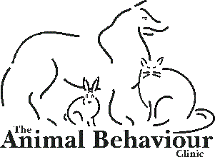

REFERRAL FORM
Behaviour problems may arise both directly and indirectly as the result of concurrent or previous medical problems. Veterinary involvement is therefore essential in eliminating organic causes of the problem and prioritising their diagnostic and treatment strategy to be used in any given case. In order to safeguard the welfare of your patient and indicate your approval for referral, please complete the following form.

VETERINARY DETAILS
Referring Veterinarian:
Telephone number:
E-mail:

CLIENT DETAILS
Owners name:
Patient's Name/Age/Breed:
Gender:
Neuter status & date of neuter:
Date of last health check:
Presenting problem:

Please provide details of any ongoing medical problems, tests and treatments.

I _________________________________________ (MRCVS) approve for the client described above
to be referred to Celia Callan for management of the current behaviour problem.

Signed ___________________________________ MRCVS Date _______________

I _________________________________, the owner of the above named animal, consent to the disclosure of relevant clinical information between my referring veterinary surgeon and Celia Callan.

Signed ____________________________________ Date _______________

Please email medical history to abcdogtrainingschool@gmail.com

