Located at 10 Smythes Road Delacombe, Vic 3356
P: 03 5309 3159 F: 03 5342 9521

Taking new patients. Walk in appointments available.
We endeavour to provide a high-quality service to the residents of the Delacombe and neighbouring suburbs.

We offer an array of services which include:
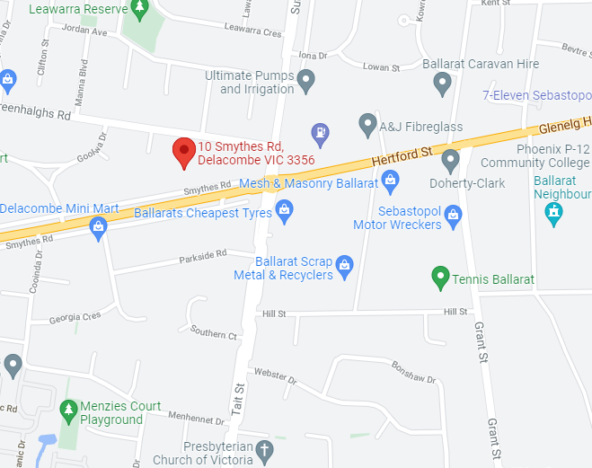
- Male and Female GP’s
- On-Site Pharmacy
- Podiatry
- Aesthetic Nurse
- Psychologist
- Dietician
- Woman and Men’s Health
- Chronic Disease Management
- Skin Checks
- Pre-Employment Medical Assessments
- On-Site Pathology
- Pain Specialist
- Neurologist
- Immunisations / Vaccinations
- Travel Vaccination

COVID-19 VACCINES NOW AVAILABLE

Our range of services are designed to assist patients gain better access to all types of health professionals in one location taking the stress out if seeking ongoing care

We are a mixed billing clinic with bulk billing options available to those who have a current healthcare or pension card and for all children under the age of 16

To secure an appointment please contact our friendly reception staff on 03 5309 3159 or alternatively you can book online at www.lotusfamilyclinics.com.au via Hotdoc

We look forward to assisting you with all your healthcare needs.

Opening Hours:
Monday – Friday 8.00am to 6.00pm
Saturday – Sunday CLOSED
Public Holidays 9.00am – 1.00pm

After Hours Service
0493 378 047

