News about the International Symposium on Nature-based Interventions and Public Health
By Binxia Xue, HTR

The 2025 International Symposium on Nature-based Interventions and Public Health was successfully held at the School of Architecture and Design, Harbin Institute of Technology in China from October 16th to 18th, 2025. The conference focused on the core theme of "Interdisciplinary Integration for Nature-based Health Promotion", covering the cutting-edge fields such as the mechanism of natural healing factors, evidence-based design and efficacy evaluation, innovative technologies for healing environments, and interdisciplinary collaborative pathways in this area. The symposium was planned, organized and initiated by two registered horticultural therapists (HTRs) from the American Horticultural Therapy Association (AHTA), Binxia Xue and Tongyu Li, associate professors from the School of Architecture and Design, Harbin Institute of Technology, China. Currently, Binxia Xue also serves on the AHTA Board of Directors.

More than 100 experts, scholars, and teachers from over 30 universities and research institutes from 13 countries including China, the United States, the United Kingdom, Canada, Italy, Sweden, Australia, Singapore, Japan, South Korea, Kazakhstan, Yemen, Tanzania, as well as Hong Kong, China, attended the conference. They shared and discussed the cutting-edge perspectives, aiming to solve the key problems in disciplinary integration, clarify future research directions, and provide theoretical support and practical references for the promotion of the "Healthy China" strategy.
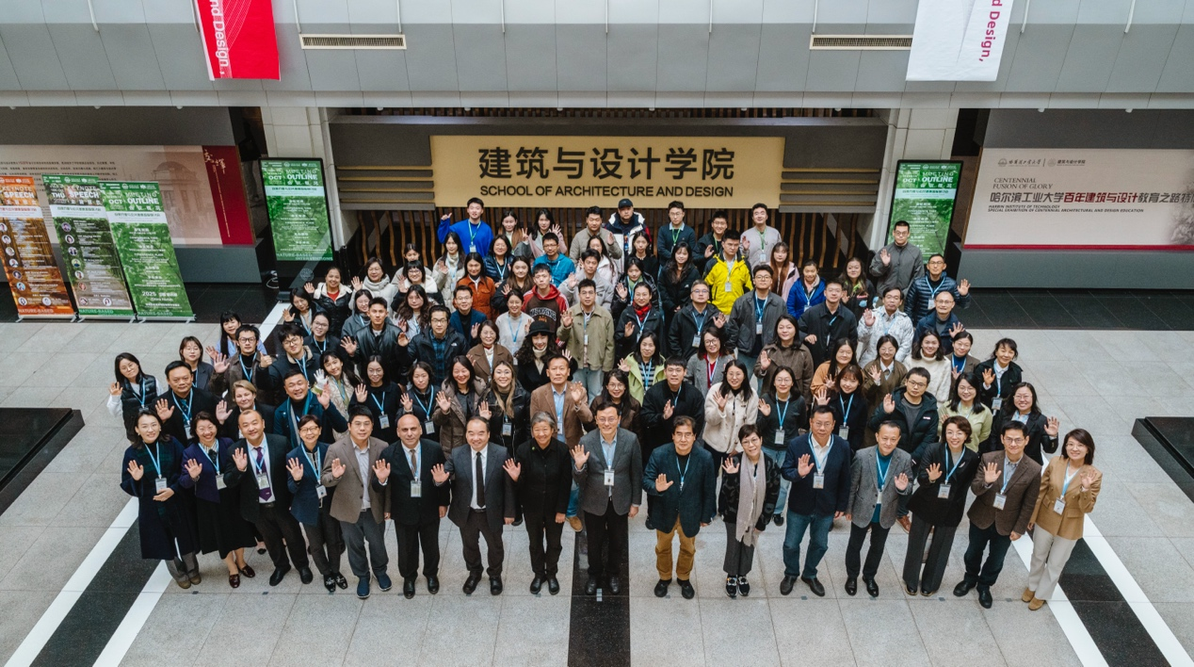
Group photo of the attendees of the symposium.

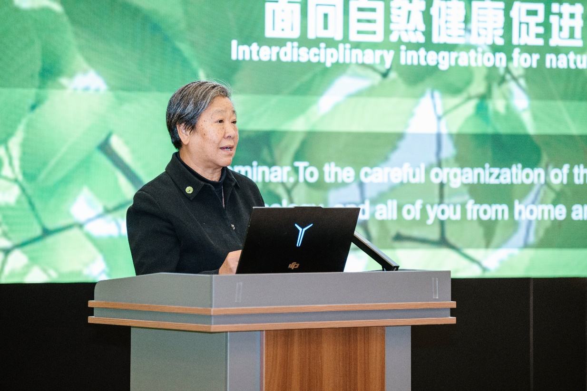
Xiaoping Zuo, the secretary general of Chinese Society of Landscape Architecture expressed her congratulations on the opening of the symposium.
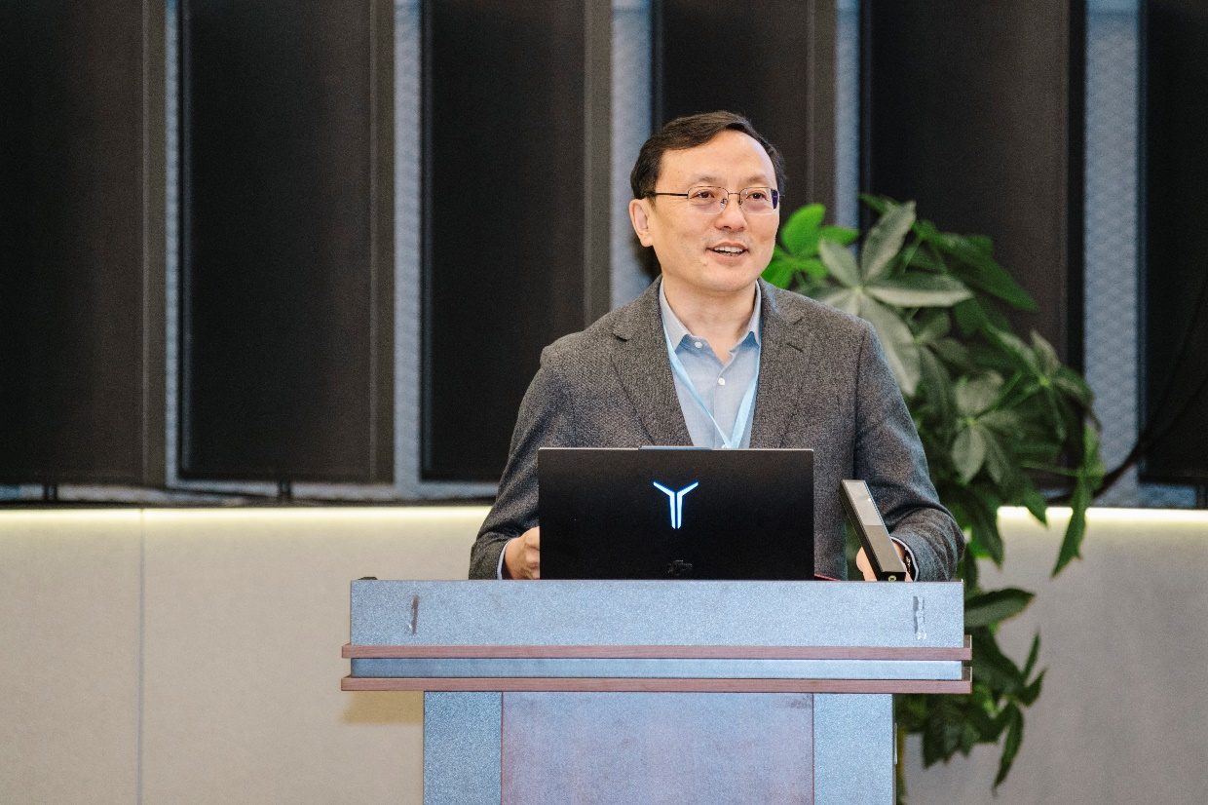
Chairperson Cheng Sun, Dean of School of Architecture and Design, Harbin Institute of Technology，welcomed guests from the universities and institutions of different countries.
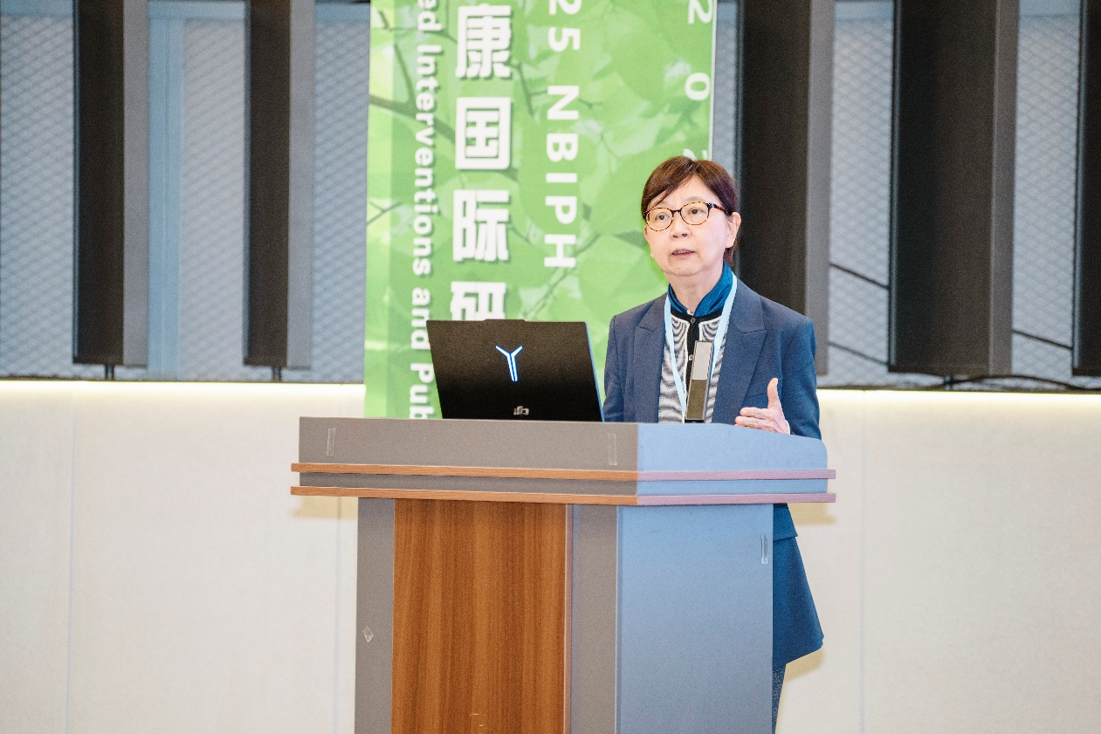
Claudia Kam Yuk Lai, the honorary chairperson and the receiver of the 2019 Charles A. Lewis Excellence in Research Award, was giving her keynote speech.
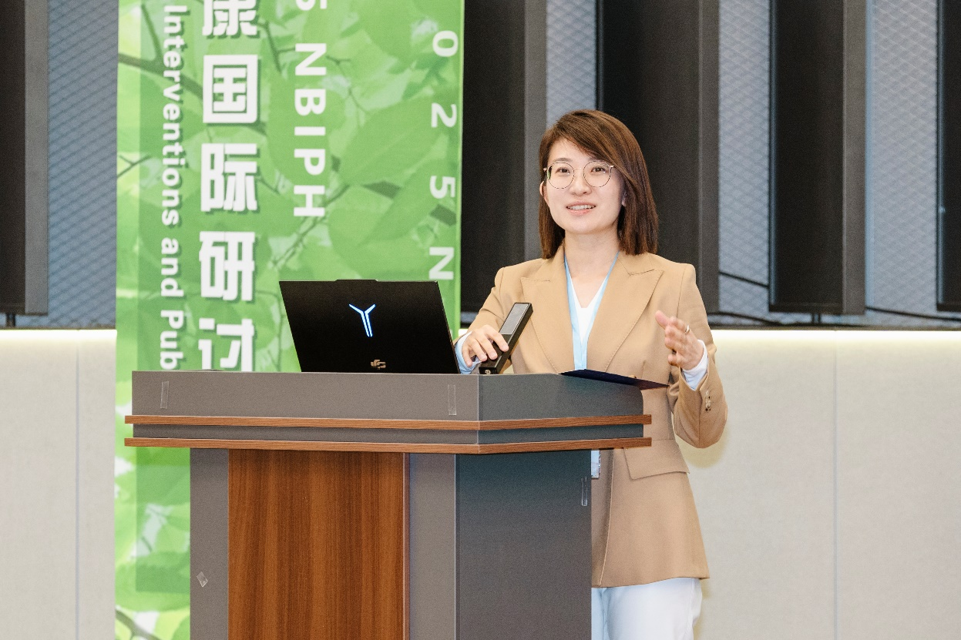 Tongyu Li, HTR, the executive chairperson and secretary general hosted the keynote speech during the symposium.
Nature-based Interventions, as an emerging interdisciplinary field that integrates knowledge from multiple disciplines such as architecture, landscape architecture, nursing, horticulture, and environmental psychology, is increasingly becoming an important innovative direction in the field of public health. This conference is hosted by Harbin Institute of Technology, jointly organized by the School of Architecture and Design, the School of Business, and the Digital Economy, Ice and Snow Economy, and Creative Design Platform of Harbin Institute of Technology. The Professional Committee of Landscape Health and Horticultural Therapy of the Chinese Society of Landscape Architecture, the International Plant and People Council (IPPC), Program on Chinese Cities of the University of North Carolina (UNC PCC), and the Polar Architecture Research Center of the Polar Research Institute of Harbin Institute of Technology served as supporting units to provide full guidance throughout the conference.

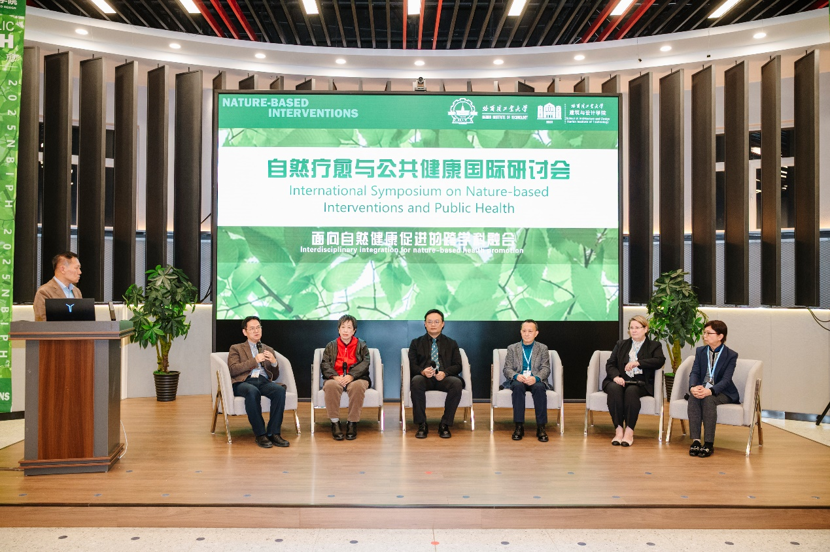
Binxia Xue, HTR, the executive chairperson hosted the round-table meeting at the symposium..
The attending experts generally believe that this symposium actively responds to the strategic needs of "Healthy China", closely follows the forefront trends of the global development over public health and human settlement environment, and the agenda setting has significant foresight and intersectionality. The conference delved into how to transform the scientific principles of nature-based Interventions into replicable practical solutions through interdisciplinary collaboration, providing new academic perspectives, methodological support, and practical guidance for promoting nature-based public health interventions and enhancing the health quality of living environments.
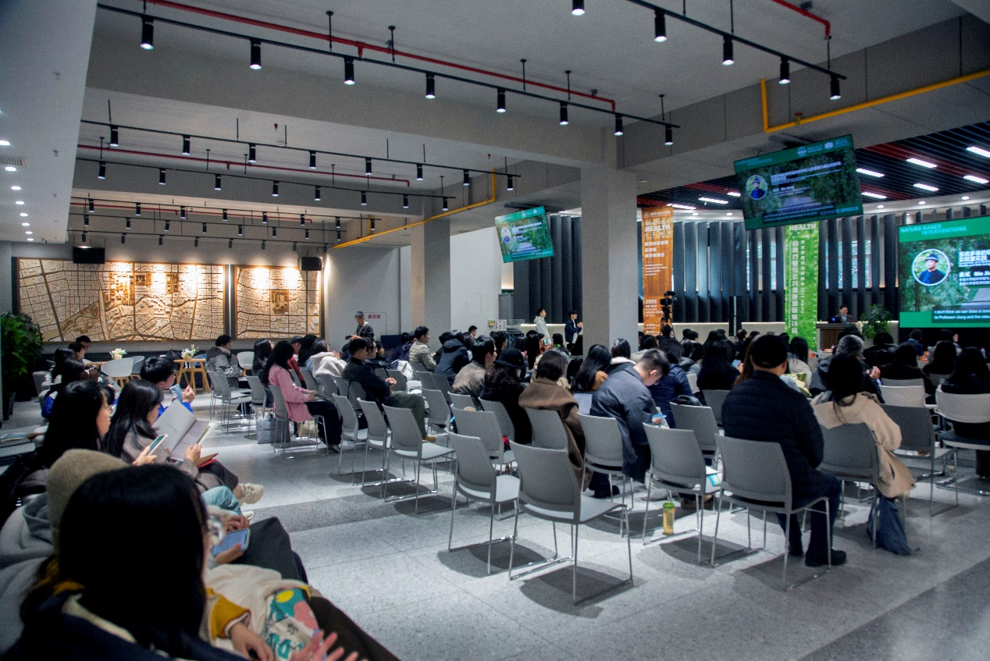
The scene of the keynote speech venue.
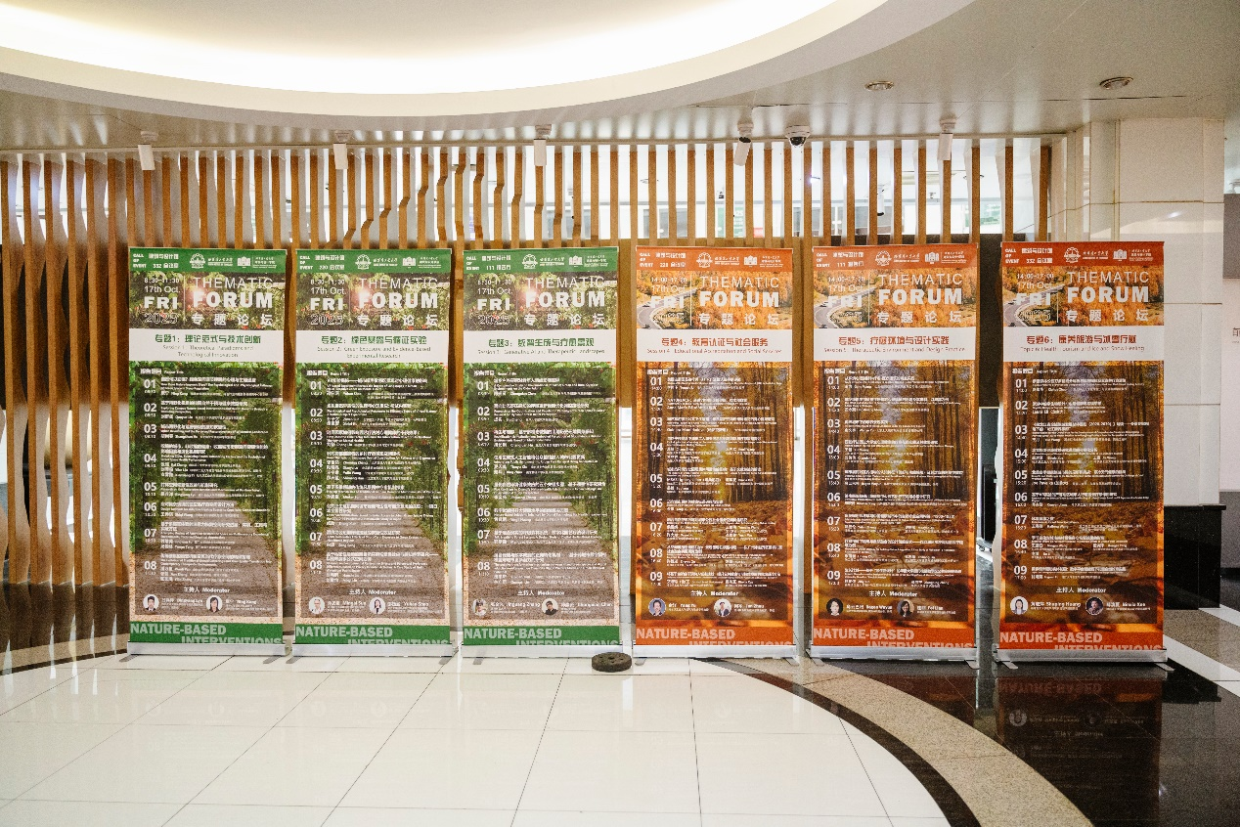
Posters for parallel forums,

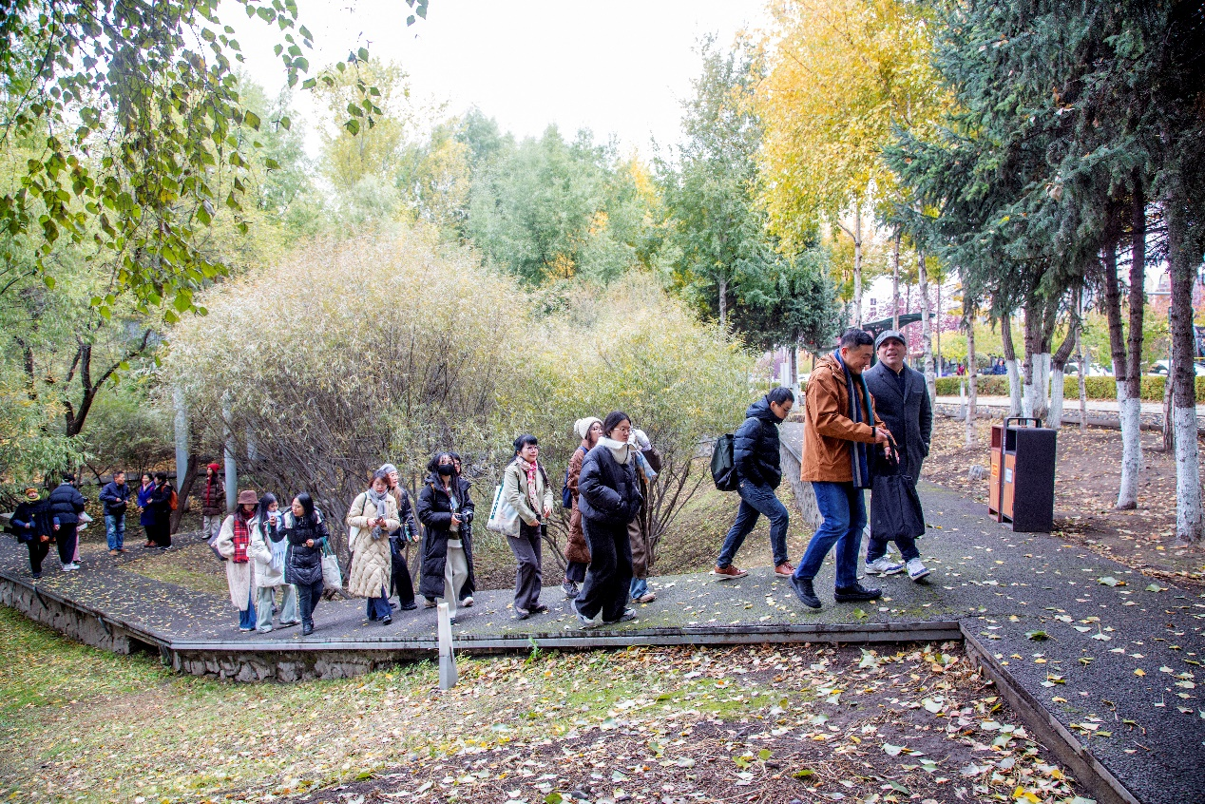
Attendees at the technical visit.
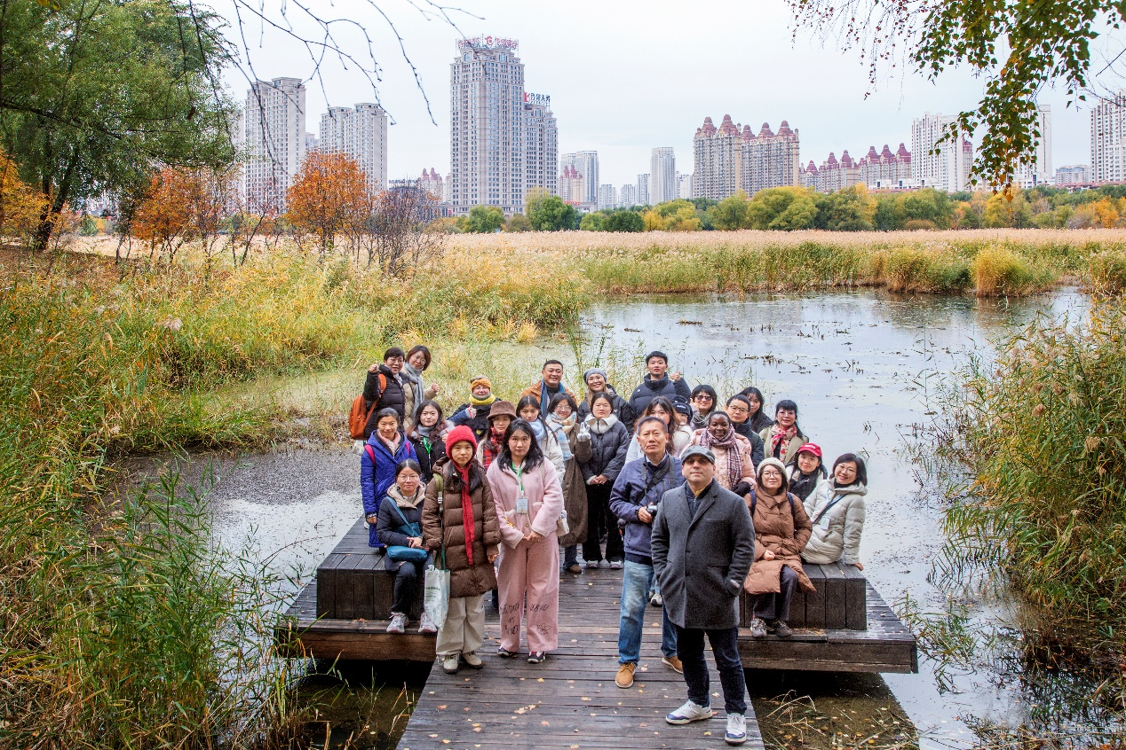
Group photo of the attendees at the wetland park.
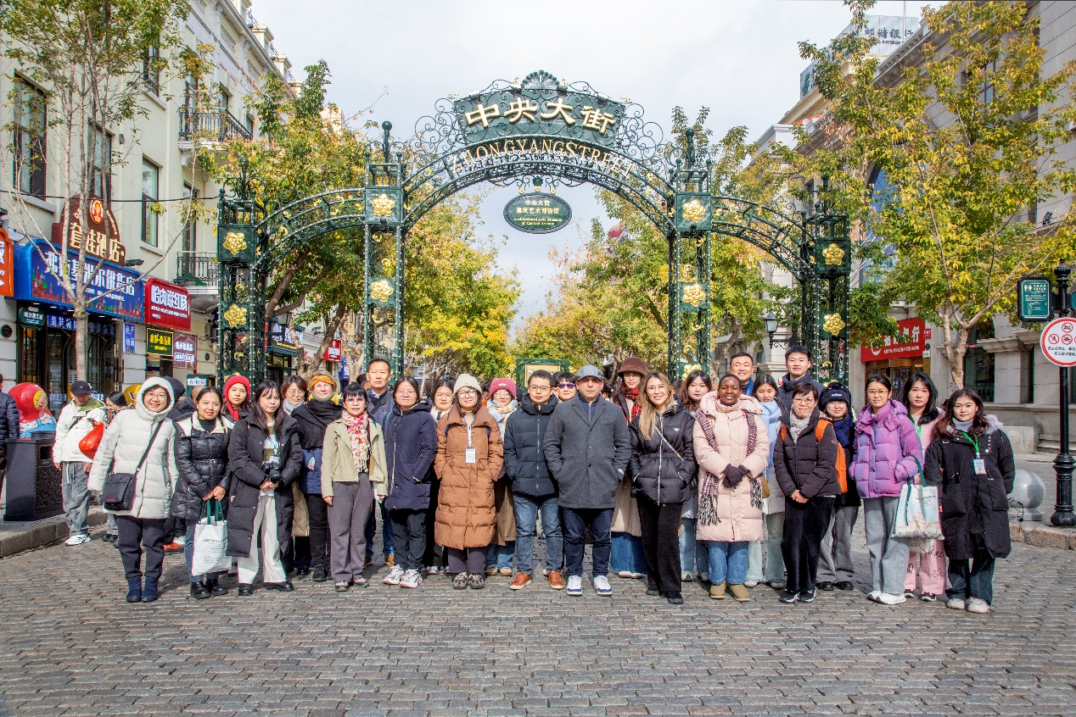
Technical visit at Harbin Central Avenue, the first commercial walking street in China.

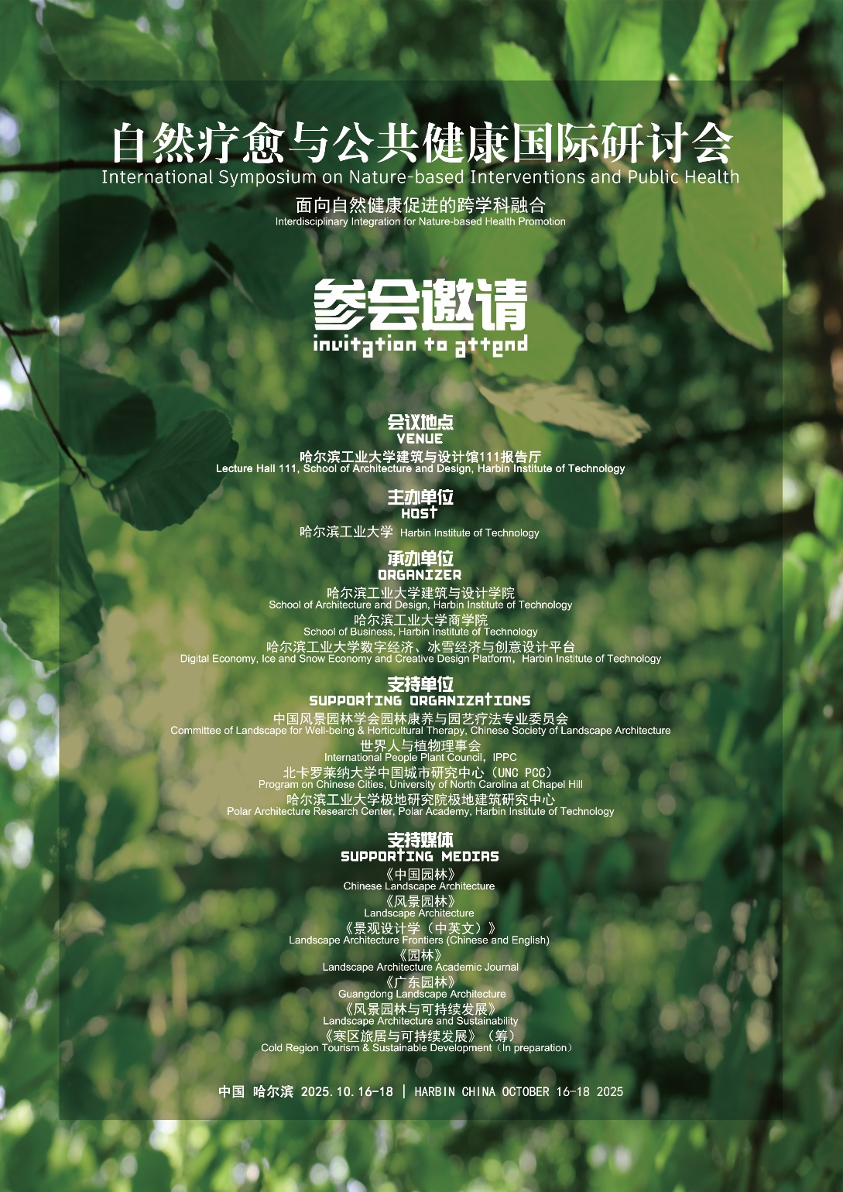
Poster for the symposium

