Infectious Diseases Policy
To be read with -
Immunisation and Disease Prevention Policy
NQS
QA2 | 2.1.2 | Health practices and procedures - Effective illness and injury management and hygiene practices are promoted and implemented.
National Regulations
Regs | 77 | Health, hygiene and safe food practices
Regs | 85 | Incident, injury, trauma and illness policies and procedures
Regs | 86 | Notification to parents of incident, injury, trauma and illness
Regs | 87 | Incident, injury, trauma and illness record
Regs | 88 | Infectious diseases
Regs | 90 | Medical conditions policy
Regs | 162 | Health information to be kept in enrolment record
Aim
Immunisation is a simple, safe and effective way of protecting people against harmful diseases before they come into contact with them in the community. Immunisation not only protects individuals, but also others in the community, by reducing the spread of disease.
Related Policies
Educator and Management Policy
Enrolment Policy
Food Nutrition and Beverage Policy
Health, Hygiene and Safe Food Policy
Incident, Injury, Trauma and Illness Policy
Immunisation Policy
Medical Conditions Policy
Privacy and Confidentiality Policy

Who is affected by this policy?
Child
Parents
Family
Educators
Management
Visitors
Volunteers
Implementation
Educators and the Nominated Supervisor will:
- minimise the spread of potential infectious diseases between children by excluding children who may have an infectious disease or are too ill to attend the service and facilitating the prevention and effective management of acute illness in children
- notify the local public health authority when required of notifiable disease within 24 hours
- use the attached Recommended Minimum Periods of Exclusion to exclude children with infectious diseases and inform parents of exclusion and non-exclusion periods

Educators will also advise the Nominated Supervisor as soon as they believe they have an infectious disease and are unable to care for children

Children might be brought to care with symptoms or signs of illness or while in care suddenly develop an illness that has not been diagnosed by a doctor, and that might be potentially infectious or potentially life-threatening for the child. Symptoms may not clearly fit those listed in exclusion diseases making it difficult for educators to decide whether to accept or exclude the child. If educators suspect a child may have an infectious disease, they will exclude the child for 48 hours or until they receive a medical certificate stating the child is not contagious and is okay to attend the Service.

Parents must advise educators on arrival verbally or in writing of any symptoms requiring administration of medication to their child in the past 48 hours and the cause of the symptoms if known. This advice must be provided the first time the child attends after the medication has been administered.

Many illnesses, while not fitting exclusion criteria, can transmit disease to other children in care, and can make a child too ill to participate in normal activities. All children who are unwell should not attend the Service and educators will ask parents of children who are unwell to collect the child from the residence/venue within one hour or to make alternative arrangements for their child’s care.
The Nominated Supervisor will:
- assist educators in making notification to public health authorities
- organise a pool of regular relief educators to cover educators who are ill and unable to care for children
- request a medical certificate from educators who have been ill stating they are not contagious and are okay to return to work
If an infectious disease arises at a residence/venue educators will respond to any symptoms in the following manner -
- Isolate the child from other children
- Ensure the child is comfortable and appropriately supervised
- Contact the child’s parents or nominated emergency contact (if the child’s parents are unavailable we will contact authorised nominees) and ask them to pick the child up as quickly as possible (and within one hour). Educators will provide information in the child’s home language if possible
- Any person picking the child up from the service must be able to show identification if unknown to the educator
- Ensure all bedding, towels and clothing which has been used by the child are washed separately and if possible air dried in the sun
- Ensure all toys used by the child are disinfected
- Ensure all eating utensils used by the child are separated and sterilised.
- Inform all families of the presence of an infectious disease verbally and by placing a notice near the front door. The child’s name will not be revealed
- Ensure confidentiality of any personal of health related information related to any child or family

Fevers
Unwell children include those with fevers. Fevers refer to temperatures above 38°C, and are usually a sign of infection (eg virus). When children develop a fever at the service, educators and staff will:
- contact parents and ask them to collect the child unless we have written advice from a medical practitioner that the fever is not caused by an infectious disease (eg teething). Babies less than 3 months old with fevers must always be collected by parents /authorised nominees who will be advised to take the baby to a doctor. Parents will also be advised fever can be a symptom of a serious illness and they should also consider taking older children to the doctor
- administer first aid if required in line with service procedures. This may include calling an ambulance. Educators and staff will be especially vigilant caring for babies less than 3 months old with fevers
- if the child is distressed, bathe their face in lukewarm water, and administer paracetamol if parents have given written permission and administration is consistent with the Administration of Medication Policy
- offer water to the child and ensure they are not overdressed and their clothing is comfortable
- monitor the child’s behaviour, alertness and any other symptoms that could indicate serious infection including rash, stiffness, vomiting, coughing or convulsions
- remind parents that ill children must stay home. If child returns the following day with illness or fever the parents will be called to collect child again.

Local Public Health Units - Advice and Notifications
Local Public Health Units are an important source of information and advice about many contagious/notifiable diseases including measles, meningococcal disease, Haemophilus influenzae type b (Hib), hepatitis A, and pertussis (whooping cough). Nominated Supervisors will telephone these Units as soon as possible when needed/appropriate for advice about an illness and how to control the spread of the illness and follow any advice. In particular, the nominated supervisor will always phone the local Health Unit as soon as possible (and within 24 hours) when there are:
- two or more cases (children or staff) of gastroenteritis in the centre (including norovirus, rotavirus, salmonellosis which are types of gastroenteritis) within 48 hours of each other. Symptoms include diarrhoea, vomiting, fever, abdominal cramps
- two or more cases (children or staff) of Shigellosis which is a severe intestinal infection. Symptoms include diarrhoea, fever, vomiting and cramps.
Qld Health has a list of local Public health Units which you can search for at https://www.health.qld.gov.au/.

Note only doctors and pathologists must make notifications for the ‘notifiable diseases’ listed in Schedule 1 of the Public Health Regulation 2018.

Obligations under Public Health Act 2005
The person in charge of a child care service has an obligation to reduce the spread of contagious conditions by first advising the child’s parent that they suspect the child may have a prescribed contagious condition. If the child continues to attend the service, the Nominated Supervisor may (after consulting the local Population Health Unit) direct the parent to remove the child until the child is no longer contagious. They may also (after consulting the local Population health Unit) direct the parent of an unvaccinated child to remove the child until the outbreak is over.
The following information must be included in the direction to a parent:
- The suspected contagious condition
- The prescribed period for the condition
- The circumstances in which the child may be readmitted to the service.

COVID-19
Preventing the spread of COVID-19
Our service follows best practice for preventing the spread of COVID-19:
- We strongly encourage our staff to stay up to date with COVID vaccines
- Staff and children are aware that they should stay at home if they have cold or flu symptoms and we strongly encourage testing for COVID
- Adults and children wash hands using soap and water or, if soap and water are not available, use hand sanitiser. See our Hand Washing Procedure in our Health, Hygiene and Safe Food Policy
- We ensure our indoor spaces have clean air via ventilation (fresh air flow) and filtration (removing particles from the air with a filtering device)
- Where we can, we:
  - conduct our program of activities outdoors especially activities that have a higher chance of transmitting the virus (e.g. singing, physical activities)
  - try to reduce the number of people in small, enclosed spaces that are poorly ventilated
  - try to have smaller groups playing together and limit the number of indoor whole of group activities. Also, we try to space activity stations as much as possible
  - stagger mealtimes and outdoor play
  - reduce mixing between different ages/room groups to keep the virus contained
- Beds/stretchers/cots are spaced out in well ventilated sleep/rest rooms
- We maintain strict hygiene measures to prevent contamination of equipment, surfaces, and spaces as described in our Health, Hygiene and Safe Food Policy
- Although masks are no longer mandatory for staff in children’s services, our service supports staff who prefer to wear masks when they are indoors or can’t physically distance themselves from others. We also promote the use of face masks:
  - for staff and visitors when there is a high level COVID in the community
  - for anyone over 12 who has tested positive to COVID (or influenza) in the last 7 days
  - anyone over 12 who is a household/close contact of someone with COVID (for at least 5 days following the person’s positive test)
  - for anyone who is at risk of severe illness.

Stay at home until well
Rapid Antigen Tests (RATs) very often do not identify COVID cases - a negative result on a RAT does not necessarily mean you do not have COVID-19. The health department continues to strongly encourage those with COVID-19 symptoms stay home until they are well.
For children or staff with seasonal allergic rhinitis or other conditions that have similar symptoms to COVID-19, we encourage testing for COVID before attending our service. Following this, only if the person's symptoms change from their usual symptoms, then a repeat COVID-19 testing should be performed. We also encourage testing for children, families and staff who are a household/close contact of someone who has COVID-19.
Testing positive to COVID-19
We are obliged to take reasonable steps to prevent the spread of infectious diseases, including COVID. Staff, volunteers/students must tell the nominated supervisor if they have tested positive for COVID-19 so we can advise others to get tested if they become symptomatic. Families must also notify staff if their child tests positive for COVID.
Children and adults who have COVID-19 are excluded from our service until their symptoms have resolved, usually 5-7 days.
We are required to ensure that a parent or an authorised emergency contact of each child being educated and cared for by the service is notified of any positive cases at the service as soon as practicable.
After having COVID-19
If a child, staff member, volunteer or student returns to the service within 5 days after a positive COVID-19 test, they should:
- Wear a face mask covering their nose and mouth indoors (if over 12 years old)
- Avoid contact with anyone at the service who is at higher risk of severe disease
- Wash their hands regularly
- Follow respiratory etiquette (including coughing into the crease of their elbow – see our Health, Hygiene and Safe Food Policy)
- Tell others they are in contact with to test for COVID if they develop symptoms.

Notifying the regulatory authority
Services are not required to notify positive cases of COVID-19 to the regulatory authority in QLD.

However, the approved provider must notify the QLD Department of Education, via the NQA IT System, if the service has to temporarily close or reduce the number of children attending because of COVID. The approved provider will follow QLD Health advice in making any decisions about closures or reducing numbers.

Vaccinations
Education and care workers are no longer required to be vaccinated against COVID-19. However, we strongly encourage all staff, students, volunteers, families and eligible children to stay up-to-date with COVID-19 vaccines. See our Immunisation and Disease Prevention Policy for more information about vaccinations.
Managing medically vulnerable children
Some children might be at a higher risk of developing severe COVID-19, such as those with chronic medical conditions. Our service will follow our Medical Conditions Policy, which describes how we manage children with medical conditions.
Employment law, Workplace Health and Safety and COVID-19
Our service educates our staff, students and volunteers on their rights and obligations under workplace laws that concern COVID-19.
Work Health and Safety law requires businesses manage the risks of exposure and transmission of COVID-19 to workers and others in the workplace. This means our service must:
- Keep up to date with advice and guidance from the health department and comply with all their rules
- Continue to review/update our COVID-19 risk assessment, which identifies the hazards/risks of COVID-19 entering and spreading
- Implement control measures that prevent exposure and transmission
- Manage and respond to COVID-19 cases and/or outbreaks (we will do that according to this Policy and other relevant policies)
- Maintain to date emergency contact details in the NQA ITS in case we need to be contacted after hours
- Ensure that children who have compromised immunity or other relevant health care needs have up-to-date Medical Management, Risk Minimisation and Communication Plans in place
- Consider canvassing casual educators and staff as backup for staff absences due to COVID
- Notify Workplace Health and Safety Queensland (WHSQ) of a confirmed case of COVID arising out the conduct of our service or undertaking that requires the person to have immediate treatment as in-patient in a hospital for COVID-19, or if the person dies, or any COVID infection for which the carrying out of work is a significant contributing factor, (including any infection that is reliably attributable to carrying out work that
involves providing treatment or care to a person, or that involves contact with human blood or bodily substances).

Recommended Minimum Periods of Exclusion
(available to download here)
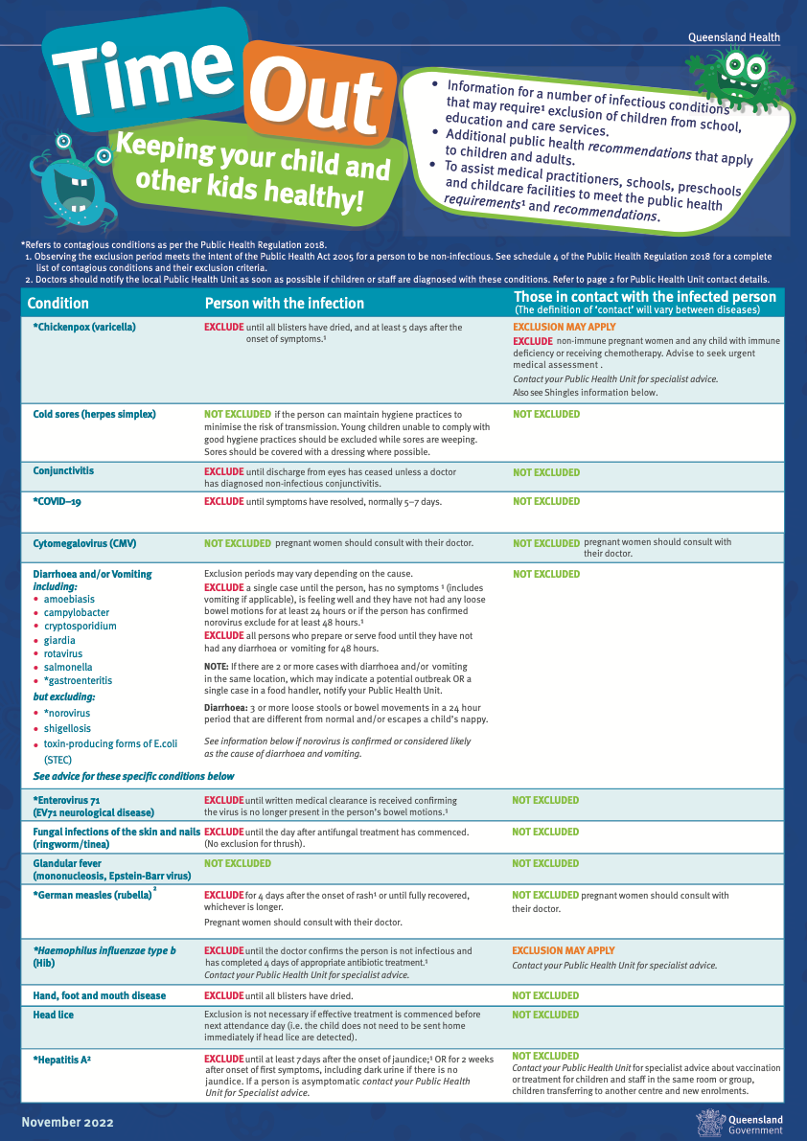
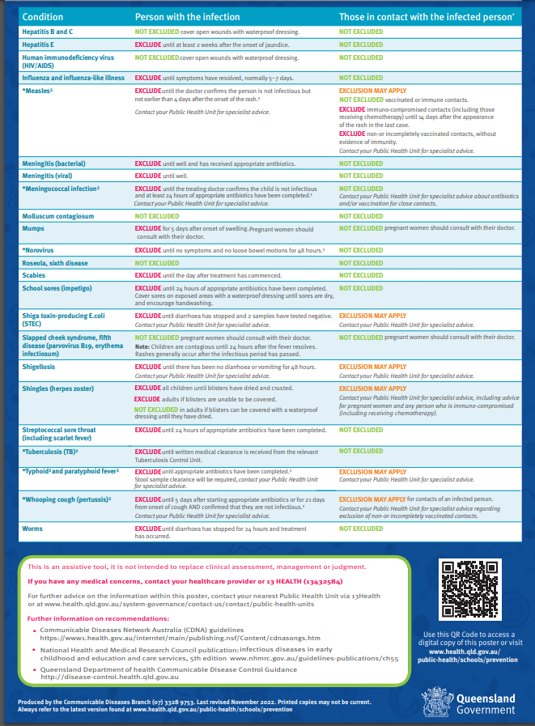

Sources
Education and Care Services National Law and Regulations
National Quality Standard
Viral or Suspected Viral Gastroenteritis Outbreaks QLD Health
Information for Schools, Education and Care Services and Child Care Services Contagious Conditions: QLD Health
Staying Healthy 5th edition NHMRC
Work Health and Safety Act 2011
Work Health and Safety Regulation 2011
Public Health Act 2005
Public Health Regulation 2018
QLD Health
Review
The policy will be reviewed annually by:
- Management
- Employees
- Families
- Interested Parties
Last reviewed: 20 April 2026 Date for next review: 20 April 2027

