
Caring Alternatives of Muskego
January 2026

Celebrating January  Book Blitz Month  International Brain  Teaser Month  New Year’s Day  January 1  Someday We’ll Laugh  About This Week  January 2–8  Bobblehead Day  January 7  Make Your Dream  Come True Day  January 13  Fresh Squeezed Juice Week  January 18–24  Disc Jockey Day  January 20  Belly Laugh Day  January 24  Curmudgeons Day  January 29 | North to the Future  Every January, as we turn the calendar to a new year, Alaskans mark another milestone: the anniversary of statehood. On January 3, 1959, Alaska officially became the 49th state of the United States, opening a new chapter in its history and symbolizing resilience, opportunity, and the promise of the future.  For many, the statehood anniversary pairs naturally with the season of resolutions and fresh beginnings. Just as individuals set goals for the year ahead, Alaska once set its sights on growth, self-determination, and a stronger voice within the nation. That step forward, more than six decades ago, remains a reminder of what it means to embrace change and move with confidence into the unknown.  Alaska’s motto, “North to the Future,” captures this spirit. Chosen shortly after statehood, it reflects both the geographic identity of America’s northernmost state and the sense of direction it offers. The words suggest not only exploration but also progress—ideas that fit well with the energy of January, when many people look ahead with renewed purpose.  Moose, a familiar sight to residents and visitors alike, can also serve as a fitting symbol for the season. Towering and powerful, yet able to withstand harsh conditions, the moose embodies strength and resilience. These qualities mirror the challenges Alaskans have faced—from extreme weather to geographic isolation—and the determination that helped them build thriving communities in the years since statehood.  Today, Alaska continues to look forward while honoring its past. Statehood Day isn’t just a historical date; it’s an annual reminder of endurance, adaptability, and possibility. Whether you live in Alaska or simply admire its story from afar, the anniversary offers inspiration for the start of a new year.  As we settle into January, Alaska’s journey can encourage us to take our own steps toward renewal. Like the state that looked north and saw its future, we too can embrace new beginnings with strength, resilience, and hope for the year ahead.
  From Playtime to Patents    January 17 is the day of the K.I.D.—that’s short for Kid Inventors’ Day. This special day honors Benjamin Franklin’s birthday on January 17. Most people know Franklin for his bifocals and experiments with electricity, but fewer realize that at age 11 he invented swim flippers for the hands.  But Franklin isn’t the only kid inventor. Perhaps the following inventions by kids will inspire you to take your own unique product from idea to “patent pending” (through the federal Patent Office).  In 1905, an 11-year-old boy from San Francisco named Frank Epperson stirred some sugary soda powder into water and left the mix outside all night.  He awoke to discover it had frozen solid in the cold. When he licked it straight from the wooden stirrer, he knew he had accidentally made something delicious. The “Epsicle,” as he called it, was the first Popsicle.  On the last day of middle school, Sarah Buckel watched as a friend struggled to scrape off the glue used to stick posters and other decor to the locker wall. Over summer break, Buckel came up with a solution: magnetic wallpaper. Fortunately, Buckel’s father ran a magnet manufacturing company. In no time, her decorative magnetic wallpaper could be found at Staples, Target, and other large chains.  The list of young inventors doesn’t end there. Chester Greenwood invented earmuffs at age  15. Louis Braille invented braille, the alphabet for the blind using raised dots, at age 15. Hart Main, 13, conceived of a line of candles for men called Man Cans, offering “manly” scents like sawdust.  At 15, Param Jaggi had the idea to insert algae into  a car’s muffler to eat up carbon dioxide before it entered the atmosphere. And Mattie Knight, dubbed “Lady Edison” by fans, developed a safety device at age 12 that became a standard fixture on looms.  How’s that for ingenuity? All of these kids prove there’s no minimum age for having an inventive spirit and leaving your mark in the world.  January 2026 | Kindness in Kalamazoo  While records of a man named Ralph C. Morrison—sometimes known as “The Peddler of Encouragement”—exist, little is known of the holiday he founded, the Toad Hollow Day of Encouragement, which is celebrated January 26. Morrison was an educator and storyteller in Kalamazoo, Michigan. One day he came across a newspaper article detailing the childhood of one of his older students, a woman named Eunice. Eunice had once attended Toad Hollow Country School. The name Toad Hollow stuck in the imagination of the storyteller, and he crafted many delightful tales about the place—so many tales, in fact, that Toad Hollow became  a place of legend.  Kalamazoo County eventually offered Morrison a local park to do his storytelling. He accepted and soon formed a volunteer group dedicated to maintaining and refurbishing the park, complete with an 1800s-era, waterwheel-powered gristmill. These volunteers, or so-called “voluntoads,” embodied kindness, dedication, and selflessness—all characteristics celebrated during the Toad Hollow Day of Encouragement.  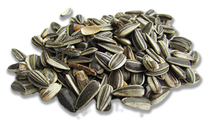  Trading Tomorrow’s Gardens  Each year, eager gardeners await the last Saturday in January, Seed Swap Day. It’s a chance to connect people with excess seeds to those searching for the perfect additions to their gardens.  Washington Gardener magazine, which organized the first seed exchange in 2006, explains that seed swapping is a fundamental part of the history of human society; seeds  were some of the first commodities valued and exchanged among humans. Whether they’re seeds for crops or flowers, a vibrant exchange promotes plant biodiversity. American president and avid gardener Thomas Jefferson once  said, “The greatest service which can be rendered any country is to add a useful plant to its culture.”
Aussie All Around  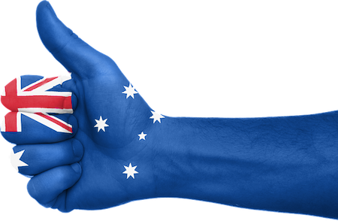  January 26 is a big to-do down under. All across Australia, citizens observe Australia Day as the anniversary of the first arrival of British ships on the island continent.  On January 26, 1788, British Captain Arthur Phillip hoisted the Union Jack flag in Sydney Cove—and unloaded 759 British convicts from  11 ships. For the next 70 years, 160,000 felons would arrive in Australia’s penal colony and overwhelm the aboriginal Australian population. Indeed, this anniversary seems to mark a rather inglorious beginning to Australia’s British-national history. Even former Australian Tourist Commission Managing Director Ken Boundy calls Australia “the only country in the world that marks its national holiday not by celebrating its identity but by questioning it.”  From these inequitable beginnings, Australia Day has grown into a day recognizing and celebrating equality. For many, Australia Day means celebrating everyone’s right to identify as a “true blue” Aussie—as many Australians call themselves—in whichever way they choose.  Perhaps there’s no better example of the Australian spirit of equality than on the sporting field. “Within the story of sport in Australia, the idea of egalitarianism is very powerful,” says Australian sociologist Catriona Elder. Sport, she says, is “the key place where equality is practiced.” The idea of a level playing field, where talent and hard work make you a winner, seems to embody exactly what it means to be Australian.  So maybe it’s no coincidence that the Australian Open tennis tournament falls from mid- to late- January, or that so many Australians celebrate Australia Day by lighting up the barbecue and playing national sports like rugby, cricket, or Australian Rules Football, that curious mishmash of American football, soccer, and rugby, played with an oval ball on an oval field. No matter what you play, there’s no one way to be a “true blue” Aussie.  January 2026 | Employee of the Month: CeCe  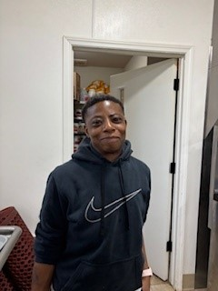  Our January Employee of the Month is our facility chef Cecil (better known to us as “CeCe”). While she has only been on our team a few months, CeCe wasted no time developing a menu that mixes resident favorites with a culinary touch. CeCe is very focused on not only the plate, but presentation as well. Our residents are dining in style with CeCe’s in charge! Congrats CeCe, on this well deserved recognition!  Winged Wonders  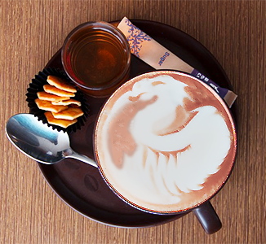  Why wait every 12 years for the Chinese Year of the Dragon when you can enjoy Appreciate a Dragon Day every year on January 16? These massive flying, fire-breathing beasts are enough to appreciate in and of themselves, but perhaps even more fascinating is how the belief in dragons evolved independently among ancient peoples living in China, Europe, Australia, and the Americas. Anthropologist David E. Jones thought the widespread belief in dragons grew from the discovery of dinosaur fossils or whalebones that seemed to back up superpredator myths. With real-life 18-foot Nile crocodiles in Africa and eight-foot Australian perentie lizards, it seems that humans already have plenty of reptiles—of the non-fire-breathing variety—to wrangle.
Pop Therapy    All those who love the sensation of popping Bubble Wrap can hardly wait for January 25, Bubble Wrap Appreciation Day, to arrive. Why on earth do so many of us insist on popping those tiny little bubbles? Professor of psychology Kathleen M. Dillon believed that the answer stems from the power of touch.  In ancient Greece, it was common for people to carry a smooth stone called a “fingering piece” or “worry bead” in their pockets. Touching or petting the stone created a calming effect. These stones, Dillon observed, are similar to Catholic rosary beads or needlework projects like embroidery or knitting in their ability to calm the mind. Dillon even went so far as to conduct experiments on her students using sheets of Bubble Wrap. As it turns out, students who popped the bubbles were more relaxed and more focused than those who did not pop. She concluded that releasing muscle tension in the hands reduces stress in the rest of the body.  Sealed Air Corporation, the maker of Bubble  Wrap since 1957, has updated its packaging options in recent years. In 2024, the company introduced a new fiber-based wrap that provides cushioning while being recyclable and more  space-efficient for shipping. The design is intended to protect products during transit and reduce material use, though the classic poppable Bubble Wrap is still produced for those who enjoy the traditional experience.  That’s good news for people like April Holliday, a member of an online group called “Popping Bubble Wrap.” She loves the material so much that she has even wrapped herself in a blanket of it. And if several YouTube videos are any indication, even raccoons would be sad to see the pop go out of Bubble Wrap. If you feel the urge to pop but don’t have any Bubble Wrap on hand, you can virtually pop the bubbles in a number of online games. Clicking a bubble and hearing the familiar popping sound is almost as satisfying as the real thing!  January 2026 | January Birthdays  28th Gail  The Power of Z  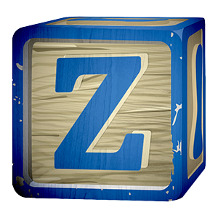  On the first day of the year, the last shall be first. This is the philosophy behind Z Day, a day when all those whose names begin with the letter Z will flaunt alphabetical order and put Z first. It’s an order that affects us all—from seats in school to places in line.  So where did alphabetical order come from?  It’s a 3,500-year-old mystery that social scientist William Watt believes he has solved. The English alphabet, or at least letters A through T, were ordered by a Semitic scribe living in modern-day Lebanon or Syria around the year 1500 BC. Watt believes the letters were arranged according to where the sounds are made in the mouth. Similar sounding letters were separated so that children would not become confused in their learning. Adding the letters U and W in the 16th century meant more bad news for Zach and Zoe. As usual, they had to wait for their final place in history.


