**PFM PHYSIO - Your Bladder Diary**

To help understand how to treat or better manage your bladder control, a health professional may ask you to keep a bladder diary.

A bladder diary is a record you keep of when and how much urine (wee) you passed or leaked during the day and overnight. When you record this information over a few days, you may start seeing patterns.

These patterns may help work out what is causing the problem or how to better manage it. For example, you may only be having problems during certain parts of the day or night, or after certain drinks.

Your doctor, nurse, continence specialist or pelvic health physiotherapist will use this information as part of your continence assessment.

How do I full in a diary?

* Record information for at least three days in a row.
* Choose carefully which part of the week you record. For example, patterns during the weekends may be different to your weekdays.
* Follow the example given at the top of the diary to help you fill it out correctly.
* Write in the diary when you wake up at the start of each day and when you go to bed.

Drinks/fluids intake (how much you have)

* Record the type of fluids you drink and how much.
* Include foods that are mainly liquid such as soups, jellies and custard.
* To help you measure, fill your favourite tea/coffee cup. Once full, pour the drink or fluid into a measuring jug to give you an idea of the amount that cup holds in milliliters (ml). Now continue to use the same type of cup to know the measurement.



How much urine passed

* Measure and record how much urine you passed in the toilet. Use a large plastic container and place it directly into the toilet bowl to catch your urine. Then tip the urine into a measuring jug to measure the amount.
* Once you have recorded how much urine you passed, tip the urine back into the toilet to flush.

Pad Weight Record

* Record the brand and its capacity in the comments box.
* Record when you changed pads and how much leakage was in the pads.
* Weigh DRY PAD BEFORE use on digital scales and record weight.
* Weigh USED PAD before disposing and record weight.
* The volume of leakage in the used pad is calculated:

Dry pad weight = 15g

Used pad weight = 20g

15g-10g which is 5g of leakage



What happened at the time of the leak?

* Describe where you were and what you were doing at the time of the leak. For example, did you leak when you coughed, or while lifting a heavy object.

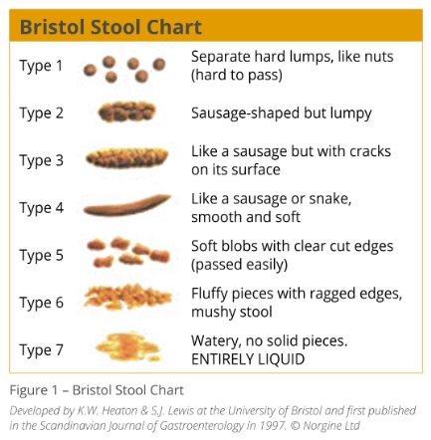Bristol Stool Chart:

**PFM PHYSIO - Your Bowel Diary**

To help understand how to treat or better manage your bowel control, a health professional may ask you to keep a bowel diary.

A bowel diary is a record you keep at the times and types of bowel motions (poo or stool) you passed or leaked. When you record this information over a few days, you may start seeing patterns.

These patterns may help work out what is causing the problem or how to better manage it. For example, you may only be having problems during certain parts of the day or night, or after certain foods or drinks.

Your doctor, nurse, continence specialist or pelvic health physiotherapist will use this information as part of your continence assessment.

How do I full in a diary?

* Record information for a full week (7 days in a row).
* Follow the example given at the top of the diary to help you fill it out correctly.
* Use the Bristol Stool Chart to help describe your bowel motions.





What is a continence assessment:

In a continence assessment, your health professional will ask you a few questions, do a physical check and may ask for more tests to be done.

Based on the results of your assessment, they will then prepare a plan for you to help treat or better manage your bowel issue. The plan may include:

* Changes to your diet or fluid intake
* Pelvic floor muscle exercises
* Changes to your medications



More information and advice

The Continence Foundation of Australia is the national peak body for continence prevention, management, education, awareness, information and advocacy.

[www.continence.org.au](http://www.continence.org.au)

The National Public Toilet Map shows the location of public and private toilet facilities across Australia.

[www.toiletmap.gov.au](http://www.toiletmap.gov.au)

For more information you can also visit:

[www.health.gov.au/bladder-bowel](http://www.health.gov.au/bladder-bowel)