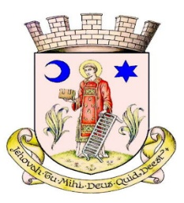
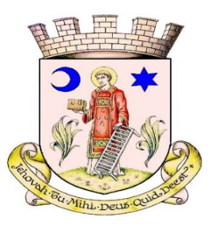
/
FORRES HIGHLAND GAMES

Forres and District Pipe Band Open Practice Chanter Competition
Saturday 4th July 2026 - Commencing 11:30am
Entry fee - £3
Please complete the form and email entries by the 30^{th of} June to: treasurer.forrespipeband@gmail.com Payment by Bank Transfer as follows: Forres and District Pipeband, Bank of Scotland, Sort Code: 80.22.60, Acct. No: 18052264
Entries will be accepted on the day cash payment only and must be handed in at Forres and District Pipeband tent by 11am

Name:
Date of Birth:
Age on day of competition:
Address:

Tele Number: Email:
Please circle which class you are entering, you may only enter ONE and must NOT HAVE YET MOVED ONTO BAGPIPES but are still learning the chanter.

Under 12 years 12 – 13 years 14 + years

Trophy will be presented to the best 12 and under years performance
The Bob Thompson Memorial Trophy will be presented to the best 12 - 13 years performance
The Forres and District Pipe Band Trophy will be presented to the best 14 + years performance
Winners will be awarded a cash prize and a trophy in each class
ALL ENTRIES MUST BE IN BY 11AM ON THE DAY

Draw will commence at 11:15am Competition will commence at 11:30am

Competitors report to practice chanter judge Mr Roy Fraser at the Forres and District Pipe Band Tent
RULES

This competition is open to players who are learning on the practice chanter but have not yet moved onto the bagpipes.
Players may not enter more than one of the practice chanter classes, and are not eligible to enter any of the solo bagpipe competitions.

13 years and under
A 2/4 March play once through.

14 + Years
A 2-part March played twice through, time signature of own choice.

Marks awarded by adjudicator.
90+ or Outstanding | An exceptional performance both technically and artistically
87-89 or Distinction | An excellent performance technically and artistically
84-86 or Commended | A convincing performance technically and artistically
81-83 or Merit | A capable performance showing some artistic appreciation and/or technical ability
78-80 or Moderate | A performance showing development of technique and/or communication
75-77 or Fair | A performance limited in its communication

The descriptors will appear on the adjudication sheets together with the adjudicator’s comments and are intended to help competitors understand what they have achieved and how they can progress.

Persons awarded trophies are expected to arrange for and meet the cost of engraving and sign a letter of undertaking for its safekeeping and return. Trophies must be returned as instructed not later than 4 weeks before the start of the following years Forres Highland Games.

