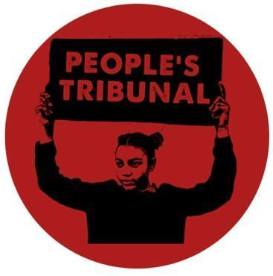

The People’s Tribunal on Police Killings

Announcement of first session 5-6 April 2025

The People’s Tribunal on Police Killings has emerged as a radical grassroots initiative led by families of those killed by the police in the UK. With more than 3000 deaths at the hands of the police over the past 50 years there have only been 4 successful prosecutions that led to police officers being convicted and going to prison. This figure of ‘success’ is one of the lowest in the world.

The disproportionate number of Black people killed represents the depth of racism that is ingrained in the police forces of the UK. Policing structures are corrupt and must be abolished.

The rate of police killings has been increasing over the decades. Police violence is going up but the prospect of justice is going down. Anyone who believes that the situation is improving, or that tweaks to the system will prevent further deaths, is delusional.

The failure to prosecute successfully has led to the formation of the PTPK supported by the United Families & Friends Campaign, Migrant Media, Black Lives Matter and 4WardEverUK. Its aim is to radically challenge the existing structures and the ongoing collusion that had led to this failure of justice. The PTPK is led by families and friends of those killed by the police and volunteer investigators who do not have faith that the system will ever deliver justice.

We are instigating the reopening of all of the several thousand deaths and initiating their reinvestigations. These investigations will be led by lawyers from outside the UK supported by an international team of activists and academics. These will lead to other actions.

We are asking all people to take the following actions:

- Reject the inquest system. The inquest system has failed to provide an opportunity to successfully prosecute one single police officer for the killings. Even if an inquest jury finds evidence of police criminality the Crown Prosecution Service protects the police. It is a legal framework of containment. It is an archaic distraction from the mechanisms of real justice.

- Reject any more governmental inquiries. Every single inquiry that the government had undertaken has failed to make the substantive changes needed for justice as well as prevention. They have not benefited the families despite millions of pounds being paid to judges, lawyers and organisations colluding in these cover ups.

- Reject the language of liberalism that is set by the government. These are not ‘deaths in police custody’. If you examine the sustained and systematic nature of these cases, and the political protection of the police then these can only be referred to as police killings.

- Accept that the amount of evidence against the police, including video and eye witnesses, is undeniable and we will not allow the state to suppress this evidence from the public any longer.

- Accept the fact that we need no more legislation, no more excuses, no more police training. The criminal law needs to be applied to police officers. What has been missing is the political will by successive governments to implement justice. That is what must be created through the will of the people.

What we aim for:

The People’s Tribunal on Police Killings will expose the extent of this injustice and implement a series of actions to make the real revolutionary change that is needed. The PTPK adopts the position that an injury to one is an injury to all. We will no longer tolerate the media strategy of highlighting individual cases. Justice for one is not justice for all.

The blood of the victims of police violence has run dry but the tears have not stopped and nor has the passion for justice. A generation of families have gone to their graves with the painful knowledge that the state had gotten away with the killings of their loved ones. You cannot rest when murder is a shadow that follows you. A new generation is emerging, the children and grandchildren of those killed by the police continue to call for justice but the appeal is no longer to the British state. It is international.

The People’s Tribunal on Police Killings will have its first intervention on 4-5 April 2025. It is an international initiative with a 10 year plan of actions that aims to deliver the justice that every family has demanded. Come as a supporter, come as a witness, come to be the agent of change.

Email: tribunalpeoples@gmail.com
Instagram: @thepeoplestribunal

