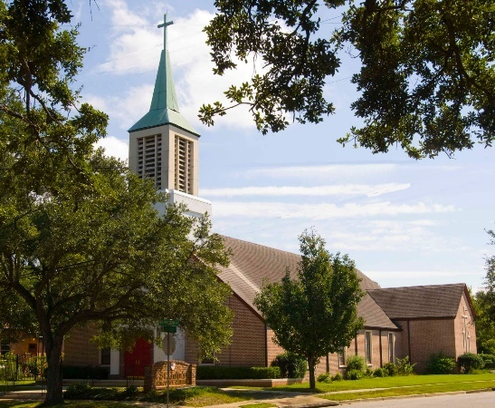
Welcome to Saint John’s Episcopal Church

The Fourth Sunday
After Pentecost

June 21, 2026
Communion under Special Circumstances

Ten O’clock in the Morning

Saint John’s Church, Mobile
Welcome to Saint John’s! Since its founding in 1853 Saint John’s has been an Episcopal church in the heart of Mobile. From our beginning worship has been central to our common life. Originally located ten streets West of Christ Church, Saint John’s moved to its current location in 1956, to what was then nearly at the city limits.

If you are interested in learning more about Saint John’s or becoming a member of our community, please speak with our priest or call the church office at (251) 479-5474. Our office hours are 9-2pm on Tuesdays. Outside of office hours, or in the event of a pastoral need, you can reach out to Father John Talbert at 205-354-3699. You can also contact us through our website, www.stjohnsmobile.org.

Prelude

The Entrance Rite
Entrance Song
All stand as the organ begins the introduction to the entrance hymn. The Congregation sings the hymn as the ministers of the assembly enter.
Hymn 518 Westminster Abbey
Christ is made the sure foundation
(see next page)

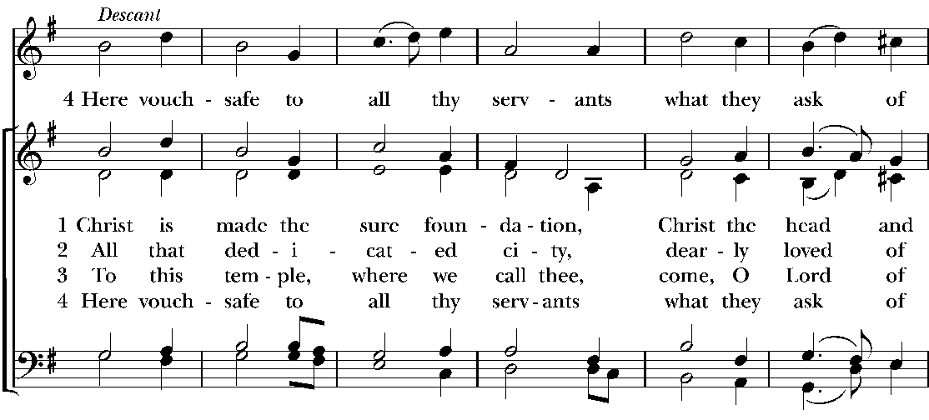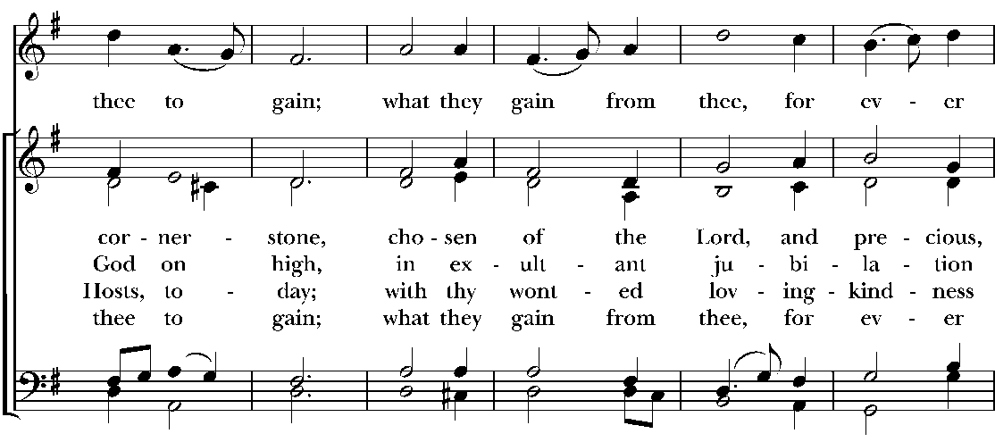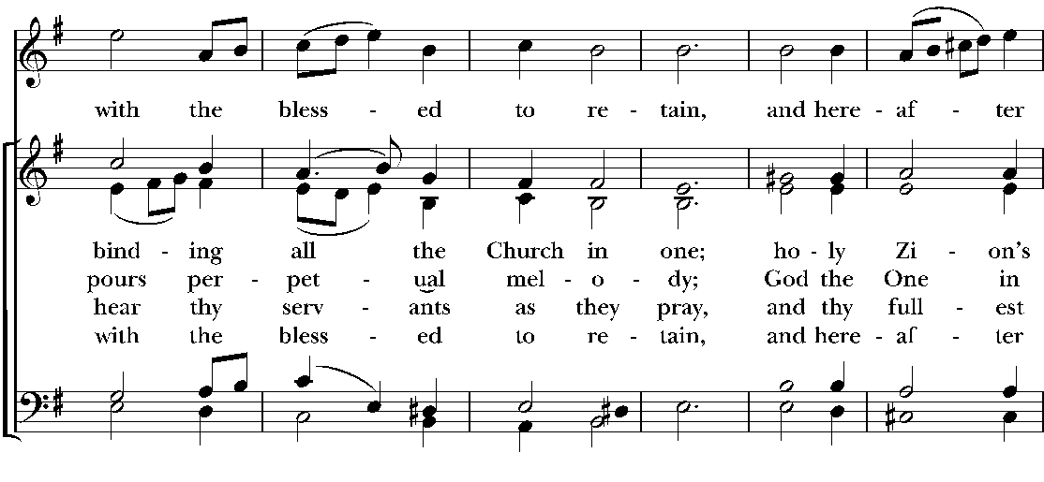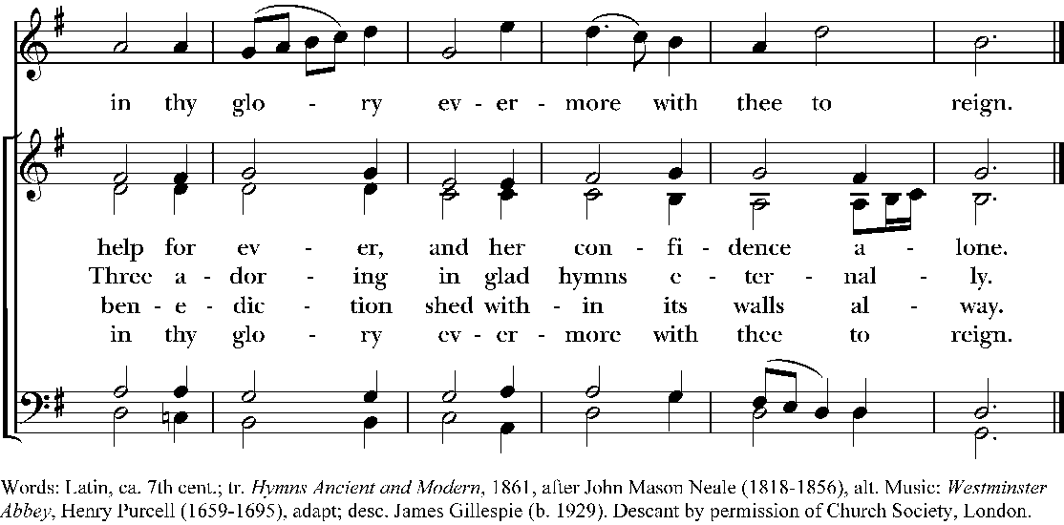

Officiant
Dear friends in Christ, we have come together in the presence of God to offer praise and thanksgiving, to hear and receive the Word of God, to bring before God the needs of the world and to ask for the forgiveness of our sins. Today the bread and wine for our Communion were consecrated as part of a Eucharist celebrated at another time and place. For centuries, the church has reserved consecrated elements in order to include those unable, because of infirmity or distance, to be present at Eucharist, and also to include worshiping communities on occasions when no priest is available to preside.

Opening Acclamation
Officiant Blessed be God: Father, Son and Holy Spirit.
People And blessed be God’s kingdom; now and forever. Amen.
Officiant
Almighty God, to you all hearts are open, all desires known, and from you no secrets are hid; Cleanse the thoughts of our hearts by the inspiration of your Holy Spirit, that we may perfectly love you, and worthily magnify your holy Name; through Christ our Lord. Amen.

The people remain standing for the Collect of the Day.
The Collect of the Day BCP p. 211
The Officiant says
The Lord be with you.
People And also with you.
Officiant Let us pray.
O Lord, make us have perpetual love and reverence for your holy Name, for you never fail to help and govern those whom you have set upon the sure foundation of your loving-kindness; through Jesus Christ our Lord, who lives and reigns with you and the Holy Spirit, one God, for ever and ever. Amen.

The Readings
The People are seated. The first lesson, Genesis 21:8-21, is now read
The child grew, and was weaned; and Abraham made a great feast on the day that Isaac was weaned. But Sarah saw the son of Hagar the Egyptian, whom she had borne to Abraham, playing with her son Isaac. So she said to Abraham, “Cast out this slave woman with her son; for the son of this slave woman shall not inherit along with my son Isaac.” The matter was very distressing to Abraham on account of his son. But God said to Abraham, “Do not be distressed because of the boy and because of your slave woman; whatever Sarah says to you, do as she tells you, for it is through Isaac that offspring shall be named for you. As for the son of the slave woman, I will make a nation of him also, because he is your offspring.” So Abraham rose early in the morning, and took bread and a skin of water, and gave it to Hagar, putting it on her shoulder, along with the child, and sent her away. And she departed, and wandered about in the wilderness of Beer-sheba.
When the water in the skin was gone, she cast the child under one of the bushes. Then she went and sat down opposite him a good way off, about the distance of a bowshot; for she said, “Do not let me look on the death of the child.” And as she sat opposite him, she lifted up her voice and wept. And God heard the voice of the boy; and the angel of God called to Hagar from heaven, and said to her, “What troubles you, Hagar? Do not be afraid; for God has heard the voice of the boy where he is. Come, lift up the boy and hold him fast with your hand, for I will make a great nation of him.” Then God opened her eyes and she saw a well of water. She went, and filled the skin with water, and gave the boy a drink.
God was with the boy, and he grew up; he lived in the wilderness, and became an expert with the bow. He lived in the wilderness of Paran; and his mother got a wife for him from the land of Egypt.
The Reader concludes
The Word of the Lord.
People Thanks be to God.

The People join in singing Psalm 86:1-10,16-17
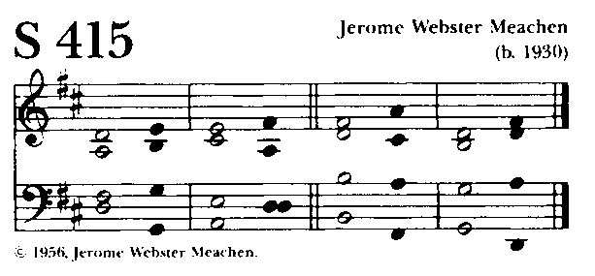
1 Bow down your ear, O Lord, and answer me, *
for I am poor and in misery.
2 Keep watch over my life, for I am faithful; *
save your servant who puts his trust in you.
3 Be merciful to me, O Lord, for you are my God; *
I call upon you all the day long.

4 Gladden the soul of your servant, *
for to you, O Lord, I lift up my soul.
5 For you, O Lord, are good and forgiving, *
and great is your love toward all who call upon you.
6 Give ear, O Lord, to my prayer, *
and attend to the voice of my supplications.
7 In the time of my trouble I will call upon you, *
for you will answer me.
8 Among the gods there is none like you, O Lord, *
nor anything like your works.
9 All nations you have made will come and worship you, O Lord, *
and glorify your Name.
10 For you are great;
you do wondrous things; *
and you alone are God.
16 Turn to me and have mercy upon me; *
give your strength to your servant;
and save the child of your handmaid.
17 Show me a sign of your favor,
so that those who hate me may see it and be ashamed; *
because you, O Lord, have helped me and comforted me.

The second lesson, Romans 6:1b-11, is now read
Should we continue in sin in order that grace may abound? By no means! How can we who died to sin go on living in it? Do you not know that all of us who have been baptized into Christ Jesus were baptized into his death? Therefore we have been buried with him by baptism into death, so that, just as Christ was raised from the dead by the glory of the Father, so we too might walk in newness of life.
For if we have been united with him in a death like his, we will certainly be united with him in a resurrection like his. We know that our old self was crucified with him so that the body of sin might be destroyed, and we might no longer be enslaved to sin. For whoever has died is freed from sin. But if we have died with Christ, we believe that we will also live with him. We know that Christ, being raised from the dead, will never die again; death no longer has dominion over him. The death he died, he died to sin, once for all; but the life he lives, he lives to God. So you also must consider yourselves dead to sin and alive to God in Christ Jesus.

The Reader concludes
The Word of the Lord.
People Thanks be to God.
Hymn 626 Quam dilecta
Lord, be thy word my rule
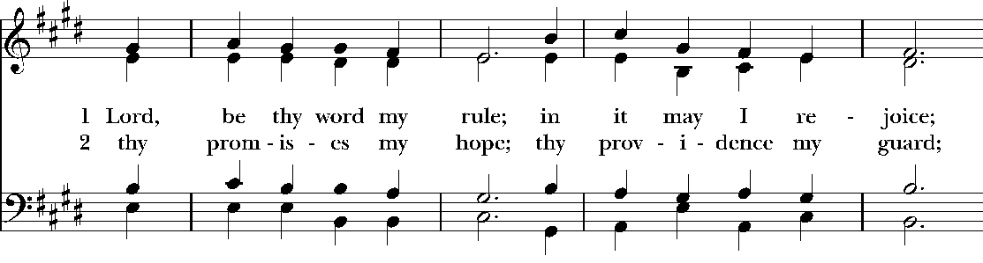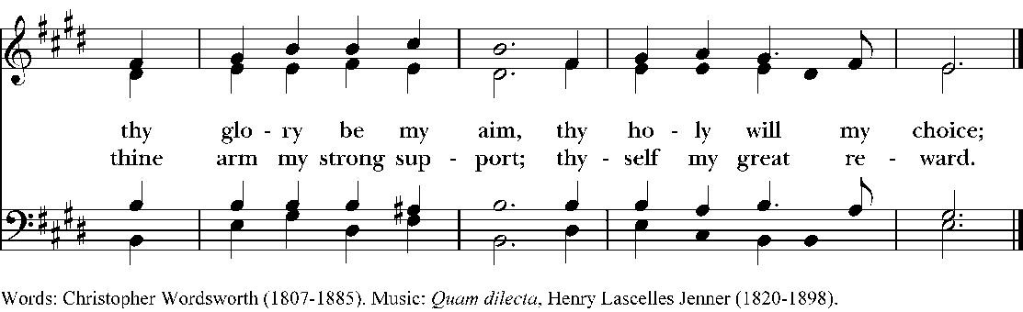

The Gospel lesson, Matthew 10:24-39 is now read
Jesus said to the twelve disciples, “A disciple is not above the teacher, nor a slave above the master; it is enough for the disciple to be like the teacher, and the slave like the master. If they have called the master of the house Beelzebul, how much more will they malign those of his household!
“So have no fear of them; for nothing is covered up that will not be uncovered, and nothing secret that will not become known. What I say to you in the dark, tell in the light; and what you hear whispered, proclaim from the housetops. Do not fear those who kill the body but cannot kill the soul; rather fear him who can destroy both soul and body in hell. Are not two sparrows sold for a penny? Yet not one of them will fall to the ground apart from your Father. And even the hairs of your head are all counted. So do not be afraid; you are of more value than many sparrows.
“Everyone therefore who acknowledges me before others, I also will acknowledge before my Father in heaven; but whoever denies me before others, I also will deny before my Father in heaven.
“Do not think that I have come to bring peace to the earth; I have not come to bring peace, but a sword.
For I have come to set a man against his father,
and a daughter against her mother,
and a daughter-in-law against her mother-in-law;
and one’s foes will be members of one’s own household.
Whoever loves father or mother more than me is not worthy of me; and whoever loves son or daughter more than me is not worthy of me; and whoever does not take up the cross and follow me is not worthy of me. Those who find their life will lose it, and those who lose their life for my sake will find it.”
The Reader concludes
The Word of the Lord.
People Thanks be to God.
The Homily Dr. Nikki Shaw

The Nicene Creed BCP p. 358
The people stand as the Officiant stands and all join in saying:
We believe in one God,
the Father, the Almighty,
maker of heaven and earth,
of all that is, seen and unseen.
We believe in one Lord, Jesus Christ,
the only Son of God,
eternally begotten of the Father,
God from God, Light from Light,
true God from true God,
begotten, not made,
of one Being with the Father.
Through him all things were made.
For us and for our salvation
he came down from heaven:
by the power of the Holy Spirit
he became incarnate from the Virgin Mary,
and was made man.
For our sake he was crucified under Pontius Pilate;
he suffered death and was buried.
On the third day he rose again
in accordance with the Scriptures;
he ascended into heaven
and is seated at the right hand of the Father.
He will come again in glory to judge the living and the dead,
and his kingdom will have no end.
We believe in the Holy Spirit, the Lord, the giver of life,
who proceeds from the Father and the Son.
With the Father and the Son he is worshiped and glorified.
He has spoken through the Prophets.
We believe in one holy catholic and apostolic Church.
We acknowledge one baptism for the forgiveness of sins.
We look for the resurrection of the dead,
and the life of the world to come. Amen.
The Prayers of the People
All may stand or sit. A minister bids these prayers of the assembly:
Let us pray for the Church and for the world.

Grant, Almighty God, that all who confess your Name may be united in your truth, live together in your love, and reveal your glory in the world.
Lord, in your mercy. Hear our prayer.

Guide the people of this land, and of all the nations, in the ways of justice and peace; that we may honor one another and serve the common good.
Lord, in your mercy. Hear our prayer.

Give us all a reverence for the earth as your own creation, that we may use its resources rightly in the service of others and to your honor and glory.
Lord, in your mercy. Hear our prayer.

Bless all whose lives are closely linked with ours, and grant that we may serve Christ in them, and love one another as he loves us.
Lord, in your mercy. Hear our prayer.

Comfort and heal all those who suffer in body, mind, or spirit; give them courage and hope in their troubles and bring them the joy of your salvation.
Lord, in your mercy. Hear our prayer.

Receive unto to your mercy all who have died, that your will for them may be fulfilled; and we pray that we may share with all your saints in your eternal kingdom.
Lord, in your mercy. Hear our prayer.

The Officiant adds a concluding collect.
Lord Jesus Christ, you said to your apostles, "Peace I give to you; my own peace I leave with you:" Regard not our sins, but the faith of your Church, and give to us the peace and unity of that heavenly City, where with the Father and the Holy Spirit you live and reign, now and for ever. Amen.
The Confession of Sin
The Officiant says
Let us confess our sins against God and our neighbor.
Silence is observed after which the Officiant and People pray
Most merciful God,
we confess that we have sinned against you
in thought, word and deed
by what we have done and by what we have left undone.
We have not loved you with our whole heart;
we have not loved our neighbors as ourselves.
We are truly sorry and we humbly repent.
For the sake of your Son Jesus Christ,
have mercy on us and forgive us;
that we may delight in your will,
and walk in your ways,
to the glory of your Name. Amen.
The Officiant says
Almighty God have mercy on us, forgive us all our sins through our Lord Jesus Christ, strengthen us in all goodness, and by the power of the Holy Spirit keep us in eternal life. Amen.
The Peace
The Officiant says
The peace of the Lord be always with you.
People And also with you.
The Ministers and People greet one another in the name of the Lord.
Announcements
The Congregation may be seated for the announcements.
The Liturgy of Communion
The Preparation of the Gifts
The Congregation is seated for the Offertory.

Hymn 675 Bourbon
Take up your cross the Savior said
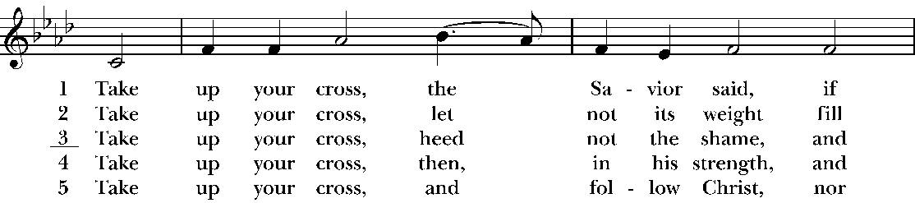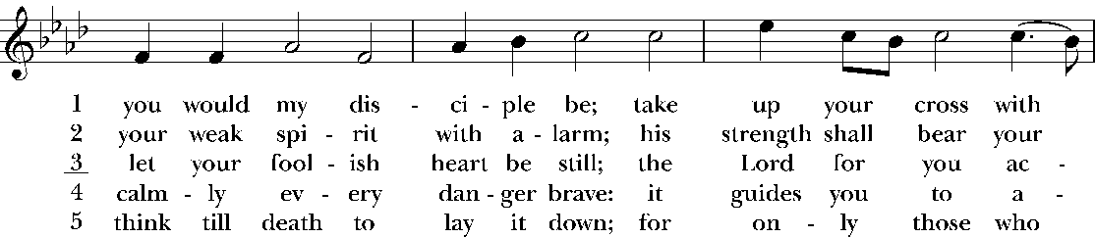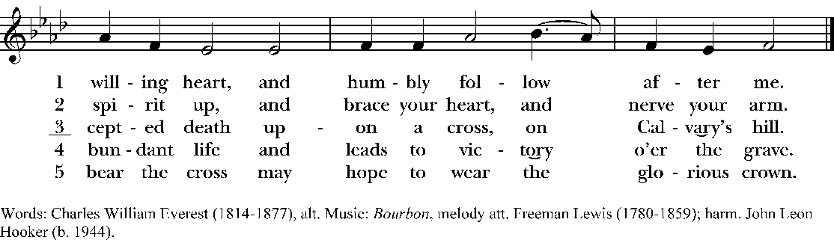
The Congregation stands and sings the Presentation Hymn while the ushers bring forward the people’s gifts of bread, wine, money and other gifts.
Hymn 380 Old 100th
All people that on earth do dwell
Vs 3 only
Praise God, from whom all blessings flow;
praise him, all creatures here below;
praise him above, ye heavenly host;
praise Father, Son, and Holy Ghost. Amen.
The Officiant says
Sisters and brothers, on the fourteenth day of June, in the year of Our Lord, 2026, the people of St. John’s, in Mobile, Alabama, gathered as the Body of Christ to celebrate the Holy Eucharist. A portion of the Sacred Bread and Precious Blood was reserved from that Eucharist, and have been reverently kept for us, that we may this day join with those who gathered then, in communion with God and all Christians of every place and every time to share in this foretaste of the Heavenly Banquet.
Officiant Sisters and brothers, the cup of blessing that was blessed
People is the communion of the Blood of Christ.
Officiant For we were all baptized by one Spirit into one body
People and all made to drink of one Spirit.
Officiant The Bread that was broken
People is the Communion of the Body of Christ.
Officiant Because there is One Bread
People we who are many are one body, for we all share in the One Bread.

All: Almighty Father, whose dear Son on the night before He suffered, instituted the Sacrament of his Body and Blood; Mercifully grant that we may receive it thankfully in remembrance of Jesus Christ our Lord, Who in these holy mysteries gives us a pledge of eternal life; and Who lives and reigns for ever and ever. Amen.

And now, as our Savior Christ has taught us, we are bold to say
Our Father, who art in heaven,
hallowed be thy name,
thy kingdom come,
thy will be done,
on earth as it is in heaven.
Give us this day our daily bread,
and forgive us our trespasses,
as we forgive those who trespass against us.
And lead us not into temptation,
but deliver us from evil.
For thine is the kingdom,
and the power, and the glory,
for ever and ever. Amen.
The Invitation
The Officiant invites the people to receive the Holy Communion.
Officiant The gifts of God for the People of God.

We are all invited to the Lord’s Table
In the Episcopal Church, all baptized persons are invited to receive the Holy Communion. Persons who do not wish to receive Communion are invited to come forward with everyone else to receive a prayer of intercession.
During the distribution of communion, the Congregation remains seated and sings the Communion Hymn.
Hymn 321 Rockingham
My God, thy table now is spread
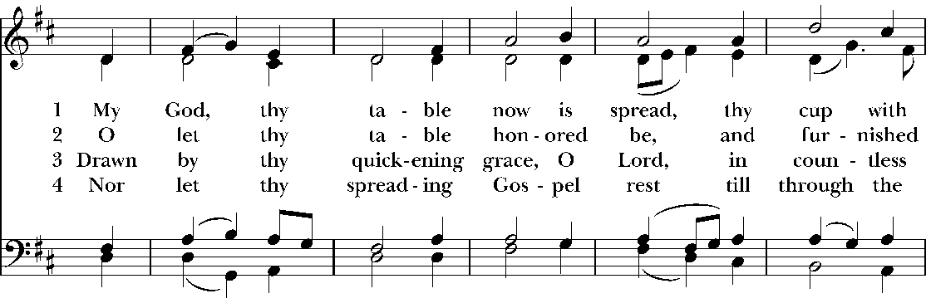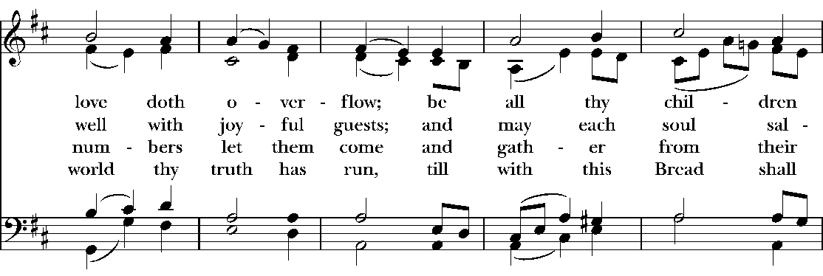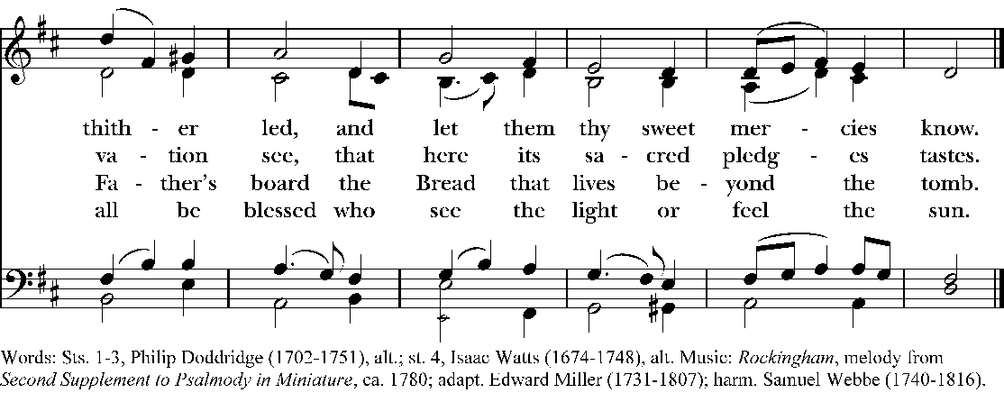
Postcommunion Prayer BCP p. 366
The People stand or kneel. The Officiant says
Let us pray.
Officiant and People
Almighty and everliving God,
we thank you for feeding us with the spiritual food
of the most precious Body and Blood
of your Son our Savior Jesus Christ;
and for assuring us in these holy mysteries
that we are living members of the Body of your Son,
and heirs of your eternal kingdom.
And now, Father, send us out
to do the work you have given us to do,
to love and serve you
as faithful witnesses of Christ our Lord.
To him, to you, and to the Holy Spirit,
be honor and glory, now and for ever. Amen.
The people stand and sing the recessional hymn.
Hymn 637 Lyons
How firm a foundation
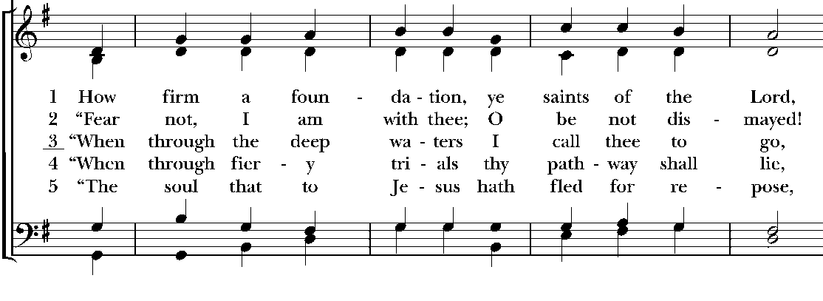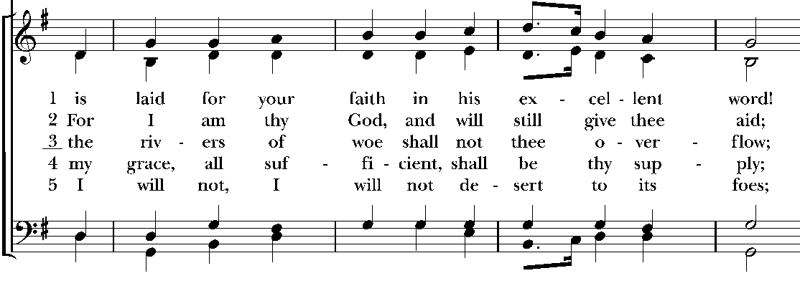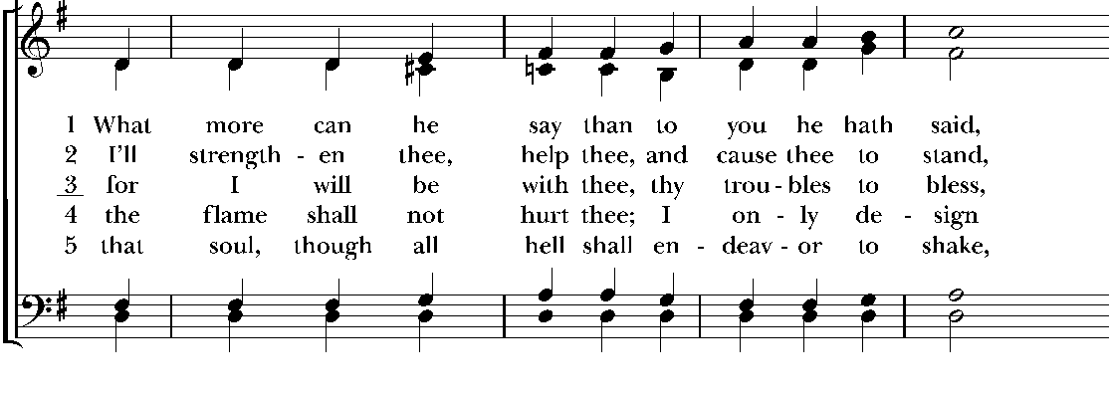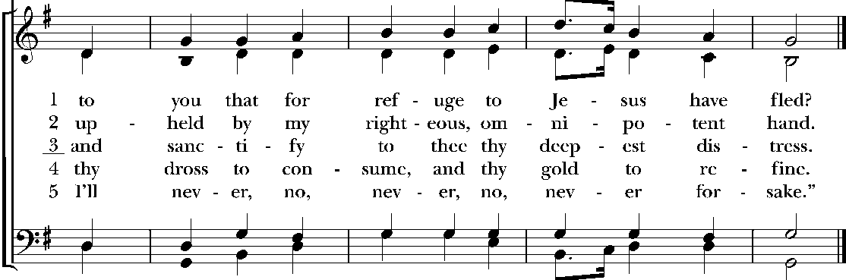

The Dismissal
The Officiant dismisses them saying
Officiant Let us go forth into the world rejoicing in the Spirit. Alleluia, Alleluia!
People Thanks be to God. Alleluia, Alleluia!

Postlude

Serving in today’s liturgy:
Officiant Nikki Shaw
First Lesson Lector Paula Ross
Second Lesson Lector Helen Guthrie
Third Lesson Lector Janet Buckley
Lay Eucharistic Minister Lee Dorsey
Altar Guild Lee Dorsey & Kristen Turner
Vestry Tellers Helen Guthrie & Connie McLean
Assisting Minister Lee Dorsey
Digital Evangelist Kristen Turner

This week at Saint John’s:

Today, June 21 10:00AM Holy Communion: Pentecost 4
11:15AM Fellowship Time in the Great Hall
Tues., June 23 9-2PM Church Office Open
6:00PM Choir Practice
Sunday, June 28 10:00AM Holy Eucharist: Pentecost 5

The Flowers on the Altar
are given by Connie McLean
to the glory of God

Recent Attendance:
29 May 31, Trinity Sunday
35 June 7, The Second Sunday after Pentecost
28 June 14, The Third Sunday after Pentecost

Please remember in your prayers:
We lift up to you members of this church family, especially:
Cookie and David Rich, Bootsie Cieutat, Eddy Velaski, Julie Garner, Pat Fulford, Marie Brown, Bob Anderson, Helen Guthrie, Mike and Frances Barbour, Carolyn Pearce, Ashley Garris, and Jayson Chestang.
We pray for our family and friends, especially:
Madison Pittman, Liz Levy Reichman, Ty Lofton, Sabrina Jones, Bill Cutts, David Bryars, Todd McGill, Chris Velaski, Colin Guthrie, Sheila Velaski, Larry DeBert, Emily Brown, Dennis Clardy, Sarah Guthrie, Morris Levy, Judy Lynch, Adam Strong, Angie Leon, David Hamilton, Sheila Granger, Barbara Bonner, David Brunner, Karl Gieseler, Nancy Payne, Bonnie Jernigan, Rev. Frances LeBlanc.
Our sisters and brothers serving in the Armed Forces:
Nicholas Boykin, Ryan Hurt, Marcus Rich, Ross Hussmann, Ellis Garner, Bryant Andrews, Austin & Beka Denigan.

THE CLERGY AND STAFF OF ST. JOHN’S
The Rt. Reverend J. Russell. Kendrick, Bishop of the Diocese of the Central Gulf Coast
The Reverend John Talbert, Rector (frjohn@stjohnsmobile.org)
Mr. Louis F. Daniel, organist & choir director (music@stjohnsmobile.org)
Ms. Kathe Gieseler, financial secretary (finance@stjohnsmobile.org)
Dr. Nikki Shaw, office volunteer (office@stjohnsmobile.org)

The Vestry and Wardens of St. John’s
Class of 2026: Ms. Helen Guthrie. and Ms. Kathe Gieseler.
Class of 2027: Ms. Connie McLean, senior warden, and Mr. Eddy Velaski.
Class of 2028: Mr. Hugh Tomlin, junior warden, and Ms. Janet Buckley, clerk.
and Ms. Cindy Gass, treasurer.

