July 2026

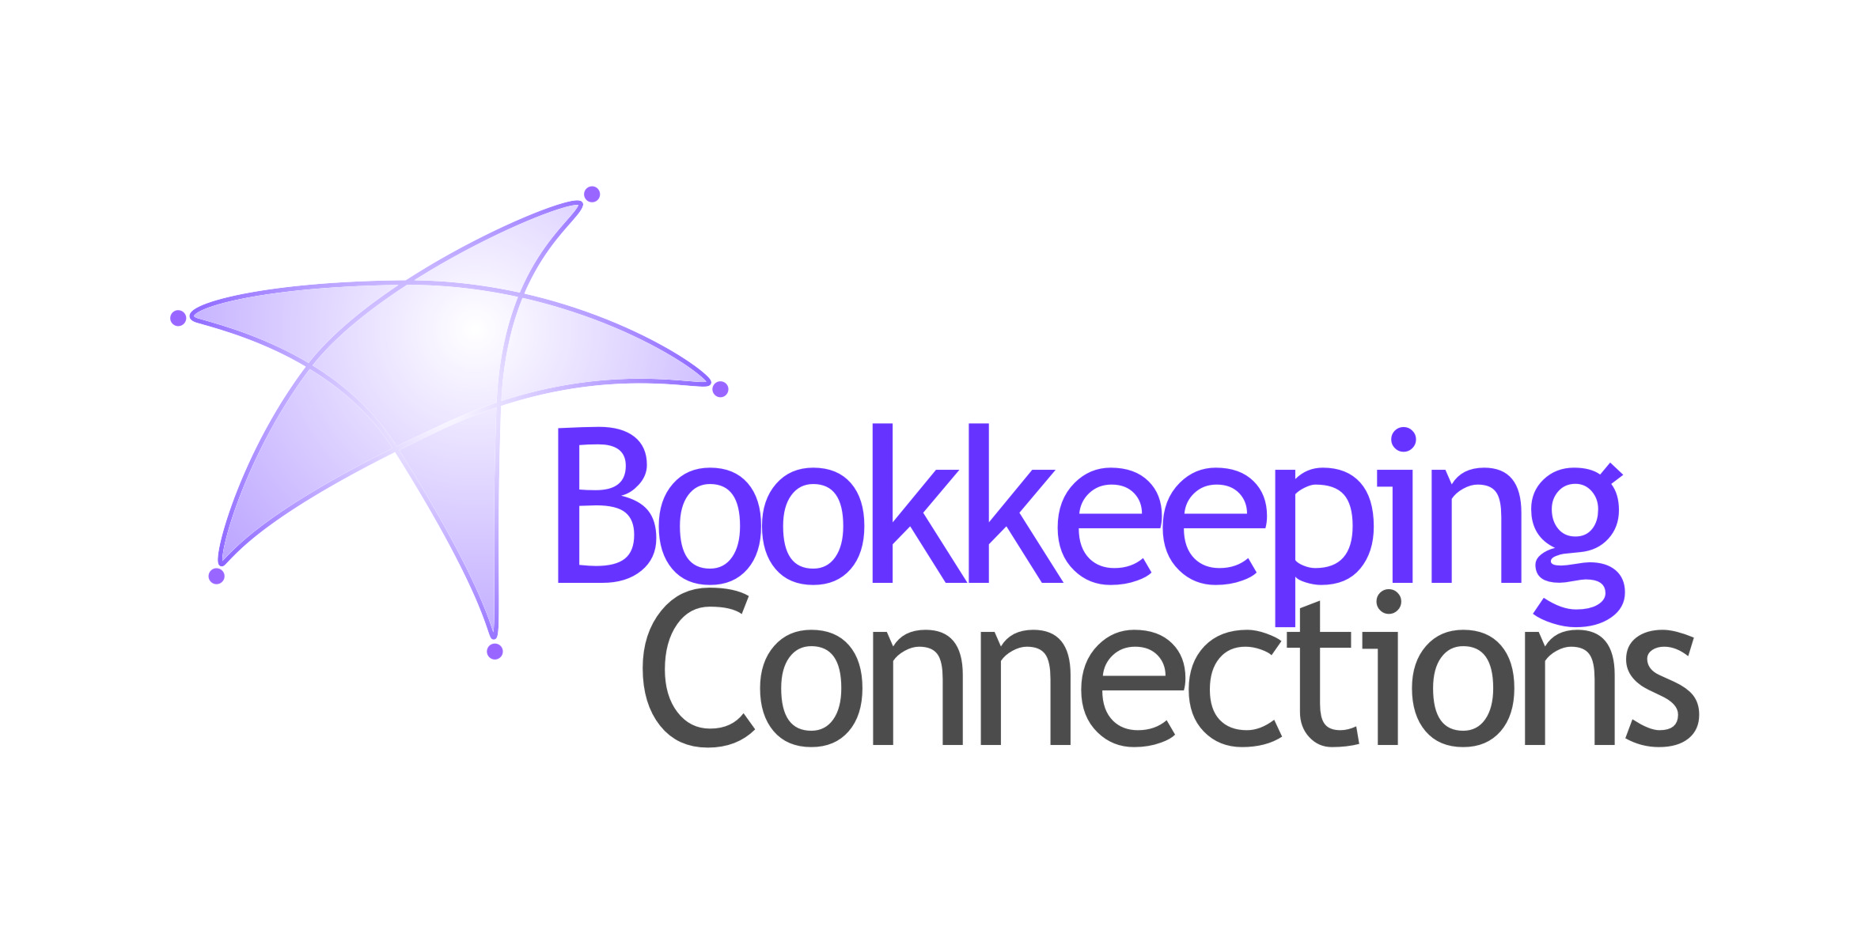

These dates are from the ATO website and do not account for possible extensions.
You remain responsible for ensuring that the necessary information is with us in time.
See ATO Due dates by month to check monthly lodgment and payment dates.
BAS/IAS Monthly Lodgements
Final dates for lodgements and payments:
July Activity Statement
21 August 2026
August Activity Statement
21 September 2026

BAS Quarterly Lodgements
Final dates for lodgements and payments:
4th Quarter 2026 Financial Year:
June Quarter 2026 (incl. PAYGI)
28 July, 2026
1st Quarter 2027 Financial Year:
September Quarter 2026 (incl. PAYGI)
28 October, 2026
When a due date falls on a Saturday, Sunday or Public Holiday*, you can lodge or pay on the next business day.
*A day that is a public holiday for the whole of any state or territory in Australia.

Due date for super guarantee contributions:
4th Quarter 2026 Financial Year:
April to June 2026 – contributions must be in the fund by 28 July, 2026
From 1st July 2026, Payday Super applies.
Superannuation contributions must be received by the employee's super fund within seven calendar days of payday.
If a payment is made late, additional obligations and charges may apply.
ATO Lodgement Dates

ATO Signals First-Year Payday Super Approach

Adopting Payday Super From July
The ATO has provided further insight into how it intends to administer Payday Super during the first year of operation. Through its draft Practical Compliance Guideline (PCG), the ATO has acknowledged that employers may need time to deploy, test and embed changes to payroll systems and business processes following the commencement of Payday Super on 1st July 2026.
The ATO has indicated that employers who are genuinely attempting to comply with Payday Super and pay super on a payday cycle will not be the focus of compliance activity, provided errors are corrected as soon as reasonably practicable.
This recognises that some employers may experience implementation issues as they transition to the new requirements. However, the ATO has also made it clear that employers who continue to pay superannuation quarterly after 1st July 2026 will be viewed differently.
Under the draft compliance approach:
- Employers paying super on a payday cycle and correcting issues promptly will generally not be the focus of ATO compliance resources.
- Employers continuing to pay quarterly will be considered medium risk.
- Employers with unpaid super beyond the current quarterly due dates will be considered high risk.
The ATO has advised that compliance resources will be directed towards high-risk employers ahead of medium-risk employers during the first year of Payday Super.
The ATO has also indicated that employers operating within this approach should carefully consider whether lodging a Voluntary Disclosure Statement (VDS) is necessary. Lodging a VDS requires the ATO to assess the employer’s circumstances, and the ATO has indicated that employers making a genuine effort to comply would generally not be expected to lodge one.
The expectation is that employers adopt Payday Super processes from July 2026 and begin paying super in line with pay runs rather than continuing quarterly payment arrangements. If the process doesn’t allocate the funds to the member’s account within the 7 days, just keep paying each payday and fixing any errors you are made aware of.
ATO has indicated that if they see that behaviour, then you are considered low risk, and they will not take action. The first-year compliance approach is intended to support employers making a genuine effort to comply with the new system. It is not intended to provide a transition period for employers who choose not to implement Payday Super.
Source: PCG 2026/1 | Legal database


Payroll Changes
From 1st July 2026, key changes to the National Minimum Wage and Minimum Award Rates will come into effect. These changes will affect payroll, budgeting, and compliance responsibilities for small businesses across Australia. Preparing early will help avoid unnecessary stress when the new financial year begins.

Minimum Wage Increase
The National Minimum Wage will increase by 4.75%.
For employees not covered by an award or enterprise agreement, the new base rates will be:
- $26.44 per hour.
- $1,004.90 per week (based on a 38-hour week).
- $52,254.80 per year.
The new rates will apply from the first full pay period starting on or after 1st July 2026. For example, if your business runs weekly pay cycles beginning on Mondays, the increase will apply from Monday, 6th July 2026.
Payroll systems will automatically update award rates. However, bookkeepers should still confirm that each employee is linked to the correct award classification and that no manual rates or custom pay items have been overlooked.
Must Do: Check any repeating direct debit payment systems to amend the amount of pay based on the new rates.
Source: Minimum wages increase from 1 July 2026 - Fair Work Ombudsman

New Pay Rates Available
To access the new pay rates now, you can:
- Use the FWO Pay and Conditions Tool.
(To access the new rates in the Pay Calculator, set the calculation date to 1 July 2026 or later.)
- Download an updated pay guide from Pay guides.
For further information, please read Minimum wages - Fair Work Ombudsman
Disclaimer: All or any advice contained in this newsletter is of a general nature only and may not apply to your individual business circumstances
For specific advice relating to your specific situation, please contact your accountant or contact me for further discussion.
This newsletter is produced by the Institute of Certified Bookkeepers and distributed by members.


