
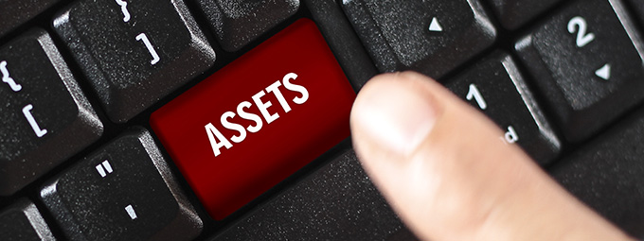
These dates are from the ATO website and do not account for possible extensions.
You remain responsible for ensuring that the necessary information is with us in time.
See ATO Due dates by month to check monthly lodgment and payment dates.
BAS/IAS Monthly Lodgements
Final dates for lodgements and payments:
February Activity Statement
21 March 2026
March Activity Statement
21 April 2026

BAS Quarterly Lodgements
Final dates for lodgements and payments:
2nd Quarter 2026 Financial Year:
December Quarter 2025 (incl. PAYGI)
28 February, 2026
3rd Quarter 2026 Financial Year:
March Quarter 2026 (incl. PAYGI)
28 April, 2026
When a due date falls on a Saturday, Sunday or Public Holiday*, you can lodge or pay on the next business day.
*A day that is a public holiday for the whole of any state or territory in Australia.

Due date for super guarantee contributions:
2nd Quarter 2026 Financial Year:
October to December 2025 – contributions must be in the fund by 28 January, 2026
3rd Quarter 2026 Financial Year:
January to March 2026 – contributions must be in the fund by 28 April, 2026
Late payments of superannuation are not tax deductible. If your business has overdue superannuation guarantee payments and you are unsure of how to proceed, please contact us to discuss.
ATO Lodgement Dates

Instant Asset Write-off - Now Law 2026

$20,000 Instant Asset Write-off For 2025–26
The $20,000 instant asset write-off is now law. Small businesses with an annual turnover of less than $10 million can immediately deduct the business portion of eligible assets that cost under $20,000.
Assets can be new or second-hand. They must be first used or installed, and ready for business use, between 1st July 2025 and 30th June 2026.
The $20,000 threshold applies per asset, so you can claim multiple assets if each one is below the limit.
Normal deduction rules still apply, and you’ll need records to support your claim.
For more information visit, Instant asset write-off for eligible businesses | Australian Taxation Office

What is Instant Asset Write-off
The instant asset write-off allows an immediate deduction of the full cost of eligible assets, rather than depreciating them over several years. Businesses can write off multiple assets, provided each asset is under the $20,000 threshold.
The deduction applies only to the portion of the asset used for business purposes, and proper records must be maintained to substantiate the purchase and business use. This write-off provides immediate tax relief and can help reduce taxable income for eligible businesses.

The Role of Your Bookkeeper
Your Bookkeeper keeps track of asset purchases and installations so they are recorded correctly, with the right dates and amounts.
In most cases, assets should be coded to a fixed asset account, even if they cost less than $20,000. The instant asset write-off is a tax decision made by your accountant, not a bookkeeping one. Your bookkeeper may follow written instructions from your accountant about how specific purchases should be treated during the year.
At the end of the financial year, your bookkeeper will flag all relevant asset purchases for your accountant so that any eligible deductions can be assessed and applied correctly in your tax return.
Source: ATO - Instant asset write-off for eligible businesses (QC61417)


The Small Business Super Clearing House

End of the Small Business Super Clearing House
The Small Business Superannuation Clearing House (SBSCH) is being phased out as part of the move to Payday Super. It has already stopped taking new registrations as of October 2025 and will close completely on 1st July 2026. After that date, employers will no longer be able to use it to send super contributions.
Every small business that still relies on the SBSCH needs a new way to pay super before the first payday after 1st July 2026.

What You Need To Do
Choose a new way to pay super that suits your business. Most employers will adopt the super clearing service built into their payroll software because it centralises payments and reporting.
If you do not use payroll software, you can register with a commercial super clearing house or contact your default super fund to ask about their clearing options.
If you are unsure which option is right for you, speak with your Bookkeeper. They can guide you through the transition and help you choose a solution that fits your business.
Once the SBSCH closes, super payments sent through it will not be processed. Putting a new solution in place early will help you avoid delays, missed payments and compliance issues.
If you’re an existing registered user of the SBSCH, you need to:
- Choose an alternative payment method.
- Switch to the new method as soon as possible, before 1 July 2026.
- Download your super records from the SBSCH before 1 July 2026.
For more information, you can visit the ATO’s guidance on super payment options for employers on the ATO website. Source: Small Business Superannuation Clearing House | Australian Taxation Office
Disclaimer: All or any advice contained in this newsletter is of a general nature only and may not apply to your individual business circumstances
For specific advice relating to your specific situation, please contact your accountant or contact me for further discussion.
This newsletter is produced by the Institute of Certified Bookkeepers and distributed by members.


