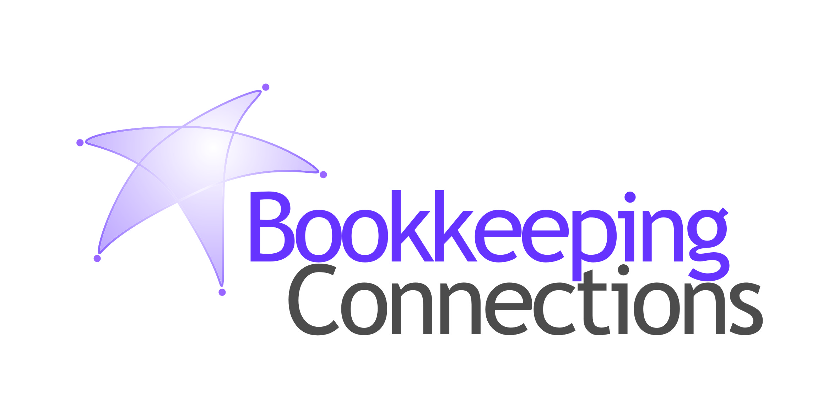

These dates are from the ATO website and do not account for possible extensions.
You remain responsible for ensuring that the necessary information is with us in time.
See ATO Due dates by month to check monthly lodgment and payment dates.
BAS/IAS Monthly Lodgements
Final dates for lodgements and payments:
April Activity Statement
21 May 2026
May Activity Statement
21 June 2026

BAS Quarterly Lodgements
Final dates for lodgements and payments:
3rd Quarter 2026 Financial Year:
March Quarter 2026 (incl. PAYGI)
28 April, 2026
4th Quarter 2026 Financial Year:
June Quarter 2026 (incl. PAYGI)
28 July, 2026
When a due date falls on a Saturday, Sunday or Public Holiday*, you can lodge or pay on the next business day.
*A day that is a public holiday for the whole of any state or territory in Australia.

Due date for super guarantee contributions:
3rd Quarter 2026 Financial Year:
January to March 2026 – contributions must be in the fund by 28 April, 2026
4th Quarter 2026 Financial Year:
April to June 2026 – contributions must be in the fund by 28 July, 2026
Late payments of superannuation are not tax deductible. If your business has overdue superannuation guarantee payments and you are unsure of how to proceed, please contact us to discuss.
ATO Lodgement Dates

Payday Super – What Employers Need to Know
From 1st July 2026, superannuation must be paid at the same time as wages. This is called Payday Super.
Instead of paying super quarterly, it will move into the normal payroll cycle. Whether wages are paid weekly, fortnightly, or monthly, super will follow the same pattern and be included in each pay run, with contributions required to reach the employee’s fund within 7 days of payday.

What Is Changing
This is not a change to how super is calculated. It is a change to when it is paid.
Rather than being set aside and dealt with at the end of the quarter, superannuation becomes part of each payroll. As wages are processed, super is calculated, processed and paid at the same time.

What This Means For Your Business
The shift is really about timing and consistency. Super becomes a regular outgoing that sits alongside wages, which means it needs to be funded and processed each pay cycle rather than planned for quarterly.
For many businesses, the main adjustment will be to manage cash flow differently and ensure payroll and payment processes run on time without delay.
There is also a change to how superannuation is paid. The Small Business Superannuation Clearing House (SBSCH) will close from 30th June 2026, so if you currently use it, you will need to move to an alternative payment method before Payday Super starts.
It’s also important to remember that, while your Bookkeeper may manage payroll and process payments, the responsibility for ensuring super is paid correctly and on time remains with the employer.

What To Review Now
It’s worth reviewing how your current process will operate under this approach
- Payroll process
Super will need to be paid each pay run, so your payroll process needs to support this consistently without anything falling behind. Most payroll software will support this change, but it’s worth confirming how it will work in your setup.
- Payment method
If you currently use the Small Business Superannuation Clearing House, you will need to transition to another clearing or payment solution before 30th June 2026.
- Payment timing
If you use a clearing house, allow enough time for the super to move through the system and be received by the fund within 7 days of payday.
- Cash flow
Super will shift from a quarterly expense to a regular outgoing, so it’s important to factor that into your pay cycle.
- Roles and approvals
If your Bookkeeper manages payroll, make sure responsibilities and approvals are clear so payments don’t sit waiting.

What Happens And When
- 28th April 2026 – January to March quarterly super payment due.
- 30th June 2026 – SBSCH access ends. Download all records before this time.
- 1st July 2026 – Payday Super starts. Super must be paid for each payday.
- 14th July 2026 – STP finalisation for 2025–26 (no change to this process).
- 28th July 2026 – final quarterly super payment due.
- 29th July 2026 – all super payments will be allocated towards Payday Super guarantee (SG).
Between 1st July and 28th July 2026, transitional rules apply. Payments made during this period may first be applied to any outstanding quarterly obligations before being allocated to Payday Super.
For Further Details: Employers | Australian Taxation Office

Late Payments
Late super will be more visible under this approach.
The current rules still apply, but there is less room to catch up later. With the phase-out of late-payment offsets, the focus shifts to getting the timing right from the start and keeping payments aligned with each pay run.

Working With Your Bookkeeper
It is encouraged that you discuss this with your Bookkeeper, who is skilled at managing payroll and can play a central role in making this new process work smoothly.
They can review your setup, help you move to the right payment solution if needed, confirm how your software will handle Payday Super, and adjust your process so super is paid consistently alongside wages.

Start Now – Don’t Wait Until the Last Minute!
Your payroll and super payment process needs to be ready before 1st July 2026. Waiting until the last minute increases the risk of delays while systems, payment methods and approvals are still being worked through.
A review now gives you time to make the necessary adjustments and ensure everything runs as it should from day one.


Payday Super – What This Means for Employees
Please share the below with your employees.
From 1st July 2026, superannuation will be paid at the same time as wages, rather than quarterly.
This means employees will begin to see smaller super contributions being paid more regularly, rather than one larger payment every few months, and generally closer to when wages are received.
Super contributions will not appear in the fund immediately. After each pay run, payments are processed and then move through a clearing system before being received and allocated by the super fund.
Depending on the fund and payment method, this can take a few days. Under the new rules, contributions must reach the fund within 7 days of payday.
There’s nothing employees need to do differently as a result of this change. However, it is recommended that super accounts be checked from time to time, particularly during the early stages of the transition.
Contributions should appear regularly and broadly align with payslips, and super fund details should be kept up to date to avoid delays.
If a contribution does not appear as expected, the first step is to speak with the employer, as this will often be due to timing or processing. If the issue is not resolved, the super fund can confirm whether a payment has been received.
Where contributions are missing or there is an ongoing concern, employees can contact the Australian Taxation Office for further assistance. See: Unpaid super from your employer | Australian Taxation Office
Over time, super accounts will show more frequent transactions than previously. This is expected and reflects the move from quarterly payments to contributions being made with each pay run.
Source: Employees | Australian Taxation Office
Disclaimer: All or any advice contained in this newsletter is of a general nature only and may not apply to your individual business circumstances
For specific advice relating to your specific situation, please contact your accountant or contact me for further discussion.
This newsletter is produced by the Institute of Certified Bookkeepers and distributed by members.


