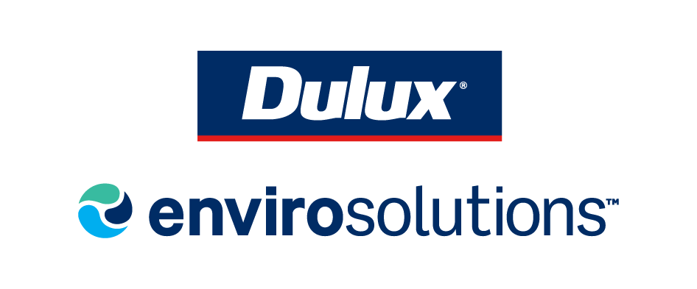

Certificate of Completion

Presented to:

Michael Francescano

This certificate means that the recipient has completed the relevant training and is able to participate in the Dulux Envirosolutions Recovery Program. The program is an Australian Government Accredited Product Stewardship Scheme.

Completion Date:

27 February 2025


