December 15, 2025
Dear Oklahoma Lions!
Cowboy Cash is back again!
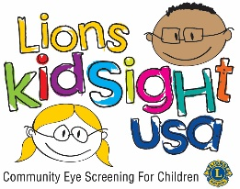


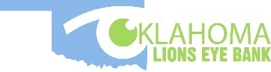
This is the Oklahoma Lions’ premiere fundraising event. It helps support Lions State Projects, the Ok Lions Eye Bank, the Ok Lions Boys Ranch “Meadows of Hope”, the Mobile Health Screening Unit, Eye Glass Recycling, and the KidSight Program!
We are proud to announce that the drawing will have a crowd at the Ok Lions State Convention. The event will be in conjunction with the Friday evening activities at the Ok State Convention. I am sure it will be a Cowboy Theme!

The drawing will be April 24, 2026, at 7:00 PM at the FISTA Event Center, 200 SW A Avenue, Lawton, Ok 73501. The Grand Prize winner will receive $10,000 Cash! In addition, the remaining two districts are guaranteed to win a 2nd place prize of $1000.00 Cash. We are also adding additional prizes per district of $500.00 each! So, this is truly a Cowboy Cash Fundraiser!

IMPORTANT! Tickets are $10.00 each and only 12 thousand will be sold! That gives each ticket holder a one in 12K chance of winning! These are very good odds!

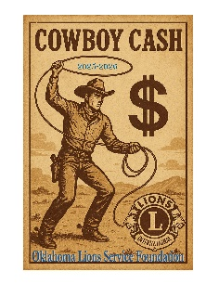
Please set a goal to collect $50 in donations per member at a minimum. $50 from each member in the state will help reach our goal to raise over $100K for Lions well deserving projects. REMEMBER Lions who sell $50 will also receive a 2025-2026 Cowboy Cash award pin.

Let’s BELIEVE BIG and remember this special event’s purpose is to bring awareness to the work Oklahoma State Lions Projects are doing. Lives are being changed everyday thanks to the dedication of Oklahoma Lions!

LIONS Cowboy Cash posters, tickets, and tracking forms are included in this packet. Please return ticket stubs and monies to the state office before April 20, 2026. Clubs can continue selling tickets through the drawing on Friday, April 24, 2026, if tickets are presented at the Convention prior to the drawing.
Important!!!! Please use the provided spreadsheets for your club’s tally for OLSF to distribute CC Pins after the fundraiser. These include the information we need to properly track sales and will help us to ensure proper credit for all the participants.

There has always been a limited number of tickets, however, this year we will not be able to send out additional tickets to clubs who have already been issued tickets until monies have been returned for the previous tickets issued. The odds are 12k and 1 for the grand prize, but the odds increase for the additional winnings to 1333 and 1 for a cash prize!

CLUB AWARDS
- 10% of club sales are awarded to each top selling club in the District.
- 15% of club sales are awarded to the TOP-SELLING CLUB in the state (per capita of club membership).

INDIVIDUAL AWARDS
- Special Recognition to Top-Selling Lion in the State and a special award.
- All individual sales will go toward a Louis Lackey Fellowship ($250) or Dr. Bob McCullough Fellowship ($500), and the Judge Edgar Vaught ($1000) Awards.
- These will be awarded at the end of the fiscal year based on a combination of individual contributions, Cowboy Cash ticket sales, and Building the Foundation contributions.
- 2026 LIONS Cowboy Cash Pin (new design) to each Lion with a minimum of $50 in ticket sales.

For those of you with email, or who use the internet, OLSF can send this information electronically as well or you can download it from www.oklionsfoundation.org.
OLSF wants to express our deepest gratitude to all the participants of the Cowboy Cash fundraising campaign. The work you do has a long-lasting affect that brings healing to those in need. This reward far exceeds any monetary or temporal reward! WE SERVE! Sincerely,

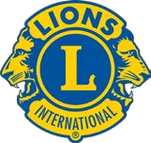
Diana Drummond
President, OLSF

