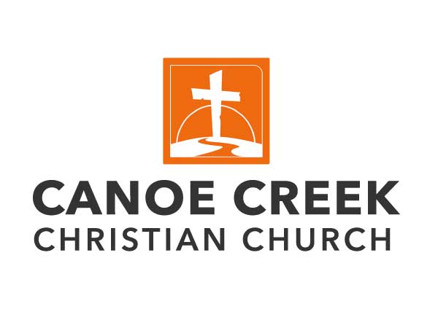
CONNECT – GROW – GO
4080 Pine Tree Drive / / Saint Cloud, FL 34772
407-891-1492 / / info@canoecreekchristian.org
Facilities Manager

Summary Description: We are seeking a dedicated and organized Facilities Manager to oversee the maintenance and operations of our church facilities. This position plays a crucial role in ensuring our church buildings are well-maintained, safe, and conducive to worship and community activities. The Facilities Manager will manage vendors, volunteer teams, provide event support, and accomplish various tasks for the smooth functioning of day-to-day operations.

Responsibilities:
- Coordinate and oversee the setup and takedown of facilities for church services, events, and programs.
- Maintain a schedule for regular maintenance for HVAC systems, plumbing, electrical, groundskeeping, and other buildings and grounds needs.
- Perform routine maintenance tasks, including plumbing, electrical work, HVAC system upkeep, and general repairs, to ensure the facility remains in optimal condition.
- Manage and supervise volunteer teams involved in maintenance, cleaning, and event setup.
- Ensure compliance with health and safety regulations and church policies regarding facility usage and maintenance.
- Oversee and manage all janitorial duties to ensure a clean, safe, and welcoming environment including routine cleaning, maintenance, and upkeep of church facilities.
- Respond promptly to facility maintenance issues and emergencies as they arise.
- Manage inventory and ordering of supplies necessary for building maintenance and event setup.
- Develop and maintain relationships with contractors and vendors for specialized maintenance and repair needs.
- Assist in the planning and execution of facility improvement projects as needed.
- Prepare and manage the facilities budget, ensuring cost-effective management of resources.
- Maintain accurate records of maintenance and repair activities.

Qualifications:
- Proven experience in facilities management, preferably in a church or similar nonprofit environment.
- Strong organizational and leadership skills with the ability to manage and motivate volunteer teams effectively.
- Have general and growing knowledge of building systems and maintenance procedures, including HVAC, plumbing, and electrical systems. (Basic maintenance skills and general repair work will be required.)
- Ability to prioritize tasks and manage time efficiently in a dynamic environment.
- Excellent communication skills, both verbal, written and electronic, with the ability to interact effectively with staff, volunteers, and contractors.
- Understanding of health and safety regulations and best practices in facility management.
- Proficiency in basic computer applications (e.g., Microsoft Office suite, email, management software, internet).

Working Conditions:
- This is a full-time position approximately 40+ hours per week, with flexibility required for evening and weekend work based on event schedules and emergencies.
- The role involves physical activities such as lifting, carrying, and moving equipment and supplies.

Benefits:
- Competitive compensation based on experience and qualifications.
- Health Benefits
- 2 Weeks of paid vacation
- Opportunities for professional development and growth within a supportive community environment.

This job description is not meant to be an all-inclusive statement of every duty and responsibility that will be required of an employee in this position. Therefore, additional duties may be assigned.

Send cover letter, resume and references to Doug Johnson (Executive Pastor) – dj@canoecreekchristian.org

