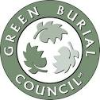
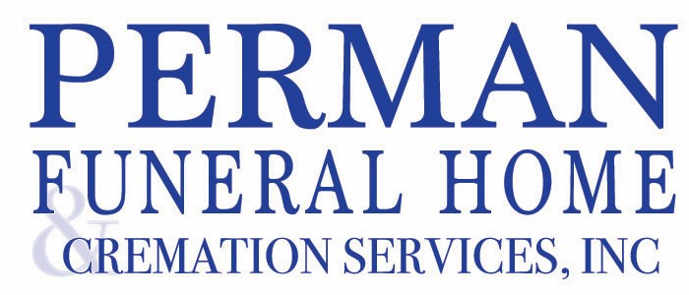

923 Saxonburg Boulevard Pittsburgh Pennsylvania 15223 412-486-3600

GREEN BURIAL PRICE LIST

Effective October 1, 2024

Perman Funeral Home and Cremation Services, Inc. meets the criteria for providing green funeral service and is certified by the Green Burial Council; a tax-exempt, nonprofit organization working to encourage environmental sustainability in the field of funeral service. Our Green Burial packages allow for a funeral to take place by using non-toxic and biodegradable materials and processes. Those packages may include our services for body preparation, storage, transportation, and the filling out of all necessary documentation, permits and certificates. A burial container, which can be either a biodegradable casket or burial shroud, is available at an additional cost.

Simple Green Burial $2495

- Professional Services of the Funeral Director and staff
- Local transportation of your loved one to our facilities
- Arrangement consultation
- Completion of all required documents
- Preparation and/or refrigeration of your loved one
- Local transportation to cemetery
- Online obituary tribute with access to online guest book

Simple Green Burial with Final Goodbye $2895
Same as the Simple Green Burial with the following added:
- Preparation of deceased for Final Goodbye
- Final Goodbye at our facility with up to 10 immediate family members for up to 30 minutes

Simple Green Burial with Memorial Service $3095
Same as the Simple Green Burial with the following added:
- Memorial service at our facility or a local church or location
- Memorial Package-includes register book, memorial cards, and printed thank you notes with envelopes

Simple Green Burial with Final Goodbye and Memorial Service $3395
Same as the Simple Green Burial with the following added:
- Preparation of your loved one for Final Goodbye
- Final Goodbye at our facility with immediate family members for up to 30 minutes
- Memorial service at our facility or a local church or other location
- Memorial Package-includes register book, memorial cards, and printed thank you notes with envelopes

Green Burial with Visitation and a Same Day Services $5795
- Professional Services of the Funeral Director and staff
- Local transportation of your loved one to our facilities
- Arrangement consultation
- Completion of all required documents
- Non-Formaldehyde preparation of your loved one for public viewing. Autopsy and/or Organ Donation is extra.
- Online obituary tribute with access to online guest book
- Public visitation for up to 2 hours at the funeral home or home prior to Services
- Services at our facility or a local church or other location
- Necessary funeral procession vehicles
- Memorial Package-includes register book, memorial cards, and thank you notes with envelopes

Green Burial with a Full Day Visitation with Services the Following Day $6295
- Professional Services of the Funeral Director and staff
- Local transportation of your loved one to our facilities
- Arrangement consultation
- Completion of all required documents
- Non-Formaldehyde preparation of your loved one for public viewing. Autopsy and/or Organ Donation is extra.
- Online obituary tribute with access to online guest book
- Public visitation for up to 4 hours at the funeral home or home
- Services at our facility or a local church or location
- Necessary funeral procession vehicles
- Memorial Package-includes register book, memorial cards, and thank you notes with envelopes
Funeral merchandise is not included in any of these packages. That merchandise may be the Green Burial Casket or Burial Shroud. Due to changing inventory, a current Green Burial Merchandise Price List will be provided on request.
* Autopsies and/or Organ Donors require embalming for an additional charge of $700
Weekend Fee is $300 per day for Saturday or Sunday.

Other items may be selected and are not included in these packages such as:

- Cemetery Charges
- Church/Clergy Honoraria
- Newspaper Death Notices
- Certified Copies of the Death Certificate
- Funeral Luncheon
- Flowers
- Hairdresser
- Burial Clothing
- Cremation Urns, Keepsake Urns and Jewelry
- DNA Sampling and Banking
- Dove Release
- Balloon Release
- Musicians/Vocalist
- Memorial DVD
- Memorial Package-Prayer Cards, Register Book, Thank You Cards and Envelopes

Perman Funeral Home Payment Policy
To lose someone you love can be a devastating human experience that can seriously impact judgment. We believe in the importance of a meaningful celebration of a life lived. We will assist in arranging appropriate services to meet your individual needs.
It is important that arrangements be in keeping with a family's budget and wishes. It is also important to be realistic in respect to funeral expenditures.
Payment is due at time of arrangements.
To avoid any possibility of misunderstanding and for your convenience, we accept the following methods of payment:
Cash
Check
Visa
MasterCard
Discover
American Express
Irrevocable Assignment of a Verified Life Insurance Policy
Funeral Financing if Qualified
Advance Payment by a forwarding or receiving Funeral Home
Pre-Paid Advance Planning

Credit Cards will be charged a 3% processing fee. Life Insurance Assignments will occur a 4% fee of the benefit value of the policy.

