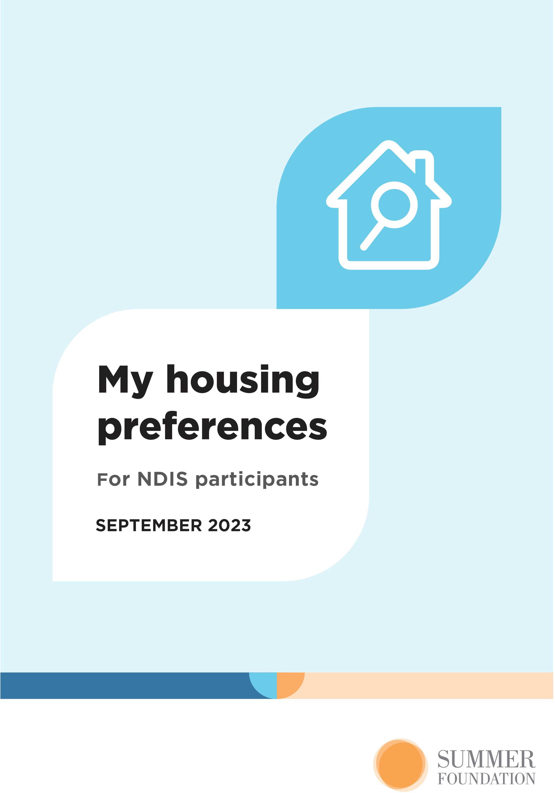

About this tool
This tool helps you think about where you want to live, who you would like to live with, and the type of housing that you would like to live in. You can use this tool to tell your housing story and work out your housing goals.
This tool provides links to digital stories that show people with complex needs living in different types of housing. Watching these may help you to think about what housing options might suit you.
If your NDIS plan includes capacity building funding to explore your housing options, the information you put in here will help when you talk to your support coordinator about your housing goals and preferences.
This is not a housing application form, but the information you put in here will assist you to look for suitable housing. You can cut and paste the information from this tool into housing application forms.

The tool is in 3 parts.
Part 1 explains housing and support under the NDIS.
Part 2 asks about you and your routine. It also asks about your housing history, needs and preferences. The information you write down will help your support coordinator choose the right allied health professionals to work with you to reach your housing goals.
Your support coordinator will also use this information and reports from allied health professionals to show the NDIS what supports are reasonable and necessary for you to live in the community.
Part 3 includes more detailed information about you and your long-term goals and aspirations. You don’t need to fill in this section if you have already gathered this information. Part 3 will be useful if you don’t already have all this information in one place, or your goals have changed.
As you work through this tool, only answer the questions that are important to you. You can also add in any extra information that you think is important.

Part 1: Housing and support under the NDIS
The NDIS provides funding for reasonable and necessary support to people with a disability to reach their goals and live an ordinary life.
For most people, ‘an ordinary life’ means leaving their parents’ family home as a young adult and either living on their own, in a shared house with friends, or with a partner. But without access to appropriate housing and support, many people with disability live with their parents later into adulthood, or live in a group home or residential aged care.
An important change that occurred with the rollout of the NDIS is that housing and support are considered separately. This gives NDIS participants more choice and control over where they live and the services they use.
The NDIS does not own or operate any housing, but the NDIS can provide capacity building funding to help people with disability to find housing that supports their independence. This funding is for allied health assessments, and to help you to build your capacity to live more independently. Your support coordinator will work with you to search for appropriate housing and write your housing plan, which will include evidence of:
- Your housing history, preferences, and goals
- Your search for housing
- The impact of your disability on your day-to-day functioning
- Any need you have for modifications to your home or specialist housing design features to support your independence
You can find out more about using NDIS funding to look for somewhere to live in our guide:
summerfoundation.org.au/resources/looking-for-somewhere-to-live

Using the information in your housing plan, the NDIS will make a decision about your reasonable and necessary supports related to housing. The NDIS may provide funding for home modifications or, for a small number of participants (around 6%), specialist disability accommodation (SDA) payments. SDA is housing that has been specially designed or modified to suit the needs of people who have an ‘extreme functional impairment’ or ‘very high support needs’. You can find out more about SDA payments in our guide:
summerfoundation.org.au/sda-payments-guide

Part 2: About me

Today’s date:

Name:

Address:

Date of birth:

Gender:

My disability:

My main source of income is:

  - Other things may be important when talking your housing needs.
For example: Do you currently live with your partner and/or children?
  - Are you Aboriginal or a Torres Strait Islander?
  - Do you have any cultural or religious practices that will need to be considered?

Other important information about me:

My identity impacts my housing preferences in the following ways:

  - For the questions below, double-click the YES or NO box and select ‘Ticked’ under ‘Default value’ in the window that appears.

I am an NDIS participant: Yes No

If ‘yes’,

Do you have capacity building funding
in your NDIS plan to explore your
housing options? Yes No

Do you have SDA in your NDIS plan? Yes No

If you have SDA in your plan, provide details (including SDA design category, building type, location, and whether you have been funded to live on your own or with others.)

My current work, hobbies and community involvement
Your housing plan should include a brief description of any paid or voluntary work that you do, or would like to do.
  - Do you do any of the following? If so, please tick the box, (double-click the box and select ‘Ticked’ under ‘Default value’ in the window that appears).
  - Write down where you do it in the ‘Location’ box and circle or indicate which days you regularly attend.
 | Location | Days
Paid work |  | M T W T F S S
Voluntary work |  | M T W T F S S
Study |  | M T W T F S S
Day program |  | M T W T F S S
Group program |  | M T W T F S S
Visit friends and family |  | M T W T F S S
Visit cafes/restaurant/pub |  | M T W T F S S
Go to the movies/bowling etc |  | M T W T F S S
Shopping |  | M T W T F S S
Gym/tai chi/training |  | M T W T F S S
Other (please list) |  | M T W T F S S
Other important information

Thinking about housing
If you’re currently living in an aged care facility or in hospital and can’t go home, thinking about where you would like to live may be really hard. The Summer Foundation has made digital stories about how some people with disability have chosen to live after leaving an aged care facility. Watching these stories is a good way to start thinking about your housing options:
summerfoundation.org.au/video-stories
Once you’ve watched these stories, take some time to think about what your perfect home would be like.
  - From the digital stories, what types of housing and support did you like?
  - Why? Were there any models of housing or support that you didn’t like? Why?
  - Include all these thoughts in your answers as you work through this Tool.

My housing preferences
Your housing needs and wants are important. The following questions will help your support coordinator to write a housing plan that clearly states your housing needs and wants.
  - Where would you like to live? Would you like to live near your school, workplace, or the local shops?
  - Is there a suburb(s), town(s) or municipality that you would like to live in?
  - For the questions below, please tick the box that applies, (double-click the box and select ‘Ticked’ under ‘Default value’ in the window that appears).

This is where I want to live:

I would like to live in:
 | Yes | No | Maybe
The inner city
Suburbs close to the city
The outer suburbs
A safe community that is easy to get around (good footpaths and safe places to cross busy roads)
A neighbourhood with a strong sense of community
A diverse neighbourhood with access to a range of different foods and cultures
A neighbourhood with people who have similar values and who are from the same culture as me.
Other (please list)
Other important information

It’s important that I live close to:
 | Yes | No | Maybe
Family
Friends
Community facilities (library, pool, community centre)
Accessible community services (library, pool, community centre)
Public transport
An accessible train station
An accessible bus stop
An accessible tram stop
A shopping centre
An accessible shopping centre
Medical facilities
Accessible medical facilities
Other (please list)
Other important information

I would like to live in these suburbs:
Suburb | Postcode | Why (for e.g. close to family, employment, study etc.)
1.
2.
3.
Other important information

  - Would you like to live by yourself, or with other people?
  - If you don’t want to live by yourself, who would you like to live with?

I would like to live:
 | Yes | No | Maybe
By myself
With my partner / children
With a family member (i.e. sibling or parent)
With friend/s
With a host family
With other people without a disability
With other people with a disability
In a home sharing arrangement
Other (please list)
Other important information

If I was to share with others, it’s important to me that I live with:
 | Yes | No | Maybe
One other person
2-4 other people
People my own age
Men
Women
A mix of genders
People I can communicate with
People I share interests with
Other (please list)
Other important information

  - What things do you want to be able to do in your home?
  - Would you like to have friends over?
  - Would you like to share your life with a partner and/or children?
  - Is having control over when and what you do important to you?
  - How do you like to express yourself?
  - Include all these thoughts in your answer below

My ideal home would allow me to:

  - The type of housing you live in can affect how much contact you have with other people. If you live close to other people, it’s important to respect their right to peace and quiet in their home.
  - Living in a house may give you access to a private garden, but houses are sometimes located a long way from community facilities. If you share a house with other people you may spend a lot of time with them, so it’s important that you get along together. You will usually share the kitchen and lounge area, and you may share a bathroom.
  - Living in a duplex, villa, or townhouse may also give you access to a small garden. While a duplex/villa/townhouse will have its own entry, they usually share walls with neighbours. You will have to obey the rules of the development.
  - Living in an apartment may mean that you don’t have access to a garden and that you live close to your neighbours. It’s important that you can get along with your neighbours and their visitors as you will be sharing areas such as hallways, lifts, entries, and the car park. You will have to obey rules of the development and take part in fire drills.
  - To live in a moveable unit or bungalow, you have to have a good relationship with the landowner and the other people who live on the property.

I would like to live in this type of housing:
 | Yes | No | Maybe
A house
A duplex/villa/townhouse
An apartment
A moveable unit or bungalow
Other (please list)

I would like to live in this housing arrangement:
 | Yes | No | Maybe
A group home/shared supported accommodation
A self-contained flat, sharing support with other people with disability living nearby
My own self-contained unit area within a larger development
A young person’s unit attached to a nursing home or hospital
A different residential aged care facility
A supported residential service (SRS)
A rooming house
Other (please list)
Other important information

I have trouble with the following
 | Yes | No | Maybe
Thinking before I act
Remembering what people tell me, which can lead to arguments
Understanding things from other people’s point of view
Controlling my anger
Other (please list)
Other important information

If you answered ‘Yes’ to any of the above, do you have a behaviour support plan that helps you manage these issues?
Yes No Not sure

My housing history
The following information will give your support coordinator a clear picture of your previous housing arrangements.
  - This information is sometimes talked about as your ‘housing career’. For each section, include the suburb/town and some details about the type of housing you lived in and who you lived with. Add extra sections if you need to.

I grew up in…

I moved to…

I have lived in the following housing arrangements…

Previous housing arrangements have ended because…

The housing arrangements that worked best for me were…

My current home
Your housing plan will need to include information about where you live now.
  - What suburb or town do you live in now?
  - What sort of housing do you live in?
  - Does your current housing have any special features that support you?

I currently live:

  - What do you like most about your current housing?
  - What features of your current housing would you like to keep the same (safety, accessibility, comfort, independence etc.)?

The best things about my current home are:

  - What things about your current housing aren’t working very well? Write these down to discuss with your support coordinator.

The things that I would like to change about my current housing:

  - What do you like most about your neighbourhood?
  - What things in your neighbourhood are important to you (community, environment, neighbours, services, shops etc.)?
  - What things do you like living close to?

The best things about my neighbourhood are:

  - Are there things you don’t like about your neighbourhood?
  - Are there places you like or need to go to that are difficult to get to from your current home?
  - Write these things down to talk about with your support coordinator.

I am limited by the location of my current housing because:

  - Is it important for you to move from your current housing?

I need to move because:

  - Do you feel unsafe in your current housing?
  - Are there any things that you haven’t already written about that your support coordinator should know about?

My current housing puts me at risk of the following:

My search for mainstream housing options
You should start your housing search by looking at housing options that are available to everyone (mainstream housing) – including renting privately and community/social housing. Your support coordinator can help you look for mainstream and/or existing housing options.
Can you live in a mainstream or existing housing option?
Yes No Maybe
If no, explain why:

If yes or maybe, your support coordinator should help you to search for mainstream housing and existing housing for people with disability. Your housing plan should include evidence of this search and the outcome. Have you looked into:
This housing type has been explored and is suitable/not suitable for the following reason…
Public housing
Community/social housing
Cooperative housing
Purpose-built specialist housing
An existing group home
Private rental
Home sharing
Shared equity
A moveable unit or bungalow
Other (please list)
Outcome:

If you have any paperwork related to your search for housing, please make sure you include or attach it.

My independence
Your support coordinator and allied health professionals will use the information below to write a skill development plan, which is a plan to help you to be more independent (do more things on your own).
  - Do you need help with personal hygiene or toileting?
  - Or bathing and dressing?
  - Or meal preparation, eating and/or taking your medication?
  - Write the things you need help with every day here.

Things I need help with every day:

  - Do you need help with shopping, housework or home maintenance?
  - Do you need help working out your money or paying your bills?
  - Or with decisions, or planning your activities?

Things I need help with occasionally:

The things I would like to do more independently are:

The way I would like to be supported is:
This support model would/would not be suitable for me for the following reason
Support staff working in my home on their own roster (in-home support)
Support staff working from an office in the housing development and coming to my home at agreed times or if I call unexpectedly (onsite support)
Support staff only coming to my home at agreed times (offsite support)
Other (please list)
Other important information

Think about the equipment you currently use to make you more independent.

I use this equipment to be more independent:

Communication
 | I currently use | I don’t use, but would benefit from | Not sure | I don’t need
Specialised vision/hearing devices
Hearing aids and accessories
Desktop electronic magnification
Telescopes
Daisy player
Video magnifier (optical, handheld)
OCR reading machine
Computer or tablet (laptop, iPad)
Devices/software; refreshable electronic braille display; multipage communication books
Electronic voice/voice prostheses, voice amplification
Speech generating devices (communication devices that provide you with a voice)
Other (please list)
Other important information

Mobility
 | I currently use | I don’t use but would benefit from | Not sure | I don’t need
Walking stick, crutch, wheeled walker
Handrails
Slip resistant coatings
Portable ramps
Fixed ramps
Specialised stroller
Mobility scooter
Assistance animal
Manual wheelchair
Powered wheelchair
Other (please list)
Other important information

Transfer and movement equipment
 | I currently use | I don’t use but would benefit from | Not sure | I don’t need
Grab rails
Slide sheet
Slide board
Swivel disc
Transfer belts
Monkey bar
Transfer bench
Mobile hoist
Ceiling hoist and sling
Other (please list)
Other important information

Bathing and toileting
 | I currently use | I don’t use but would benefit from | Not sure | I don’t need
Hand-shower and diverter
Individualised shower commode
Shower screen removed
Bath seat
Transfer bench
Bath lift
Over-toilet frame
Static commode
Bidet attached to toilet
Other (please list)
Other important information

Bedroom
 | I currently use | I don’t use but would benefit from | Not sure | I don’t need
Bedrails
Adjustable bed
A specialist mattress
Complex pressure care management
Other (please list)
Other important information

Personal care and safety
 | I currently use | I don’t use but would benefit from | Not sure | I don’t need
Specialised seating
Adaptive seating and positioning system for complex posture
Respiratory devices
Simple environmental control unit (ECU)
Medium complexity environmental control unit (ECU)
Personal alarm
Activity monitoring devices
Other (please list)
Other important information

Specialist housing features to support my independence
Specialist housing design features may assist you to be more independent.
From the lists below, please indicate which housing design features would assist you to maximise your independence.

Improved livability
 | I currently use | I don’t use but would benefit from | Not sure | I don’t need
Internal finishes that clearly identify doorways, stairs and ramps etc. to assist people with vision impairment to move safely around their home
Other important information

Robust
 | I currently use | I don’t use but would benefit from | Not sure | I don’t need
High impact wall linings
High impact fittings and fixtures
Secure windows
Secure internal and doors
Sound proofing
Laminated glass
Safe space for support worker
Other (please list)
Other important information

Fully accessible
 | I currently use | I don’t use but would benefit from | Not sure | I don’t need
Accessible external doors and outdoor areas – for me this means:

Accessible bathroom and vanity – for me this means:

Accessible kitchen sink – for me this means:

Accessible cooktop – for me this means:

Accessible meal preparation bench – for me this means:

Accessible key appliances – for me this means:

Power to doors and windows

Other (please list)

Other important information

High physical support
 | I currently use | I don’t use but would benefit from | Not sure | I don’t need
Everything listed in fully accessible, plus:
A ceiling hoist
Assistive technology – for example, operating heating and cooling, opening doors, blinds etc. by remote control
Emergency communication system
Wide door openings to all rooms (950mm)
Emergency power back up for 2 hours
Other (please list)
Other important information

  - Everyone’s housing needs change over time.
  - Some people may need less housing related supports as their independence increases; others will need more supports as their disability progresses and/or they age.

I expect the following changes in my housing needs over the next 5 years:

My transition to new housing
Moving house means that you may have to do some things differently. Think about the changes there may be to your day-to-day routine. If any of those changes might be difficult for you, think about what supports would help to make things easier.
  - When you move house, what changes will there be to the way you live?
  - Are there any things about moving that you are worried about?
  - Are there any things about life in your new home that you are worried about?
  - Are there things that you can do – or things that other people can do for you – that will make living in your new home easier?
  - For example, you might not have to worry about money at the moment, but you will have to be responsible for your money in your new house. If you’re not comfortable managing your own money, it may help if someone supports you with decisions about how you spend your money.
  - Think about all the things that may be difficult for you and write them down here to discuss with your support coordinator.

Moving to a new home may be difficult for me because:

To overcome these difficulties, I will need the following supports:

Part 3: More information about me
  - Your answers below will help people – such as your support coordinator, NDIA planner or a potential housing provider – get to know you and understand your long-term goals and aspirations.
  - What do you like to do?
  - What do you want to achieve in the next year?
  - What would you like your life to be like in 5 years time?
  - Include all these thoughts in your answers below.

My goals are:

My likes or interests are:

The thing(s) I would most like people to know about me are:

The most important things in my life are:

My favourite things are:

My informal supports
‘Informal supports’ are people who spend time with you, or help you to do things or go places, but don’t get paid for their help. Often these people are family or friends.
  - Who do you like to spend time with?
  - Who helps you at home?
  - What things do they help you with?
  - Does anyone help you with cooking, cleaning, showering or getting dressed?
  - Does anyone help you to read or understand difficult paperwork?
  - Does anyone help you when you’re away from home?
  - What things do they help you with?
  - If you have to go somewhere, does anyone help you?
  - Include all of these people in your answer below.

The following people and relationships are important
in my life:

My community connections
Think about the different roles that people have in their family and community. These roles keep us connected with others and give our lives meaning.
  - There may be roles listed below that you don’t have at the moment,
but would like to have at some stage in the future.
  - Add other roles that are meaningful to you.

The following roles in my family and community are important to me:
 | I have this role now | I would like this role
Partner (wife, husband, partner, girlfriend, or boyfriend)
Parent (mum or dad)
Student
Worker
Volunteer
Caregiver
Home maintainer
Friend
Family member (sibling, child, aunt, uncle, relative)
Artist or hobbyist
Member of a faith community (religion)
Member of an organisation or club
Leader (organiser, committee member, councillor, tutor)
Advocate (speaker, author, companion)
Other (please list)

Other important information

  - Do you currently do any paid or unpaid (voluntary) work?
  - Also think about any work that you would like to do in the future – this may be new work, or a change from your current work, or extra work that you would like to do.
  - Write these things down to discuss with your support coordinator.

I’m currently involved in the following paid or voluntary work:

I would like to be involved in the following paid or voluntary work:

  - Do you currently go to school, college, TAFE or university, or study online?
  - What hobbies or activities are you currently doing? (Include things you do in your home, as well as any hobbies or activity you may do away from home.)
  - There may also be some more study that would like to do in the future.
  - Write these things down to discuss with your support coordinator.

I’m currently involved in the following study:

I would like to study:

  - What hobbies or activities are you currently doing? (Include things you do in your home, as well as any hobbies or activity you may do away from home.)
  - There may be activities or hobbies that you are not currently doing but would like to try at some stage in the future.
  - Write these things down to discuss with your support coordinator.

My current hobbies/activities:

I would like to try the following hobbies/activities:

My goals and hopes for the future:

What is important to you about living in a community?
  - You may want to join a sporting club, attend local community resident meetings, or get to know your local shops and cafes. Think about your goals
for community living and write them down here.

These are my goals for community living:

Spend some time thinking about the things you look forward to or would like to do in the future.
  - We all have big things we hope to do at some stage in the future. Some people would like to get a particular job; some people would like to have a boyfriend or girlfriend or get married and/or have children; some people would like to be able to travel to a special place.
  - Write down the things you look forward to doing here.

These are my hopes for the future:

Summer Foundation Ltd, ABN 90 117 719 516
PO Box 108 Box Hill VIC 3128 Australia
P: 1300 626 560 E: info@summerfoundation.org.au www.summerfoundation.org.au

