Monroe County Fair Book

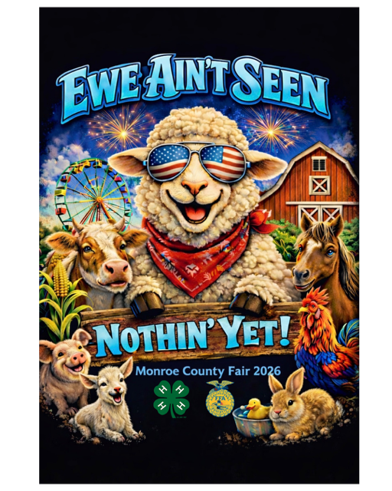

July 29 – August 3, 2026

MONROE COUNTY FAIR BOOK 2026

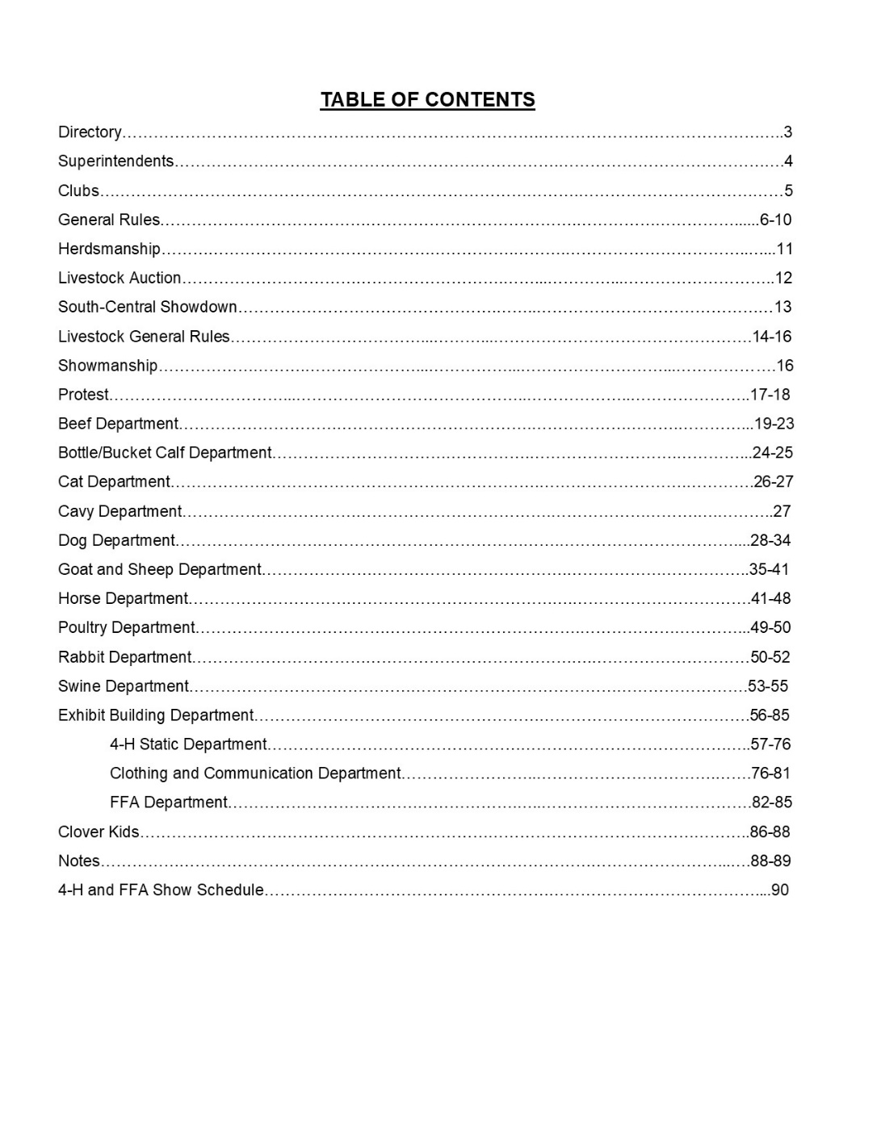
MONROE COUNTY FAIR BOARD MEMBER DIRECTORY
President - Justin Rozenboom (641)777-1061
Vice President – Chad Lathrop (641)777-6072
Secretary / Treasurer - Angela Wilson (641)777-2937
Co-Secretary/Treasurer – Billie Stout (641)629-0925
Fair Maintenance - Carl Kendall (641)799-6022, Chris Duncan

Board of Directors

Chelsea Bachman, Landon Rozenboom, Macey Lathrop, Carl Kendall, Jason Crall, Lisa Shepard, Mark Shepard, Tyson Patton, Nate Ammons, Blaine Stout, Jerry Findley

Association Members:
Kevin Wilson, Gene Beary, Chris Knowles, Curt Peterson, Denny Amoss, Carla Kendall-Duncan, Helen Kline-Lahart, Mary Helen Husmann, Kyle Bachman, Jim Koffman, Mark Jacobs, Denny Cason, Brian Crall, Cara Emanuel, Kenny Emanuel, Jeff Lathen, Jennifer Harter-Lathen, Stephanie Haywood, Mike Stocker, John Crall, Dean Lathrop, Michael Lathrop, Nathalie Lathrop, Jeff Bettis, Bryan Reed, Ron Clark, Mike Gray, Steve Kline, Jerry Durian, Sara Long, Sheryl Smith, Cory Smith, Kim Wynn, Dan Yule, Christine Crawford, Doug Wolfer, Matt Stocker, Kathy Stocker, Michael Fisher, Russ Vandenberg, Tonya Findley, John Knowles, Kenny Carr, Harlee Stout, Jennifer Landgrebe

MONROE COUNTY EXTENSION COUNCIL MEMBER DIRECTORY
Chair – Wendy Dyson (641)777-5292
Vice Chair – Jennifer Harter-Lathen (641)777-9407
Secretary – Kim Wynn (641)777-6757
Treasurer – Aandrea Beary (641)780-5188
Members:
Josh Simms, Jim Koffman, Jill Kosman, Christy Lautner, Maddi Tyrrel

EXTENSION OFFICE DIRECTORY
Courtney May - Region 25 Director
Maggie Hougland - Region 25 Youth Program Specialist
Amie Koffman - County Youth Coordinator
- Office Program Assistant
FFA CHAPTERS AND ADVISORS’ DIRECTORY
Agri-Power FFA Chapter– Melissa Appel, Advisor
Albia FFA Chapter- Alicin Hindman, Advisor
Twin Cedars FFA Chapter– Jordan Moody, Advisor
Moravia FFA Chapter– Arianna Weilbrenner, Advisor
DEPARTMENT SUPERINTENDENTS

Beef Bucket Calf
Chair-Brian Crall 641-777-4290 Chair- Ally & Andrew Schnebly
Denny Cason, Joni Murphy 712-790-4906
Kenny Carr, John Crall
Cat
Chair- Suzie Smith 641-799-7711

Cavy Clothing & Communication
Chair– Marti McLain 641-777-8655 Chair- Jody Buckingham
Suzie Smith 515-669-0879

Exhibit Building
Dog Chair– Kim Wynn 641-777-6757
Chair– Marti McLain 641-777-8655 Kelcie Hindman, Cindy Cronin,
Tyler Havard Chelsea Bachman

Goat & Sheep Horse
Chair– Harlie Riley Chair– Christy Hoksbergen
641-799-6815 641-670-0969
Jim Koffman, Jill Kosman Emily Hunt, Deanna Keeton,
Chris Knowles, Carl Kendall Maddison Tyrrel
Rabbit
Poultry Chair– Suzie Smith 641-799-7711
Chair- Suzie Smith-641-799-7711 Loretta Brinegar
Loretta Brinegar

Swine
Chair– Dan Yule– 641-919-0125
Ryan Ammons, Adam Rozenboom,
Jeff Lathen, Dean Lathrop, Curt Houk

4-H Clubs
Bluff Creek Progressives
Dana McKim 641-799-5105
Brandi Manser
Boots & Blue Jeans
Jim Koffman, Jeff Lathen
641-777-8468

Dog Obedience Club
Tiffany and Tyler Havard,
Brandi Manser
641-895-0892
Food Club
Annie Tharp, Kris Knowles
641-799-6199

Hoof Beats of 4-H
Christy Hoksbergen
641-670-0969
Garden Beets
Courteney Riley
641-569-3506

Albia Troy Troopers
Kim Wynn, Chelsea Bachman.
Abbi Starcevic
641-777-6757
Melrose Majors
Kari Knowles, Steph Haywood, Jill Kosman,
641-799-7850

Youth Council
Kim Wynn, Chelsea Bachman, Jennie Stephens, Abbi Starcevic
641-777-6757
Choose Your Adventure
Amie Koffman
641-932-5612

Clover Clubs

Melrose Mini Majors
Lil’ Boots & Blue Jeans
Jennifer Harter, Amie Koffman
641-777-9407
Anna McGee,
Mallory Kromray
641-799-8790
Troy Mini Troopers
Kelcie Hindman
515-249-4746
Bluff Creek Minis
Jessica Manser
641-218-0156

GENERAL RULES
- Only 4-H members enrolled in a Monroe County 4-H Club or enrolled FFA Members are permitted to show at the Monroe County Fair
  - 4-Her’s who have completed 4th through 12th grade (or the equivalent) of the completed the school year 2025-2026, may exhibit at the county fair, providing they meet organization requirements.
  - 4-H re-enrollment for 4-H membership on the 4-H Online 2.0 program must be completed by February 1st of each year. Re-enrollment and/or enrollment is open each year on September 1 on the 4-H Online 2.0 web page at https://v2.4honline.com/.
  - FFA members must meet their own organization’s requirements for exhibiting beyond high school graduation.
- It is the intent that any assistance provided to youth while preparing for and during the Monroe County Fair is done with the intent to enhance the learning of the 4-H and/or FFA member.
- Livestock entries must be on the grounds and checked in during their specified times on Wednesday of fair.
- Bucket of Junk Challenge Class items must be at the Fairgrounds on Wednesday of fair.
- All 4-H exhibits will be entered and judged on Thursday of fair and housed in the Exhibit Building at the Monroe County Fairgrounds. FFA will be judged on Tuesday.
- The Department Superintendents, Iowa State University Extension and Outreach, FFA Chapters and/or Fair Board will not be responsible for loss, injury or liable for accidents.
- Premiums will be paid as follows: $4.00 for purple/lavender- $3.50 for blue- $2.50 for red- $1.50 for white. Exhibit building premiums will be paid upon presentation of designated form to the appropriate table area in the Exhibit Building upon conclusion judging by each individual 4-H exhibitor. FFA Exhibit Building Premiums will be paid upon completion of judging by the FFA Chapter Advisor’s. 4-H & FFA Livestock Exhibitor’s premiums will be paid on the Monday of Fair prior to the Livestock Auction at 4:00p.m. from the Fair Board Office Building. All premium funds not claimed during designated times at the fair will be made available at the Fair Board Office Building during times to be determined for all exhibitors’ convenience until August 31st. All funds not claimed by that date will be forfeited and returned to the Monroe County Fair Board. No premium funds will be mailed under any circumstances to any exhibitor.
- The department superintendents will enforce department rules as written in Fair book. If questions or complaints arise, the Protest Advisory Group consists of one appointed official from each listed group consisting of the Monroe County Extension Council, Monroe County Fair Board, and active FFA organizations. Each group will appoint a representative to serve in this capacity each year by June 1st. This person cannot be actively serving as a department superintendent or hold a chairperson or president office within their respective group. If in any case an issue would arise that would directly include or affect said representative that representative would excuse themselves by contacting the chairperson or president of their appropriate group. The Protest Advisory Group members’ names and contact information will be available in the Monroe County Extension Fair Office, the Monroe County Fair Board Office, and on the website for easy accessibility. No Fair event-related protest will be accepted in any other type of communication efforts.
- It is highly recommended that 4-H members present one presentation at a club meeting. It is mandatory that 4-H club members must attend at least six (6) club meetings, club activities or club service projects to participate in the county fair. Must be member club(s) activity enrolled in on 4-H online.
- All livestock stalls and pen areas are expected to be clean and presentable to the public for viewing at all times during fair exhibition. The final cleaning and emptying of your designated stall or pen area is YOUR responsibility on the final day of the fair prior to the Livestock Auction. Failure to comply or any reporting of neglect in this area will be an automatic forfeit of premium payment.
- All 4-H and FFA members, parents, leaders, and volunteers must conduct themselves in an appropriate manner, refraining from using foul language and inappropriate conversations around youth.
- No personal security systems of any kind will be allowed in any barns or buildings located on the fairgrounds.
- In no case will the Monroe County Fair Board be held responsible in any way for any loss, damage, bodily injury, or claim if defamation of character of any person, property, or article while on the fairgrounds. The Monroe County Fair Board and Volunteers will provide the safest environment possible during the county fair event. The Monroe County Fair Board will not make any type of monetary payment for claim of any such loss, damage, or injury.
- In consideration of the general public attending the Monroe County Fair the following pet policy has been put into place. Trained Service animal as currently defined under the ADA are the only ones allowed on the fairgrounds. Trained Service animals must be under owner’s control at all times and remain on a leash or harness. (This does not include comfort, therapy, or emotional support animals of any kind. Those must have prior approval from the Monroe County Fair Board.) Only animals entered in the 4-H & FFA Dog Show or Open Pet Show will be allowed the day of their respective show or special event as listed in the Fair Schedule. The animals are allowed to be on the grounds 1 hour before and 1 hour upon the conclusion of their respective show or special event. Pets are allowed in the camper area and must always be kept under owner’s control.
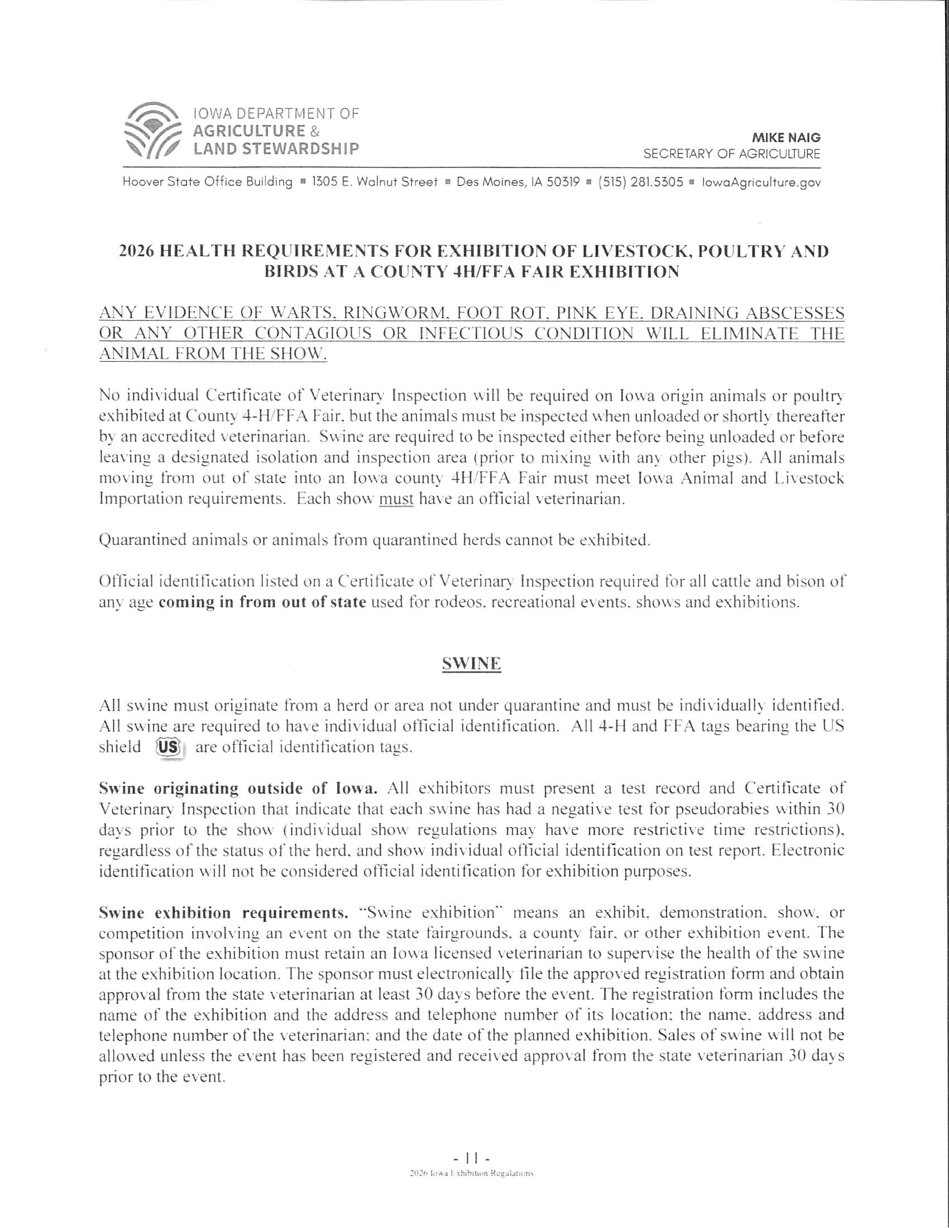

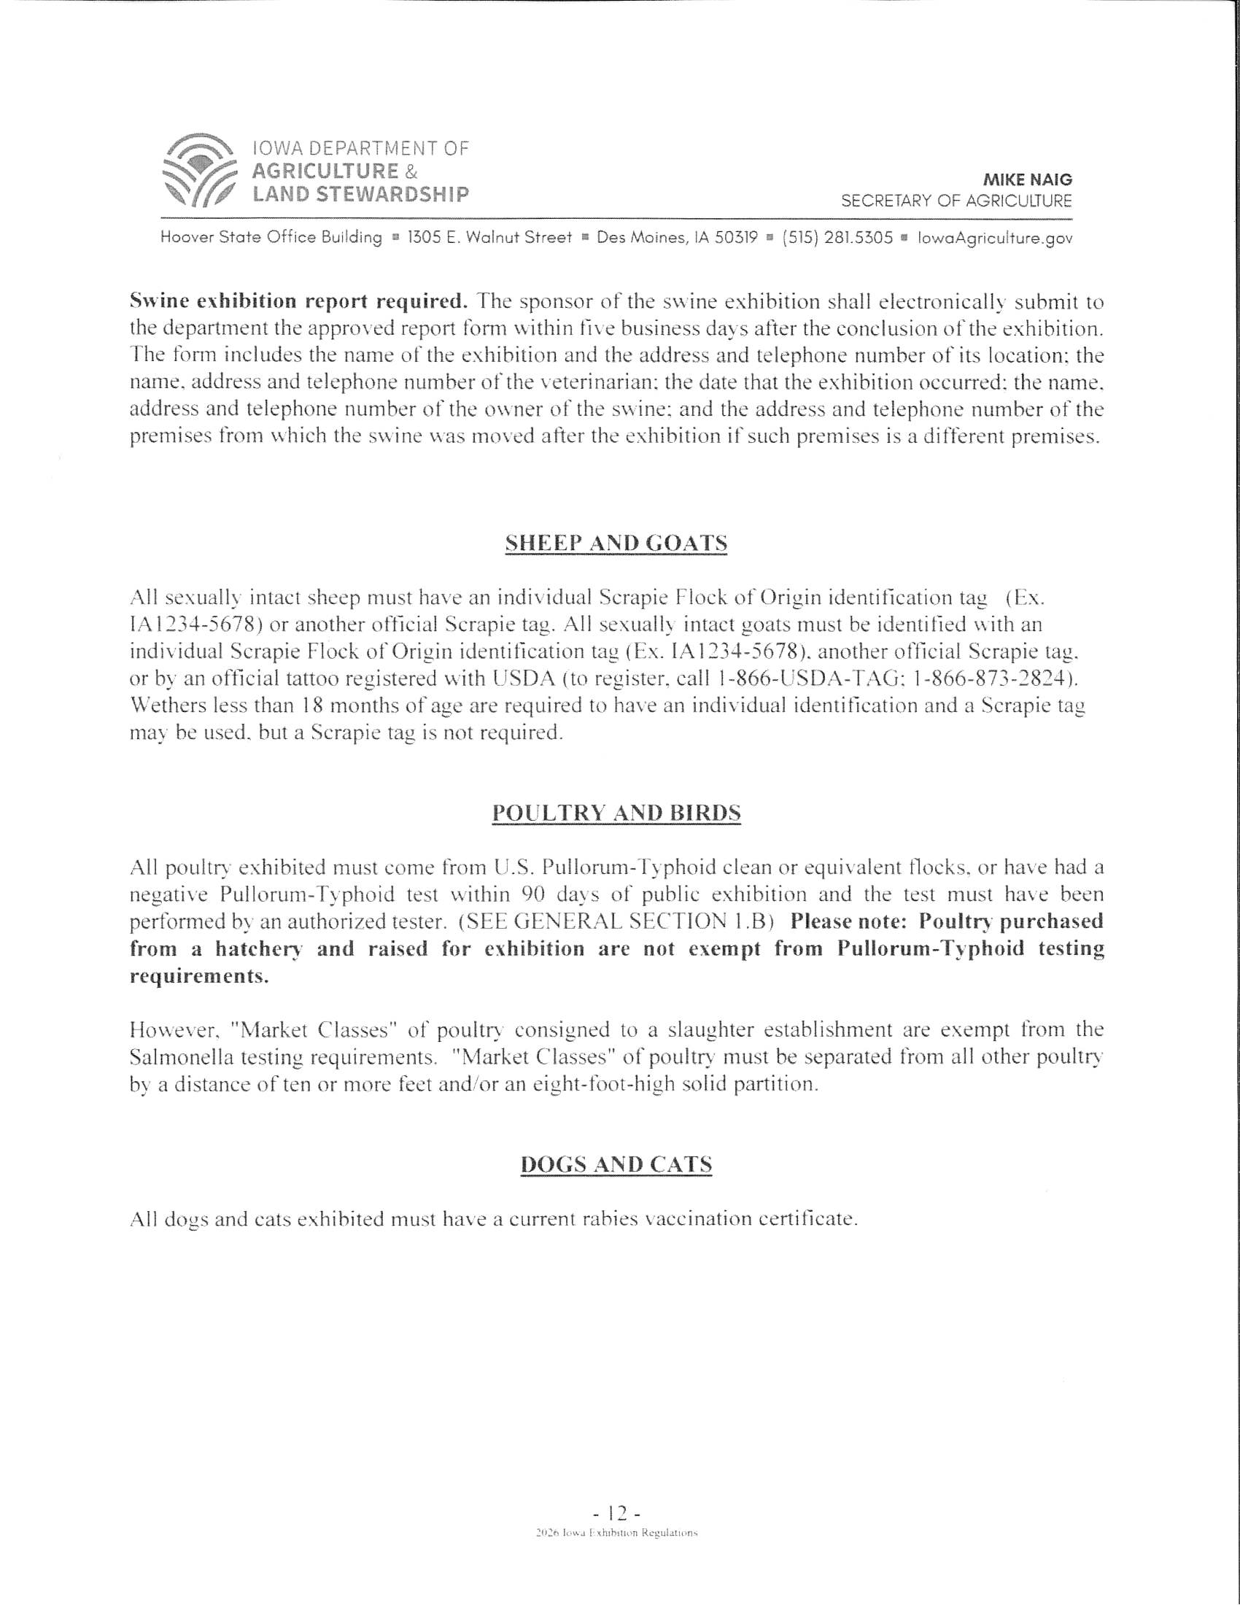
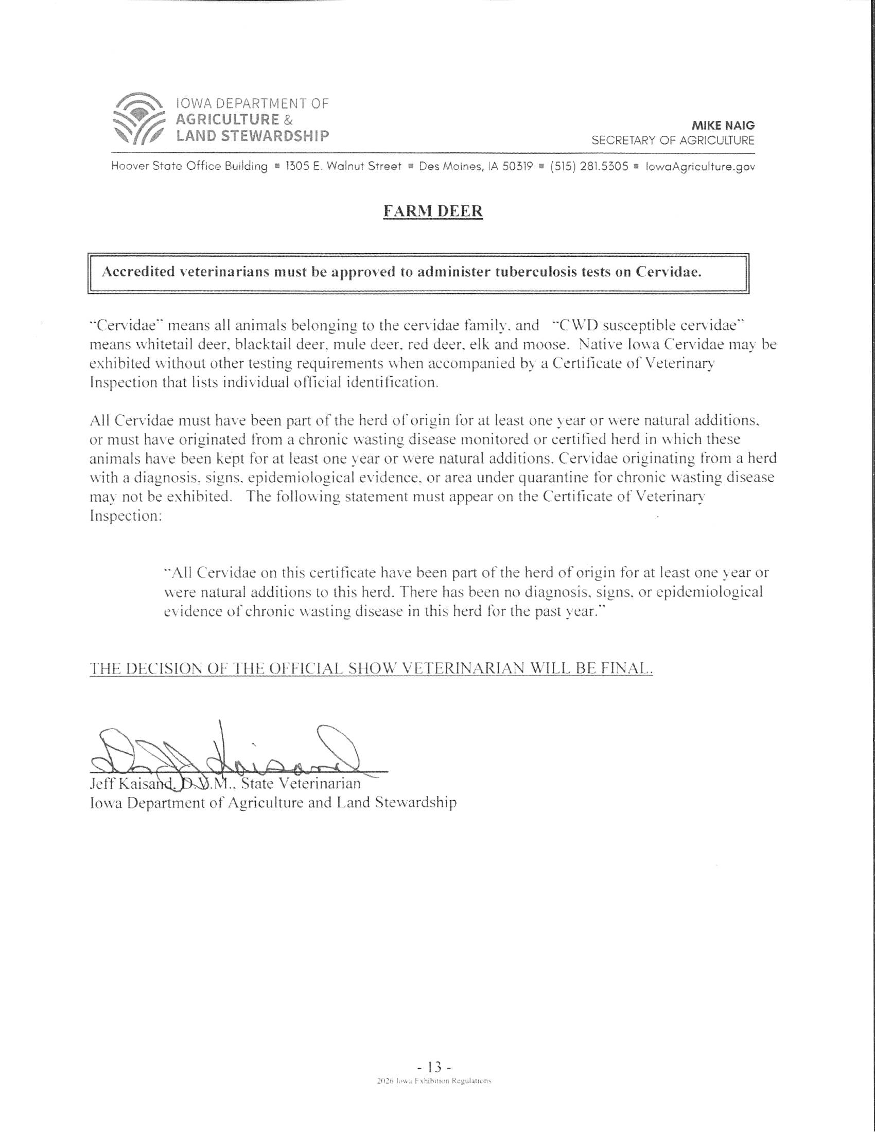

HERDSMANSHIP

A herdsman is someone who owns or tends to a herd of animals. Herdsman ship is the way one tends to the animal or herd. If you are an exhibitor of livestock at the county fair your herdsman ship skills become very important! While at the county fair your animal or animals will be exposed to all kinds of different stresses they may not experience at home. The crowds, noise, other livestock, inclement weather, change in stalls or pens can all sometimes make it hard for them to adjust. It is your responsibility to see that your animal or animals and barn stalling areas are always maintained to the highest of standards for the entire duration of the county fair.
Each 4-H Club & FFA Chapter will be judged daily between the hours of 7:00 p.m. and 9:00 p.m. by volunteers who will go through the barns and score based on aisle cleanliness, animal cleanliness, bedding cleanliness, pen or stall display, adequate lighting and signage, and attendant’s manners. There must be adequate arrangements made to ensure that representation is present during these hours. The Monroe County Fair Board will award and present the winning club or chapter a cash award of $100.00 along with an additional $200.00 at the beginning of the Livestock Auction on Monday of the fair.
It is the responsibility of each exhibitor to see that the care of their animal or animals are always maintained to the highest level during the county fair. If you require assistance, please discuss this with your 4-H Club Leader or FFA Advisor as they will be glad to help in any way. If you are approached by anyone that you are not familiar with during your fair exhibition it is important that you reach out immediately to your 4-H Club Leader, FFA Advisor, or any adult fair official. Working together with other exhibitors within your assigned stall or pen area is an important part of herdsmanship during fair exhibition to ensure that the welfare of all animals is top notch.
Make it your personal goal and maybe even the goal of your club or chapter to be an outstanding herdsman at home and during exhibition at all times. The county fair is your time to shine and how your animal or animals, pens and stalls look is a reflection on you, your family, and your club or chapter.

LIVESTOCK SALE
The Livestock Auction is conducted under the leadership of the Monroe County Fair Board and First Iowa State Bank, Albia, Iowa. Volunteers and staff will conduct the auction which will begin at 5:00 p.m. on the Monday of the fair. All financial matters will be conducted by the Monroe County Fair Board and First Iowa State Bank of Albia. No exhibitors will be paid directly by any buyer. All checks from buyers will be made out to Monroe County Fair Sale.
The order of the sale in 2026 will be as follows: Rabbits, Poultry, Sheep, Goats, Beef and Swine
A meal free of charge to all in attendance for the Livestock Auction will be available at the Fair Food Stand from 4:30 to 6:00 p.m. This grand effort is made possible by Wyffels Hybrid, Leighton Locker, Chariton Valley Electric Cooperative and the Monroe County Fair Board; served to by volunteers.
IMPORTANT INFORMATION: It is the responsibility of each exhibitor to ensure that their animal or animals that they wish to place in the sale are presented to the Monroe County Fair Board Office by the Sunday of the fair at 9:00 a.m. The Auction Commitment Form will need to be completed for each species to ensure that your sale entries are correct and accountable on the official sale bill and to be readily available to the buyers prior to the sale event. Volunteers will be available in the office to assist you with this anytime during the fair. Please do not wait until the last minute to complete this task. It is important to have you, and your animal or animals placed on the sale bill correctly so that adequate marketing can be presented to the buyers prior to the start of the auction event.
Once checks are available specific dates and times for distribution will be made public. Checks are expected to be picked up as soon as possible and properly cashed or deposited upon the exhibitor’s wishes to ensure timely closing of the auction books. It is suggested that a personal thank you and handshake to them in the crowd is a great way to start! It is also highly stressed that you send a personal written thank you note upon completion of the fair. The Monroe County Fair Board can help you obtain appropriate names and addresses if needed. The Monroe County Fair Board can also assist you with any sale documentation that you would need for your records.

SOUTH CENTRAL IOWA SHOWDOWN
2026


The Monroe County Extension and Outreach Employees are not your contact for this event and will not have any information available. Please contact a Monroe County Fair Board Officer for any, and all information.
Monroe County has been invited to send the following animals to the South-Central Iowa Showdown. Grand Champion Market Steer, Supreme Champion Heifer, Grand Champion Market Lamb, Grand Champion Breeding Ewe, Grand Champion Market Goat, Grand Champion Breeding Doe, Grand Champion Market Hog, and Grand Champion Breeding Gilt. This is completely optional and a choice that the selected exhibitor and family will make. If the Grand or Supreme animals chooses not to participate, the Reserve in that respective show will be asked. The Showdown in an Open Show and not in any way affiliated with 4-H or FFA.
Monroe County Fair Beef, Swine, Sheep, and Goat Department Superintendents in conjunction with the Monroe County Extension and Monroe County Fair Board grant permission for the animals selected and agreed upon by the South-Central Iowa Showdown Representatives to be released for exhibition. Exhibitors and families with specified animals only will be released to travel to the show destination. To help give the Monroe County exhibitors and their entries the best possible advantage animals can leave on Saturday of the fair starting at 4:00p.m. Trailers will be allowed to load during that time only and must leave immediately after. If exhibitor and their family would like to stay on the grounds until Sunday, they are welcome and can then load and leave any time after 5:00a.m. on the Sunday of the fair. There is no exception to this release statement. Market animals to be sold during the livestock auction must be back and stalled on the grounds by 7:00a.m. Monday of the fair. If selected animal is not being sold it is not required to return to the fairgrounds. Please see specific department rules for any further information regarding this exhibitor opportunity. If any exhibitor does not show at the South-Central Iowa Showdown after being released or does not follow the specific animal release and return protocol, they will be ineligible to exhibit at the next Monroe County Fair.
Information packets and special awards will be available from the show representative in cooperation with the Monroe County Fair Board upon completion of each livestock show eligible for the Showdown.
There will be a parade of Champions for all exhibitors representing Monroe County held on the Saturday of the fair for the public. More information will be available at fair time.
The Monroe County Fair board will host a watch party for those at the fair that cannot attend the Showdown. The event will be live streamed. More information will be available at fair time.

4-H and FFA Agricultural Livestock
Department

GENERAL LIVESTOCK RULES
Weigh In Dates
Market Beef: December 27, 2025, 8:30-10:30am
Swine: April 11, 2026, 9:00-11:00am
Sheep/Goat: May 8, 2026, 5:30-7:00pm

1. Animals identified as part of a 4-H project cannot also be identified or exhibited as an FFA project. Example Youth showing Breeding 4-H cannot show Breeding FFA. Youth can show Breeding 4-H and Market FFA.
Offspring in one program cannot be shown in the other program during that year.
2. ALL 4-H & FFA livestock must be entered during designated times on Wednesday, July 29th and remain until the livestock release time (10:00 a.m.) Monday, August 3rd. (With the exception of a mare and foal horse project for Sunday’s horse show and animals attending the South-Central Iowa Showdown). ALL ANIMALS MUST BE INSPECTED BEFORE UNLOADING BY THE FAIR VETERINARIAN.
3. All animals must be owned by May 15th.
4. Market beef must be weighed and identified on the weigh-in date that was held or another Iowa county approved weigh in and verified by February 1st on 4-H Online 2.0. and any identification requirements that need to be done for FFA. Breeding Beef heifers must be tagged, tattooed, and identified for fair on 4-H Online 2.0 by May 15th and any identification requirements that need to be done for FFA. Market lambs must have been weighed and identified on the weigh-in date that was held and identified on 4-H Online 2.0 or FFA identification requirements by May 15th. All goats must have been tagged and weighed on the weigh-in date and identified on 4-H Online 2.0 or FFA identification requirements by May 15th. Swine must have been weighed and identified on the weigh-in date. ALL 4-H Animal Identification must be done online at 4-H Online 2.0 and must be completed by May 15th https://v2.4honline.com/. No Exceptions! Help sheets for Identification can be found at https://www.extension.iastate.edu/4h/.
5. All animals must use current Monroe County approved tags.
6. All animals must be entered on FairEntry.
7. Ownership Requirements: All animals must be identified by an individual 4-H member. When registration papers are involved, the papers must be in the 4-H member’s name or show a logical family relationship.
8. A Monroe County 4-H or FFA member enrolled in a livestock project must own the project, or in partnership with a family member. The member must assume primary management of the project after weigh-in. Livestock needs to be weighed and tagged in Monroe County; unless they are weighed and tagged at a state fair weigh-in held out of county. If the exhibitor cannot make it on weigh-in date they need to make, arrangements ahead of time with the Extension Office, see department rules for specifics.
9. An exhibitor may not make more than two entries in any one class, except beef, rabbits, pets, swine, sheep, and poultry projects. Bucket calf and bucket calf plus one-year where three may be identified but only one bucket calf and/or one bucket calf plus one-year may be exhibited at Fair. Please see individual livestock rules for limitations.
10. All animals must comply with the Health Rules and Regulations of the State Department of Agriculture as listed in requirements. Any animal not meeting the above stated rules will not be allowed to show. The official Fair Veterinarian decision is final.
11. Only bona-fide market projects which are shown in the show ring are eligible to be sold at the livestock sale, this will also include carcass calves. Exceptions will be decided by the department Superintendents such as Carcass Beef. Animals offered for sale in an auction are considered to have changed ownership even if bought back by the original owner, given back by buyer or if the owner refuses a bid or says, “No Sale!” All animals offered for sale are terminated as 4-H/FFA projects.
12. All animals must be shown by a 4-H or FFA member actively involved in Monroe County programs. If exhibitor has more than one animal in a class, the exhibitor will be responsible for having someone to show other animals BEFORE the show begins.
13. Any animal shown in a purebred class may not be shown again in a market class and vice versa unless superseded by specific department rules.
14. The superintendent of each barn shall have the right to change stall assignment if needed. If there is an issue, see barn superintendents.
15. All FFA animal identification paperwork must follow any identification rules set by Iowa FFA, FFA entries need to be turned into the respective FFA chapter advisor and the Extension Office on May 15th.
16. The responsibility for grooming animals for show is primarily the responsibility of the exhibitor. See Department for specific rules.
17. Drenching is not allowed on any species.
18. All livestock are expected to remain in their stalls or pens from 6:00 p.m. to 9:00 p.m. every evening during the fair. This is for safety purposes and availability of livestock to be viewed by public. (The only exception will be to the livestock showing at the South-Central Iowa Showdown or the night before or following the show.)
19. Violations of the Rules and Regulations can result in the withholding of premium money, any, and all other awards, and the option of showing that species.
20. Show ring dress will be as follows: Exhibitors must wear a white blouse, shirt, or T-shirt (must have sleeves) with 4-H emblem or FFA shirt with emblem or approved county fair T-shirt and blue jeans unless excused by the superintendent. This dress code includes ALL Shows. It is required that fully enclosed footwear is worn during all livestock shows for the exhibitor’s safety.
21. ALL stalls must be kept clean at all times.
22. Exhibits will be awarded premiums based on purple, blue and red ribbons.
23. ALL exhibitors are to be certified with Youth for the Quality care of Animals (YQCA) program; 4-H certificates due by July 1st.
24. Livestock Trailers are not allowed to be left parked during the Monroe County Fair on the grounds and are for unloading and loading purposes only with the exception, of horse exhibitors where there is a designated area that is utilized for this purpose only. There is no designated trailer parking on the grounds for the duration of the fair for any other livestock species exhibitors. Specific rules can be found with more information regarding Beef & Horse Show Events in those department rules within this publication. This is to ensure adequate parking for the fairgoers attending other events on the grounds, at all, times. Trailer parking is available across the road at the old sale barn.

General Showmanship Rules
Junior 1st Year Showman- 1st year showing specific species- 4th graders only eligible 2025-2026 school year.
Junior Showman- 5th and 6th grade 2025-2026 school year.
Intermediate Showman- 7th and 8th grade 2025-2026 school year.
Senior Showman- 9th, 10th, 11th, and 12th grade 2025-2026 school year.

Any 4-H/FFA member who wins Senior Showmanship can immediately advance to Supreme Showmanship. Supreme Showmanship is open to enter and/or win multiple years which includes out of school FFA Members.
1. An exhibitor must show their own animal.
Special exception to this rule would be if member had a project identified and was unable to bring to the fair, they could then show:

1st Option – A sibling’s project or
2nd Option – If there is not a sibling, then another 4-H or FFA member’s project in respective species.

2. Showmanship classes can only be won once in an age division. Winners will advance to the next division the following year, except for Supreme Showman, where Senior Showman winner may advance to show in Supreme in the same year. Once an exhibitor wins a showmanship class, he/she is required to move to the next level regardless of age.
3. An Exhibitor may choose not to enter Showmanship, but it is highly suggested that they do as it is a good educational class and challenges your knowledge of your livestock project.
PROTESTS
Protests 4-H & FFA Livestock Shows Only
- All Fair Related Protests must be presented on a written form available for easy accessibility from the Monroe County Extension Fair Office, the Monroe County Fair Board Office, or by web access at www.monroecountyiafair. Forms must be completed in their entirety and signed and dated. The protest form must be completed and on file in the Monroe County Extension Fair Office or Fair Board Office by 10:00 p.m. on the respective day of the protest issue. THERE WILL BE NO EXCEPTIONS TO THIS SET TIMELINE. This includes Pre-Fair Weigh-in/Identification events and the complete Exhibitor Fair Schedule beginning with Fair Clean Up Day and ending with Fair Auction Day each year. A protest will not be considered based upon a statement that a judge made or questioning the competency of any judge. A $100.00 cash deposit must be accompanied with the protest form upon filing of the document at the Monroe County Extension Fair Office or Fair Board Office. The deposit will be forfeited if the protest is pursued but not founded. In an incident where the protest is pursued and founded, the deposit will be returned to the individual representing the protest. Protest forms will be presented to the Protest Advisory Group as outlined in the General Rules and read as follows:
8. The department superintendents will enforce department rules as written in Fair book. If questions or complaints arise, the Protest Advisory Group consists of one appointed official from each listed group consisting of the Monroe County Extension Council, Monroe County Fair Board, and active FFA organizations. Each group will appoint a representative to serve in this capacity each year by June 1st. This person cannot be actively serving as a department superintendent or hold a chairperson or president office within their respective group. If in any case an issue would arise that would directly include or affect said representative that representative would excuse themselves by contacting the chairperson or president of their appropriate group. The Protest Advisory Group members’ names and contact information will be available in the Monroe County Extension Fair Office, the Monroe County Fair Board Office, and on the website for easy accessibility. No Fair event-related protest will be accepted in any other type of communication efforts.

4-H Static Exhibit, Clothing, Communication Protests – 4-H Staff directly
FFA Exhibit Protests – FFA Advisors directly
Open Class Protests – Monroe County Fair Board President

PUBLIC PROTESTS

Protests are allowed on the grounds during the advertised days of the Monroe County Fair. Protests are allowed during the hours of 3:00a.m.—5:00a.m in the southeast corner of the grandstand arena only. All Violators of this rule will be subject to the Monroe County Law Enforcement Center.

MONROE COUNTY FAIR PROTEST FORM

Name__________________________________________________________
Date____________________________
Please state below the specific action, rule or incident to be brought before the Superintendent Advisory Committee. Please be specific on situation and provide documentation if necessary.
__________________________________________________________________________________________________________________________________________________________________________________________________________________________________________________________________________________________________________________________________________________________________________________________________________________________________________________________________________________________________________________________________________________________________________________________________________________________________________________________________________________________________________________________________________________________________________________________________________________________________________________________________________________________________________________
Signature of Person Completing Form_____________________________________________________
Date________________ Phone Number__________________________
Signature of Person Accepting Form & Deposit______________________________________________
BEEF DEPARTMENT
Superintendents
Brian Crall – Chair
Denny Cason, John Crall,
Joni Murphy, Kenny Carr

BEEF DEPARTMENT RULES
1.A Monroe County 4-H or FFA members enrolled in a livestock project must own the project or be in partnership with a family member.
a. The member must assume primary management of the project after weigh-in.
b. Market Beef are required to attend scheduled weigh-in date to show at the Monroe County fair unless previous arrangements have been made with the beef superintendents and Extension Office or FFA Advisor. Must use Monroe County tags from the Extension Office or FFA Advisor. All beef must have 840 tag.
c. Registered Market Beef must have breed designated in 4-H online by February 1st.
2. Any loss of county or state 4-H tags needs to be reported and documented at the Monroe County Extension Office immediately. The Extension Office will then contact a beef superintendent to retag the animal. Only 2 beef superintendents and CYC can retag the animal. IF the animal was retinal scanned at weigh in, the animal will be re-scanned.
3. Any loss of county or state FFA tags needs to be reported and documented with the respective FFA chapter advisor and the Monroe County Extension Office immediately. A beef superintendent needs to be contacted to retag the animal. Only 2 beef superintendents and FFA advisor can retag the animal.
4. The use of butt fans will be prohibited in the Beef Department. All fans must have a protective screen and safe wiring. Only overhead fans located in the front half of the stalling area will be allowed.
5. If room allows - one chute per family will be allowed on show day only across from livestock. Livestock on one side - grooming supplies and chutes on the other side. Final decision made at entry time.
6. Livestock trailers will be allowed in a designated area for the Beef Show Day only. Trailers may come to the designated area any time after 10:00 p.m. Friday, of fair, and must be removed by 5:00 pm Saturday, of fair. Superintendents will have specific instructions.
7. The use of artificial tail fins or the addition of any hair or hair-like substance to the animal's body excluding false tails will not be permitted.
8. Information on weight, rate of gain, the birth date of animals, or other appropriate information will be furnished to the judge if desired.
9. Beef Show Order will be posted on Friday, of fair by 5:00 p.m.
10. First and second place individuals are to be shown for champion and reserve champion, respectively. First and second place individuals in their class are to be shown for top five overall.
11. All beef exhibits will be placed in blue and red ribbon groups with the exceptional quality given a purple ribbon. Exhibits will be awarded premiums based on purple, blue and red ribbons.
12. The beef superintendents, ISU Extension and Outreach, FFA, and/or fair board will not be responsible for loss, injury, or liable for accidents.
13. Porta coolers will be allowed during fair, contact Superintendent so stalling arrangements can be made.

BEEF SHOWMANSHIP
See more Showmanship rules in the front pages of the book.
BREEDING BEEF
Registered – Commercial
1. Breeding heifer classes will be offered for registered and commercial with no preference to class size. If an exhibitor does not want the heifer to be in the registered class, they may go to their own weight group for the commercial show. A copy of the registration papers must be brought to the Extension Office on or before July FairEntry due date to exhibit in a registered class at the fair. No digital registration papers will be accepted.
2. Registered heifers will be classed by birthdate.
3. Commercial heifers will be classed by weight.
4. To show at the Monroe County Fair ALL breeding heifers, both purebred and commercial, must have two methods of identification. Acceptable identifications are:
Tattoo (required for ALL heifers, both purebred and commercial) and
An EID Button Tag
A 4-H or FFA EID tag from Extension Office or FFA Advisor

These identifiers MUST have been entered on 4-H Online 2.0 webpage https://v2.4honline.com/ by May 15th or as FFA requires identification paperwork to be done.

NO FRESH TATTOOS WILL BE ALLOWED.

6. Tattoos, EID or 4-H or FFA tags and registration papers will be read and verified at the fair weigh-in.
7. A County Born Champion will be selected for the breeding heifers. County born is interpreted to mean the calf must be born in Monroe County.

Lot 80A –Commercial Breeding Heifer- Born on or between September 1, 2024, and December 31, 2025
Lot 80B- Registered Breeding Heifer (shown by breed)- Born on or between September 1, 2024, and December 31, 2025

UNHALTERED COW-CALF CLASS
1. The member must get a tag for the calf and cow-calf card from the Extension Office or FFA Advisor. The member is then required to return the cow-calf card to the Extension Office and ID their cow-calf projects on 4-H Online 2.0 by May 15th or as FFA requires identification to be done.
2. If the calf is not born by May 15th, the cow must be identified online. The calf must be born, tagged, and identified by the time of the fair.
3. Although the livestock does not have to be haltered, they should be gentled down. Animals will be kept in the cow-calf barn or pens will be made to accommodate stalling. They will be judged from the barn, and the calves do need to be weighed in on Wednesday, of fair weigh-in.
4. They will show in their own class and will not show for Supreme Champion Breeding Beef.
Lot 81A – Un-haltered Cow-Calf, 1st Calf Heifer- Cow with calf born in 2026
Lot 81B - Un-haltered Cow-Calf, Mature Cow- Cow with calf born in 2026

HALTERED COW-CALF
1. The exhibitor must get a tag for the calf and cow-calf card from the Extension Office or FFA Advisor. The member is then required to return the cow-calf card to the Extension Office and ID their cow-calf projects on 4-H Online 2.0 by May 15th or as FFA requires identification to be done.
2. If the calf is not born by May 15th, the cow must be identified online. The calf must be born, tagged, and identified by the time of the fair.
3. The calf is to be weighed in on Wednesday, of fair weigh-in. The project will be stalled with the exhibitor’s other haltered beef animals.
4. They will not show for Supreme Champion Breeding Beef

Lot 82A – Haltered Cow-Calf, 1st Calf Heifer - Cow with calf born in 2026
Lot 82B – Haltered Cow-Calf, Mature Cow - Cow with calf born in 2026

PRODUCE OF DAM
1. The exhibitor must get a tag for 2026 calf and cow-calf card from the Extension Office or FFA Advisor. The member is then required to return the cow-calf card to the Extension Office and ID their cow, 2025 calf, and 2026 calf on 4-H Online 2.0 by May 15th or as FFA requires identification to be done.
2. If the 2026 calf is not born by May 15th, the cow and 2025 calf must be identified online. The 2026 calf must have been born, tagged, and identified by the time of fair. The 2025 calf must be identified on 4-H Online 2.0 by May 15th or as FFA requires identification to be done.
3. The calves are to be weighed in on Wednesday, of fair weigh-in. The project will be stalled with the exhibitor’s other haltered beef animals.
Lot 83 – Produce of Dam-Cow with 2025 calf and 2026 calf.
MARKET BEEF
Heifers – Steers
1. Market Beef are required to attend scheduled weigh-in date to show at the Monroe County Fair unless previous arrangements have been made with beef superintendents and Extension Office or FFA advisor. NO EXCEPTIONS!
2. All Market Beef selling at fair auction will be sold using their weight at the weigh-in on Wednesday of fair, for their sale weight. They will not be re-weighed before the auction.
3. Market beef projects must be born in 2025 to be exhibited.
4. Market Beef will be exhibited by weight groups. Superintendents will divide classes according to weights at the fair weigh-in.
5. For market steers to qualify for a purple or blue ribbon, they must gain 2.2 pounds or more daily from the December weigh-in until county fair weigh-in. Steers not gaining 2.2 pounds will not receive more than a red ribbon but will show with respective weight class. The number of classes will be determined by the superintendents.
6. For market heifers to qualify for a purple or blue ribbon, they must gain 2.0 pounds or more daily from the December weigh-in until the county fair weigh-in. Heifers not gaining 2.0 pounds, will not receive more than a red ribbon but will show with respective weight class. The number of classes will be determined by the superintendents.
7. Top 2 rate of gain market animals will receive purple ribbons.3rd-10th will receive blue. This class will only include haltered animals.
8. A County Born Champion will be selected for market beef. County born is interpreted to mean the calf must have been born in Monroe County.

Registered Market Steer
1. A copy of the registration papers must be brought to the Extension Office on or before July FairEntry due date to exhibit in a registered class at the fair. No digital copies of registration papers will be accepted.
2. Tattoos and tags will be read and verified at Market Beef weigh-in. Tattoos, tags and registration papers will be checked at Fair weigh-ins. Must have tattoo and EID 840 tag or 4-H EID or FFA EID tag. NO FRESH TATTOOS WILL BE ALLOWED.
3. Classes will be divided by breed then weight.

Lot 84 – Market Steer
Lot 84b- Registered Market Steer
Lot 85 – Market Heifer
Lot 85b- Registered Market Heifer
Ultrasound Market Beef
The Two Divisions are:
1. Haltered Ultrasound Market Beef
2. Un-haltered Ultrasound Market Beef

1. This class includes ultrasound haltered and un-haltered cattle.
2. The haltered market beef does not have to participate.
3. The project is to be weighed in at the Monroe County Market Beef weigh-in.
4. The project will be weighed in at Wednesday, of fair weigh-in. The un-haltered calves do not need to be broken to lead but should be gentled down.
5. Calves will not be segregated as steer and heifer when they are shown.
6. Animals will have an ultrasound. Those results along with county fair weigh-in results will be given to the judge.
7. There will be an ultrasound carcass class for un-haltered and haltered market beef. Please designate at the fair weigh-in on Wednesday, of fair. If you sign up for this class, you must follow through.
8. Ultrasound carcass results are not a part of the haltered market beef show.
9. Top 2 individuals for the rate of gain un-haltered ultrasound market animals, will receive purple ribbons, 3rd – 10th will receive blue. The rate of gain rules will be the same as those listed in the respective market heifer and market steer divisions of the haltered show.
10. All ultrasounds will be evaluated on a quality grid only.
11. There will be live judging for un-haltered ultrasound.
12. Each division will award the top three places for carcass quality.

Lot 86–Un-haltered Ultrasound Market Beef Live Judging
Lot 86A- Un-haltered Ultrasound Market Beef Ultrasound Judging
Lot 87–Haltered Ultrasound Market Beef Live Judging
Lot 87A–Haltered Ultrasound Market Beef Ultrasound Judging

PROSPECT CALF CLASS
1. Prospect calves are 2026 calves from the following projects: Un-haltered Cow Calf (calf must be broke to lead), Haltered Cow-Calf, or Bucket/Bottle Calf.
2. Prospect calves need to be weighed on Wednesday, of fair, to be considered for class breakdown.
3. Classes will be broken by weight.
4. Class breakdown will be dependent on entries and will be decided on Wednesday, of fair.

Lot 88 – Prospect Heifer
Lot 89 – Prospect Bull/Steer

BOTTLE/BUCKET CALF &
BOTTLE/BUCKET CALF PLUS ONE-YEAR DEPARTMENT

Superintendents
Ally and Andrew Schnebly

BUCKET CALF DEPARTMENT

1. Any newborn or orphan calf, male or female, dairy, or beef crossbred that has born on January 1, 2026, to May 15, 2026. Must be purchased and in possession of member within two weeks of birth: identified by 4-H tag, identified on 4-H Online 2.0 by May 15th and FairEntry.
2. Please unload through the beef scale.
3. Calf must be bucket or bottle fed. (No nursing permitted)
4. An exhibitor may identify up to 3 calves but show only 1. These are eligible to be shown only in the Bucket-Bottle Calf class in 2026.
5. Calves will be shown at halter. They will be divided into classes depending on the number of entries and at the discretion of the superintendents. After Wednesday check-in for fair, superintendents will divide into divisions: 1st year (4th - 5th grade), Junior (5th - 6th grade), Intermediate (7th –8th grade), and Senior (9th –12th grade). This will depend on number of entries– some groups may be combined.
6. Judging will be based on:
a. What the exhibitor has learned about care and development of the calf (interview in ring),
b. General health, condition, and management of the calf and the 4-Her’s knowledge of this area (interview in ring),
c. Essay, submitted in advance of fair, about what the 4-Her has learned. Essay due to the Extension Office by June 30th,
d. Poster to be hung above stall showing the 4-Her with calf.
7. The ribbon and awards selection will be based solely on the interview done in the ring and essay completed by each exhibitor. The 4-Hers will receive their ribbons following the judging in the ring.
8. Exhibitors may keep calves for Breeding Heifer, Market Class, and/or Bucket +1 during the following year, or they may sell at private treaty.
9. Essay guidelines and judging scoring sheets are available online at www.extension.iastate.edu/monroe. Essays are due back at the Extension Office by June 30th to be able to exhibit at the Monroe County 4-H and FFA County Fair. No late essays will be accepted.
10. For information on Prospect Class visit Page 23.

Lot AA — Bucket Calf

BUCKET CALF PLUS ONE-YEAR DEPARTMENT

1. A calf that was born between January 1, 2025, to May 15, 2025. The calf was identified by a 4-H tag and identified on 4-H Online 2.0 by May 15th, 2026, as the 4-H member’s 2024/2025 4-H bottle calf project. The calf was identified by the same member on 4-H Online 2.0 by May 15th for bucket calf plus one year, breeding beef or market class.
2. Please unload through the beef scale.
3. Calf must be bucket or bottle fed. (No nursing permitted)
4. An exhibitor may identify and show 1 calf. This can be shown in the bucket calf plus one-year class, and can be shown in market beef, breeding beef, or dairy class. (Must be correctly registered for any other class calf will be showing in)
5. The calf will be shown at halter. They will be divided into classes depending (1st year, Junior, Intermediate, Senior) after Wednesday weigh-in before the fair, depending on number of entries and the discretion of the superintendents.
6. Judging will be based on:
a. Show ring interview about what the member has learned about care and growth of their calf.
b. The fitting and showing of calf (according to beef and dairy guidelines) with emphasis on what the member has learned.
c. General health, condition, and management of the calf and 4-Her’s knowledge of that area.
d. An Essay submitted before the fair about what the member learned from their project.
e. Poster exhibited above stall are.
7. If the calf is to be shown in the breeding or market beef classes, it must follow those class rules also.
8. Bottle calf tags MUST remain in place for showing in the Bucket Calf Plus One-Year class. If a large tag is preferred for market or breeding class, tag should be placed in opposite ear.
9. Essays are due back to the Extension Office by June 30th to be able to exhibit at the Monroe County 4-H & FFA County Fair. No late essays will be accepted.

Lot BB- Bucket Calf Plus One-Year

Cat Department
Superintendent
Suzie Smith

CATS
All cats must have been identified on 4-H Online 2.0 or FFA requirements by May 15. Cats must be entered into FairEntry.
1.Each exhibitor is limited to a maximum of (3) animals (mixed or pedigreed), but not more than 2 animals in a class.
2. Cats will not be housed at the fairgrounds. They are to be brought in and returned home the day of the show. Check-in will be at 12:00 p.m. on Friday, of fair.
3. A Poster of your cat will need to be completed and brought to the fair the morning of the show, to exhibit in the 4-H exhibit building. This is to show fair goers your project, as your cat will not be on display at the fair. You could include:
Breed of your cat
Long hair or short hair
His/her age
When he/she became part of your family
Include pictures of you and your cat. Make it fun! Please keep your posters the size of a 22” x 28” poster board and no bigger.
4. Cats show starts after the cavy portion of show. Cats will be released following the show.
5. Cats will be judged by the following criteria. They are listed according to importance:
Condition
Cleanliness
Grooming
General Appearance and Individuality
Disposition
6. Exhibitors need to have their cat seen by the fair vet the morning of the show at 12:00 and present current proof of rabies vaccination.
7. Distemper vaccination is suggested but not required.
8. Cats showing signs of parasites or disease will be excused.
9. The decision of the judge will be final.
10. All toenails of cats MUST be clipped just before the fair.
11. No pregnant or nursing mother cats may be shown.
12. Cats should be brought to the fair in a secure (WELL VENTILATED) container.
13. Kittens will not be judged against adult cats. Kittens must be at least four and under eight months of age by August 1, of current year.
14. Cats or kittens will not be judged with ribbons, collars, or other identifying marks on necks or bodies.
15. If member shows more than one cat in the same class there should be someone present to handle the second cat during the show, 4-H’er or FFA member only.

Kittens - 4-7 months old
Class 1- Longhair Kittens
Class 2- Shorthair Kittens

Adult Cats - 8 months and older
Class 3- Longhair Cats
Class 4- Shorthair Cats

Cavy Department
Superintendents
Marti McLain, Suzie Smith

Cavy Department
1. All Cavy must have been identified on 4-H Online 2.0 or FFA Identification by May 15 and in the exhibitor possession.
2. Cavies, if staying at the fairgrounds must arrive on Wednesday, of fair and must stay until Monday of fair. Rabbit/Cavy/Poultry barn cleanup will begin at 9 am sharp. Please bring your pet carriers, as you will be required to take your Cavy out of show cages, all cages will then be cleaned and put away. And the barn will be swept and cleaned. If you are checking in your cavy the day of the show you need to be at the fairgrounds Rabbit/Cavy/Poultry barn by 1:00 pm.
3. Members must check in with necessary information. It is optional for members to bring their cavies to display at the fair daily; But they must check-in Friday of fair before the show. Members bring their own cages and set their cavy up on a table in the Rabbit/Cavy/Poultry barn for display. Members then may take them home with them for the evening and return with them the following day and so on.

4. All cavies must be entered into FairEntry by the July deadline.
5. All cavies must be free from communicable disease and pass health standards. Any cavy in an unhealthy or unthrifty condition may be DQ from show. In case of DQ, decision of appointed veterinarian shall be final.
6. Classes may be adjusted according to entry numbers.
7. Judge’s decision is final.
8. All cavies may sell at the sale if they so desire. Champion and Reserve Champion sold individually first. But if they enter the show ring they cannot come back to the fair as the current owner’s/exhibitor’s 4-H project even if the buyer gives you the cavy back.
Dog Department
Superintendents
Marti McLain, Tyler Havard

Dog Department

1. Dogs will be shown on July 27, 2026, at 9:00 a.m. and will be released at the end of exhibition. Dogs and exhibitors need to arrive on the grounds and check in at 8:30 a.m. All exhibitors must obtain an exhibitor number at check-in.
2. A photo must be taken of you, your dog, and your award for the newspaper. Poster, for donors and fair goers to see. Posters must be delivered to the fair Exhibit Building on Monday after the dog show.

3. All dogs must have been identified with rabies certificate on 4-H Online 2.0 or FFA Identification by May 15, and health papers must be on file with the dog superintendents.

4. All dogs must be entered into FairEntry by the July deadline.
5. Exhibitor Conduct- exhibitors shall not strike dogs nor use any other unnecessarily harsh means of disciplining dogs. The exhibitor must be ready when the class is called.
6. Dogs are to be shown by the 4-H or FFA member.
7. Equipment- All dogs must be leashed or crated while waiting for their class to be called. Dog owners will provide their own water pan. The use of choke chains for obedience and buckle collars and show leads in handling are to be used while showing. No prong or pinch collars, gentle leaders or harnesses will be used in the show rings at any time. Dogs must not be taken into the livestock barns.
8. No harsh or excessive corrections are to be made on the grounds.
9. Dogs can remain on short leash in designated area if exhibitor so desires.
10. Dogs must be at least 6 months of age on entry day of fair.
11. Any bitch in season or nursing may not be shown.
12. All exhibitors must maintain composure and uphold an upstanding matter prior to, during, and upon conclusion of exhibition. All members are always expected to represent the program in a positive manner. Please review Iowa 4-H Code of Ethics Form prior to exhibition.
13. All exhibitors must attend 2 indoor meetings and 5 outdoor dog workshops this year to be able to exhibit at this year’s Fair. It is highly suggested that you attend all outdoor workshops.
14. Exhibitors are not to feed their dogs while around other dogs AT ANY TIME. This includes, outside, and inside the show ring, or show area, or before, during or after the show.
15. Any dog that shows any aggressive behavior in any way towards another dog or person will be excused from show and asked to be removed from the fairgrounds.
16. Must receive blue or higher ribbon to be eligible to receive a trophy or banner.

DOG OBEDIENCE

1. Entries in this division are open to purebred or mixed breed dogs and may or may not be owned by the exhibitor. In all classes, the dog is to have been trained, cared for, and managed by the exhibitor.
2. Titled dogs may be entered only in the classes above their title. The exception is if the dog has earned by CD or CDX title during the current project year, it may be exhibited in Novice or Open Classes.
3. 4-H/FFA exhibitor may have only one entry in an obedience class.
4. No two exhibitors can use the same dog.

OBEDIENCE CLASSES:

Intro Class- Heel & Figure 8 On leash 40 pts, Sit for examination On leash 40 pts, Recall (no finish) On leash 40 pts, Long sit (1 min) Handler at the end of the leash 40 pts, Long down (1 min) Handler at the end of the leash 40 pts

OB0-Intro class- is for First year exhibitor with First year dog only. Dogs must not have earned any obedience title through AKC, UKC, etc.

Beginners Novice A &B- Heel On leash 40 pts, Figure 8 On leash 40 pts, Sit for Examination On leash 40 pts, Sit/stay Handler walks ring Drop leash 40 pts, Recall (No finish) Off leash 40 pts.

OB1-Beginners Novice A is only for dogs and handler teams in their 2nd year of training. Exhibitor/Dog team may only enter this class 1 year. Dogs must not have earned any obedience title through AKC, UKC, etc.

OB2- Beginners Novice B is for dog/handler teams, where either the dog has had previous training, but this is the first year for the exhibitor, or for an exhibitor with experience, but this is the first year for the dog. This class is also open to exhibitor/dog teams in their 3rd year of training that did not receive a qualifying score in Beginners Novice A last year.
Any dog that has earned a ‘PCD” level title or higher, before January 1, of the current year, is not eligible to enter these classes.

Preferred Novice A&B- Heel & Figure 8 On leash 40 pts, Stand for Examination Off leash 30 pts, Heel Free Off leash 40 pts, Recall with finish Off leash 30 pts, Stay – Sit or Down Handler walks ring 30 pts, Sit Stay Get your Leash Off leash 30 pts.

OB3- Preferred Novice A - A handler /Dog team may enter this class 1 year.

OB4- Preferred Novice B- A handler/Dog team may enter this class until they receive a qualifying score.
Any dog that has earned a ‘PCD” level title or higher, before January 1, of the current year, is not eligible to enter these classes.

Novice A&B- Heel & Figure Eight On leash 40 pts, Stand for Examination Off leash 30 pts, Heel Free Off leash 40 pts, Recall with Finish Off leash 30 pts, Sit Stay Get Your Leash On leash 30 pts, Group Exercise – Sit & Down Stay 30 pts.

OB5- Novice A - A handler/Dog team may enter this class 1 year.
OB6- Novice B - A handler/Dog team may enter this class until they receive a qualifying score.
Any dog that has earned any ‘CD” level title before January 1, of the current year, is not eligible to enter these classes.

Graduate Novice A&B-Heel Free and Figure Eight Off leash 40 points, Drop on Recall Off leash 40 points, Dumbbell Recall Off leash 30 points, Dumbbell Recall over High Jump Off leash 30 points, Recall over Broad Jump Off leash 30 points, Stand Stay – Get Your Leash Off leash 30 points,

OB7- Graduate Novice A – For dogs attempting the dumbbell work and have not received a qualifying score.

OB8- Graduate Novice B – For dogs that readily carry the dumbbell or have received a qualifying score in Graduate Novice A.
Dogs must not have received any ‘CDX’ level.

OB9-Open- Heel Free & Figure Eight Off leash 40 points, Command Discrimination (Stand, Down, Sit) Off leash 30 points, Drop on Recall Off leash 30 points, Retrieve on Flat Off leash 20 points, Retrieve over High Jump Off leash 30 points, Broad Jump Off leash 20 points, Stand Stay Get Your Leash Off leash 30 point.

DOG AGILITY CLASS
This is an obstacle course designed to test the agility of the dog. There will be approximately ten obstacles. The dog is required to go through a course of objects and complete each one. One point will be given for each obstacle completed. The event will also be timed. The only restrictions are that the dog is not physically forced to do any one object. The dog is given three refusals before being asked to move on. The dog and handler with the highest points and lowest time will be the winner.

To participate in the Agility Class, the member must also be an active participant of the Obedience class.

A1- Agility Novice A - For dogs which have not previously competed in any rally class & are in their first year of rally training. All exercises are performed on leash.

A2- Agility Novice B - For dogs which have competed in any agility class & are in their 2nd or 3rd year of rally training. Exhibitor/dog combinations are limited to 2 years in this class. All exercises are performed on leash.

A3- Agility Intermediate - For dogs which have competed in any rally class and are in their 3rd year of agility training or more, or for a dog who has earned any agility Novice title (AKC, UKC, etc). Exhibitor/dog combinations are limited to 2 years in this class. All exercises are performed on leash.

A4- Agility Advanced - For dogs which have competed in a rally class with 4 or more years in agility training or for a dog who has earned any Agility Intermediate title (AKC, UKC, etc.). There is no limit on the number of years an exhibitor/dog combination can compete in this class. All exercises are performed OFF leash.

HANDLING (SHOWMANSHIP)

Showmanship classes are based on care and management of dog and less on performance.
Entries in this division are open to purebred or mixed breed dogs and may or may not be owned by the exhibitor. In all classes, the dog is to have been trained, cared for, and managed by the exhibitor.
All exhibitors entering the Handling division MUST ALSO enter and exhibit in at least one Obedience Class.
The exhibitor is limited to one entry in this division.
The Handler grades are as of the current completed school year.
Class determination is based on the age of the handler.
Handling classes will be judged using the following Showmanship:
Score Card: Exhibitor (appearance, attitude) 15 points
Dog Grooming and Condition -25 points
Handling-30 points
Questions-30 points
Total- 100 points

Ribbons will be awarded as follows: Purple 90-100 points, Blue 80-89 points, Red 70-79 points, White 69 points or less.
First place winners in the Junior, Intermediate, Senior, or Supreme divisions will receive a Top Handler Award.
OB6 Senior 9th, 10th, 11th, & 12th grade 2025-2026

OB7 Intermediate – 7th, 8th grade 2025-2026

OB8 Junior – 5th, 6th grade 2025-2026

OB9 1st Year Showman – 4th grade only 2025-2026

OB10 Supreme Champion Senior Showmanship – member must have won in senior showmanship in previous years. This is open to enter and/or win multiple years.

DOG RALLY CLASS

1. This class is open to every exhibitor. Exhibitors are allowed one entry in the class, except Rally Advanced, where two entries are allowed.
2. Dogs must enter and leave the ring on leash. An exhibitor leaving the ring without the dog on a leash will have major points deducted from their score.
3. A dog who has received any Rally Novice title in any sanctioned show such as AKC (American Kennel Club) or UKC (United Kennel Club), etc., must compete in Rally Intermediate or Rally Advanced.
4. AKC guidelines and rally signs will be used as judging guidelines for these rally classes. State fair courses will not be released until the day of the show. Exhibitors are to know the signs in their appropriate class level prior to entering the class.
5. Exhibitors will walk the course without their dog prior to showing. The judge will be available at walk-throughs to answer any questions.
6. Exhibitor must participate in Dog Obedience to be in Dog Rally Class.

R1- Rally Novice A - For dogs which have not previously competed in any rally class & are in their first year of rally training. All exercises are performed on leash. There will be between 10-15 stations (start and finish not included) with a minimum of three and a maximum of five stationary exercises. Exhibitors are allowed to pat their legs, clap their hands or talk to encourage the dog. Exhibitors may touch their dog only for a stand exercise. AKC Rally Novice level signs will be used for this class.

R2- Rally Novice B - For dogs which have competed in any rally class & are in their 2nd or 3rd year of rally training. Exhibitor/dog combinations are limited to 2 years in this class. All exercises are performed on leash. There will be between 10-15 stations (start and finish not included) with a minimum of three and a maximum of five stationary exercises. Exhibitors are allowed to pat their legs, clap their hands or talk to encourage the dog. Exhibitors may touch their dog only for a stand exercise. AKC Rally Novice level signs will be used for this class. Novice A course will be used.

R3- Rally Intermediate - For dogs which have competed in any rally class and are in their 3rd year of rally training or more, or for a dog who has earned any Rally Novice title (AKC, UKC, etc ). Exhibitor/dog combinations are limited to 2 years in this class. All exercises are performed on leash. There will be between 12-17 stations (start and finish not included) with a minimum of three and a maximum of seven stationary exercises. Intermediate courses will have a minimum of three Advanced level stations. There are no jumps in this class. Exhibitors are allowed to pat their legs, clap their hands or talk to encourage the dog. Exhibitors may touch their dog only for a stand exercise. AKC Rally Intermediate level signs will be used for this class.

R4- Rally Advanced - For dogs which have competed in a rally class with 4 or more years in rally training or for a dog who has earned any Rally Intermediate title (AKC, UKC, etc.). There is no limit on the number of years an exhibitor/dog combination can compete in this class. All exercises are performed OFF leash. There will be between 12-17 stations (start and finish not included) with a minimum of three and a maximum of seven stationary exercises. Courses will have a minimum of three advanced level stations plus one required jump. Exhibitors are allowed to pat their legs, clap their hands, or talk to encourage the dog. Exhibitors may touch their dog only for a stand exercise. AKC Advanced level signs will be used for this class.

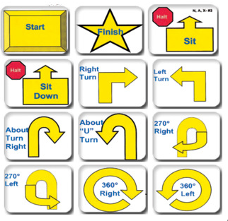

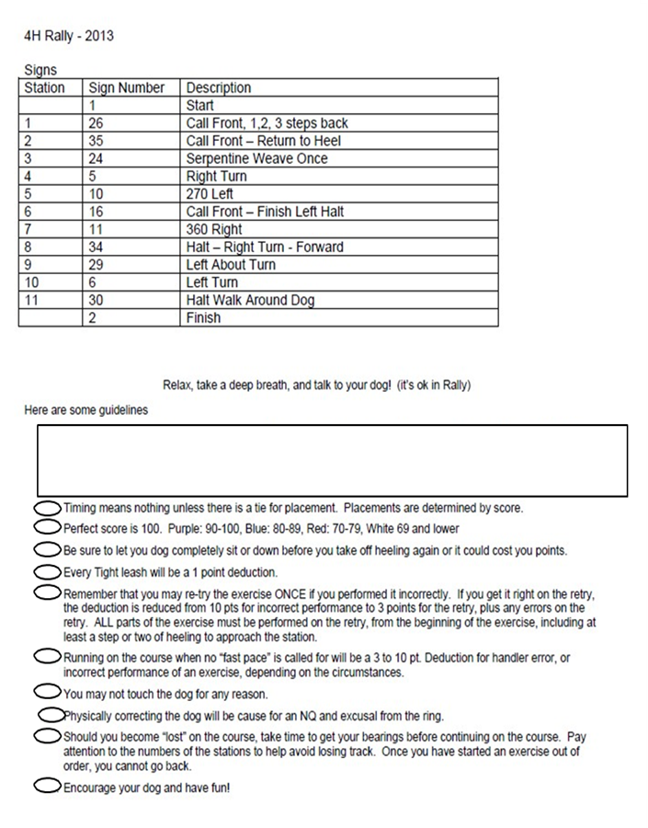

Rally Sign Example

DOG RALLY CLASS CONTINUED… Example Only
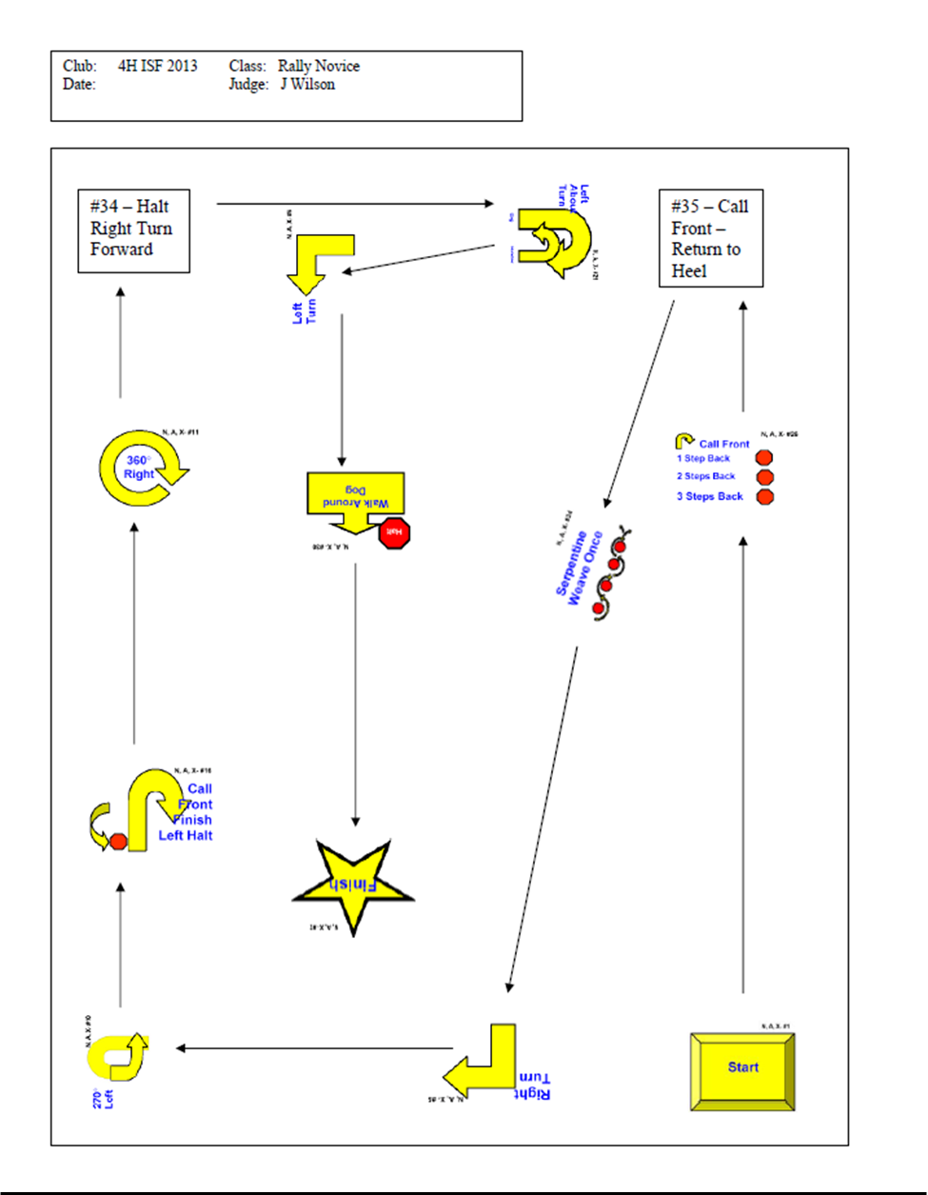

Goat/Sheep Department
Superintendents
Harlie Riley- Chair
Carl Kendall, Jim Koffman, Chris Knowles, Jill Kosman

GOAT AND SHEEP GENERAL RULES

1. All goats and sheep showing (except for bottle projects and registered breeding with an identifying tattoo) must attend the Sheep/Goat weigh-ins May 8th to be tagged. If weighing-in out of county, you must let the Extension Office know prior to weigh-in.
2. All does must have birthday entered on 4-H Online 2.0 by May 15th.
3. Animals identified as part of a 4-H project cannot also be identified or exhibited as an FFA project. Example Youth showing Breeding 4-H cannot show Breeding FFA. Youth can show Breeding 4-H and Market FFA.
4. All sheep and goats must be of show quality and free of any disease or external parasites.
5. Absolutely no covers (blankets, sleeves, wraps, tubes, etc.) allowed during vet check or weigh-ins at fair. Blankets, sleeves, wraps, tubes, etc. must be fully removed during vet check and remain off until after the animal leaves the scale.
6. The grooming of goat/sheep projects is the responsibility of the 4-H or FFA member. Help may be given by his/her parents, siblings, grandparents, Monroe County Sheep/Goat Superintendent, or a fellow Monroe County 4-H or FFA Chapter member (Albia, Eddyville, Moravia, or Twin Cedars), leader or FFA Advisor of Monroe County. Grooming includes washing, clipping, combing, spraying, fitting, etc. Anyone may help if needed to get the animals around by halter/lead.
7. No painting, powdering, or artificial coloring is allowed. Any surgical procedure or injection of any foreign substance or drug or the external application of any substance (irritant, Cool Blue, Alcohol, counterirritant, or similar substance) which could affect the animal’s performance or alter its natural contour, confirmation, or appearance, except external applications of substances to the hoofs or horns of animal which affect appearance only is prohibited.
8. All Sheep and Goats will be wiped down to check for color or coloring agent. If any color comes off on the towel the animal will be disqualified.
9. During the exhibition of meat goats, bracing is allowed. However, all goats must always have four feet on the floor in the show ring. Lifting feet off the ground or placing them on any support or altered ring surface is not acceptable. Exhibitors will receive one warning, second offense will result in automatic exhibitor disqualification from the Meat Goat Show.
10. During the exhibition of goats or sheep no slapping or hitting animals is permitted. Exhibitors will receive one warning, second offenses will result in automatic exhibitor disqualification from the show.
11. A County Born Champion will be selected for Breeding Meat Goat and Market Meat Goat. County born is interpreted to mean born within the county or on the member's family farm in the event he/she resides outside of Monroe County, or a portion of the farm is located outside of the county. The top County Born goat in each class will re-enter the ring to compete for County Born Champion.
12. Market and commercial lambs must be slick shorn prior to entering the check-in line There will be no coloring agent or paint used on any sheep. Sheep in violation will not be allowed to show.
.

Bottle Lamb/Goat Department
1. Superintendents will divide into divisions:
a. 1st year (4th grade),
b. Junior (5th – 6th grade),
c. Intermediate (7th – 8th grade),
d. Senior (9th – 12th grade).
This will depend on number of entries – some groups may be combined.
2.Any newborn or orphan lamb/goat, male or female, dairy or meat, crossbred that was born on January 1, 2026, to May 15, 2026. Must be purchased/ farmed and in possession of member within two weeks of birth: identified by 4-H tag and identified on 4-H online 2.0 or FFA identification requirements and must have scrapie tag in place by May 15. NO BUCKS WILL BE PERMITTED TO SHOW IN THE BOTTLE CLASS.
3. Lamb/Goat must be bottle fed.
4.An exhibitor may identify up to 3 lamb/goat but show only 1. These are eligible to be shown only in the Bottle Lamb/Goat Class in the year of their birth.
5. Project will be shown in showring. They will be divided into classes depending on the number of entries and at the discretion of the superintendents.
6. Judging will be based on:
a. What the member has learned about care and development of the lamb/goat (interview in ring).
b. General health, condition, and management of the lamb/goat and the 4-Hers knowledge of this area (interview in ring).
c. Project record sheet filled out, about what the exhibitor has learned.
d. Poster to be hung above the stall showing exhibitor with lamb/goat.
7. The ribbon and awards selection will be based solely on the interview done in the ring and project record sheet completed by each exhibitor. The exhibitor will receive their ribbons following the judging in the ring.
8. If exhibitor is also planning on exhibiting bottle goat in a market, breeding, dairy, or pygmy class the goat or lamb will have to be identified as such on 4-H online 2.0 or FFA Identification by May 15th. Scrapie tag numbers must be included. They MUST also attend the goat weigh-in on May 8, 2026

Lot 187 -- Bottle Lamb/Goat

GOAT DEPARTMENT RULES
Dairy Goats
See Goat and Sheep General Rules at beginning of section.
1. All Dairy goats must be identified on 4-H Online 2.0 or FFA Identification and tagged with a 4-H tag/ FFA tag or have an official tattoo by May 15th. Scrapie tag numbers must be included on the identification of the animal on or before May 15th.
2. Only does (female goats) may be exhibited.
3. Dairy Goats will be judged along dairy characteristics.
4. Birthdates must be included on the Identification on 4-H Online 2.0 or FFA by May 15.
5. Superintendents will verify age at the Fair check-in date of Wednesday of Fair, according to teeth in mouth.
6. All dairy goats must be dehorned.
*Age on July 15

Lot 100 – Junior under 6 months of age
Lot 101 – Junior six months old and under one year
Lot 102 – Junior one year old and under two years
Lot 103 – Senior Two years old and older – in milk

Pygmy Goat

See Goat and Sheep General Rules at beginning of section.
1. Pygmy goats must be ear tagged at the county sheep/goat weigh-in on May 8, 2026.
2. A maximum of 5 pygmy goats can be nominated by an exhibitor and identified by May 15th on 4-H Online 2.0 or FFA Identification.
3. Horns: Exhibitors will be required to have horns disbudded, dehorned, or tipped blunt on all Pygmy goats before arrival on fairgrounds. Removal of horns on fairgrounds is NOT permitted.
4. All pygmy goats must have a scrapie tag in place and identified by May 15th on 4-H Online 2.0 or FFA Identification.
5. Only Does will show in the Pygmy Goat Class.

Lot 111 – Pygmy Goat

Market Meat Goats

See Goat and Sheep General Rules at beginning of section.
1. Market goats must be weighed in and ear tagged at the sheep/goat weigh in on May 8, 2026. A total of 10 goats can be weighed and ID online.
2. All goats must have Scrapie tags in place to be eligible for show.
3. Market Meat Goat wethers or does may be shown. The show will be open to all breeds, which will compete together, except for underweight goats.
4. Individual market meat goats will be weighed upon arrival at the fair on Wednesday of fair. Market goats are automatically entered in the rate of gain contest and calculations will be taken from the May weigh-in date.
5. Meat goats must weigh a minimum of 50 pounds upon arrival at the fair on Wednesday of fair.
6. Meat goats must have kid teeth in normal positions at time of check-in. Any meat goat having lost any kid teeth will be disqualified.
7. Market goats will be exhibited by weight groups. Superintendents will divide classes according to weight.
8. An exhibitor may enter and show a maximum of 5 market Goats.
9. Horns: Exhibitors will be required to have horns disbudded, dehorned, or tipped blunt on all market goats before arrival on fairgrounds. Removal of horns on fairgrounds is NOT permitted.
10. All market goats must be uniformly clipped, and suggested hair length should be 3/8-inch hair length or less above the knee and hock joints to include the head, excluding the tail. Tail clipping is optional.

Lot 104- Market Meat Goat
Light-Weight Market Goat Class
Goats in this class are only eligible for red and blue ribbons.

See Goat and Sheep General Rules at beginning of section.

All Market goats must be weighed in and ear tagged at the Monroe County Sheep/Goat Weigh-in on May 8, 2026.
1. All Market Goats weighing under the 50-pound mark will show in this class.
2. All Market Goats weighing under the 50-pound mark will be eligible to sell at the fair auction if there is a floor buyer.
3. Horns: Exhibitors will be required to have horns disbudded, dehorned, or tipped blunt on all market goats before arrival on fairgrounds. Removal of horns on fairgrounds is NOT permitted.
4. Market Goats wethers or does may be shown. The show will be open to all breeds which will compete together.
5. Classes will be determined by Goat Superintendents following weigh-in at fair.

Lot 110 – Light -weight Market Goat Class

Breeding Meat Goats

See Goat and Sheep General Rules at beginning of section.
1. Breeding meat goats must be ear tagged at the county sheep/goat weigh-ins on May 8, 2026. All breeding meat goats must be identified on 4-H Online 2.0 or FFA Identification by May 15th and tagged with a 4-H/FFA tag by a Superintendent by May 15th. Scrapie tag numbers and birthdays must be included on 4-H Online 2.0 or FFA identification of animal on or before May 15th.
3. Only does (female goats) may be shown. The show will be open to all breeds which will compete together.
4. Superintendents will verify age at the fair check-in date on Wednesday of fair, according to teeth in mouth.
5.Breeding Meat goats will be split by birthdate, then Superintendents will divide classes according to weights.
6. All breeding meat goats must be clipped accordingly under the stomach and neck areas. Tail clipping is optional.
*Age on July 15

Lot 107 – Junior under one year
Lot 108 – Junior one year old and under two years
Lot 109 – Senior two years old and older

Sheep Department Rules
See Goat and Sheep General Rules at beginning of section.
1. Market lambs must weigh 80 lbs. at weigh-in time at county fair, if not, will show in under-weight class and only eligible for red ribbon.
2. Individual market lambs will be weighed upon arrival at the fair on Wednesday of fair. Market lambs are automatically entered in the rate of gain contest and calculations will be taken from the May weigh-in date.
3. All market lambs must have been weighed in on May 8, 2026, at the Monroe County Fairgrounds. An exhibitor may weigh-in 15 market lambs.
4. An exhibitor may enter and show a maximum of 5 market lambs. Market lambs can be an ewe or wether.
5. An exhibitor may weigh an additional 5 lambs for the feeder lamb class and show 3.
6. Commercial Ewes cannot be shown as individuals in the Market Lamb classes.
7. Commercial Yearling Ewes may be either a market ewe or commercial ewe that was a project in the previous year, and/or be identified at weigh-in as a yearling ewe.
8. An exhibitor may tag 10 Commercial Ewe Lambs at May 8, 2026, weigh-in & show 3. May show no more than 2 in a division.
9. All market lambs and breeding sheep must have been sheared over the entire body with a regular comb. Suggested fleece length: market lambs 1/4"; breeding sheep 1/4" to 3/4" maximum. There will be no shearing deadline.
10. Market and Commercial lambs must be slick shorn prior to entering the check-in line. There will be no coloring agent or paint used on any sheep. Sheep in violation will not be allowed to show.
11. A County Born Champion will be selected for Commercial Ewe Lamb and Market Lamb. County born is interpreted to mean born within the county or on the member's family farm in the event he/she resides outside of Monroe County, or a portion of the farm is located outside of the county. The top County Born lamb in each class will re-enter the ring to compete for County Born Champion.
12. All sexually intact sheep must have an individual Scrapie tag, 4-H tag and be identified on 4-H Online 2.0 or FFA by May 15th.

Feeder Lamb Class

1. Exhibitor may weigh in 5 feeder lambs and must identify them on 4-H Online 2.0 or FFA. This is a separate class from the regular Market Lamb Class and will be judged totally different.
2. Three lambs can be exhibited.
3. 30-day pelt (1# grade pelt)- do not shear after June 29
4. Exhibitor will get 1 pen.
5. Lambs will be judged in the pens.
6. Placing determined on basis of lambs, records, and interview.
7. Record kept on display with each pen.
8. Lambs excluded from Rate of Gain Class.
9. Class will be placed, and ribbons given accordingly.
10. All feeder lambs will be sold at the Livestock Auction on Monday of fair.
11. Records kept are to include the following information (get from Extension Office)
a. Feed ration, quantity, and total cost
b. Value of lamb at beginning of project
c. Rate of Gain- average of the three
d. What did you learn from this project?
12. Any interpretation of the above will be determined by a consensus of the Sheep Superintendents.

Lot 107a- Feeder Lamb Class

Market Lambs

Lot 108- Individual Market Lamb

Commercial Ewes

Lot 109- Commercial Ewe Lamb
Lot 110- Commercial Yearling Ewe- Ewes over 1 year and under 2 years. Must have been the member’s project last year or be identified at weigh-in as a yearling ewe.

Purebred Sheep

Entries in purebred sheep classes must be registered or registration applied for. Registration papers must be turned into the Extension Office at fair.

There must be two or more for a purebred class or purebreds will show as commercial.

*Age on July 15
Suffolk
Lot 111- Ewe, 1 year, under 2
Lot 112- Ewe, under 1 year

Hampshire
Lot 114- Ewe, 1 year, under 2
Lot 115- Ewe, under 1 year

Columbia
Lot 117- Ewe, 1 year, under 2
Lot 118- Ewe, under 1 year

Other Breeds
Lot 120- Ewe, 1 year, under 2
Lot 121- Ewe, under 1 year

Horse and Pony Department
Superintendents
Christy Hoksbergen- Chair,
Deanna Keeton, Emily Hunt, Maddi Tyrrell

Horse and Pony Department Rules

Animals must be Identified in 4-H Online 2.0 or FFA identification on or before May 15th WITH PHOTOS. There will be no exceptions!
1. See General Rules in front of Fair Book and General Livestock Rules in front of this section. NO LIVESTOCK IS TO BE UNLOADED/STALLED UNTIL SEEN BY A VETERINARIAN. The vet has the right to send any equine project home if he/she feels horse is not fit. The vet’s decision is final. Show will start Sunday at 8:30 a.m.

2. Fair check-in will be Wednesday evening from 4:00-5:00 p.m. only. There will be no check in on Sunday morning unless there is a mare and foal. Mare and foal projects MUST be checked in on Sunday Morning at 7:30a.m. by the veterinarian. NO EXCEPTIONS!
3. Upon arrival at the fairgrounds, exhibitors shall take their mounts to the assigned stalls after being inspected by a veterinarian or have presented a horse superintendent a signed health certificate. (See #1 Above) The veterinarian will fill out a form that documents any injuries. All horses and ponies must have a completed Equine Vet Check Form that will be available at the appointed check in point. The Equine Vet Check- In Form will include the Henneke Body Condition Scoring System. Please review that prior to arrival. The veterinarian has the right to send any equine project home if he/she feels horse is not fit. The veterinarian’s decision is final.
4. All Horses and ponies will be measured to confirm animal is horse or pony. Size Rule: A horse is clarified in the 4-H Rules and Regulations 4H511C page 10:3 as being 14.1 hands (57”) and over. Ponies are any equine under 14.1 hands (57”). Please see page 11 in the said rule book on how to measure your equine project.
5. All equines will be tied by head in their assigned stalls. No riding or sitting on horse while horse is in the barn. This rule will be enforced.
6. Exhibitors may exercise their mounts in the assigned area only. Horses shall be ridden by exhibitors only.
7. Horse exhibitors for the 2026 Monroe County Fair will be required to attend a TOTAL of 3 clinics sponsored by the Horse Superintendents. Clinics must consist of at least one indoor and one outdoor. The exhibitor must bring the horse that he/she is planning to show at the fair to the outdoor clinics for it to count as one of the attended clinics. Please contact a Horse Superintendent if you have questions or need an alternate date.
8. Each member may exhibit only 3 projects from ponies, horses, mules, or donkeys. A mare and foal will count as one head.
9. All exhibitors must follow rules for shows, equipment, and apparel guidelines from the book, “4-H Rules and Regulations for Equine Shows in Iowa”. Copies can be found and downloaded at Horse and Pony | 4-H Youth Development (iastate.edu) horse show rules.pdf.
10. All horses are to be in stalls by Wednesday of fair at 5:00 p.m. and remain until horses are released on Monday of fair at 10:00 a.m. except for mare and foal. Mare and foal are to arrive on Sunday of fair and will be allowed to return home immediately after showing.

11. A Horse or Pony may not be removed from the fair without a veterinarian’s inspection at the fairgrounds with two horse superintendents as witness.
12. Each exhibitor must ride his or her own horse. Horses can be identified by more than one 4-H member provided the members are all 4-H members and are siblings. If siblings identify the same horse, it cannot be used in any class twice regardless of rider’s division.
13. A 4-H or FFA member enrolled in the horse project may own or manage a horse. If the horse is managed, the 4-H or FFA member must assume at least 75 percent of the management of the horse.
14. The term “manage” includes all the following: Feeding, grooming, exercising, training, stall management and use of the horse.
15. 4-H or FFA members using a non-family-owned horse must have the owner complete an owner's affidavit stating the 4-H or FFA member is assuming at least 75 percent of the management. An affidavit may be obtained at the Extension Office and must be on file by May 15. A maximum of two animals may be leased.
16. A leased horse may not be shown in Halter Class
17. Substitution of project horses or ponies will not be permitted after May 15 of each club year.
18. A stallion can be shown only as a foal in the mare and foal class, or a weanling in halter. Yearlings and other stallions are ineligible for 4-H shows.
19. A colt or filly foaled after June 1 is eligible for show during the current year ONLY if it is the foal of a project mare and is shown in a mare and foal class.
20. In any class, the judge shall have the authority to require the removal or alteration of any piece of equipment that, in the judge’s opinion, is unsafe, would tend to give a horse an unfair advantage, or is inhumane. Prohibited equipment mandates disqualification.
21. Judge’s decision is final.
22. Speed events – members must be mounted when entering the arena. No assistance to either horse or rider is permitted up to or past the arena gate. If an exhibitor/horse is assisted in any manner, the exhibitor shall automatically be disqualified. There will be a 5 second penalty for each barrel or pole knocked down during these events. Exhibitor must wait until the gate is closed before starting their event, or there will be a 5 second penalty added to their time. For more rules on timed events See page 12 and 122-124 in the 4-H rules and regulations book Horse and Pony | 4-H Youth Development (iastate.edu) horse show rules.pdf Exhibitors must be mounted when entering the arena and must dismount before leaving the arena.
23. High Point Horse Award – Junior, Intermediate, Senior Division: One horse/One exhibitor team to be designated on Sunday morning before the show starts at 8:30 a.m. The horse will be marked with an “H” in green on both hips by a Horse Superintendent during check in. Points will be based on number of horses in each class with the first-place horse receiving the most points. All classes except showmanship will count towards high point total at the end of the show.
24. High point exhibitor awards will be based on individual exhibitor, not horses. Points will be as follows: Champion (1st) 6 points, Reserve (2nd) 5 points, Purple 4 points, Blue 3 points, Red 2 points.
25. All showmanship trophies can only be won once in a particular age division. Winners will advance to next age division the following year.
26. Champion Pony class is for first and second place winners in lots 124 through 128.
27. Champion Horse class is for first and second place winners in lots 129 through 134.
28. All classes will be awarded purple, blue, or red ribbons.
29. You must lead your horse, pony, or mule to and from the barn or trailer to the show ring and vice versa.
30. Horses need to be stalled unless being exercised or ridden by the exhibitor only and must in their stalls by 6:00p.m.- 9:00 p.m. Exhibitors may exercise their mounts only in the arena unless approved by a horse superintendent.
31. Riding your horse, mule, or pony in the camping area is prohibited.

The 4-H rules and regulations for equine shows in Iowa can be found at horse show rules.pdf

Horse Show Attire
1. Protective Headgear Policy–All exhibitors must wear properly fitting protective headgear passing or surpassing current applicable ASTM/SEI (American Society for Testing and Materials/ Safety Equipment Institute) standards with harness secured while riding anywhere on the competition grounds. Harness must be secured and properly fitted. NO HATS, SCARVES, ETC., ARE TO BE WORN UNDER THE HELMET. It is the responsibility of the rider, parent, or guardian to see that the headgear worn complies with appropriate safety standards for protective headgear intended for equestrian use and is properly fitted and in good condition.
2. Any rider violating this rule at any time must immediately be prohibited from further riding until such headgear is in place.
3. No helmet will result in disqualification.
4. Halter classes exhibitor is to wear a cowboy hat. All other dress show attire for halter class will be the same as all other classes including timed events.
5. Horse exhibitors must wear a solid, plain front button or snap long-sleeve, collared shirt, or blouse of any color (including white). The following is prohibited: personalized logos or embroidery, zippers, sheer or lace fabric, embellishments of bling of any kind including, but not limited to, sequins, rhinestones, chains, etc. Shirt must be tucked in.
6. 4-H armbands must be worn on the upper, left arm or a chevron can be worn on the upper left chest. Failure to do so will result in disqualification.
7. Dark blue jeans without holes must be worn. A belt is required.
8. Western boots must be worn. Fashion heels are prohibited, as well as twisted X or riding shoes.
9. Spurs are permissible. Spurs must be dull and the rowels free moving.
10. Chaps, ball caps, tank tops, T-shirts, or jersey-type shirts ARE NOT to be worn.
11. Failure to wear appropriate attire will result in dropping of a ribbon group.

Horse and Pony Classes
The following classes will be part of Horse Show and are not in any, certain order.
All classes other than Halter, will be shown in the exhibitor’s age division.
1st Year Exhibitor - 4th grade only
Junior Exhibitor - 4th, 5th & 6th grade
Intermediate Exhibitor- 7th & 8th grade
Senior Exhibitor - 9th, 10th, 11th, and 12th grade

Horse Showmanship

Showmanship classes can only be won once in a particular age division. Supreme Showmanship is for any exhibitor that has won the senior division.

Lot 123 Supreme Showmanship
Lot 123a Senior Showmanship
Lot 123b Intermediate Showmanship
Lot 123c Junior Showmanship
Lot 123d 1st Year Showmanship
horse show rules.pdf page 13

HALTER CLASS
Equines are to be shown in-hand at a walk and jog or trot. Exhibitors must use only the right hand on the lead where the chain veins, and lead on the horse’s left side. A chain may be used under the chin or hanging from the halter. Leads may be used without chains. In-hand equine must be shown in a halter, regular or show-type is acceptable.
- Ponies (UNDER 57”)
  - Lot 124 Foals (foaled in calendar year of show)
  - Lot 125 Yearlings (foaled in preceding calendar year)
  - Lot 126 Two-year Old and Under 3
  - Lot 127 Three-year old and older
  - Lot 128 Mare and Foal (Foal must have been foaled in the calendar year of the show)
- Horses (57” and OVER)
  - Lot 129 Foals (foaled in calendar year of show)
  - Lot 130 Yearlings (foaled in preceding calendar year)
  - Lot 131 Two-year Old and Under 3
  - Lot 132 Three-Year-Old and Older Mares
  - Lot 133 Three-Year-Old and Older Geldings
  - Lot 134 Mare and Foal (Foal must have been foaled in the calendar year of the show)
- Mules and Donkeys
  - Lot 135 Mule and Donkey (all sizes)

WALK TROT

Horses will be shown at a walk and jog or trot both clockwise and counterclockwise around the arena.

Lot 136JR Junior Walk Trot
Lot 136IN Intermediate Walk Trot
Lot 136SR Senior Walk Trot

WESTERN HORSEMANSHIP

Riders will be judged on seat, hands, performance of horse, actions of horse and rider and suitability of horse to rider. The rider's methods of achieving good horse performance are to be considered more important than the performance of the horse. Exhibitors are eligible to receive the award more than one time in the Junior, Intermediate, and Senior Horsemanship classes. horse show rules.pdf page 54

Lot 137 First Year Western Horsemanship
Lot 137a Junior Western Horsemanship
Lot 137b Intermediate Western Horsemanship
Lot 137c Senior Western Horsemanship

PLEASURE CLASS
Horse will be shown at a walk, jog, trot, and lope both clockwise and counterclockwise around the arena. Horses will be asked to back. Judging is predominately on the performance of the horse and conformation. Exhibitors may not enter the same horse/pony in Western Pleasure and Ranch Horse/Pony Pleasure Classes. Pony is termed under 57” and Horse is 57” and over. horse show rules.pdf page 58

WESTERN PLEASURE Pony
Lot 138 Junior Western Pleasure Pony
Lot 138a Intermediate Western Pleasure Pony
Lot 138b Senior Western Pleasure Pony

WESTERN PLEASURE Horse
Lot 139 Junior Western Pleasure Horse
Lot 139a Intermediate Western Pleasure Horse
Lot 139b Senior Western Pleasure Horse

RANCH PLEASURE Pony
Lot 140 Jr Ranch Pleasure Pony
Lot 140a Intermediate Ranch Pleasure Pony
Lot 140b Senior Ranch Pleasure Pony

RANCH PLEASURE Horse
Lot 141 Jr Ranch Pleasure Horse
Lot 141a Intermediate Ranch Pleasure Horse
Lot 141b Senior Ranch Pleasure Horse

RANCH RIDING CLASS
This class the horse is judged on its ability to work at a forward, working speed while performing required and optional maneuvers. It reflects the versatility, attitude, and movement of a working horse. horse show rules.pdf

Lot 142 Junior Ranch Riding
Lot 142a Intermediate Ranch Riding
Lot 142b Senior Ranch Riding

TRAIL CLASS

1. The trail ride class shall include at least 5 and not more than 10 of the obstacles as listed for this class in 4H-511C. pages 88-100 https://www.extension.iastate.edu/4h/projects/horse . Please see horse show rules.pdf page 60-65 the full set of rules 1-15 for Trail Class

Lot 143 Junior Trail Class
Lot 143a Intermediate Trail Class
Lot 143b Senior Trail Class

TRAIL IN HAND

1. The trail class shall include at least 5 and not more than 10 of the obstacles as listed for this class in 4H-511C. These horse will be shown at the end of a halter and not allowed to be shown in any riding classes. pages 69-71 https://www.extension.iastate.edu/4h/projects/horse . Please see horse show rules.pdf page 69-71 the full set of rules 1-15 for Trail in Hand Class

Lot 143c Trail in Hand Class (all classes)

POLE BENDING

1. https://www.extension.iastate.edu/4h/projects/horse . Please see horse show rules.pdf at the above address for the full set of rules 1-4 for pole bending page 93
Lot 144 Junior Pole Bending
Lot 144a Intermediate Pole Bending
Lot 144b Senior Pole Bending

BARREL RACING

2. https://www.extension.iastate.edu/4h/projects/horse . Please horse show rules.pdf page 91 for the full set of rules 1-3 for barrels.

Lot 145 Junior Barrel Racing
Lot 145a Intermediate Barrel Racing
Lot 145b Senior Barrel Racing

FLAGS

https://www.extension.iastate.edu/4h/projects/horse . Please see the 4-H rules and regulations for equine shows in Iowa at the above address for the full set of rules 1-4 for Flags page 128
Lot 146 Junior Flag Race
Lot 146a Intermediate Flag Race
Lot 146b Senior Flag Race

ENGLISH CLASSES
horse show rules.pdf . Please see the 4-H rules and regulations for equine shows in Iowa at the above address for the full set of rules 1-6 for English Class page 22
Lot 147 Hunter Under Saddle (walk trot)- All Age Divisions
Lot 148 Hunter Under Saddle- All Age Divisions
Lot 149 Hunt Seat Equitation- All Age Division

Driving Class

The Driving Class is judged on the animal’s quality of gaits, manners, and responsiveness. One or two animals is shown hitched to a suitable two-wheeled or four-wheeled vehicle. The harness and vehicle must be safe, clean, and in serviceable condition. The judge will dismiss any entry he or she feels is unsafe, whether the unsafe condition is due to equipment or to animal behavior.

Lot 153- Junior- 4th, 5th, 6th grade

Lot 154- Intermediate- 7th, 8th grade

Lot 155- Senior- 9th, 10th, 11th, 12th grade

*See State Rule book for pattern and additional criteria. horse show rules.pdf page 99

Poultry Department
Superintendents
Chair- Suzie Smith, Loretta Brinegar

Poultry Department Rules

All poultry must be identified on 4-H Online 2.0 by their breed and sex by May 15th.
1. Poultry need to arrive on Wednesday, of fair, from 10:00am-12:00p.m. and must stay until Monday, of fair, at 10:00a.m. Poultry barn cleanup will begin at 9:00a.m. sharp. Please bring your pet carriers, as you will be required to take your poultry projects out of show cages. All cages will then be cleaned and put away in the shed; the barn will be swept and cleaned.

2. Poultry exhibitors must enter poultry on FairEntry.
3. Cages will be furnished.
4. All poultry must have a blood test (Pullorum-Typhoid) before exhibiting at the county fair. Check with the Extension Office for more details.

5. All birds are required to be tagged; Exhibitors must pick up tags by May 15 from the Extension Office.

*All Poultry may sell at the sale if they so desire. Champion and Reserve Champion sold individually first, then pens to follow. If they enter the show ring they cannot come back to the fair as the current owner’s/exhibitor’s 4-H project even if the buyer gives you the project/poultry back.
Age Classification *Age at time of Fair

Cock—male chicken over 1 year
Cockerel—male chicken under 1 year
Hen—female chicken over 1 year; female duck; female turkey
Pullets-female chicken under 1 year
Drake—male duck
Tom—male turkey
Gander—male goose
Goose—female goose

Layers
Pen—3 hens or 3 pullets
Lot 161—Pen of 3 hens
Lot 162—Pen of 3 pullets

Standard Breed Chicken
Lot 163—cock
Lot 164—cockerel
Lot 165—hen
Lot 166—pullet

Bantam Breed Chicken
Lot 167---cock
Lot 168—cockerel
Lot 169---hen
Lot 170---pullet

Other Poultry
Lot 173—ducks (either sex)
Lot 174—turkey (either sex)
Lot 175—geese (either sex)
Lot 176—guinea (either sex)
Lot 177—peafowl (either sex)
Lot 171-- other Bantam (call ducks)

Breeding Pair
Lot 178—cock and hen (cockerel and pullet)
Lot 179—drake and hen
Lot 180—tom and hen
Lot 181—gander and goose

COSTUME CLASS- POULTRY
Poultry exhibitors have 15 minutes after Grand Champion is picked to dress
their poultry. The Costume theme can be anything, but the costume must be
worn by the poultry.

Rabbit Department
Superintendents
Chair- Suzie Smith, Loretta Brinegar

Rabbit Department Rules
1. All rabbits must have been identified on 4-H Online 2.0 by May 15. Maximum of 15 rabbits can be ID.
2. Rabbits need to arrive on Wednesday, of fair, between 10:00am-12:00p.m. and must stay until 10:00 a.m. on Monday, of fair. Rabbit barn cleanup will begin at 9:00a.m. sharp. Please bring your pet carriers, as you will be required to take your rabbits out of show cages. All cages will then be cleaned and put away, and the barn will be swept and cleaned.
3. Tattoos are required.

4. All Rabbits must be entered into FairEntry.
5. All rabbits must be free from communicable disease and pass health standards. Any rabbit in an unhealthy or unthrifty condition may be refused pen room. In case of arbitration, decision of appointed veterinarian shall be final.
6. An exhibitor is allowed 3 entries per class. Entries must be within the age and weight limits for the class and lot. Class is defined by 3 commercial / 3 Fancy/ 3 Crossbred.
7. Classes may be adjusted according to entry numbers.
8. Judge’s decision is final.
9. Exhibitor must attend Pre-Fair set up.
10. All rabbits may sell at the sale if they desire. Champion and Reserve Champion sold individually first, then pens will follow. But if they enter the show ring they cannot come back to the fair as the current owner’s/exhibitor’s 4-H project even if the buyer gives the rabbit back.

Commercial Breeds
French Angora, Giant Angora, Blanc de Hotot, Champagne d’ argent, Californian, Cinnamon, American, Chinchilla, Crème d’Argent, French Lop, New Zealand, Palomino, Rex, American Stable, Satin, Silver Fox, Silver Martin

*Age a time of Fair
Senior Buck – 9 months and over
Senior Doe – 9 months and over
Intermediate Buck- 6 to 9 months
Intermediate Doe- 6 to 9 months
Junior Buck- (under 6 months)
Junior Doe- (under 6 months)

Fancy Breeds
American Fuzzy Lop, English Angora, Standard Chinchilla, Dutch, Dwarf Hotot, Havana, Holland Lop, Jersey Wooly, Lilac, Mini Lop, Mini Satin, Netherland Dwarf, Polish, Sliver Thrianta, Mini Rex, Harlequin
*Age a time of Fair
Senior Buck – 6 months and over
Senior Doe – 6 months and over
Junior Buck- (under 6 months)
Junior Doe- (under 6 months)

Crossbred Rabbits
Any rabbit that does not fit into the Commercial, Pure Bred or Fancy breed class will be shown in the Crossbred class.
*Age at time of Fair
Senior Buck – 6 months and over
Senior Doe – 6 months and over
Junior Buck- (under 6 months)
Junior Doe- (under 6 months)

MARKET RABBITS
MEAT PEN
1. Meat pens will consist of three rabbits of the same breed and variety. Age limit not over 10 weeks and weight limit of 3.5 to 5.5 pounds each.
2. This division allows crossbred rabbits; however, they must be of the same variety.
3. Each exhibitor may enter one meat pen.
4. Champion and Reserve Champion Meat Pen will be selected.
CLASS ● Meat Pen- Class of 3 Rabbits

SINGLE FRYER
1. Single Fryer consists of one rabbit not over 10 weeks of age and weight limit of 3.5 to 5.5 pounds each.
2. This division allows crossbred rabbits.
3. Champion and Reserve Champion Single Fryer will be selected.
4. Each exhibitor is limited to one Single Fryer entry. The fryer must not be pulled from meat pen.
CLASS ● Single Fryer
ROASTER
1. Roaster consists of one rabbit under 6 months of age with a minimum weight over 5.5 pounds and maximum weight of 9 pounds.
2. This division allows crossbred rabbits.
3. Champion and Reserve Champion Roaster will be selected.
4. Each exhibitor is limited to one Roaster entry.
CLASS ● Roaster

Rabbit Showmanship
Rabbit Showmanship is based on what you know about your rabbit. Please see page 15 for general showmanship rules.

Costume Class- Rabbits
Rabbit exhibitors have 15 minutes after Grand Champion is picked to dress their rabbit. The costume theme can be anything, but the costumes must be worn by the rabbit.

Swine Department
Superintendents
Dan Yule-Chair
Ryan Ammons, Jeff Lathen, Dean Lathrop,
Adam Rozenboom, Curt Houk

Swine Department Rules
1. Swine must be weighed, identified, and owned by the Monroe County spring weigh-in date.
2. All swine must be weighed and tagged at the Monroe County spring weigh-in date, or at a state fair weigh-in held at an adjoining county. No swine may be weighed in after the Monroe County date. If an exhibitor is unable to make the Monroe County weigh-in date they need to make, arrangements with the Swine Superintendent and the Extension Office or FFA advisor to weigh-in their animals prior to the Monroe County weigh-in date. Monroe County tags must be used. Swine weighing-in before Monroe County weigh in date will deduct 1 pound per day of the 150 pounds weight limit. Example: If weighing-in 20 days prior to Monroe County weigh in, your weight limit is 130 pounds.
4. All Swine are required to be ear notched.
5. Any loss of county or state 4-H or FFA tags needs to be reported and documented at the Monroe County Extension Office or your FFA Advisor immediately. The Extension Office will then contact a swine superintendent to retag the animal. Only a swine superintendent can retag the animal.
6. Swine will be checked in and weighed-in on Wednesday of fair 8:00am-10:00am. There will be no reweighs.
7. All classes need to be designated by 12:00pm Wednesday of fair.
9. Scales will be open until 11:00p.m. the night before the show. They will be reopened at 5:00a.m., the morning of the show.
10. All swine must be inspected by a veterinarian upon arrival before being unloaded.
11. It is expected that all swine will arrive on the fairgrounds clean and ready to be on exhibit.
12. Each exhibitor may weigh in a maximum of 10 swine animals at the April weigh-in date for potential county fair exhibiting. The maximum weigh-in weight is 150 lbs. Swine weighing over 150 lbs. may still be tagged for state fair but are not eligible to show at the county fair. Swine weighing in before Monroe County weigh in date will deduct 1 pound per day of the 150 pounds weight limit. Example: If weighing in 20 days prior to Monroe County weigh in, your weight limit is 130 pounds.
13. Each exhibitor must have an adult present on the April weigh-in date to assist with handling their pigs.
14. Each Exhibitor must have an adult present on the Wednesday of fair weigh-in time.
15. All swine animals weighed on the April weigh-in date are eligible for the Rate of Gain contest. Derby entries must have a minimum Rate of Gain of 1.25 lbs. per day on feed. Derby entry not meeting this level of production will receive a Red Ribbon.
16. Swine weighing 220 lbs. and over will be eligible for the Market Hog class. Swine weighing under 220 lbs. may be shown in the Feeder Pig or Commercial Gilt classes.
17. Swine showing in the Feeder Pig class are NOT eligible for the Champion Market Hog; and will receive ribbon of judge’s choice.
18. Purebred Swine registration papers must be turned into the Extension Office by July FairEntry Deadline.
19. Exhibitors may show a maximum of 5 head of swine at the county fair. All swine brought to the fair must be exhibited at the fair.
a. Maximum of 3 Market Hog/Purebred Market Hog/Feeder Pig/Single S
b. Maximum of 2 Commercial/Purebred Gilt entries
c. Maximum of 1 Derby Pig entry
d. Maximum of 1 Pen of 3 entries
20. Market Gilts and/or Derby entries may be part of the Pen of 3. Commercial Gilts/Purebred Gilts are not eligible to be shown in Pen of 3.
21. Derby Pig entries are required to go through the auction.
22. All Derby Pig entries must be processed at the established locker, judged on the rail, and will be available for viewing on the predetermined night after the fair is completed provided a locker can be secured. If no locker is secured, then the swine committee will secure an ultrasound technician to scan the Derby entries.
23. During the Swine Show at the fair, only the Swine Superintendents, Exhibitors, and 1 parent/guardian will be allowed into the barn.
24. The grooming and care of swine projects during the fair is the responsibility of the exhibitor. Help may be provided by parents, siblings, grandparents, a fellow 4-H/FFA member of their club/chapter of Monroe County, Swine Superintendent or the exhibitor’s 4-H/FFA leader. Any assistance given outside these parameters shall result in disqualification of the animal.
25. Each exhibitor will be assigned 1 pen during the fair. NO exceptions to this rule. Club/Chapter tack pens will be made available if space allows.
26. Each exhibitor must clean pens and provide fresh bedding daily during the fair. Exhibitor must clean pen and obtain swine superintendent approval before departure. This includes cleaning your stall following the auction. A $25 fee will be charged per exhibitor if pens are not cleaned upon departure.
27. Floor bid will be established before the sale. During the Auction, only Swine Superintendents, Exhibitors, 1 Parent/Guardian, and volunteers approved by the Swine Superintendent Chair are to help with the Swine animals.
28. The auction order will be determined by Swine Superintendents.
29. 1st and 2nd place swine in each class must weigh back. All pigs must be no more than 15 lbs. over the beginning of fair weight to be eligible to return for Championship Drive. Pigs over 15 lbs. over the beginning of fair weight will be disqualified. Pen of 3 will be the average weight used. (45 total lbs. for the pen)
30. The Swine Barn will be closed to all fair ground’s attendees (including exhibitors & parents) from 11:00 pm to 5:00 am daily.
31. Any swine animal that is ill or requires a veterinary to inspect during the fair will be blood tested.
32. All swine sold during the auction must go to a designated locker or to the floor bidder.
33. The top 5 Gilts, top 5 Individual Market Hogs, top 5 Single Source Swine will be selected.
34. Single Source Pigs must be purchased through Swine Superintendent designated breeder, must be signed up with Extension Office by February 13, 2026, at 4:30pm. You may purchase up to 3 swine (depending on availability), they will be part of the Exhibitors 5 swine limit.
a. Single Source swine will be weighed in at Spring Weigh-ins at Monroe County ONLY
b. Single Source swine must be identified by May 15 and entered into FairEntry
c. Gate cut off the trailer on selected date
d. Swine will be weighed in on Wednesday of Fair
e. Swine are eligible for Rate of Gain
f. Swine are eligible for Single Source Class or all other classes

Swine Classes:
Lot # 104 – Commercial Gilt
Lot # 104B- Purebred Gilt
Lot # 105 – Derby
Lot # 106 – Feeder Pig
Lot # 107 – Individual Market Hog
Lot # 107A- Purebred Market Hog
Lot # 107B- Single Source Swine
Lot # 108 – Pen of 3 Market
Lot # 109 – Showmanship
109A – 1st Year Junior (4th grade)
109B – Junior (5-6th grade)
109C – Intermediate (7-8th grade)
109D – Senior (9-12th grade)
109E – Supreme (Anyone who has won Senior Showmanship)
If you have won a showmanship age class in the past, you will move up to the next age group older.

Exhibit Building
Superintendents
Kim Wynn, Chelsea Bachman, Kelcie Hindman, Cindy Cronin

This department is open to youth who are participating in 4-H Youth Development Programs conducted by Iowa State University Extension. All exhibitors are responsible to read and comply with the Monroe County Fair 4-H General Exhibit Rules, 4-H General Rules and Regulations, and all 4-H department exhibit class rules and regulations.
$40 CASH PRIZE WILL BE AWARDED IN EACH OF THESE CATEGORIES
1. MOST EXHIBIT PROJECTS- in the Exhibit Building
2. PHOTOGRAPHY- “Ewe Ain’t Seen Nothin’ Yet” theme
3. PURCHASED GARMENT- “Show us your style”
4. FAMILY HERITAGE- Exhibit of family heritage (grandparent’s recipes- family heirloom etc.)
5. MOST CREATIVE EXHIBIT
6. EXHIBIT WITH MONROE COUNTY TIES
7. GROW YOUR EXHIBIT- Vegetable or floral exhibit
8. BEST DECORATED CAKE- Celebrating America’s 250th Birthday

Special Awards given by our Community Partners

These special awards are given in addition to your ribbon. Winners of these awards will be acknowledged at the same time as State Fair Exhibits are acknowledged. Please see the stipulations on each award and keep them in mind when preparing your exhibits.

“Historical Award” given by the Monroe County Historical Society. The Monroe County Historical Society will present a $25 award for an exhibit that preserves the history of Monroe County or its families. The Historical significance of the exhibit should be noted in the write-up on the goal sheet along with why the exhibit is important to the 4-Her. The 4-Her should sign the Historical Society’s sheet on the check in table for the exhibit to be considered for the award.
“Welding Award” given by Kaster Fabrication. 2 $50 Awards for an exhibit in Welding project area.
“Non-Live Beef Award” given by Monroe County Cattlemen. An exhibit that shows the promotion and learning of the beef industry including but not limited to photography, visual arts, family & consumer science, home improvements, personal development and science, engineering & technology. Ownership of an animal is not required.
“EmPOWERment Award” given by Chariton Valley Electric. EmPOWERment project award is for a fair project that shows/demonstrates leadership. Youth inspiring and empowering youth to be leaders in their community. The youth receiving this award will receive a $50 cash voucher. You will take the voucher to the Chariton Valley Electric Office located at 2090 HWY 5 South, Albia, Iowa to receive your cash award. Youth accepting this award maybe asked to have their photo taken with sponsor to use in their publications.

GENERAL EXHIBIT RULES
1. Exhibit building entry process: Exhibitors are required to enter 4-H projects into FairEntry prior to fair for a quicker check-in. Entry Tags will be printed off FairEntry and available at Exhibit Building Check-in on Thursday of fair. 4- H Projects will be exhibited and judged in the 4-H exhibit building on Thursday, July 30th, see fair schedule for club judging times. Superintendents and Staff will be available to help with entry process.
2. 4-H members who have completed 5th grade through 12th grade (or that equivalent) in 2026 are eligible to exhibit at the Iowa State Fair. Exception: Group exhibits from an entire club may include 4th grade members.
3. Outstanding 4th grade member projects will be chosen by judges and given a purple ribbon. These projects will be given special recognition.
4. No more than 2 (two) exhibits per 4-H member will be chosen to advance to the Iowa State Fair under Monroe County Quota. Exceptions will be made if quality exhibit numbers are low or special areas to fulfill the quota and under the direction of Monroe County Extension Staff and Department Superintendents. ON PICK UP OF EXHIBITS, YOU WILL RECEIVE A LETTER WHICH WILL HAVE DETAILED INSTRUCTIONS ON WHEN AND HOW YOUR EXHIBIT SHOULD ARRIVE AT THE EXTENSION OFFICE. Arranging transportation of larger State Fair exhibits will be the responsibility of the 4-H member’s family.
5. All judges’ decisions are final.
6. Eligible exhibits are an outgrowth of work done as a planned part of the 4-H members participation in 4-H projects or programs during the current 4-H year. Exhibits can be done by an individual or group and may represent all or part of the learning in the project or program.
7. Exhibitors in 4-H classes are not eligible to exhibit in a similar department of the FFA divisions or vice versa. See also “4-H Department General Rules and Regulations”.
8. Exhibits previously entered in an FFA Ag Science Fair or any other FFA event or competition may not be entered in any 4-H exhibit class.
9. Exhibits that do not comply with the class description, size guidelines, copyright restrictions, safety and approved methods will be disqualified and will not be put on public display.
10. If the exhibitor chooses a display to illustrate what was learned:
• Posters may not exceed 24” x 36” in size. (See classes 10490 and 10530 for small requirements.)
• Chart boards, graph boards, project presentation boards, model displays, etc., may not exceed 48” x 48” in size. Maximum size is determined by measuring the flat (unfolded) dimensions.
• Display boxes may not exceed 28” x 22” in height or width and 12” in depth.
11.Endangered, threatened and “special concern” plants and animals (includes insects), or songbird feathers and nests may NOT be used in any exhibit. Game animals legally taken are acceptable, with the exception of any hogs (Sus species)- per State Law. Live specimens of noxious weeds or invasive species are NOT permitted in any exhibit. Dried specimens are acceptable to use in exhibits, however viable noxious plant seeds shall not be included.
*State-listed animals: https://www.legis.iowa.gov/docs/ACO/rule/571.77.2.pdf
*State-listed plants: https://www.legis.iowa.gov/docs/ACO/rule/571.77.3.pdf
*Iowa Noxious weed list: Iowa Code Section 317.1A(2022) – Noxious weeds. :: 2022 Iowa Code :: US Codes and Statutes :: US Law :: Justia
12. Exhibits may not include actual firearms or live ammunition. Archery equipment is allowed if tips are removed from arrows.
13. Copyrighted materials and designs may not be used in an exhibit that is presented as original work by the exhibitor. Exhibitors must include permission from the copyright holder/owner when using copyrighted materials. Exhibitors must give proper credit to the original source of all materials/designs used in exhibits. (See also special rules for Visual Arts and general copyright information for 4-H members.)
14. The 4-H member goal and applicable exhibit standards will form the basis of the evaluation process. Evaluation criteria will include demonstrated learning, workmanship and techniques, and general appearance and design. Exhibitors will receive oral evaluation comments on the exhibits and a purple, blue or red Monroe County Fair exhibitor’s ribbon. Refer to exhibit class tip sheets for detailed evaluation criteria in each class. Tip sheets are located on each 4-H project page at https://www.extension.iastate.edu/4h/exhibit-tip-sheets
15. A written explanation, audio recording, or video recording is to be included as part of each exhibit. Audio or video should not be longer than 10 minutes. The exhibitor should respond briefly to the following questions about the exhibit:
• What did you plan to learn or do? (What was your exhibit goal(s)?)
• What steps did you take to learn or do this?
• What were the most important things you learned?
***Check for additional requirements in exhibit classes for food and nutrition, photography, and visual art classes.
• What Design Elements and Art Principles did you use (see Design Elements & Art Principles sheet for minimums).
16. Each item in an exhibit must be securely labeled, including the name of the member’s club, class number, class name, exhibitor’s name, and how many years exhibiting in the class. Each exhibit must have a completed entry tag attached securely prior to judging. Entry tags will be available at the check-in table located in the 4-H exhibit building during judging day.
17. 4-H & FFA members may exhibit as many items as they choose to prepare, unless specified in department or class rules. No 4-H or FFA member may exhibit duplicate items or processes at the County Fair. No two exhibits from the same pattern, recipe, etc. will be accepted.
18. All exhibits selected to compete in the Iowa State Fair must have appropriate information added before State Fair entry if it is directed by the Judge. Written evaluation forms will be available to each exhibitor at exhibit release time.
19. Awards will be presented to each of the 4-H State Fair qualifiers in the Exhibit Building.
20. Exhibits will be released on Sunday, August 2nd at 8:00 pm and Monday, August 3rd from 8:00 am —12:00 pm. Please plan to have projects picked up by 12:00 pm on Monday, August 3rd. Will not be responsible for loss or damage of exhibits but every care will be taken to assure their safety.

State Fair
1. Winning exhibits eligible for the State Fair will be taken by an Extension Staff Member or Volunteer to and from the State fair EXCEPT when an article is too large for transport in available vehicle, then the 4-H member will be responsible for transporting their exhibit to and from the State Fair.
2. No premium is awarded from State Fair exhibits & Counties are limited in the number of entries to the State Fair.
3. Outfits or accessories which will be worn in either Fashion Revue or Clothing Selection at the State Fair may not be entered as a State Fair Static exhibit from the county.
4. Exhibitors in 4-H classes are not eligible to exhibit in a similar department of the FFA divisions or vise-versa.

MONROE COUNTY ONLY CLASSES
Lots 5001-5048 are eligible for County Fair only (If you wish to enter individual vegetable specimens at the Iowa State Fair, they must be entered online at Iowa4holine.com/fairentry.com Office by July 1, 2026.)
1. Exhibit must come from member's garden or field. Exhibits will be judged at time assigned to club member.
2. Name of the variety must be on each product.
3. Member must arrange own exhibit.
4. Exhibits are limited to five total Vegetable entries, with a maximum of two varieties in any one class.
5. The publication used as a standard for preparing and displaying vegetables is bulletin 4H-462 "Harvesting and Preparing "Vegetables for Exhibit." This publication will be used as the standard for exhibiting.
6. Each exhibit should be on a standard 9" white paper plate. (PAPER PLATE WILL BE FURNISHED AT THE FAIRGROUNDS)
7. First year exhibitor’s class consists of members who are exhibiting vegetables for the first time at the county fair.
8. Exhibitors are limited to three flower entries.
9. Flower entries will not allow additional foliage.
10. Exhibitor must furnish own container for flower entries (pop bottle).

Division 500
5001 Beans, Snap 6 specimens
5002 Beans, Yellow wax, 6 specimens
5003 Beets, 3 specimens
5004 Cabbage, round, 1 specimen
5005 Cabbage, red, 1 specimen
5006 Cantaloupe, any variety, 1 specimen
5007 Carrots, 3 specimens
5008 Cucumbers, for slicing, 3 specimens
5009 Cucumbers, dill 3-5 inches,3 specimens
5010 Cucumbers, for pickling, 6 specimens
5011 Eggplant, standard or traditional,1 specimen
5012 Eggplant, cylindrical,1 specimen
5013 Honeydew Melon, smooth skin, 1 specimen
5014 Kohlrabi, 3 specimens
5015 Onions, red, 3 specimens
5016 Onions, white, 3 specimens
5017 Onions, yellow, 3 specimens
5018 Onions, other, 3 specimens
5019 Peppers, bell, sweet, green, 3 specimens
5020 Peppers, sweet, red, 3 specimens
5021 Peppers, sweet, yellow,3 specimens
5022 Peppers, sweet, any other variety,3 specimens
5023 Peppers, hot jalapeno, 3 specimens
5024 Peppers, hot, new Mexican, 3 specimens (includes Anaheim, Big Slim, Slim Jim, etc.)
5025 Peppers, hot, Cayenne, 3 specimens
5027 Peppers, hot, any other variety, 3 specimens
5028 Potatoes, red, 3 specimens
5029 Potatoes, white, 3 specimens
5030 Potatoes, other, 3 specimens, includes blue, gold, yellow
5031 Pumpkin, sugar pie, 1 specimen
5032 Squash, summer, scallop, or patty pan, 3 specimens
5033 Squash, summer, zucchini, green, 3 specimens
5034 Squash, summer, zucchini, yellow, 3 specimens
5035 Squash, summer, any other, 3 specimens
5036 Squash, winter, acorn, green, 1 specimen
5037 Squash, winter, acorn, acorn, all other colors 1sp
5038 Squash, winter, butternut type, 1 specimen
5039 Squash, winter, any other variety, 1 specimen
5040 Sweet Corn, 3 ears exhibited with husks open on 1 side
5041 Sweet Potatoes or Yams, 3 specimens
5042 Tomato, red slicing, 3 specimens
5043 Tomato, yellow slicing, 3 specimens
5044 Tomato, cherry type, 6 specimens
5045 Tomato, processing type, 3 specimens
5046 Tomato, other, 3 specimens
5047 Watermelon, any variety (large or small) 1spec.
5048 Any other kind of vegetable not included in any previously named class, 3 specimens

County Class 200 Single Specimen - any flower If you wish to enter class 5101 through 5407 at the State Fair contact the Monroe County Extension Office for entry information. or go to httsp://iowa4honline.com. Entries must be made by July 1, 2026.
Herbs
5101 Parsley, 3 sprigs in bottle of water
5102 Dill, 3 sprigs, in bottle of water
5103 Basil, 3 sprigs, in bottle of water
5104 Any other individual herb, 3 sprigs in bottle of water.
5105 Collection of 4 herb species to be displayed in separate bottles of water. Specimens should include 3 sprigs with stems of adequate length for each species. Collection MUST include species information on card.

Ornamentals
5201 Pumpkin, decorated, woody stem, any full pumpkin decorated with other vegetables, paint or other material. No carving. 1 specimen
5202 Pumpkin, miniature, 3 specimens
5203 Pumpkin, Jack-O-Lantern type, not over 16” tall, 1 specimen
5204 Gourds, small ornamentals, 3 specimens
5205 Gourds, small ornamentals, mixed, 3 specimens
Vegetable Container
Display Class
5301 The vegetable display must include five or more different vegetable crops grown in the exhibitor’s home garden. More than one variety of any particular vegetable can be displayed; however, not more than four items of the same vegetable can be displayed. For example, four tomatoes would constitute one vegetable, e.g., one large red slicing, one cherry tomato, one yellow tomato and one processing tomato. The amount of produce exhibited should fit into the container. The container display will be reduced one placing if it contains more than four vegetables of any one kind, e.g., more than four beans. The vegetables should be prepared for exhibit as instructed in 4H-462, “Harvesting and Preparing Vegetables for Exhibit.” Any decorative basket, box, or other decorative container, not larger than one-half bushel in size, can be used. The exhibit will be judged 75% for the cultural perfection of the vegetables and 25% for decorative arrangement. A variety card MUST accompany the exhibit with each crop clearly labeled as to the variety.

First Year Exhibitor’s Class
5302 Plate of mixed vegetables exhibited by a 4-H member who has never participated in the Iowa State Fair 4-H Horticulture Show before. Plate is to consist of one tomato, one onion, one pepper and two other vegetables of the exhibitor’s choice. A variety card MUST accompany the exhibit with each crop clearly labeled as to the variety. The amount of produce exhibited MUST fit on one regular plate (large or small).

County Vegetable Platter
5303 This platter must be exhibited by a minimum of two county 4-H exhibitors who already are exhibiting vegetables in other 4-H vegetable classes. A platter must include 5 different vegetable species. A platter must include 2 tomatoes, 2 onions, 2 peppers, and 2 vegetable species from the following list: 2 beets, 2 carrots, 2 cucumbers, 2 potatoes, 2 summer squash. A card MUST accompany the exhibit with the variety information.

Class
5401 Cabbage (maximum of 3 wrapper leaves), 1 specimen
5402 Potato, 1 specimen
5403 Pumpkin (woody stem), 1 specimen
5404 Squash, zucchini, 1 specimen
5405 Squash, any other variety with fleshy stem, 1 specimen
5406 Tomato, 1 specimen
5407 Watermelon, 1 specimen

MONROE COUNTY CHALLENGE CLASS - Cookie Challenge
1. Members may enter one entry in this class in their appropriate age division (Junior, Intermediate, Senior)
2. The winner is based on evaluation of product. A $5.00 cash award will be presented to the outstanding member in each age division by the Monroe County Fair Board. All entries will receive regular premium according to ribbon placing.
3. You will be asked to evaluate your own Soft and Chewy Chocolate Chips Cookies at the time of fair judging. Judging worksheet is included in this fair book and web page www.extension.iastate.edu/monroe and must be completed in front of the judge.
4. Exhibit entry will be on a firm paper plate which is labeled with a 4-H entry tag(FairEntry) and accompanied by the Judging Worksheet.
5. The purpose of this contest is to use the following recipe – make, bake, and present your best Soft and Chewy Oatmeal Chocolate Chip Cookies. Be sure to only use the ingredients listed. DO NOT USE SUBSTITUTE INGREDIENTS.
6. Exhibits in this class are NOT eligible for State Fair consideration or exhibition.

Soft and Chewy Oatmeal Chocolate Chip Cookies
Ingredients:
1 ½ cup all-purpose flour (spooned & leveled)
1 teaspoon ground cinnamon
1 teaspoon baking soda
¾ teaspoon salt
1 cup unsalted butter, softened to room temperature
1 cup packed light or dark brown sugar
½ cup granulated sugar
2 large eggs, at room temperature
1 tablespoon dark molasses
2 tablespoons vanilla
3 cups old-fashioned whole rolled oats
1 ¾ cups semi-sweet chocolate chips
Optional: flaky sea salt for sprinkling

Directions:
1. In a medium bowl, whisk the flour, cinnamon, baking soda, and salt together. Set aside.
2. In a large bowl using a mixer or stand mixer beat the butter, brown sugar, and granulated sugar together on medium-high speed until combined and creamed, about 3 minutes. Add the eggs, molasses, and vanilla and beat on high speed until combined, about 1 minute. Scrape down the sides and bottom of the bowl and beat again as needed to combine.
3. Add the dry ingredients to the wet ingredients and mix on low speed until combined. Beat in the oats and chocolate chips. Dough will be thick and sticky.
4. Cover and refrigerate the dough for at least 45 minutes in the refrigerator. If chilling for longer than a few hours, allow to sit at room temperature for at least 30 minutes before rolling and baking because the dough will be quite firm.
5. Preheat oven to 350 degrees Fahrenheit. Line baking sheets with parchment paper. Set aside.
6. Use a medium cookie scoop to scoop the cookie dough, about 2 tablespoons of dough per cookie, and place 3 inches apart on the baking sheets. Bake for 13-14 minutes or until lightly browned on the sides. The centers will look very soft.
7. Remove from oven and allow to cool on baking sheet before removing. While cooling sprinkle with sea salt.

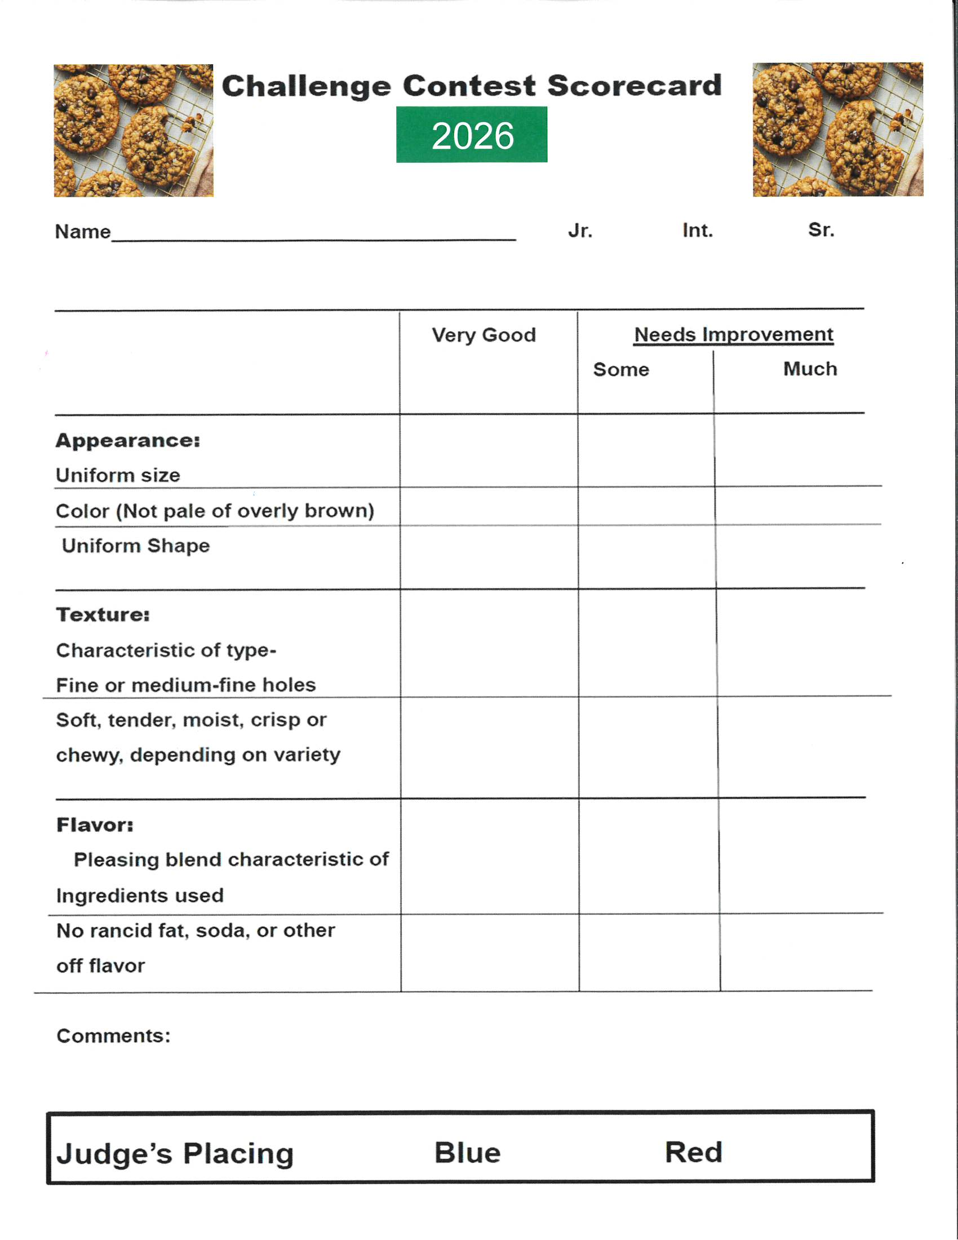

MONROE COUNTY CHALLENGE CLASS- BUCKET OF JUNK
RULES:
1. Each team will be made up of one 4-H member and one adult.
2. Each team will get one bucket. Each bucket will have similar “junk”.
3. The goal is to use all the items in the bucket to create a sculpture or lawn art piece.
4. You will need to name your creation when you turn in the finished project.
5. You may clean, sand, weld, glue, cut, bolt, fasten, bend, shape paint or finish the items that you are provided. You may add your own items, but all items form the bucket must be used.
6. Entries will be judged on artistic merit, technical merit and on the member’s Exhibit write-up.
7. All entries will be judged at the fairground’s 4-H exhibit building on Thursday, the day of regular 4-H static judging.
8. All entries must be completed and delivered to the Monroe County Fairgrounds Wednesday of fair between 5:00 pm – 9:00 pm in the Exhibit Building. Be sure to get your picture taken for the silent auction form.
9. Please return your bucket to the Extension Office; they will be used for next year’s challenge.
10. County class form for non-state fair consideration, or projects are eligible to advance to the State Fair if you fill out the 4-H Project sheet.
11. The finished projects are auctioned off at the fair by Silent Auction. The Auction will be in the Exhibit Building. The proceeds will go to Monroe County 4-H Enrollment Fund.
12. Special Cash prizes will be given to at least the top 4 challenge winners.

MONROE COUNTY CHALLENGE CLASS –CAKE DECORATING
1. Members may enter one entry in this class in their appropriate age division (Junior, Intermediate, Senior)
2. The winner is based on evaluation of product. A $5.00 cash award will be presented to the outstanding member in each age division. All entries will receive regular premium according to ribbon placing.
3. Exhibitor must use a cake form or cake dummy.
4. Cakes will only be judged based on technique, skills, and appearance. No tasting will take place. Project write up must include piping tips used in the creation.
5. All decorations must be edible.
6. Exhibitors must follow all copyright laws.
7. Exhibit entry will be on a firm cake board or cardboard which is labeled with a 4-H entry tag (FairEntry) and accompanied by the Judging Worksheet. Cake overall size cannot exceed 10”x16”x16”.
8. Will be judged Thursday of fair by the county class judge during exhibit building static project judging period.

9. All cake projects will be photographed with the exhibitor after judging, cakes then need to be thrown away or taken home. No physical cakes will be on display for the remainder of the fair.
6. Exhibits in this class are NOT eligible for State Fair consideration or exhibition.

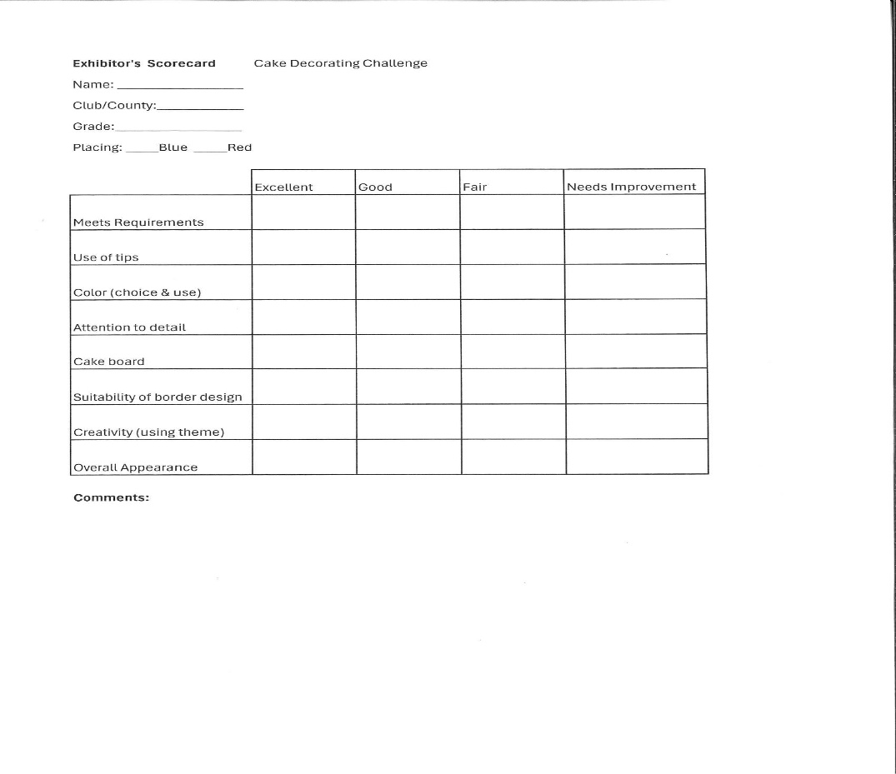

MONROE COUNTY ONLY STATIC EXHIBITS
Class Description
This class is open to any Static Exhibit the 4-H member made during the current year. Exhibit Building General Rules and 4-H Department Exhibit Class Rules and Regulations apply to the Monroe County Static Exhibits. Example: 10320 Photography rules apply to this class.
County Only Static Exhibits Special Rules:
1. Exhibits in this class are NOT eligible for State Fair Consideration or Exhibition.
2. Exhibits are eligible for Monroe County Special Awards.
3. A County Class Exhibit Form and Entry Tag (FairEntry) must be completed for each exhibit.
4-H Exhibits Class Descriptions
Most exhibit classes have specific guidelines and requirements that will be included in the judging process. Members are strongly encouraged go to www.extension.iastate.edu/4h/exhibit-tip-sheets for information on judging criteria for exhibits that they create from their 4-H project learning.
ANIMALS
10110 Animal Science - An exhibit (other than the animal itself) that show learning about a large or small animal including beef, dairy cattle, dairy goats, dogs, horse and pony, meat goats, pets, poultry, rabbits, sheep, and swine. Ownership of an animal is not required.
10120 Veterinary Science - An exhibit that shows learning about keeping animals healthy, animal diseases, animal/human interaction, or other learning related to Veterinary Science.

AGRICULTURE AND NATURAL RESOURCES
10210 Crop Production and Plant Science - An exhibit that shows learning about the growth, use, and value of field crops, plant growth, soils and soil fertility, or any other learning related to crop production and plant science.
10220 Conservation, Environment and Sustainability - An exhibit that shows the connections between humans and their environment including energy, energy conservation, stewardship, conservation, creating habitat, etc.
10222 Entomology – An exhibit (excluding live specimens) that shows learning or is an outgrowth of an entomology or bee project experience. Includes specimen collections and may include products (for example Honey) or equipment as part of the display.
10224 Fish and Wildlife - An exhibit that shows learning about a fish and/or wildlife project or program such as identification, habitats, harvest, taxidermy, etc. Any specimens must have been legally taken and must include information about date and location of harvest, and who the specimen was acquired from if not self-harvested. Feral pigs (including Russian/European Boar) are NOT permitted in taxidermy exhibits.
10226 Forestry - An exhibit, including collections, that show learning from participation in a forestry project or program.
10230 Horticulture and Plant Science - An exhibit that shows learning about the growth, use, and value of plants, soils, small fruit production, vegetable and flower gardens, plant nutrition, careers, etc. (Garden crops and herbs are exhibited in classes in the 4-H Horticulture Department under 4-H Livestock and Horticulture.)
10235 Home Grounds Improvement - An exhibit that shows learning about landscape plans, selection of landscape plants, ornamental garden features, home yard improvement, storage sheds, careers, etc.
10240 Outdoor Adventures - An exhibit that shows learning about backpacking, biking, camping, canoeing, fishing, hiking or other outdoor activities.
10250 Safety and Education in Shooting Sports - An exhibit that shows learning about safe and responsible use of firearms and archery equipment or wildlife management. (The exhibit may not include actual firearms or live ammunition. Archery equipment allowed if tips are removed from arrows).
10255 Farm Model Display- An exhibit that depends an aspect of farm life that demonstrates a practice or practices that include farm safety or farm operation. Evaluation is primarily based on a clear goal statement that outlines the purpose of the model and the research done to support the exhibit. This exhibit may be a display on a firm base no larger than 36 inches by 36 inches, accompanied by the required written or audio/video explanation of the exhibit. A binder presentation is an acceptable alternative to a physical display.
10260 Other Agriculture and Natural Resources - An exhibit that shows learning about agriculture or natural resources and does not fit in any of the classes listed above.
CREATIVE ARTS—Visual Arts & Photography
10310 Music - An exhibit that shows learning about musical performance, composition and arrangements, instruments, musical styles, or history.
10320 Photography - An exhibit, either photo(s) or an educational display, that shows learning about photography from choosing a camera to modifying your photo. Still photos only, not video.
1. Photographs may be either black and white or color. Photographs must have been taken since your county fair of the previous year. Photographs should be a minimum of 5” x 7”. Finished size (including mounting/matting) of single photographs may not exceed 11” x 14”. Square photos are allowed within the following dimensions, measured by inches 7x7, 8x8, 9x9, 10x10, 11x11. Exception: Panoramic photos must not exceed 11”x24” in length.
2. All photographs must be printed on photographic paper and must be mounted and/or matted. Maximum thickness of finished project must not exceed 1/2” thick.
3. Mounted photos can be (a) flush-mounted [no board showing] on mounting board, or (b) with mount borders [window mat or flat mount directly on board]. Exhibitors may cut their own mounting boards, use ready-cut window mats or have matting done professionally.
• 4-H members are responsible for design decisions such as mounting, matting, color, and size.
- • Framed photographs (including floating frames) will not be judged.
4. A series is a group of photographs [3 to 5] that are related or tell a step-by-step story. Photographs must be mounted together and numbered in story order or sequence. Finished size of individual photographs in a series must be a minimum of 5”x7” and should not exceed 8”x8”.
5. Edited photos should include a copy of the photo before editing.
6. Subject matter of photographs must be in good taste and be appropriate for public display in a 4-H setting.
7. Photographs depicting unsafe practices or illegal activities will not be displayed.
8. Iowa State Fair 4-H photography exhibitors must use the Photo Exhibit Label to provide required information for photo exhibits.
9. Exhibitors entered in 4-H Photography are not eligible to exhibit in the FFA Photography Show and vice-versa.
10340 Creative Photography - A photographic image that was creatively edited or modified beyond reality in a creative, imaginative, and experimental way to make it more interesting and visually engaging. The final exhibit could be a composite or multiple photographs. Must include original photograph(s).

Creative Photography Special Rules:
1. Photograph/image may be mounted/matted.
2. If mounted, photograph/image must be mounted on a foam core no smaller than 5” in length or larger than 14” length.
3. Photograph/Image can be digitally created.
4. Exhibit must have the most current Photo Exhibit Label on back with required information for photo exhibits. Exhibit write-up should include additional information about the processes and decisions used to develop the exhibit.
5. Subject matter must be in good taste and be appropriate for public display in a 4-H setting.
6. Photographs depicting unsafe practices or illegal activities will not be displayed.

10345 Photography Idea/Educational Display - An exhibit that demonstrates learning about photography that does not fit into any previous photography class. This class may include educational displays about printing, processing, editing, marketing, branding, merchandising, etc. as it relates to photography.
10540 Digital Storytelling (Entries will be entered through Personal Development Class 10540)- An exhibit that demonstrates the application of technology to produce a creative film/movie/video. Exhibits may include a finished movie or video, creation of detailed storyboard, editing techniques using digital video software, production techniques, or other display to share what was learned. Copyright permission must be obtained for any non-original material included as part of film/movie/video.

Visual Arts Rules:
1. Exhibits must be ready for (artwork framed, wall hangings and pictures ready to hang, etc.) or the member must explain how a larger, heavier exhibit will be displayed. Make sure hangers are strong enough to support the item. Command Strips or other quick attach products are usually not adequate hangers. Items not ready for display will be dropped one ribbon placing.
2. Exhibits made from kits or preformed molds will not be accepted. Exception: Preformed molds (greenware, whiteware) may be used to provide the appropriate surface for a process technique or application of original design.
3. If the exhibit is a finished art object, the source, or inspiration of the design, design sketches, or other process for creating the object and design must be included. For additional information see the Visual Arts and Design Elements & Art principles Exhibit Tip Sheets at www.extension.iastate.edu/4h/exhibit-tip-sheets.
4. If the exhibit is a finished art object, information must be included explaining the application of design elements and art principles used in creation of the work.
5. Original works of art must be a creative expression of a design unique to the artist or represent a significant modification to an existing design to make a new and original statement by the artist.
6. Exhibition of derivative works created by a 4-H member is prohibited without the written permission of the original copyright holder/owner. Use of copyrighted or trademarked designs, images, logos, or materials in 4-H visual arts exhibits is prohibited unless written permission has been obtained from the copyright or trademark holder/owner. For additional information, see 4-H Exhibit Copyright Information at https://www.extension.iastate.edu/4h/visual-art.

10350 Visual Arts Original Art - An exhibit that showcases the skills you have developed in one of more mediums. Original art is a one-of-a-kind, non-replicable design of your creation. By using one medium or a combination, an individual creates an authentic work of art that is not recognizable as another’s work. You must explain the application of the most relevant design element(s) and art principle(s) featured in this exhibit. Describe your inspirations, reasons, feelings, and/or motives for creating this work of art.
10355 Visual Arts -Design, Process, or Technique Exploration - This class emphasizes process and provides the opportunity to explore a medium, practice a skill, or study and apply elements and principles of art and design. This class is for experimenting with and practicing skills in different mediums. An explanation of the application of design elements or art principles used when making the exhibit must be included. This exhibit may be an object, portfolio, display, poster, or organized sketchbook. If a non-original design source is used, its origin (where the idea was found, any pictures, sketches, etc.) must be credited, acknowledged, or have copyright permission obtained. See visual arts special rule #5 and #6.
10360 Visual Arts - Other Visual Art Ideas/Topics - Exhibits might include the study and research about an individual artist, style, craft, business or marketing process, planning group tour, career options, etc.

FAMILY & CONSUMER SCIENCES
10410 Child Development - An exhibit that shows learning about children. An exhibit could include careers in child development, caring for children with special needs, childcare, growth and development, or safety and health. An exhibit that includes items intended for use with children, such as babysitting kits, books, learning games, or toys, must include information about what you have learned about children while creating and using the exhibit OR what the child/children learned from their use of the item(s) in the exhibit.
10420 Clothing and Fashion – Constructed/Sewn Garments & Accessories - A constructed garment or accessory (sewn, knitted, crocheted, or other process) that shows learning about style, fashion, design, thrifty spending, wardrobe planning, types of fabrics, and/or clothing care. Exhibits must be intended to be worn by humans.
10422 Clothing and Fashion – Purchased Garments & Accessories - Purchased garments or accessories that shows learning about style, fashion, design, thrifty spending, wardrobe planning, types of fabrics, and/or clothing care. Exhibits must be intended to be worn by humans.
10424 Clothing and Fashion – Other Ideas/Educational Exhibits - Any other educational exhibit that shows learning about clothing and fashion including but not limited to design illustrations, exploration of clothing styles, careers, clothing care, etc.
Clothing and Fashion Rules:
1. Outfits or accessories which will be worn during the wardrobe Clothing Event may not be entered as a 4-H Iowa State Fair exhibit.
2. Exhibits in classes 10420 and 10422 must include information about application of design elements and art principles. Exhibits in class 10424 should include information about application of design elements and art principles if appropriate for the exhibit.

10430 Consumer Management - An exhibit that shows learning through savvy budgeting, comparison shopping, money management, and consumer rights and responsibilities.
10440 Food & Nutrition – Prepared Product - An exhibit of a prepared food product that shows skills or learning about cooking, baking, eating, and choosing healthy foods, or safety practices through the making of a prepared food product. See Food & Nutrition Special Rules below and HS 76 “Foods for Iowa 4-H Fairs – Quick Reference Guide” at https://store.extension.iastate.edu/product/6434 for additional information regarding prepared food products. Display boxes are not allowed for prepared products at the Iowa State Fair.
10442 Food & Nutrition – Preserved Product - An exhibit of a preserved food product that shows skills or learning about food preservation through the making of a prepared or preserved food product. Processed honey may be exhibited in this class. See Food & Nutrition Special Rules below and HS 76 “Foods for Iowa 4-H Fairs – Quick Reference Guide” at https://store.extension.iastate.edu/product/6434 for additional information regarding preserved food products.
10445 Food & Nutrition – Educational Display - An educational exhibit (poster, report, display) that shows skills or learning about cooking, baking, eating, and choosing healthy foods, meal planning/preparation & service, safety practices, or food preservation. See Food & Nutrition Special Rules below and HS 76 “Foods for Iowa 4-H Fairs – Quick Reference Guide” for additional information regarding prepared and preserved food products. Exhibits showing learning about table setting or menu planning must include a menu.

Food & Nutrition Rules:
1. Any exhibit considered to be a food safety risk or portray a food safety risk will not be accepted, judged, or displayed.
2. All food products/exhibits should be appropriate for human consumption.
3. Food product exhibits must be prepared, baked, or cooked using only food grade utensils and containers.
4. Products that require refrigeration will not be accepted, judged, or displayed.
5. Meat jerky products are prohibited.
6. The recipe must be included for any prepared and preserved food exhibit; credit the source of the recipe.
7. Preserved foods must include the Food Preservation Exhibit Label. Only food processed after August 1, 2025, is acceptable. Current USDA and/or Iowa State University guidelines for home food preservation must be used. Processed honey must include the Honey Exhibit Label.
8. Preserved food exhibits must include two product samples. One will be opened for evaluation and discarded; the second will be placed on display and returned to the exhibitor. All perishable food products will be discarded when removed from display.
9. Prepared foods should be placed on a firm disposable plate or flat cardboard. Place food product exhibit in a Ziplock plastic bag with entry tag fastened outside the bag. Recommended number of items to include with the exhibit: Cookies, cupcakes, bars, muffins, rolls, etc. – four (4) to six (6) items Cakes, loafs, pies, etc. – one (1) whole product.
10. The use of alcoholic beverages in the preparation or production of 4-H food exhibits is NOT permitted.

10450 Health - An exhibit that shows learning through food choices, physical activity, safe activities, skills such as first aid and CPR, careers, and/or healthy lifestyle choices.
10460 Home Improvement - An exhibit that shows learning in planning, improving and caring for your home living space, including extended personal living areas immediately adjacent to the home. Exhibits may include new or refinished/reclaimed/restored items. Exhibits showing learning about home design, furniture, home accessories, and fabrics must include information about how design elements and art principles were applied.
Home Improvement Special Rules:
1. Exhibits must be ready for display (artwork framed, wall hangings and pictures ready to hang, etc.) or the member must explain how a larger, heavier exhibit will be displayed. Make sure hangers are strong enough to support the item. Command Strips or other quick attach products are usually not adequate hangers. Items not ready for display will be dropped one ribbon placing.
2. Exhibit write-up/information must include source of inspiration and/or references indicating where the idea or information was obtained, giving credit to original author(s), designer(s), artist(s).

10470 Sewing and Needle Arts – A constructed item (sewn, knitted, crocheted, or other process) that shows learning and skill in sewing, knitting, crocheting, or other needle arts. May include the construction of household items such as pillowcases, curtains, table runners, quilts, wall hangings, etc. Exhibits in this class are not intended to be worn by humans.
10472 Sewing and Needle Arts: Other Ideas/Educational Exhibits - Any other educational exhibit that shows learning about sewing and needle arts including construction techniques, use and care of fabrics and fibers, design illustrations, decorative processes, careers, etc.
Note: Exhibits in classes 10470 and 10472 should include information about application of design elements and art principles if appropriate for the exhibit.
10480 Other Family and Consumer Science - An exhibit that demonstrates learning about a family and consumer science topic that does not fit any other Family and Consumer Science class listed.
10490 Thrifty Meal Challenge – Create a balanced, nutritious meal for family of four (4) that includes a serving from each of the recommended food groups with a budget of $11. (the Supplemental Nutrition Assistance Program benefit allowance for one meal for a family of four as of November 2025).
Special Rules Thrifty Meal Challenge:
1. Each county may advance one (1) exhibit in this class to the Iowa State Fair.
2. All entries will receive an evaluation and ribbon.
3. Exhibit may be from an individual or group effort.
4. The total expense on receipt(s) must not exceed $11.
5. The meal must serve four (4) people, with a serving for each person from each of the recommended food groups: Protein, Dairy, Healthy Fats, Vegetables, Fruits, Whole Grains.
a. Recommended portion sizes per person: 3 ounces protein, 1 cup dairy, 1 Tablespoons healthy fats, ½-1 cup vegetables, ½ cup fruit, ½-1 ounce whole grain.
b. If there is a dairy allergy, you may substitute it with calcium-rich item, but you will need to indicate the allergy and identify how the item substituted provides enough calcium.
6. The exhibit will be a poster or foam board (maximum size 22” x 28” or 20”x30”) that includes:
a. The menu, a list of food items, and appropriate portions size for each food item.
b. Menu type (breakfast, lunch, or dinner).
c. Copy of grocery receipts (up to 2)
d. Photos of participant experience: grocery shopping, food preparation, and prepared meal.
e. The completed Thrifty Meal Challenge Worksheet attached to the back of the poster.
f. Failure to include the above documentation or adding a folder or binder will drop the exhibit one ribbon placing.
For more information about this: https://www.extension.iastate.edu/4h/meal-challenge.

PERSONAL DEVELOPMENT
10510 Citizenship and Civic Engagement - An exhibit that shows learning about or contributing to your community, your country, or your world.
10520 Communication - An exhibit that shows learning about written, oral, or visual communication skills. Includes learning from participation in Theatre Arts projects or programs such as puppets, stage design, etc. May include original creative writing, poetry, fiction, and non-fiction, etc.
Purpose: Provide an opportunity for 4-H’ers to communicate with and tell a story or idea visually about 4-H to the general public using the non-verbal form of communication on a poster.
10530 4-H Poster Communication Exhibit –Special poster exhibit to visually tell a story or idea about 4-H to the general public. Exhibitors must use one of the following themes:
• 4-H is . . . (open to 4-H members interpretation)
• Join 4-H
• Beyond Ready in 4-H (2025 National 4-H Week theme)
• 4-H Spirit (variation of 2026 Iowa 4-H Youth Conference theme)
• 4-H for America’s Next 250 Years (Celebrating America’s 250th birthday)
4-H Poster Communication Rules:
1. Only one poster per 4-H member may be entered. Limit of two posters per county can advance to the Iowa State Fair.
2. All posters must be designed on, or affixed to, standard poster board or foam core board -- size minimum of 14” x 20” or maximum of 15” x 22”.
3. Posters may be vertical or horizontal.
4. Posters may be any medium: watercolor, ink, crayon, acrylic, charcoal, oils, collage, digital image, etc. If digital image or a computer program is used to create the finished poster, the member needs to cite their sources on the Poster/Exhibit Entry Form.
5. Posters cannot be 3-dimensional. Materials used to make the poster may not extend more than 1/8 inch above the poster or foam core board.
6. Each poster must have the completed Poster Exhibit Entry Form attached to the back.
7. Posters cannot use copyrighted material or exact copies of other promotional designs, such as the Iowa 4-H Youth Conference theme logo.
8. 4-H members may include the 4-H clover in the poster.
9. All 4-H Communication Poster participants will receive Certificates of Recognition and written evaluation comments. Outstanding posters will receive Seals of Merit. Superior poster will receive Seals of Excellence.

10540 Digital Storytelling – (See also Creative Arts) An exhibit that demonstrates the application of technology to produce a creative movie/film/video. Exhibits may include a finished movie or video, creation of a detailed storyboard, editing techniques using digital video software, production techniques, or other display to share what was learned. Copyright permission must be obtained for any non-original material included as part of a film/movie/video.
10550 Leadership - An exhibit that shows learning about leadership skills and influencing others in a positive way.
10560 Self-Determined - An exhibit that shows learning as part of your 4-H adventure and does not fit any other class.
Personal Development Special Rule:
1. Exhibits entered in the Personal Development classes should include reflection by the 4-H member stating how they personally grew or benefited from the exhibit. Why was this exhibit important to them as a person?

SCIENCE, ENGINEERING & TECHNOLOGY
Science, Engineering, and Technology Special Rule:
- Exhibitors entered in the 4-H Science, Engineering & Technology classes are not eligible to exhibit in similar FFA Ag Mechanics classes and vice-versa.
- Exhibits must be ready to display (artwork framed, wall hangings and pictures ready to hang, etc.) or the member must explain how a larger, heavier exhibit will be displayed. Make sure hangers are strong enough to support the item. Quick attach products are usually not adequate hangers, items not ready for display will be dropped one ribbon placing.

10610 Mechanics - An exhibit that shows skills or learning about general mechanics or engineering solutions, or that combines skills related to the design, construction, and repair of structural and mechanical technologies.
10612 Automotive - Repaired or restored vehicle (Note: vehicles will be on display at the Iowa State Fair one day only, (tentatively) Thursday August 13.)
10613 Automotive - Educational display showing learning about an automotive idea including automotive maintenance, auto operations, auto safety, or automotive systems.
10614 Electric - Constructed or repaired article or educational display that shows skills or learning about electric wiring, appliances, lighting, electrical energy sources, safety, etc.
10615 Small Engine - Repaired or restored operating engine or educational display or other type exhibit that shows skills or learning about small engines. This class includes repaired or restored lawn tractors, small motorcycles, go-karts, etc.
10616 Tractor - Repaired or restored tractor (lawnmower or larger). Note: A conference judging opportunity for exhibitors of repaired or restored tractors in class 10616 will be offered during exhibit check-in at the Monroe County Fair. (Conference judging may not be available during all check-in times.) Tractors will be displayed outside throughout the Monroe County Fair. Release time Sunday, of fair, after 9:00 p.m. Please bring chocks for back tires of tractor.
10617 Tractor - Educational display showing learning related to tractors, tractor mechanics, tractor operations, or tractor safety.
10618 Welding - Constructed item or educational display that shows skills or learning about welding.
10620 Woodworking - An exhibit that shows learning about wood, woodworking techniques, and safe uses of woodworking tools and machines. Exhibits may include newly constructed or refinished/reclaimed/restored wood items.
10630 Science, Engineering & Technology - An exhibit that shows learning about or helps explain how science and technology help us interact with the world. Topics include aerospace, biological and chemical sciences, computers & networking, earth & climate, geospatial mapping (GPS/GIS) or any other application of Science, Engineering, or Technology.
10632 Aerospace - Educational display or other exhibit (including flyable models) showing learning about an aerospace idea or topic.
10634 Robotics - Educational display or other exhibit (including working robots) that shows learning about robotics and robotic systems.

4-H CLOTHING AND COMMUNICATION EVENT

Superintendent
Jody Buckingham

CLOTHING AND COMUNICATIONS RULES:
The Monroe County Clothing Event will be held at Monroe County Fairgrounds Exhibit Building starting at 2:00p.m., on Monday, July 27th, 2026.
1. Members wishing to participate in the Monroe County Clothing Event must be registered by Monday, July 9, 2026, at 4:30p.m. Please register by calling, emailing, or stopping by the Extension Office.
2. Members must have their appropriate judging forms completed before the event and must include a picture of yourself in the outfit.
3. Pick up appropriate judging forms at the Office or on-line at www.extension.iastate.edu/monroe
4. General appearance, posture and accessories will be taken into consideration. Awards and premiums will be presented at a style show to be held at the Monroe County Fair (Please see Fair Schedule for date and time). State Fair winners will be announced at that time from among the senior members.
5. All participants will receive ribbon premiums. An added $10.00 bonus per participant will be presented by the Monroe County Fair Board to all exhibitors that participate in the Clothing and Communications Event at the 2026 Monroe County Fair. (see Fair Schedule for date and time)
6. To be eligible for the Iowa State Fair 4-H Clothing Event, a member must be in the senior 4-H designated level (completed grades 9-12 the same year as the event).
7. Each county may send the following number of participants in each class to represent their county, selected from each of the county’s events:
a. Fashion Revue Class: Four participants total with no more than two (2) participants with an entry in any given category (athletic wear, formal wear, everyday wear, costume).
b. $20 Challenge Class: Four participants total with no more than two (2) participants with an entry in any given category (athletic wear, formal wear, everyday wear, costume).
c. Clothing Selection Class: Four participants total with no more than two (2) participants with an entry in any given category (athletic wear, formal wear, everyday wear, costume).
d. Innovative Design Class: Four participants total with no more than two (2) participants with an entry in any given category (athletic wear, formal wear, everyday wear, costume).

FASHION REVUE (constructed clothing garment)
1. The purpose of this class is to encourage the construction of a personal garment or outfit.
2. Consideration is given to fit, color, style, suitability, quality of construction, stage presentation, and required care.
3. Youth participants will model a garment or outfit they constructed, hand-knitted, machine-knitted, or crocheted during the current 4-H year.
4. A garment or outfit consists of one to three pieces such as, but limited to, party clothes, tailored suits, vest, slacks, shirt, skirt, active sportswear, and/or coats.
5. Blouses, shirts, and sweaters are usually considered garments. If they are used to complete an outfit, they may be constructed or selected.
6. All other accessories and undergarments may be constructed or selected.

CLOTHING SELECTION (purchased clothing)
1. The purpose of this class is to select and/or purchase an outfit that represents the 4-H member’s goal or intended use for the selected outfit.
2. Judging is based on fit, color, style, suitability, quality and construction features, stage presentation, required care, and cost comparison.
3. There is no consideration in the judging on the amount spent, only in the process of record keeping and reflection on the cost of the individual item as part of the process.
4. Outfits may be purchased at a department store, boutique, online store, sidewalk sales, retail shops or mall stores. Outfits may also be purchased at garage sales or other secondhand venues at any price point. Outfits may be gifts, hand-me-downs, relative or friend’s modern or vintage clothing, or existing personal clothing, as long as the 4-H member selected the item as part of this specific outfit for the stated purpose.
5. Home sewn clothing that was not sewn specifically for the participant are acceptable, such as purchases from a used clothing store.

THE $20 CHALLENGE
1. The class is designed to expand the 4-H member’s shopping experience to shopping venues emphasizing recycling, reducing, and reusing. Outfits must be purchased at a garage sale, consignment store, thrift store, secondhand store, or similar place. This class is not for new clothing, regardless of price.
2. Online venues are allowed and must be second-hand in nature. Shipping and handling are not included in the total calculations.
3. Traditional shopping venues may not be used, regardless of a low regular or sale price. Hand-me-downs or clothing as gifts do not qualify for this class.
4. Twenty dollars is the purchase price limit including tax. However, some secondhand stores and venues do not charge sales tax.
5. Receipt(s) for every item included as part of the calculated total must be submitted with the entry. A garage sale receipt can be a piece of paper with the name of the location such as “Jane Doe garage sale”, date, amount paid, and signature of person selling at the garage sale. If the outfit was free at the garage sale, “free” can be listed on the report form and the receipt. Failure to provide receipts will be reflected in the evaluation.
6. An outfit consists of major clothing pieces such as a shirt, sweater, jacket, and pants and/or a dress. Shoes, undergarments, and accessories are not included in the $20 purchase price limit.
7. Alterations are permitted to achieve a desired look or fit.
8. There is no additional considerations for an outfit that totals less than $20.
9. The outfit pieces should be purchased to meet the 4-H member’s goal or intended use for the purchased outfit, and the 4-H member should have had an experience in choosing shopping alternatives, evaluating fit, quality and construction features, price, and cost comparison.

INNOVATIVE DESIGN
1. The purpose of this class is to encourage creativity and out-of-the-box thinking when creating an outfit.
2. These designs can be theatrical costumes, cosplay, wearable technology, sustainable/upcycled fashion, accessible fashion, and/or outfits that use unconventional materials.
3. The outfit must be showcased as a worn garment modeled by the exhibitor or by the individual that it was designed for.
4. Exhibitors may make their garment entirely or permanently alter the silhouette of pre-existing materials through some method of permanent alternation or addition.
5. Consideration is given to originality and innovation.

COMMUNICATIONS
PURPOSE: The Communication Event program provides opportunities for 4-H youth to develop their personal communication skills by sharing talents, knowledge, or information with others. The events provide a series of developmental experiences for different age levels.
1. The County Communications judging event will be Monday, July 27, 2026, 1:30p.m. at the Monroe County Fairgrounds Exhibit Building. Judging will begin in the afternoon. All members must sign up for the Communication Event at the Monroe County Extension Office by Monday July 9, 2026, at 4:30p.m.
2. Counties may send up to 6 Educational Presentations, 4 Working Exhibits, 3 Share-The-Fun, and 2 Extemporaneous Speakers. Limit of two (2) 4-H Poster Communication entries per county. Iowa State Fair participants must be 5th-12th grade. See individualized event rules for variations on these guidelines.
3. Judges will make final decisions and awards will be given at the Communications Event during the Fair.

GENERAL COMMUNICATION EVENT PROGRAM RULES AND
REGULATIONS:
1. 4-H members who have completed 4th grade through 12th grade (or that equivalent) in 2026 are eligible to participate.
2. Educational Presentations and Working Exhibit may be given by one or more 4-H members. Teams consisting of youth of mixed grades will be entered in the class of the member in the highest-grade level (i.e. a team with a 5th grader and an 8th grader must be entered in the intermediate/senior class).
3. Topics selected by the 4-H members should be an outgrowth of their 4-H experience(s) or learning in their project area. Topics should be appropriate for presentation to a general audience.
4. Participants in the 4-H Communication Program are expected to wear appropriate clothing representative of the 4-H Youth Program and/or the topic of the presentation. Where distinctive clothing is not involved, clothing that alerts the public that it is a 4-H member giving the presentation is strongly encouraged.
5. 4-H members must always use sanitary and safe procedures and methods at all times. Educational Presentations and Working Exhibits involving food must follow established food safety guidelines, including HS 76 “Foods for Iowa Fairs- Quick Reference Guide” found at https://store.extension.iastate.edu/product/6434.
6. All participants are expected to comply with all copyright/trademark regulations. Copyrighted material may not be distributed without permission.
7. All participants will receive ribbon premiums. An added $10.00 bonus per participant, will be presented by the Monroe County Fair Board to all exhibitors that participate in the Clothing and Communications Event at the 2026 Monroe County Fair. (see Fair Schedule for date and time)

11100 Educational Presentation- Provide an opportunity for 4-H members to demonstrate communication skills by presenting knowledge, information, or a process to an audience.
Educational Presentation Rules:
1.Time limit. Junior Presentations (5th and 6th grade) must not exceed 15 minutes. Intermediate/Senior Presentations (7th-12th grade) must not exceed 20 minutes. Presenters will be verbally told to “STOP” when they exceed the time limit.
2. Participants must turn in a completed Educational Presentation Report form during event check-ins.
3. Presentation content must be the original work of the presenter(s). Extensive paraphrasing from other sources is prohibited. Use of brief quotations or excerpts from other work(s) is permitted provided the source is identified.
4. A judge’s critique/conference with each participant will be included.

11200 Working Exhibit- Provide an opportunity for 4-H members to communicate, interact with, and teach an audience in an informal and experiential way.
Working Exhibit Rules:
1. Time limit: All participants/teams will be scheduled for a 30-minute period.
2. Participants must turn in a completed Working Exhibit Report form during event check-in.
3. 4-H members may participate in one Working Exhibit per year.
4. A judge’s critique/conference with each participant will be included.

11300 Share-The-Fun- Provide the opportunity for 4-H members to share their skills and talents before an audience purely for the sake of enjoyment.
Share-The-Fun Rules:
1. Eligibility: 4-H members who have completed 5th grade (or that equivalent) in 2026. Exception: If the Share-The-Fun act involves a whole club, the following criteria must be applied to determine if the club can be entered in the Share-The-Fun Program at fair.
*At least 80 percent of the performing group must have completed 5th through 12th grade in 2026.
*Clover Kids are not eligible to participate.
2. Share-The-Fun performances must not exceed six (6) minutes in length.
3. Skits, songs, stunts, short one-act plays, dance, and other entertainment are acceptable. All performances must be appropriate for presentation to a general audience.
4. All acts must turn in a completed 4-H Share-The-Fun Report form at the event check in to confirm stage setup, cue music, etc.
5. General judge’s comments for the entire show will occur at the fair. No individual conference with the judge will occur.

11400 Extemporaneous Speaking- Encourage the development of communication skills by providing an opportunity to think, organize thoughts, prepare a speech, and respond to questions when given a limited amount of preparation time.
Extemporaneous Speaking Rules:
1. Participants must be senior 4-H members- completed 9th through 12th grade (or that equivalent) in 2026.
2. Each county may enter a maximum of two (2) entries. Individuals may participate once per year at the fair.
3. Program format:
a. Thirty minutes before the speech, each participant will draw three of the available topics, selecting one to speak on
*The selected topic will not be available to the other participants in the speaker’s assigned room. The general nature of the topics will be related to 4-H. The other two topics drawn but not chosen will be returned to the available topics for the other participants.
b. A preparation room is to be used with one participant per speaking site admitted initially and one additional participant per speaking site admitted every 15 minutes as the program progresses. A participant may not leave the preparation room until it is time to speak, nor may a participant receive help from a parent, leader, other adult, or any other youth. A program official will assist participants with the time requirements.
c. All reference material must be screened by a program official on the following basis:
*Participant may bring their own books, magazines, or newspaper clipping for referment during the thirty minutes of preparation.
*Reference material must be printed material such as books, or magazines (cannot be notes, outlines, or speeches prepared by the participant or by another person for use in the program).
*Some relevant material will be available in the preparation room. This material will consist of historical material related to the 4-H program.
d. Each speech shall be the result of the 4-H member’s own efforts using approved reference material that a participant may bring to the preparation room. No other assistance may be provided. Plain note cards will be provided for each participant in the preparation room. If the notes are used, the note cards provided must be used in delivering the speech.
e. Only notes made during the preparation period may be used.
f. Each speech shall be not less than four but no more than six minutes with five minutes additional time allowed for related questions, which shall be asked by the judge. The participant will be shown timecards in an ascending order (1, 2, 3, 4, 5) by the timekeeper. “Stop” will be said at six minutes.
g. The program keeper will introduce each participant by name, the county they represent, and read the selected question.
h. Participants are not permitted to use any props, gadgets, posters, or audiovisuals of any sort. A podium will not be available.
4. Speeches will be evaluated using the following criteria:
a. Content related to topic
b. Knowledge of subject
c. Organization of material
d. Power of Expression
e. Voice
f. Stage presence
g. General effect
h. Response to questions
5. A judge’s critique/conference with each participant will be included.

FFA EXHIBIT RULES
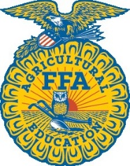
Advisors-
Melissa Appel- Agri-Power FFA
Alicin Hindman- Albia FFA
Jordan Moody- Twin Cedars FFA
Arianna Weilbrenner- Moravia FFA

Monroe County Fair FFA Exhibit Classes
Open to any FFA member of the Albia, Agri-Power, Moravia, or Twin Cedars Chapters.
All entries must be entered on Tuesday of the fair between 9:00-Noon
Entries must be picked up by 4pm on Fair Clean-Up Dat
Classes may be added at fair depending on category and class.

Ag Mechanics
Maximum of 2 entries per class in Ag Mechanics
All projects should be the work of the exhibitor
Class #
AM-1 Restored Tractor
AM-2 Computer Designed Projects
AM-3 Restored Farm Equipment
AM-4 Outdoor Woodworking
AM-5 Small Metal Working/ Welding (under 9 Sq Ft)
AM-6 Medium Metal Working/ Welding (9-30 Sq Ft)
AM-7 Large Metal Working/ Welding (Over 30 Sq Ft)
AM-8 Indoor Woodworking
AM-9 Class Project

Photography
1 side of photo must be a minimum of 6.5 inches.
No side of photo may be larger than 14 inches.
Matted frame recommended but not required.
Class #
P-1 Animals-Birds-Wildlife (Black & White or Color)
P-2 Still Life Compositions (Advertising Products) (Black & White or Color)
P-3 Iowa Landscape (The surroundings in Iowa in which we live) (Black & White or Color)
P-4 Landscape (Outside Iowa) (The surroundings outside of Iowa) (Black & White or Color)
P-5 Plants
P-6 FFA (Activities- Events- Projects- Etc.) (Black & White or Color)
P-7 Supervised Ag Experience (Must be the students SAE project) (Black & White or Color)
P-8 Ag Photo Essay (3-6 photos, no captions, all photos 5x7 or 8x10) (Black & White or Color)
P-9 Other (Black & White or Color)

Farm Crops

Class #
Corn
FC-1 Single Ear Dent Corn (10 Ears Dent Corn (Last year’s harvest)
FC-2 10 Ears Dent Corn (Last year’s harvest)
FC-3 Longest Ear-Any Corn Hybrid (Last year’s harvest)
FC-4 Gallon Shelled Corn- Dent Corn (Last year’s harvest)
FC-5 5 Ears New Crop Dent Corn

Popcorn/Ornamental Corn
FC-6 Popcorn 10 Ears
FC-7 Ornamental 5 Ears
FC-8 Ornamental Miniature 5 Ears (Ears less than 5” long)
FC-9 Ornamental Single Ear

Small Grains
FC-10 Gallon Jar- Any Wheat
FC-11 Gallon Jar- Any Oats
FC-12 Gallon Jar- Other Small Grain

Soybeans
FC-13 Gallon Jar- Any Soybeans (Last year’s harvest)

Sheaf Grains
FC-14 3” Sheaf of Any Wheat
FC-15 3” Sheaf of Any Oats
FC-16 3” Sheaf of Any Other Small Grain

Forages/Grasses/Legumes Sheaf
FC-17 3” Sheaf Any Alfalfa/Clover
FC-218 3” Sheaf Any Grass

Floriculture
Entries must be shown in a narrow-mouthed bottle of vase.

Class #
F-1 Dahlias Any Color (1 Bloom)
F-2 Roses Any Color (1 Stem)
F-3 Gladiolus Any Color (1 Spike)
F-4 Marigolds Any Color (1 Stem)
F-5 Zinnias Any Color (1 Stem)
F-6 Petunias Any Color (1 Spray)
F-7 Other Annual Any Color (1 Bloom/ Stem/ Spray)
F-8 Other Perennial Any Color (1 Bloom/ Stem/ Spray)

Horticulture
All exhibits must be placed on a white paper plate.
All exhibits must show variety name.

Class #
H-1 Beans/ Peas 6 specimens
H-2 Carrots 3 specimens
H-3 Cucumbers 2 specimens
H-4 Onions 3 specimens
H-5 Peppers 3 specimens
H-6 Squash 1 specimens
H-7 Sweet Corn 2 ears
H-8 Tomato 3 specimens
H-9 Other (Smaller than a softball) 3 specimens
H-10 Other (Larger than a softball) 1 specimens

All Other Ag
Exhibits must include a written explanation of their connection to Agriculture.
All types of exhibits are allowed.

Class #
AA-1 All Other Agriculture Projects Any Project

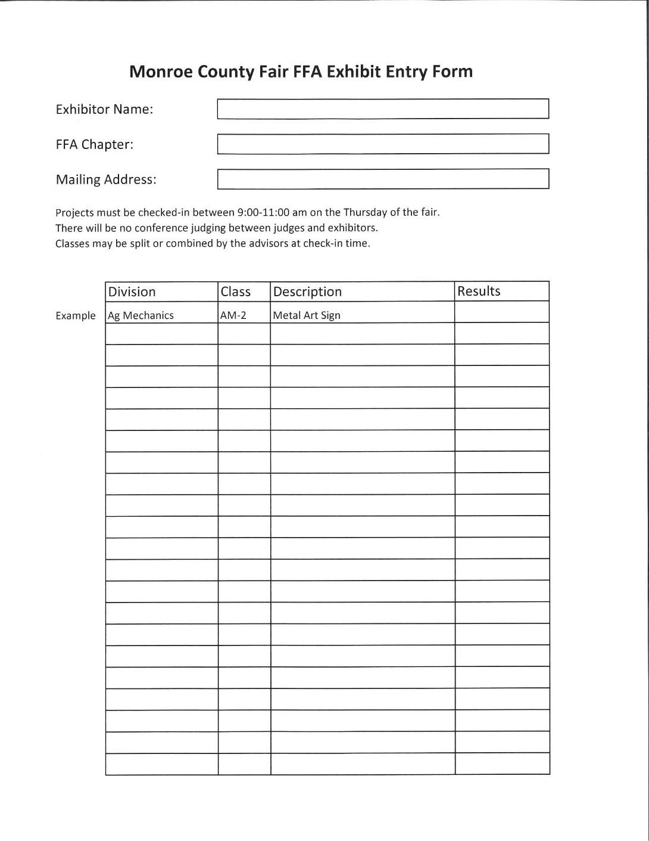

Monroe County Clover Club

General Rules:
1. Youth MUST be enrolled in a Clover Club in Monroe County 4-H online and any dues must be paid.
2. Clover Kids must attend a minimum of (6) six club meetings, Club Activities or Club Service Projects
3. Clover Club participation will be non-competitive.
4. Each exhibit will receive a Clover Club ribbon—not 1st, 2nd, or 3rd place ribbons.

Exhibit Building Entries:
1. Each Clover Club member will be eligible to bring 3 exhibits to the 4-H Exhibit Building on Thursday of fair 8:00 am—12:00 pm.
2. Clover Club members will sit with a “judge” who will talk to them about their exhibits. This is called conference judging.
3. Exhibits will be on display in the exhibit building during the fair.
4. Clover Club exhibits will be released Sunday of fair from 8:00 pm– 10:00 pm and Monday of fair between 8:00 am—12:00 pm.

Some Exhibit examples are, but not limited to…
Cookies, Drawings, Craft Items, and so much more! Anything that you can make…you can bring to the fair!
That includes all the great craft items that were made during your Clover Club meetings or workshops this past school year!

Clover Kids Clothing:
1. Clover Kid may bring 1 outfit in Fashion Revue, $20 Clothing Challenge, Clothing Selection or Innovative Design (see 4-H Clothing Section for class descriptions) to the Clothing and Communication judging on Monday, July 27, 2026, at 2:00pm and the Clothing and Communication event on Saturday evening of fair. Must be registered by Monday, July 9, 2026, at 4:30p.m. Please register by calling, emailing, or stopping by the Extension Office.
2. Members must have their appropriate judging forms completed before the
event and must include a picture of yourself in the outfit. Pick up appropriate
judging forms at the Office or on-line at www.extension.iastate.edu/monroe.
3. Clothing Exhibit does not count towards the 3 exhibits in the Exhibit Building.
4. Clover Kid may also participate in the Clothing and Communication event on Saturday evening of fair.

Clover Kid Livestock Rules:
1. Youth MUST be enrolled in a Clover Club in Monroe County 4-H online and any dues MUST be paid.

2. Youth MUST have attended a minimum of (6) six Clover Club Meetings, Club Activities or Club Service Projects.

3. Clover kids can show in either Bottle Calf Show, OR Bottle Goat/lamb show, one or the other not both.

4. Bottle project will be brought to fair on Wednesday and stay until Monday.

5. Animals must be inspected by fair veterinarians prior to unloading through designated scale areas.

6. Clover bottle projects cannot be sold at auction.

7. Clover bottle projects may not return the following year.

8. Clover Kid participation will be non-competitive.

9. Each exhibit will receive a Clover Kids ribbon – not a 1st, 2nd, or 3rd place ribbon.

10. All livestock shown by Clover Kids must be Identified on 4-H online 2.0 by May 15th.

11. Animals must be entered on FairEntry.

Clover Kids Bucket Calf Show: Superintendents – Allison and Andrew Schnebly
1. Any newborn or orphan calf, male or female, dairy or beef crossbred that has born between January 1, 2026, to May 15, 2026. Must be purchased and in possession of member within two weeks of birth: identified by an 840 or 4-H tag and identified on 4-H Online 2.0 by May 15. (Tags can be picked up in the Extension office)
2. Calf must be bucket or bottle fed. (No nursing permitted)
3. An exhibitor may identify 1 calf and is eligible to be shown only in the Clover kids Bucket-Bottle Calf Class on Sunday of fair.
4. Calves will be shown at halter. They will be divided into classes depending on the number of entries and at the discretion of the superintendents. After Wednesday check-in for fair, superintendents will divide into divisions: school grades (K-3) for the 2025-2026 school year. This will depend on number of entries – some groups may be combined.
5. Judging will be based on:
a. What the member has learned about care and development of the calf (interview in ring & Clover kids record sheet), Clover kids record sheet can be picked up the office and is in fair book following these rules.
b. Poster to be hung above stall showing Clover member with calf.
6. The Clover Kids will receive their ribbons following the judging in the ring.
7. Clover kids Project Bucket Calves may not return the following year as a clover project and are not eligible to sale at the Fair Auction, but they may sell at private treaty.
8. A bucket/ bottle calf that was raised, and shown, by a Clover Kid in 3rd grade can return the following year with the same 4th grade 4-H participant as a Bucket Calf +1.

Clover Kids Bottle Goat & Lamb Show: Superintendents – Refer to page 40 & 63
1. Any newborn or orphan lamb/goat, male or female, dairy or meat, crossbred that was born between January 1, 2026, to May 15, 2026. Must be purchased/farmed and in possession of member within two weeks of birth: identified by 4-H tag and identified on 4H online and must have a scrapie tag in place by fair. 4-H tags can be picked up at the Extension Office
2. Lamb/Goat must be bottle fed (NO Nursing Permitted)
3. NO BUCKS WILL BE PERMITTED TO SHOW IN BOTTLE CLASS
4. Projects will be shown at halter or chain. They will be divided into classes depending on the number of entries and at the discretion of the superintendents. After Wednesday check-in for fair, superintendents will divide into divisions: school grades (K-3) for the 2025-2026 school year. This will depend on number of entries – some groups may be combined.
5. Judging will be based on:
a. What the member has learned about care and development of the goat/lamb (interview in ring & Clover Kids record sheet), Clover Kids record sheet can be picked up the office and is in fair book following these rules.
b. Poster to be hung above stall showing Clover member with lamb/goat.
6. The Clover Kids will receive their ribbons following the judging in the ring.
7. Clover Kid’s Project Bottle Goat & Lambs may not return the following year as a clover project and are not eligible to sell at the Fair Auction, but they may sell at a private treaty.

Notes

Notes

