Kenmare Wheels & Meals

221 North Central Ave
Kenmare, ND 58746
Office Hours: 9:00 am-2:00 pm
Office Phone: 701-385-4364
Toll-free: 1-877-385-4364
Email: Kwheelsmeals@outlook.com

September 2026

Service to Minot Available Every Tuesday $12.00
OPEN TO THE PUBLIC

REMINDERS
September 7th Labor Day
Office Closed, No Transit
Meal Sites Closed
Frozen Meals are Available


Kenmare W & M Board Meeting
October 28th 2026 @ 2:00

Flu Shot/Vaccination Clinic
September 28th
Memorial Hall

OPEN TO THE PUBLIC
9:00 am-12:00 noon
1:00 pm-2:30 pm

(Remember to bring your Ins / Medicare Card)

Kenmare Transit is Offering Complementary Rides to Flu Shot Clinic 9/28/2026

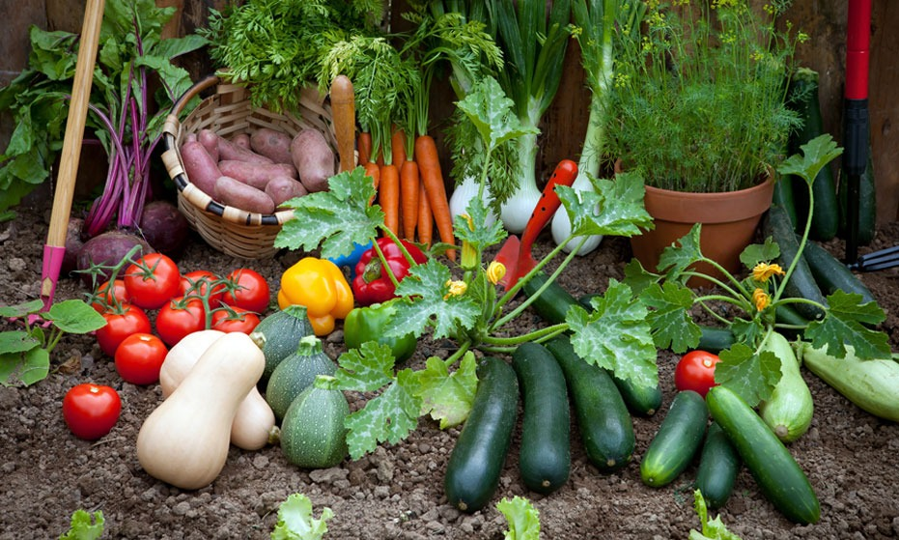

Thank You to our local gardeners. They bring local garden-fresh produce for all our clients to enjoy

Can Gardening Help Maintain
Your Brain?
Scientists and Medical Experts around the world say YES
Many of our clients have grown gardens all their lives – and continue the tradition every summer. Who can resist a garden-fresh tomato?
Just visiting a garden can boost your mood and reduce stress. Sights, scents, and colors often bring back pleasant memories. One 2006 study from the University of New South Wales, which followed Australian men and women throughout their sixties, found that those who gardened on a daily basis had a 36% lower risk of developing dementia than those who didn't. In 2015, Norway became one of the first countries to create a national dementia care plan, which includes government-offered daycare services such as Inn på tunet – translated as "into the yard" – or care farms. Now, as researchers recognize the vast cognitive benefits of working on the land, more communities are integrating gardening into healthcare – treating all kinds of health needs through socially-prescribed activities in nature, or green prescriptions..
The Netherlands and Norway lead the world with over 1,000 care farms each, while the United Kingdom, France, Italy, Belgium, Germany, and Austria also have well-established systems. The practice also exists in North America, Japan, and South Korea.
We must keep to the tradition of gardening for our current and future brain power – and those wonderful tomatoes!

