**Kenmare Wheels & Meals**

**221 North Central Ave**

**Kenmare, ND 58746**

**Office Hours: 9:00 am-2:00 pm**

**Office Phone: 701-385-4364**

**Toll-free: 1-877-385-4364**

**Email:** [wandm@restel.net](mailto:wandm@restel.net)

**www.wheelsandmeals.org**



**October 2025**

🚍 **Ride to Minot – Every Tuesday!**

Open to the Public $12.00 round trip!

**REMINDERS**



**Kenmare W & M Board Meeting**

**November 12th @ 1:00**

**Open to the Public**

**Margaret Peterson**

**Help us celebrate our favorite cook**

**“Wish her a Happy Birthday”!!!!!**

Medicare Part D plans renew automatically, but you should still review your plan annually during the Annual Election Period (AEP) (October 15 – December 7). You must read your plan's Annual Notice of Change (ANOC), which details cost and coverage changes for the next year, and consider switching plans if it's no longer the best fit for your needs. If you do nothing and like your current plan, it will remain in place. Information on all sorts of insurance questions can be answered at the ND Insurance Department. 1.888.575.6611

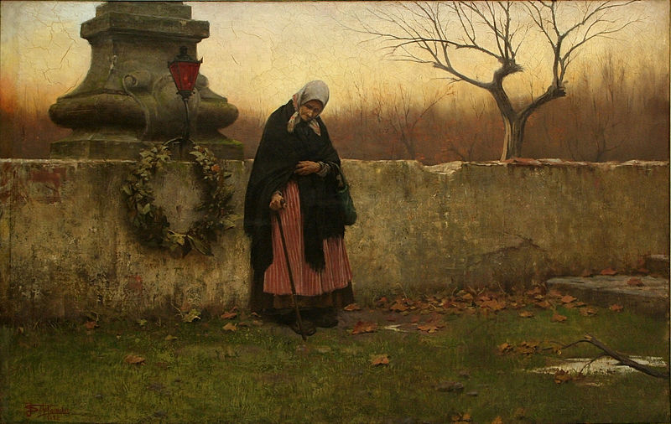

“ALL SOULS DAY” Jakub Schikaneder 1888

**2025** LIHEAP will begin issuing heating assistance payments Oct. 1. The program has moved to a year-round eligibility model, which means **if you are currently approved for LIHEAP, you do not need to reapply.** If you are unsure whether you need to reapply, you can confirm your status by logging into the Self-Service Portal (SSP) https://www.hhs.nd.gov/applyforhelp/ssp-help. 1.866.614.6005 or 701-328-1000; 711 (TTY)

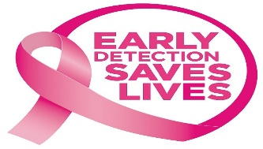.

About one in eight North Dakota women will get breast cancer during their lifetime. The exact cause of breast cancer is unknown. However, specific risk factors may increase the likelihood of developing breast cancer, including -being a woman.

**Women's Way:** This is North Dakota's official breast and cervical cancer early detection program. It provides screening mammograms, diagnostic mammograms, and other necessary tests for eligible low-income, uninsured, or underinsured women aged 40-64.

<https://www.hhs.nd.gov/health/women/womens-way>

<https://bc.screend.org/>

Many common fears can happen at any time of the year, not just Halloween

* ***Astraphobia: Fear of Thunder***
* ***Ombrophobia:****Fear of Rain*
* ***Psychrophobia : Fear of the Cold***
* ***Lilapsophobia:****Fear of Tornados*
* ***Homichlophobia:****Fear of Fog*

