-+ Kenmare Wheels & Meals
221 North Central Ave
Kenmare, ND 58746
Office Hours: 9:00 am-2:00 pm
Office Phone: 701-385-4364
Toll-free: 1-877-385-4364

Email: wandm@restel.net
www.wheelsandmeals.org

DECEMBER 2025
Transit Service to Minot – Every Tuesday
Open to the Public $12.00 round trip Agency Closed Dec 25-26 & Jan 1st
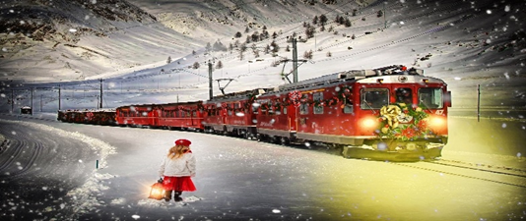

Holiday Train Dec 18th 8:30

Wishing you a joyful and peaceful Christmas season!
Thank you for your kindness, support, and the light you’ve shared throughout the year. We are truly grateful.
As we celebrate, it’s wonderful to remember that Christmas is enjoyed in beautiful and diverse ways around the world, the spirit of Christmas connects us all. No matter where we are, the heart of the season remains the same: gratitude, togetherness, and hope.
May your holidays be filled with warmth, and may the coming year bring you joy and new blessings.
Merry Christmas from your friends @ Kenmare Wheels and Meals

Thank you for the continued funding from Inspiritus. We received $7,500 to support the Burke Co FY26 Home Delivered Meal program

Christmas Around the World
Europe
Sweden: Celebrates Saint Lucia Day on December 13 and has traditions like a straw yule goat.
Finland: Believed to be the home of Santa Claus (Joulupukki), with traditions including a Christmas Eve sauna.
Spain: Festivities continue until January 6, when the Three Kings (Reyes Magos) bring gifts.
Netherlands: Celebrations begin with Sinterklaas on December 5.
Italy: The Feast of the Seven Fishes is a traditional Christmas Eve dinner.
Poland: The focus is on Christmas Eve (Wigilia) with a 12-course meal and waiting for the first star.
Czech Republic and Slovakia: The traditional Christmas meal includes carp, which some keep in the bathtub for good luck.
Asia and the Pacific
Philippines: Celebrates the longest Christmas season, starting in September. The Giant Lantern Festival is a popular tradition.
Japan: Christmas is not a religious holiday but a celebration of togetherness. Many couples exchange gifts, and fried chicken from KFC is a common Christmas Day food.
Australia: As it's summer, celebrations often include beach visits, barbecues, and outdoor gatherings.
Americas
Brazil: Christmas arrives in the summer heat and often features a late-night feast on Christmas Eve.
Venezuela: Many families attend church and roller skate in the streets on Christmas morning.
Guatemala: A unique tradition is La Quema del Diablo (Burning of the Devil), a ritual on December 7 to cleanse homes of the past year's evils.
Africa
Ethiopia: Most Orthodox Christians celebrate on January 7, following a 40-day fast.
South Africa: Due to the warm weather, many enjoy outdoor Christmas Day barbecues.

