
Holy Eucharist

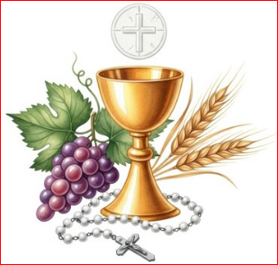

True Presence
and
Transubstantiation

Please Read, Core Catholic Teachings

St. Margaret Mary Alacoque Parish

True Presence and Transubstantiation

The Catholic Church teaches that at the consecration of the Mass, when the priest repeats the words of Jesus at the Last Supper, through the power of the Holy Spirit (not by the power the priest) the bread and wine are changed into the body, blood, soul, and divinity of Jesus Christ. That is why from that point in the Mass they are referred to as “The Body of Christ” and “The Precious Blood of Christ”, respectfully. Transubstantiation is the word that is used by the Church to describe the change of substance from bread and wine into Jesus’ Body and Blood. Notice that Jesus affects the change simply by saying the words. The word of Jesus, who is God, is all-powerful.

Mathew 26: 26 - 28:
Now as they were eating, Jesus took bread, and when he had said the blessing, he broke it and gave it to the disciples. 'Take it and eat,' he said, 'this is my body.' ²⁷ Then he took a cup, and when he had given thanks he handed it to them saying, 'Drink from this, all of you, ²⁸ for this is my blood, the blood of the covenant, poured out for many for the forgiveness of sins.

Reception of the Eucharist should not become ritualistic, that is, receiving without understanding the significance of what is taking place.

Eucharistic Miracle, #1

The Miracle of Lanciano, 750 AD
Last week, I (footnote 2) introduced this new series of articles on the Eucharistic Miracles, occasions where Christ breaks through the veil of the ordinary to wake us up to the reality of His presence in the Eucharist. It seems appropriate that we begin with the first, and most likely greatest, of these miracles, which took place in a Basilian monastery dedicated to St. Longinus in Lanciano, Italy, around the year 750.
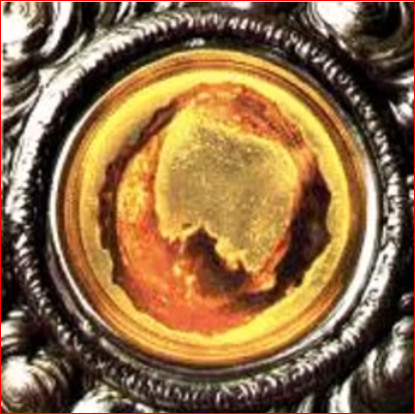
The account says a priest was experiencing doubts in his faith in the Eucharist. While he was striving to better understand the world and the sciences, he continued to struggle in faith that what he was proclaiming as he celebrated Mass was even possible. As he was celebrating Mass one day, and I’m (footnote 2) sure it was with these doubts firmly in his mind, during the words of consecration, he saw the bread and wine transformed into actual human flesh and blood. Those in attendance, and those who saw his amazement, spread the news throughout the monastery and surrounding area. Shortly after this happened, the blood on the host coagulated into five globules, while onlookers connected to the five wounds of Jesus, which the flesh remained the same. The matter was investigated and proclaimed a miracle, and the host was placed in a special vessel, which is still on display in Lanciano today.
The Flesh of Christ
The fame of this miracle spread throughout the world over the centuries, but in the 20th century, a time when perhaps we needed it most, even more was revealed. In 1970, Pope Paul VI commissioned a series of studies of the miraculous host of Lanciano. Drs. Ruggero Bertelli and Odoardo Linoli, both doctors of human anatomy and histology, performed separate investigations, which corroborated each other’s findings. Further studies were taken up by the World Health Organization in 1973 and again by Dr. Bertelli in 1981, both of which confirmed the findings and discovered even more information.
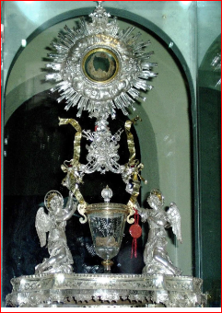
So what did these studies find? The results are truly stunning:
- The flesh has the same structure as heart tissue (myocardium) and the membrane of tissue lining cardiac cavities (endocardium). The flesh was also discovered to be fresh, as opposed to 1,200 years old, with no trace of preservatives.
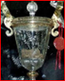
- The globules of blood were also of human origin and determined to be of type AB. Further, while blood taken from a cadaver would deteriorate quickly, these samples continued to maintain the same properties of fresh blood.
It seems appropriate that this incredible Eucharistic Miracle occurred in a monastery dedicated to St. Longinus, who tradition states was the name of the Roman soldier who thrust the spear into the side of Christ on the cross. As he beheld the water and blood flow from the side of Jesus, and the earth trembled at the moment of death, he proclaimed, “Truly, this was the Son of God.” The miracle of Lanciano has inspired the same sentiment in the minds and hearts of people for centuries, and perhaps it can do the same for us today.

Eucharistic Miracle, #2
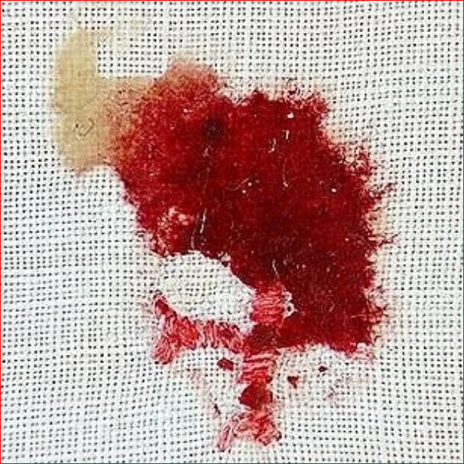
The next Eucharistic phenomenon we will discuss occurred at St. Anthony of Padua Church in Sokolka, Poland. On October 12, 2008, a priest placed a consecrated host in a container of water after it had fallen to the ground. Consecrated hosts that become dirtied are usually dissolved in this way so that they can be poured into a sacrarium for disposal. Sister Julia Dubowska, the parish sacristan, placed the container in the sacristy’s safe. One week later, she was astonished to find in the container a red substance connected to a partially dissolved host, and she quickly informed the other priests.
Part of an embroidered cross
After 18 days of submersion in water, the tissue and the associated host were moved to a linen corporal and left to dry. In January 2009, the archbishop asked two anatomical pathologists from the Medical University of Bialystok to examine the tissue. Professor Maria Elżbieta Sobaniec-Łotowska and Professor Stanislaw Sulkowski were both highly respected pathologists in their university who had each published dozens of research articles in peer-reviewed journals. Sobaniec-Łotowska took a small sample of the red portion, along with its connection to the host, and gave half of it to Sulkowski for microscopic analysis. He was not told of its origins at first so that he could independently analyze the tissue without prior biases. The professors each came to the same conclusion after inspecting the tissue with both light and electron microscopy: The samples were heart muscle.

The Polish newspaper Nasz Dziennik interviewed Sobaniec-Łotowska and Sulkowski in December 2009. The following is an excerpt from that interview:

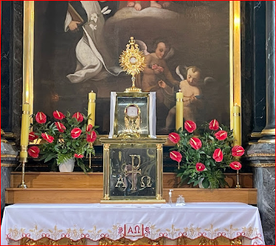
Sulkowski: If we put the Communion wafer in the water, in the normal course of events it should dissolve in a short time. In this case, however, part of the Communion wafer, for some incomprehensible reason, did not dissolve. Moreover, what is even more incomprehensible—the tissue that appeared on the Communion was tightly connected to it—infiltrating the substrate on which it was formed. Take my word for it that even if someone had intended to manipulate it, he would not have been able to connect the two structures so inseparably.
Sulkowski found two things astounding about this sample. First, the Communion wafer, which contains only flour and water, did not decompose after 18 days of submersion in water. Second, the bread and cardiac muscle tissues were intricately interwoven in a way that would be impossible to accomplish through human manipulation.
Sobaniec-Łotowska: This remarkable phenomenon of the intermingling of the Communion and the fibers of the heart muscle observed in both light microscopes and transmission electron microscopy also demonstrates to me that there could be no human interference here. In addition, please note another unusual phenomenon. The Communion wafer stayed in the water for a long time, and then even longer on the corporal. Thus, the tissue that appeared in the Communion should have undergone a process of autolysis [a type of necrosis or tissue death]. Examining the collected material, we found no such changes. “I think that at the current stage of development of knowledge, we are not able to explain the studied phenomenon solely based on natural science.”
Transmission electron microscopy can be used to visualize incredibly small details, including viral particles and atoms. After using this exquisitely sensitive tool, Sobaniec-Łotowska agreed with Sulkowski’s assessment of the interwoven fibers. This integration could not have been achieved by any human craft. She also affirmed that the cardiac tissue should have decomposed in water, yet it remained intact without any signs of degradation.

Persecution

Because of these astonishing findings, Sobaniec-Łotowska and Sulkowski were formally reprimanded by their university and accused of carrying out “illegal” and “disloyal” investigations that incorporated the “emotional” aspect of their Catholic faith (Serafini chapter 4). A tabloid magazine article speculated that the red substance might have been bacterial contamination with Serratia marcescens, even though these rod-shaped bacteria look nothing like heart tissue under the microscope. The president of the Polish Rationalist Association even initiated a frivolous lawsuit calling for a criminal investigation for murder since the heart tissue must have come from someone.

Sulkowski defended what he did (Serafini chapter 4):

“We have the duty to investigate every scientific problem… Just as a doctor cannot refuse to care for a patient, likewise, we have the duty to research every scientific problem, according to the guidelines of the Polish Academy of Sciences.”

Yet their report led to more questions than answers. Where did the heart muscle come from? Why didn’t the heart tissue decompose after 18 days in water? How did the muscle and host become so intertwined that two experts independently concluded that a human could not have fabricated it? Science cannot currently offer satisfactory answers to these questions.
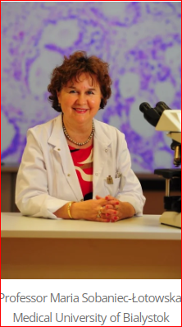
It is natural then to consider fraud. Only two people had keys to the safe with the transformed host, but let’s imagine that someone got access and wished to publicize a miracle to garner attention. It’s difficult to envision such a person going to the trouble—if they even had the ability—to fabricate a piece of heart tissue interwoven with bread in the anticipation that it would later be examined under an electron microscope.

Reporting these scientifically inexplicable findings only harmed their professional reputations at their university, so Sobaniec-Łotowska and Sulkowski lack any obvious motive for colluding or falsifying their strange results when they were already respected for publishing traditional journal articles. On the contrary, their rigorous approach convinced them to stand by their objective findings despite the surrounding controversy. Their results highlight both the usefulness of science in confirming a tissue’s identity and the limits of our current knowledge of science to explain everything. If one believes, as the Church does, that this event was a Eucharistic miracle, these mystifying findings are part of the miracle.

Catholic Online, https://www.catholic.org/bible/book.php?bible_chapter=26&id=47
Rev. Charles Ferraca, St Michael the Archangel Catholic Church
https://www.stmike.org/from-the-pastors-desk/eucharistic-miracles-lanciano-750-ad
https://www.stmike.org/from-the-pastors-desk/eucharistic-miracles-lanciano-750-ad
https://www.saintbeluga.org/eucharistic-miracles-god-under-the-microscope

