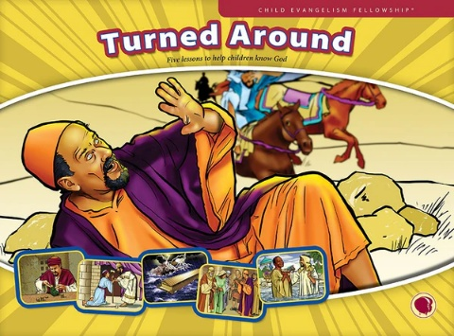
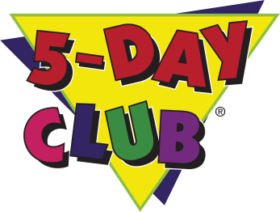
Come to 5-Day Club®
Free for Kids

Ages 5 to 12!

Bible and Missionary Stories, Games, Refreshments, Singing, and Fun!
Time—Start: 6:30pm End: 8:00pm Date: June 22-26, 2026
Location: First Baptist Church
600 Dayton Street, Yellow Springs, Ohio 45387
Sponsored by: Child Evangelism Fellowship®
Theme: “Turned Around”
Please RSVP : Cathy 937-926-4285
--------------------------------------------------------------------------------------------------------------------------------------------
Please bring this permission slip the first time you attend.

Print children’s names below
1. ______________________________________________________________________ Age: ______________
Circle one: M / F School: ___________________________________________ Grade: __________
Allergies: ____________________________________________________________________________________
2. ______________________________________________________________________ Age: ______________
Circle one: M / F School: ___________________________________________ Grade: __________
Allergies: ___________________________________________________________________________________
3. ___________________________________________________________________ Age: _______________
Circle one: M / F School: ___________________________________________ Grade: __________
Allergies: ____________________________________________________________________________________

Home Address: _______________________________________________________________________________
___________________________________________________________________________________________
Phone Number: ______________________________________________________
Emergency Contact: _________________________________________ Phone Number: _______________________

I acknowledge that participation in the activity described above involves risk to the participant (and to the participant’s parents or guardians, if the participant is a minor), and may result in various types of injury including, but not limited to, the following: sickness, exposure to infectious/communicable disease, bodily injury, death, emotional injury, personal injury, property damage, financial damage.

In consideration for the opportunity to participate in the activity described this page (the “activity”), the participant (or parent/guardian if the participant is a minor) acknowledges and accepts the risks of injury, personal financial responsibility for any injury or medical treatment, or other loss sustained associated with participation in the activity.

I hereby assign and grant to Child Evangelism Fellowship Inc., its subsidiaries and successors, and assign the unqualified right to the ownership, use and proceeds of all photographs or video of me or my minor child, without reservation or limitation, including use of photographs or video of me or my minor child for, but not limited to, advertising, educational and promotional purposes.

I agree to the Photo and Video Release: Yes No

Parent/Guardian’s name: (Print) ___________________________________________________

(Signature) ____________________________________________________________________

