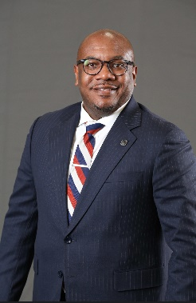

Carlton Maye, Jr., MBA, CFSP, CCO

Carlton Maye, Jr. is a pragmatic and visionary leader within the funeral service industry, bringing a diverse professional background in banking, contracting, and higher education. He is a Certified Funeral Service Practitioner, Certified Crematory Operator, and a Licensed Embalmer and Funeral Director in the states of Georgia, South Carolina, and Alabama.
Carlton serves as General Partner of Serenity Funeral Home and Cremation in Dublin, Georgia. In addition to his work in funeral service, he is employed with the United States Department of Defense as a Civilian Contract Specialist and serves as an Instructional Support Coordinator at Central Georgia Technical College on the Warner Robins, Georgia campus. His professional experience spans sales, management, human resources, and marketing, equipping him with a comprehensive understanding of both operational leadership and organizational strategy.
His educational credentials include an Associate’s degree in Mortuary Science, a Bachelor’s degree in Business Administration, and a Master of Business Administration. Carlton firmly believes in the transformative power of education and embraces lifelong learning as both a personal commitment and professional responsibility.
Committed to mentorship and academic excellence, Carlton serves as a Distance Learning Adjunct Faculty Member at Gupton-Jones College of Funeral Service and is an active member of its Advisory Board Committee. He maintains professional involvement in numerous associations, including the International Cemetery, Cremation and Funeral Association; Academy of Graduate Embalmers of Georgia; Georgia Funeral Directors Association; Georgia Funeral Service Practitioners Association; National Funeral Directors Association; National Funeral Directors and Morticians Association; and the Academy of Professional Funeral Service Practice. He actively contributes his time and leadership to support the missions and advancement of these organizations.
Within the Georgia Funeral Service Practitioners Association, Carlton serves as 6th District Chairman and Education and Research Director. He was elected as the 2024–2026 At-Large Representative to serve on the National Funeral Directors Association Board of Directors.
A graduate of the Leadership Robins Class of 2024 through the Robins Regional Chamber, Carlton is also a proud member of Alpha Phi Alpha Fraternity, Inc., through the Pi Iota Lambda Chapter of Tifton, Georgia.
Service remains one of Carlton’s central life principles. He leads with the belief that if he can help somebody as he travels along, then his living shall not be in vain.

