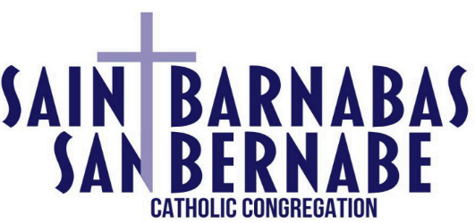
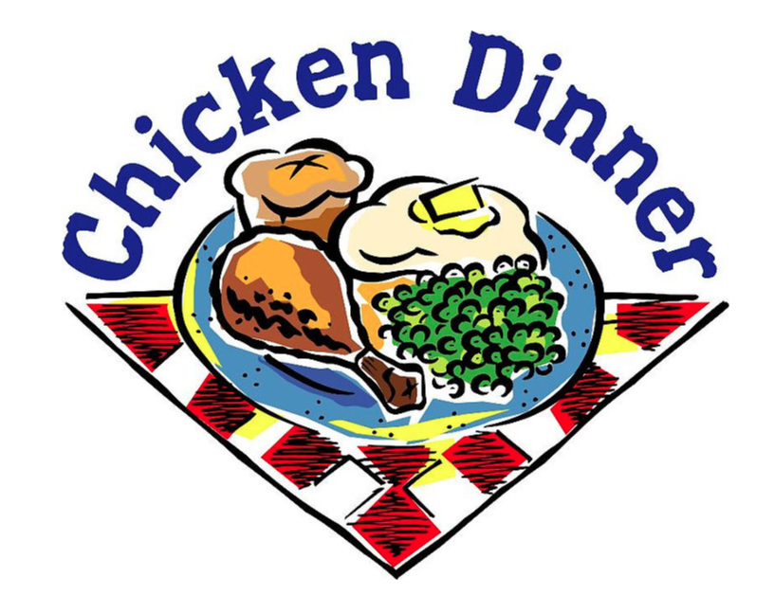

Chicken Dinner
Sunday, November 2, 2025

St. Barnabas Congregation; Holy Assumption Hall Site,
located at 1533 South 71st Street, West Allis

11:00 a.m. – 4:00 p.m.

1/2 Chicken for $15.00
(ages 3 and younger) - FREE

Dinner includes:
Chicken, Parsley-Butter Potatoes, Homemade Gravy, Dressing, Sweet & Sour Cabbage, Coleslaw, Cranberries, Green Beans, Dinner Rolls, Coffee, Milk, and Dessert.
Beer and Soda also available for a minimal charge.

Take-outs available
for any questions call Russ Miller 414-248-3888 or check our website; stbarnabascc.org
BAKE SALE & RAFFLES TOO!!

