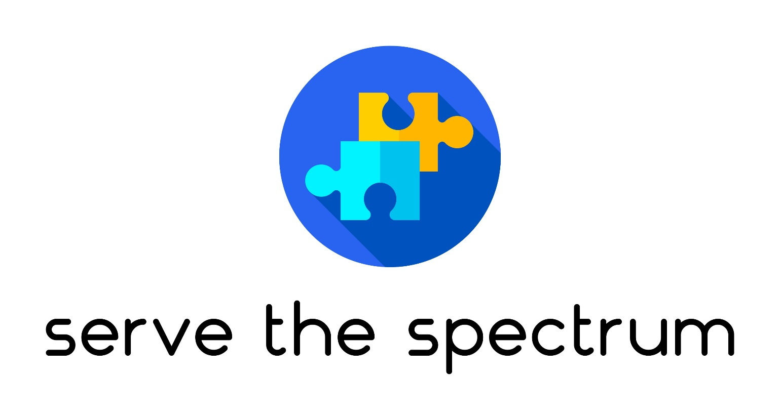
Educational Institution General Grant Application

Author: Ashley DeHaan, President and Co-founder, Serve the Spectrum Inc.

www.servethespectrum.com

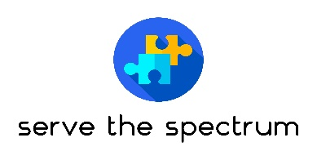 | Serve the Spectrum Inc.
Educational Institution General Grant Application

Grant Application Instructions
Educational institutions may fill out the below form to apply for a grant to be utilized to benefit students on the autism spectrum as it relates to therapy, treatment, activities, resources/tools, etc. that may improve the education and well-being of students with autism. We currently serve the greater Charlotte area.

Key Dates and Information:
- Applications are Due by November 1
- Questions regarding the application process can be emailed to info@servethespectrum.com
  - Visit our website at www.servethespectrum.com for more information
- Please email an electronic copy of the application addressed to Ashley DeHaan, President, Serve the Spectrum Inc., at info@servethespectrum.com
- Serve the Spectrum Inc. may contact applicants to ask clarifying questions from application submissions
- Award Notifications will be delivered via phone or email
- Award Criteria: Applications will be assessed for grant funding based on a combination of the organization’s needs compared to other applicants as well as available funding of the non-profit.

Organization Main Point of Contact
Full Name: |  |  |  |  |  | Date:
 | Last | First |  |  | M.I.
Title: |  |  | Email:
Phone: |  |  | Fax:

Organization Information
Organization Name:
Address:

Summary of Needs
Please fill out the answers to the below questions to the best of your knowledge to help Serve the Spectrum Inc. evaluate your organizational needs to qualify for this grant.

- Please provide a brief description of the therapy, activities, tools and/or resources where financial assistance is being requested for students with autism at your organization (put requests in priority order).

- Please provide an estimated amount of funding that is being requested for item #1 above.

- Please provide any other details that would be helpful for us to know regarding the needs of the organization to support those with autism.

Disclaimer and Signature
I certify that my answers are true and complete to the best of my knowledge.
If this application leads to a grant award, I understand that the grant must be utilized to benefit students on the autism spectrum as it relates to therapy, treatment, activities, resources/tools, etc. that may improve the education and well-being of students with autism.
Signature: |  | Date:

