**Our Lady Queen of Peace PSR**

**Who:**

Our Parish School of Religion is for kindergarten through 8th grade students who do not currently attend a Catholic day school. We have the traditional classroom model and a family model.

**What:**

Through weekly catechesis on the treasures of the Catholic faith, we assist parents in their role as the “primary faith educators” of their children. We also prepare students to receive the sacraments of Reconciliation, the Eucharist and Confirmation. (We work with students to prepare for Baptism, if needed.)

**When:**

PSR meets on Monday evenings, 6:00-7:30pm during the school year.

If you choose, the “At Home” PSR model, the parent teaches the weekly lessons at home and the parent and child will have a monthly check in with Terry Ostlund.

**Where:**

**Students are dropped off at the Church entrance between 5:45 and 6pm.** We begin with opening prayer in Church at 6:00. We invite parents to join us for this prayer. **Parents will pick up their children at 7:30 at their child’s classroom door. Please, pick up your oldest child first.**

Children can enjoy the playground before or after PSR with their parent ‘s supervision.

**Cost:** 2025-2026 tuition

1 Child: $165

2 Children: $295

3 or more: $395

2nd and 8th grade Sacramental supply fee: $40

**PARISH SCHOOL OF RELIGION**

**Why:**

Faith education is education that lasts an eternity. All parents wish to give their children the best in life. We love our children to the “moon and back”, why not love them to “heaven and back”. Giving our children faith education helps them learn how to open their hearts to accept God’s unconditional love, to listen to God speak in the quiet of their heart, to soak up the abundant graces God gives us to persevere through challenges and to celebrate the joy of the sacraments.

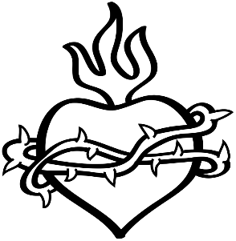

**Safe Environment at PSR:**

All our teachers have completed the Prevent and Protect training and have passed a current background check. Each of our teachers generously offers their time and talent of sharing the faith to their students in hope that the children will grow in their love for God and the Catholic faith.

**Teacher & Parent Teamwork**

We highly encourage good communication between parents and teachers. We do not have formal report cards but encourage you to take the time to discuss matters with your child’s teacher at dismissal time, if necessary.

**PARTNERING WITH FAMILIES**

**Sacraments:**

During all 9 years of PSR, students will prepare to receive three (3) of the seven sacraments of the Church.

Ongoing religious education is important for the faith development of each child. When a child misses a year of religious education, they fall behind in their faith education, just as if they missed one year of school. Faith development is extremely important.

We understand today’s hectic family schedules and are grateful you have chosen to make your faith a family priority. We are here to help you with this. If you have scheduling conflicts, we will work with you in this process to minimize any possible delays in enrolling your child in our religious education program.

**First Reconciliation** is on a Monday evening in the fall of 2nd grade.

**First Communion** is after Easter in the spring of 2nd grade.

**Confirmation** is in April or May of 8th grade.

(Note: Students are to be enrolled in a formal religious education program when preparing to receive a sacrament. At times, it is necessary for additional faith development lessons prior to receiving a sacrament. Baptism is the first sacrament a child receives.**)**

All the PSR students who have received their First Reconciliation have the opportunity to go to confession during Advent and Lent.

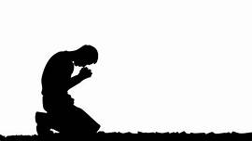

**OUR LADY QUEEN OF PEACE**

**FAMILY IS THE**

**DOMESTIC CHURCH**

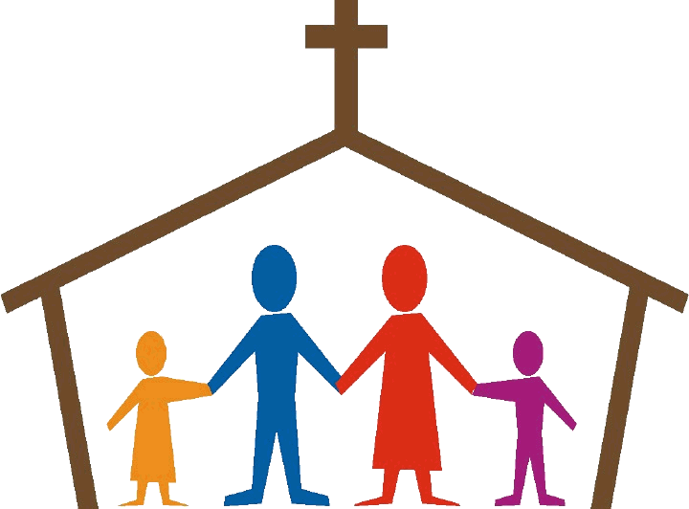

**Parents are leaders of faith in their homes.**

As parents, you lead your family in faith when you pray with your children, bring your children to Mass on Saturday evening or Sunday and by being a good role model to your children. As a parent or guardian, our vocation is to partner with God in leading our family closer to the heart of Jesus. Enjoy the vocation of family!

We are here to assist you as you lead your family closer to the heart of Jesus.

**OLQP Weekend**

**Mass Schedule**

Saturday Evening: 5pm

Sunday: 8:00 and 10:00am

The opportunity to go to Confession is available every Saturday after 8am Mass at St. Anthony of Padua in High Ridge and after 5pm Mass here.

*Children’s Liturgy of the Word* for 3 year olds through 2nd graders is offered during Sunday 10am Mass.

**GUIDED BY THE HOLY SPIRIT**

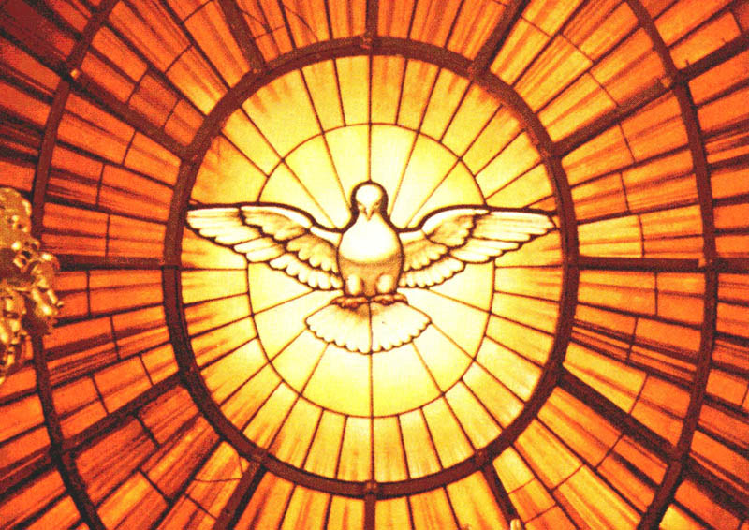

CONTACT INFORMATION

Our Lady Queen of Peace

Parish School of Religion

**Mailing Address:**

4696 Notre Dame Lane

House Springs, MO 63051

**Pastor:** Fr. Tom Miller

**Associate Pastor**: Fr. John Reiker

**Deacons**: Rev. Dr. Tom Gerling

Rev. Mr. Paul Turek

**PSR Coordinator:**

Mrs. Terry Ostlund

314-566-8363

Email: [psr@olqpmo.org](mailto:psr@olqpmo.org)

For more information, please contact Terry or visit the parish website: [www.olqpmo.org](http://www.olqpmo.org)

**Our Lady Queen of Peace Catholic Church**

**Parish School of Religion**

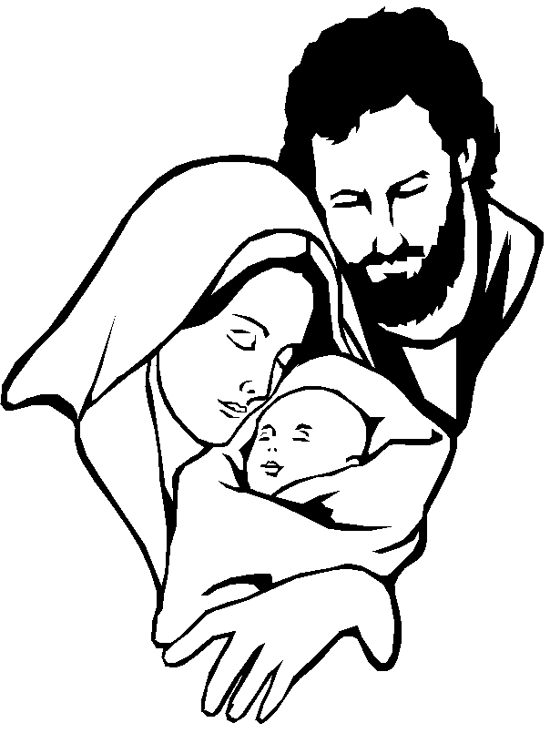

MISSION STATEMENT

Our Lady Queen of Peace PSR supports parents as *the primary faith educators* of their children by providing religious education in a loving parish environment. Through our religious instruction and sacramental preparation, we invite our students into a deeper relationship with Christ, His Church and a greater understanding of God’s Love.