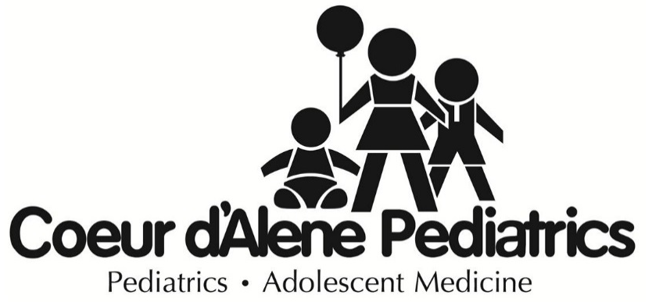
Coeur d’Alene
700 W. Ironwood Drive, Suite 155
Coeur d’Alene, ID 83814

Post Falls
1300 E. Mullan Avenue, Suite 1000
Post Falls, ID 83854

Hayden
9095 N. Hess Street
Hayden, ID 83835

Phone: 208-667-0585
Text: 208-203-8301

New Laws Affecting How Healthcare is Provided

July 16, 2025

To Our Valued Families,

We want to inform you about upcoming changes that impact how care is provided to you and your family.

Due to several recently passed healthcare and Medicaid laws, we’ve had to closely evaluate the services we currently offer to ensure we can continue providing high-quality care. These changes may come as early as October 1, 2025.

Beginning January 1, 2026, the state is changing how it supports primary care services, and these changes are expected to affect how pediatric care operates across the State of Idaho.

While we are working to adjust to these changes, you will see:

- Fewer same-day and after-hour appointments
- Limited ability to accept new Medicaid patients
- Reduced support for referrals and follow-ups

Please know that our commitment to your child’s health remains strong. We will continue to prioritize care and keep you updated as the situation evolves.

Your voice will make a difference!
Please reach out to your state legislators and the Idaho Department of Health & Welfare to let them know how important pediatric care is to your family. Contact information for both is provided below.
Thank you for trusting us with your child’s care.

Warm regards,

Coeur d’Alene Pediatrics

Food stamps, Medicaid, ICCP, and TAFI
Stay on the line when calling, and we will assist you as soon as possible.

Phone: 877-456-1233

Email: MyBenefits@dhw.idaho.gov

URL: https://idalink.idaho.gov/

Local Legislatures

Idaho State Sen/Reps | Mailing | Home Phone Number
Rep. Cornel Rasor | P.O. Box 206, Ponderay, ID 83852 | (208) 290-7403
Sen. Jim Woodward | 246 Otts Road, Sagle, ID, 83860 | (208) 946-7963
Rep. Mark Sauter | PO Box 1031, Sandpoint, ID, 83864 | (208) 254-1184
Sen. Phil Hart | PO Box 540, Kellogg, ID, 83837 | (208) 772-2522
Rep. Dale Hawkins | PO Box 245, Fernwood, ID, 83830 | (208) 568-1275
Rep. Heather Scott | P.O. Box 134, Blanchard, ID 83804 | (208) 332-1190
Sen. Doug Okuniewicz | 2519 W Berkley Ln, Hayden, ID, 83835 | (208) 918-1495
Rep. Jordan Redman | 1410 Lincoln Way, Ste 100,  Coeur d’ Alene, ID, 83814 | (208) 252-5070
Rep. Vito Barbieri | 564 E. Prairie Avenue,  Dalton Gardens, ID83815 | (208) 620-0873
Sen. Ben Toews | 911 N 5th St, Coeur d’ Alene, ID, 83814 | (208) 209-7791
Rep. Joe Alfieri | 1200 East Skyline Dr,  Coeur d’ Alene, ID, 83814 | (208) 699-0021
Rep. Elaine Price | 1107 E Sherman Ave,  Coeur d’ Alene, ID, 83814 | (208) 654-3228
Rep. Ron Mendive | 3732 S. Dusty Lane,  Coeur d'Alene, ID 83814 | (208) 667-9330
Sen. Carl Bjerke | 212 W Ironwood Dr, Ste D,  Coeur d’ Alene, ID, 83814 | (208) 704-0925
Rep. Tony Wisniewski | 15417 W Destiny Dr Post Falls, ID 83854 | (208) 889-3437

