Pastoral Letter

To all God’s beloved in Kresgeville who are called to be saints: Grace to you and peace from God our Father and the Lord Jesus Christ.
I borrowed Paul’s greeting in his letter to the Romans (1:7). Paul often referred to church members as saints. Through baptism, we’re made holy or set apart for God’s work in the world. How we do this depends on our spiritual gifts (i.e. teaching, leading, writing, woodworking, etc.). We also do this as a church through worship and welcoming, learning and serving. As saints or holy ones of God, we are blessed to be a blessing!
In the Apostles’ Creed, we confess that we believe in the communion of saints. This includes those living and dead. (And those yet to be born!) On All Saints Sunday, we gather to celebrate ALL the saints in the West End and the world, especially those who were baptized and who died this past year. (See below.) It’s one of my favorite Sundays in the church year. Our gathering song is “Blest Are They”, with the refrain: “Rejoice and be glad! Blessed are you, holy are you! Rejoice and be glad! Your’s is the Kingdom of God!” (#794 in the burgundy book, GIA Hymnal Supplement 1991).
Rejoice with us on All Saints Sunday and every Sunday. What a gift to be blessed and loved by God, chosen to share God’s love on Sunday and everyday!
In faith hope and love,
Pastor Scheffey

P.S. On All Saints Sunday, November 2, we give thanks to God for the new saints on earth through Holy Baptism and the new saints in heaven:

Baptisms
Talia Hope Dunlap—November 03, 2024, Lainey EllaMarie Smith—February 23, 2025,
Jessziyah Mitchell Kyle Dunlap Jones—February 25, 2025,
Jalyne Kelis Redding—August 3, 2025
Deaths
Mary Louise Hambrick November 7, 2024 Faye D. Kilber June 19, 2025
Alfred George Grams, III November 29, 2024 Richard A. Martini July 5, 2025
Donald Keith Smith December 3, 2024 Rena V. Baumgartner September 16, 2025
Hermann J. Bosche February 7, 2025 Kevin J. Koch September 16, 2025
Dolores R. Knappenberger April 3, 2025



NOVEMBER ANNIVERSARIES

November 6 Clarence and Mary Lou Hawk (60 years)
14 Tim and Randy Hinton



NOVEMBER BIRTHDAYS

November 1 Olivia Armitage
5 Stacey Coleman
Patricia Kuehner
9 Rich Gould
Keeley Gould
11 Leilani Mathews
13 Ron Haydt
Kim Antonucci
16 Kelly Williams
17 Randall Bowman
Shanna Szuch
18 Matt Hughart
Stephen Serfass
20 Elizabeth Strohl
25 Sonya Serfass
Adrienne Meckes
Dylan Antonucci
27 Winnie Serfass
30 Kasey Gould



POINSETTIA FLOWERS
Poinsettias will be available to decorate our chancel for Christmas Eve. The cost for a 61/2” potted is $13.00. Plants are available in red, pink or white. Orders are due on Sunday, December 1st. Complete the order form below and hand to Linda Hinton along with money in an envelope.

NAME________________________________________

PHONE NO. _____________________________________

NUMBER OF RED PLANTS_______________________
NUMBER OF PINK PLANTS_________________________
NUMBER OF WHITE PLANTS________________________

GIVEN IN MEMORY OF______________________________
___________________________________________________

___________________________________________________

GIVEN IN HONOR OF ______________________________
___________________________________________________

___________________________________________________

WHAT’S HAPPENING this MONTH:

WORSHIP

Our new schedule is 9:30am Sundays all year!

November 2 (Sun.) ALL SAINTS SUNDAY
9:30am Holy Communion with celebration of those baptized and
remembrance of those who died this past year
9 (Sun.) 9:30am Worship with Sunday School (they go upstairs after opening
worship)
16 (Sun.) 9:30am Holy Communion
23 (Sun.) CHRIST THE KING (last Sunday in church year)
9:30am Praise Service with Sunday School and Confirmation
30 (Sun.) 9:30am Healing Service
2:30pm Communion Service at Getz Home, Jonas

Weekly worship is in-person and online Facebook Live plus it’s emailed later Sunday on YouTube. (Make sure Ruby has your email—Email the church at ssplc@ptd.net)

LEARNING
November 5 (Wed) 1pm Bible Study
9 (Sun.) 9:30am Sunday School for grades K-12, starting in church with
opening worship
19 (Wed) 1pm Bible Study
23 (Sun.) 9:30am Sunday School

FUN
November 15 (Sat.) 11am Nature Walk at Van Buskirk-Haney Park in Saylorsburg
Leave church at 11am. (Rain Date is Nov.22)
CARING/SERVING
November 30 (Sun.) 2pm Help residents of Getz Home with worship. (They love visitors!)

Good Sam Offering (all month) goes to Meals on Wheels.

PVEN food pantry needs: pancake mix, pancake syrup, gravy, cranberry sauce, canned yams, and stuffing
Clothing Closet: body wash, lotion, deodorant, blankets/comforters, sheets, towels, coat & Lined hoodies (all ages, genders, & sizes), winter gloves (all ages, genders, & sizes)
Diaper Pantry: baby food & formula, adult sized pull-ups and bladder protection pads.
**************************************************************************
CONGREGATIONAL MEETING to vote on the 2026 Budget is Sunday, December 7, at 10:15am (after the late service). Copies of budget will be available by Sunday, November 28.
FILLING, APPLE DUMPLING AND CELERY SEED DRESSING SALE: We will be selling homemade filling., apple dumplings, and celery seed dressing on November 21. Prices are $4 lbs for filling, $4 ea. for Dumpling, and $4 a pint for a pint and $7 for a quart for celery seed dressing. The sign-up sheets are posted on bulletin board by church office.
Deadline is November 16, and pick-up November 21 at 5pm. Also need volunteers to help make the above items.

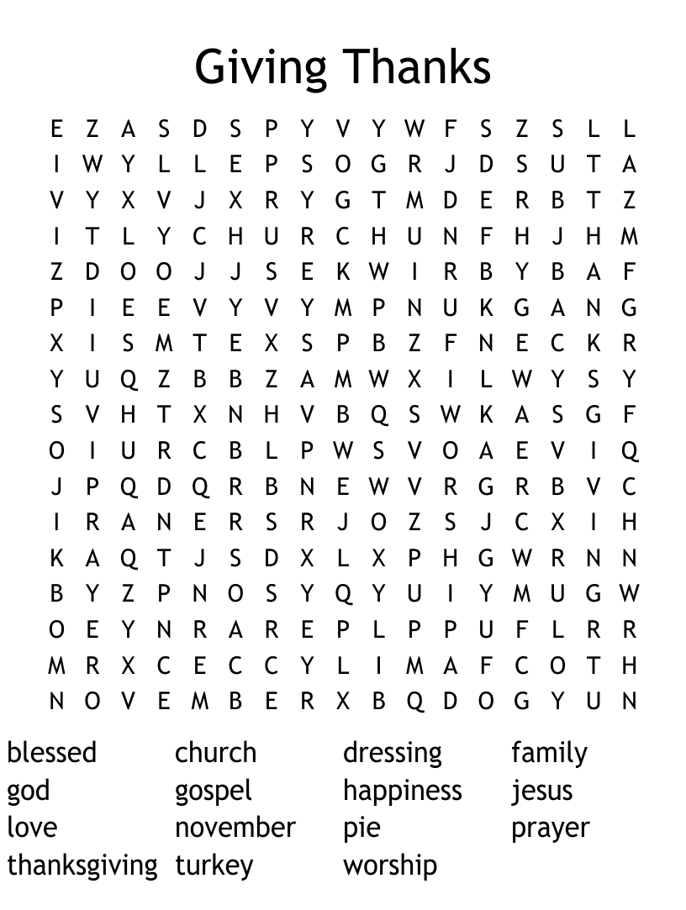



Let’s get into shape together – physically, mentally, and spiritually!
Saturday, November 15, 2025
Van Buskirk Haney Park, Saylorsburg
Leave Salem-St. Paul Lutheran Church at 11:00am
Rain Date: Saturday, November 22, at 11:00am
All are welcome!
For questions, call Pastor Scheffey: (610)-681-5191


MAIL A CARD OR A LETTER TO OUR: SHUT-INS,
And MILITARY
Gertrude Besemer Norma Correale
Walden III 177 Panther Run Road
325 N. Broadway Jim Thorpe, PA 18229
Wind Gap, PA 18091 570-688-5524

Ken Ryno Clarence and Mary Lou Hawk
219 Huntingdon Road 307 Beltzville Drive
Kunkletown, PA 18058 Kunkletown PA 18058

Dwight Redline
4169 Bunker Hill Lane W. Peter Desmedt
Walnutport, PA 18088-3001 Julia Ribaudo Extended Care Center
610-767-1997 1404 Golf Park Drive
Lake Ariel, PA 18436
Charlie Kratz
Getz’s Personal Home Care
1026 Scenic Drive
Kunkletown, PA 18058
Military
Keanu Heath Tanner Heath
15525 Greenbriar Blvd 2135 N. Oxnard Blvd
Disputanta, VA 234842 Oxnard, CA 93036

COUNCIL MEMBERS
President Gloria Helm (610) 657-4397 Nicolette Sonmez-Jones (570) 236-3441
Vice-President Jess Balbuena (917) 613-9477 Tim Hinton (570) 977-4572
Secretary Debbie Smith (610) 681-4191 Ken Jablonski (610) 392-2694
Tommy Harpster (610) 657-7894 Kim Hughart (570) 236-4191 Barb Yarashas (570) 977-0236 Joan McKinsey (570) 216-2301

SALEM-ST. PAUL’S MISSION STATEMENT
Salem-St. Paul’s Church calls people to grow in God’s love, through thanking, caring,
serving and sharing, following the example of Jesus.
SALEM-ST. PAUL EVANGELICAL LUTHERAN CHURCH
138 TRACH ROAD, P.O. BOX 168, KRESGEVILLE, PA 18333
Church office: 610-681-5191; E-mail: ssplc@ptd.net
Pastor: Rev. Deborah Scheffey (610) 681-6691
Secretary: Ruby Dunlap (570) 620-8162
New Website: salemstpaullutheranchurch.com
Facebook.com/SSPGODLOVESYOU

SALEM-ST PAUL’S
“GOOD NEWS”

NOVEMBER 2025



