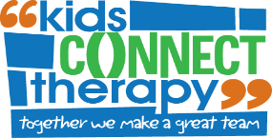

**“Skills for School”**

**SCHOOL READINESS PROGRAM**

***“SKILLS FOR SCHOOL”* is designed as a specialised practice time to help your child learn important classroom skills before they get to prep.**

**If your child is starting prep next year?**

**How can you prepare them for the best start?**

**What does the “SKILLS FOR SCHOOL” Readiness Program target?**

**Important pre-literacy skills including:**

-Letter knowledge

-Sound awareness

-Syllabification

-Print knowledge

**Fine motor skills including:**

-Pencil skills and grip

-Scissor control

-Writing own name

**The program is run by both Occupational and Speech Therapists who will work with your child to give them the best start to school possible.**

**7 x 2-hour Sessions**

**Dates:**

**Monday 22/09, Tuesday 23/09, Wednesday 24/09, Thursday 25/09**

**Monday 29/09, Tuesday 30/09, Wednesday 01/10**

**Parent Education Session via zoom – Wednesday 17/09 6:30pm-7:15pm**