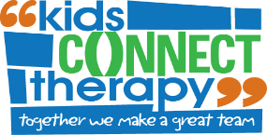

**Occupational Therapy & Speech Therapy Group Program**

**“Skills for School”**

**SCHOOL READINESS PROGRAM**

***“SKILLS FOR SCHOOL”* is designed as a specialised practice time to help your child learn important classroom skills before they get to prep.**

**Important pre-literacy skills including:**

-Letter knowledge

-Sound awareness

-Syllabification

-Print knowledge

**Fine motor skills including:**

-Pencil skills and grip

-Scissor control

-Writing own name

**The program is run by both Occupational and Speech Therapists who will work with your child to give them the best start to school possible.**

**7 x 2-hour Sessions**

**Dates:**

**January TBC**

**Next Steps:**Contact our administration staff if you wish to enrol your child on   
98071114 or email [info@kidsconnecttherapy.com.au](mailto:info@kidsconnecttherapy.com.au)

If your child does not attend Kids Connect Therapy you are required to book in for a consultation to assess suitability