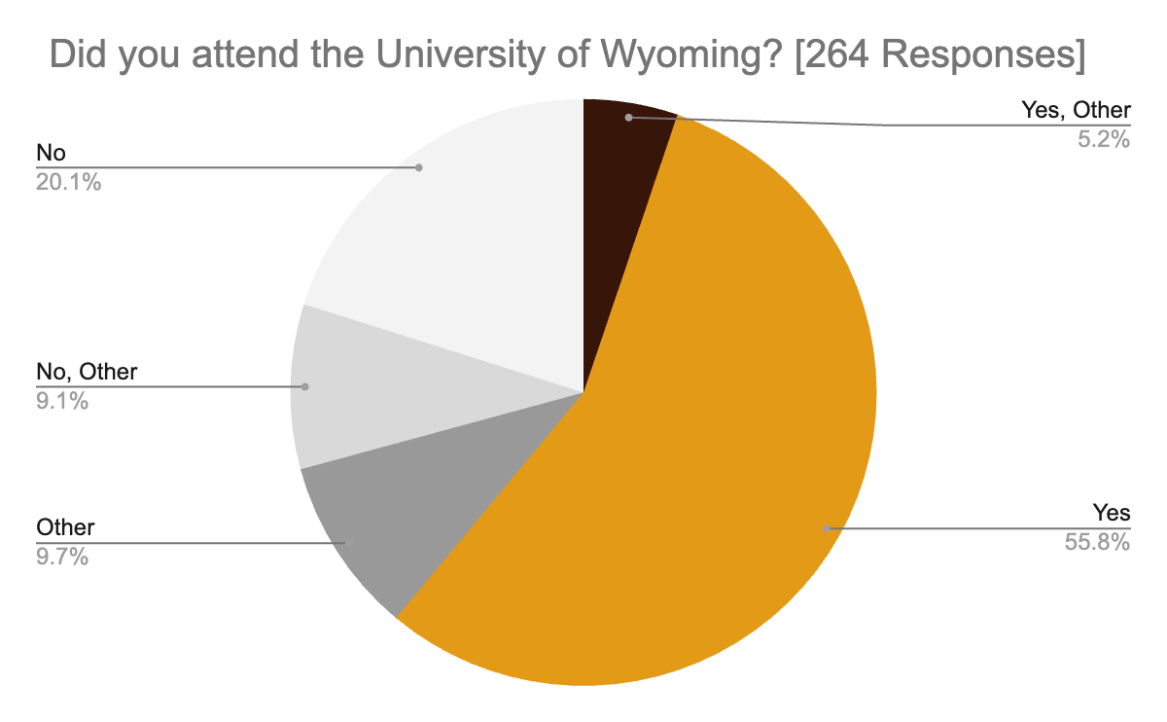

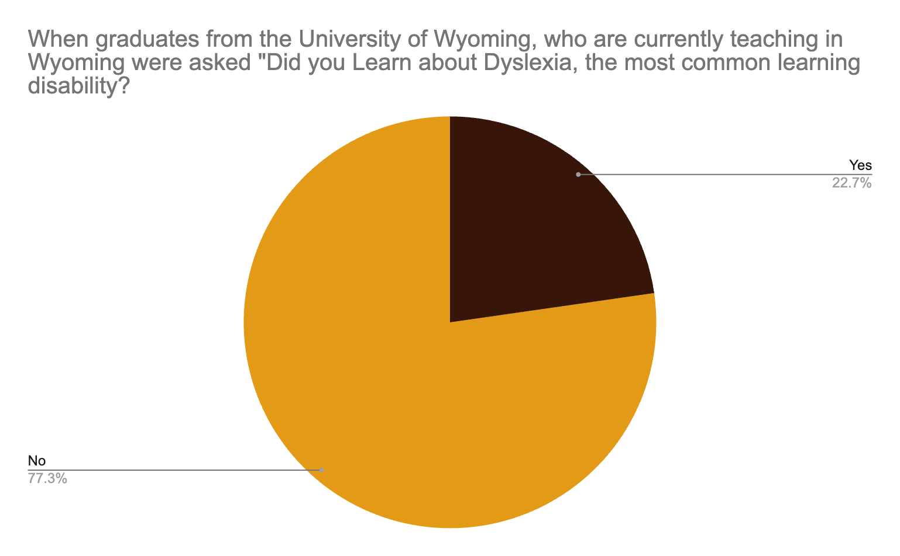

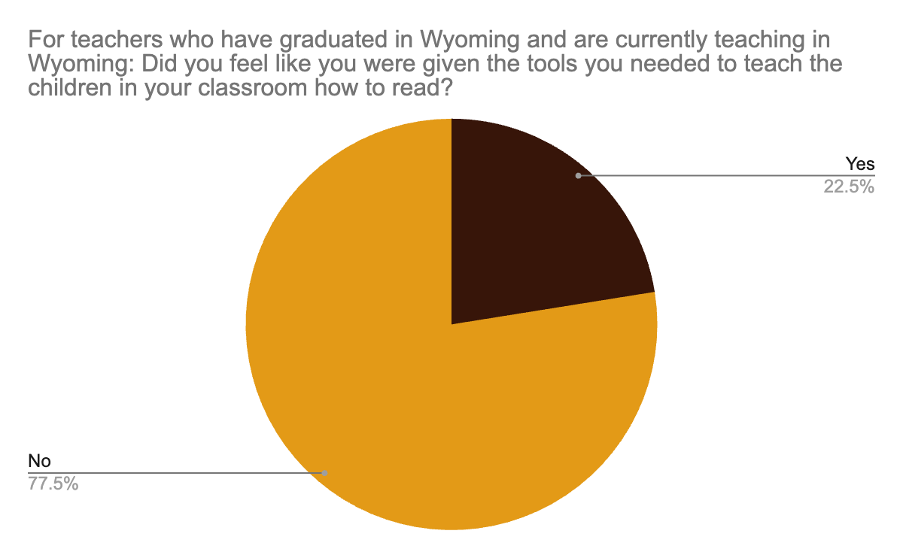

Individual Responses:

“Absolutely not. The “strategies” I was taught—such as looking at pictures, guessing based on the first letter, or relying on what “makes sense”—were profoundly inadequate. Imagine the impact if pre-service teachers were actually trained to teach reading using evidence-based, brain-aligned methods and structured literacy practices. Instead, educators who want to meet student needs have been forced to spend dozens upon dozens of hours—or more—in professional development to acquire the foundational knowledge that should have been part of our initial preparation. Meanwhile, countless students have suffered lost learning opportunities while we worked to gain the skills that should have been built into our training programs. It is deeply concerning that the leadership University of Wyoming College of Education has continued to double down on ineffective practices rather than engaging in the same process we’ve had to undertake—learning, reflecting, changing practices, and ultimately doing better for children.”

“No I do not feel like I was given many tools at all to teach reading- decoding, phonics, comprehension (literature or informational), morphology, etc. I just graduated from UW 3 years ago and have learned way more from my LETRS training as well as UFLI for the science of reading. I truly hope UW changes that and gives more direct instruction to reading at the elementary level. Now that I am in my third year teaching I feel like I have more tools to help kids learn (syllable types, phonics rules, etc) but my first year I definitely did not.”

“I am a reading interventionist. I have been given the training and materials I need to help a struggling reader become successful. For that I am grateful. What is missing is the TIME. The time to implement interventions with fidelity and in the way they were built. Also, the importance of small group!”

“No. I was not taught how to teach reading or how to help struggling learners. I have learned many valuable skills while on the job. Think of building the plane as you are flying it.”

Summary of Comments:

The majority of respondents reported that they were not adequately prepared by their university programs—particularly the University of Wyoming (UW)—to teach reading or to effectively support students with reading difficulties. Many shared that their college education focused heavily on theory rather than practical, evidence-based reading instruction. Key components such as phonics, phonemic awareness, morphology, and structured literacy were largely missing from their coursework.
Most respondents stated that they gained their real understanding of reading instruction after entering the classroom, through district-provided professional development, programs like LETRS and Orton-Gillingham, or independent study and experience. A few teachers felt UW provided a solid foundation, but even those acknowledged that reading instruction has evolved and that their training is now outdated.
Several emphasized the need for more hands-on classroom experience, time to implement interventions, and better alignment between teacher preparation programs and the science of reading. Overall, the responses reveal a strong desire for teacher education programs to offer more comprehensive, practical, and up-to-date training in how to teach all students—especially struggling readers—how to read successfully.

