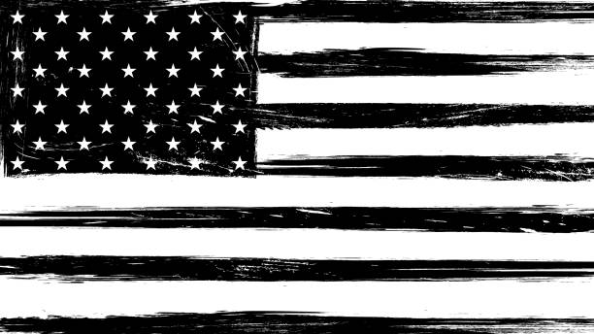 FRANKFORT TIRE DAY
TOWN OF FRANKFORT, WI, USA

SATURDAY, SEPTEMBER 27th
From: 8:00am to 12:00pm
At Bee Line Auto – Hwy 97, Edgar
PRICES:
Standard Car & Truck Tires - $3.00
Smaller Semi Tires - $15.00
Large Semi Tires (Floats) - $20.00
Tractor Tires (Small) - $30.00
Tractor Tires (Large) - $50.00
Oversized Tires - $75.00 and up
Bee Line Staff will be available to help determine the cost of Oversized tires.
This is a service provided to TOWN of FRANKFORT RESIDENTS ONLY.

