CENOTAPH PARADE SUNDAY 9TH NOVEMBER 2025

Following the success of last year’s parade, the Association registered once again for the 2025 London Cenotaph Remembrance Day.
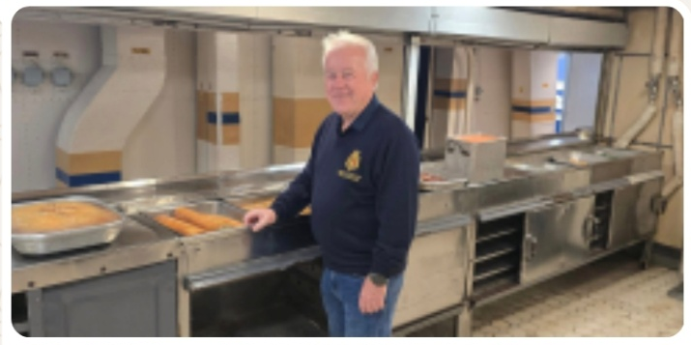
As per last year, our Chairman and Standard Bearer felt it necessary to scope the area out a few days in advance, a reconnaissance party to assess any security risks. This mainly involved visiting licensed premises and the Union Jack Club, however they did briefly find themselves drafted back to their first ship HMS Belfast, where, down in the galley they reminisced over politely telling crew, ‘Just one ******* sausage’!
The main group that were staying over, arrived on Saturday 8th November and were booked in to the Premier Inn, Southwark, Bankside. In contrast to last year at the very quiet Smithfields area, we found ourselves steps away from the bustling Borough Market.
Offering plenty of dining and drinking options, everyone eventually met in The Anchor, a pub next door to the hotel.
After a relatively early night, we mustered in the hotel foyer at 0830hrs and set off, resplendent in blazers, ties, berets and gongs. Free travel on the tube, the staff opening the gates for the many veterans making their way to Charing Cross. We then followed the masses into the Mall and Horse Guards.
I made my way to the organisers tent to collect our identification badges (A46), which assist the media in picking out groups during the march, the remainder went off to find our meeting point and the breakfast truck. The Premier Inn group were joined by Terry Herbert, Barry Campion and Douglas Hadler who had made their own way in, swelling our numbers to fifteen.
There began a long period of standing around as thousands of veterans chattered, looking out for old faces, exchanging dits (stories) and hip flasks. Yes, Rum for breakfast!
Sometime after 10am, the columns formed up and began to proceed through the Arch into Whitehall, it was a loose amble as opposed to a march.
The senior service of course, were first out and reserved a very warm welcome for the Royal Air Force as they marched by into position with a strong rendition of the Dambusters music. All taken in good spirits.
This year we had a guest among the Association ranks with Robert Masters, son of Nigel, marching alongside his Dad. Robert was an Army Logistic Corps veteran with tours of Afghanistan. A very proud moment for the Masters’ family.
As 11am fast approached, a hush descended down Whitehall and with the chime of Big Ben, an impeccably observed two minutes silence was observed. This was time to reflect on the reason why we were all there, remembering all those that laid down their lives for our freedom. With the Last Post, it was a very emotional silence standing to attention as the only movement was the golden leaves falling in the glorious autumn sunshine.
The service commenced with King Charles at the head of proceedings and the customary laying of wreaths followed.
Then, it was time for the veterans to march and in no time at all, we were underway. In lines of six, we marched down Whitehall, HMS Blake ahead of us and HMS Lowestoft to the rear (they actually joined our 3rd row as there was only three of them).
The march can be a bit of a blur, naturally blinkered straight ahead and trying to stay in step, but with the band playing and crowds cheering, it goes by in a flash. Nigel gave the ‘eyes left’ as we passed the cenotaph and handed in our association wreath. Down Whitehall and right wheel into Great George Street, large crowds in the sunshine as we headed towards Horse Guards Road.
Earlier that morning, while we were eating our breakfast rolls on the parade ground, our family members had claimed their viewing position in St James Park and had unfurled a large HMS Ajax & River Plate Veterans Association flag over the railings placed on Horse Guards Road. This section of the march is where everyone is a bit more relaxed and heads turn to look for family and waves and cheers are given. We spotted the flag as soon as we turned the corner, what a great sight. We later learnt that every Naval group and association ahead of us had cheered on seeing the Ajax flag, our ladies, children and the flag receiving lots of attention.
Before finishing back at the parade ground, a command of ‘eyes right’ to the dais and the figure of Prince Edward who this year, took the salute.
We dismissed back on the parade ground and a few group photos were taken before heading off for lunch. After last year, our resident Londoner Paul Byrne was banned from giving directions, so it was just a successful twenty minute wander to Mayfair and The Goat Tavern.
Appropriately, the venue where Lord Nelson met Lady Hamilton; the manager Juris looked after us during a well-received lunch service. A few liquid refreshments were taken and before we knew it, the evening had arrived and it was time to part ways with some and for the remainder to head back to Bankside and the Thames.
After a long day, some retired to their rooms, the hardy bunch finishing the weekend back in The Anchor. Monday morning, everyone said their goodbyes and departed to all points of the UK. Another successful Remembrance parade weekend came to a close.
Eighty years on from the end of the second world war, just 20 veterans of that conflict were there to parade.
Lest we forget.
Mike Cranswick

