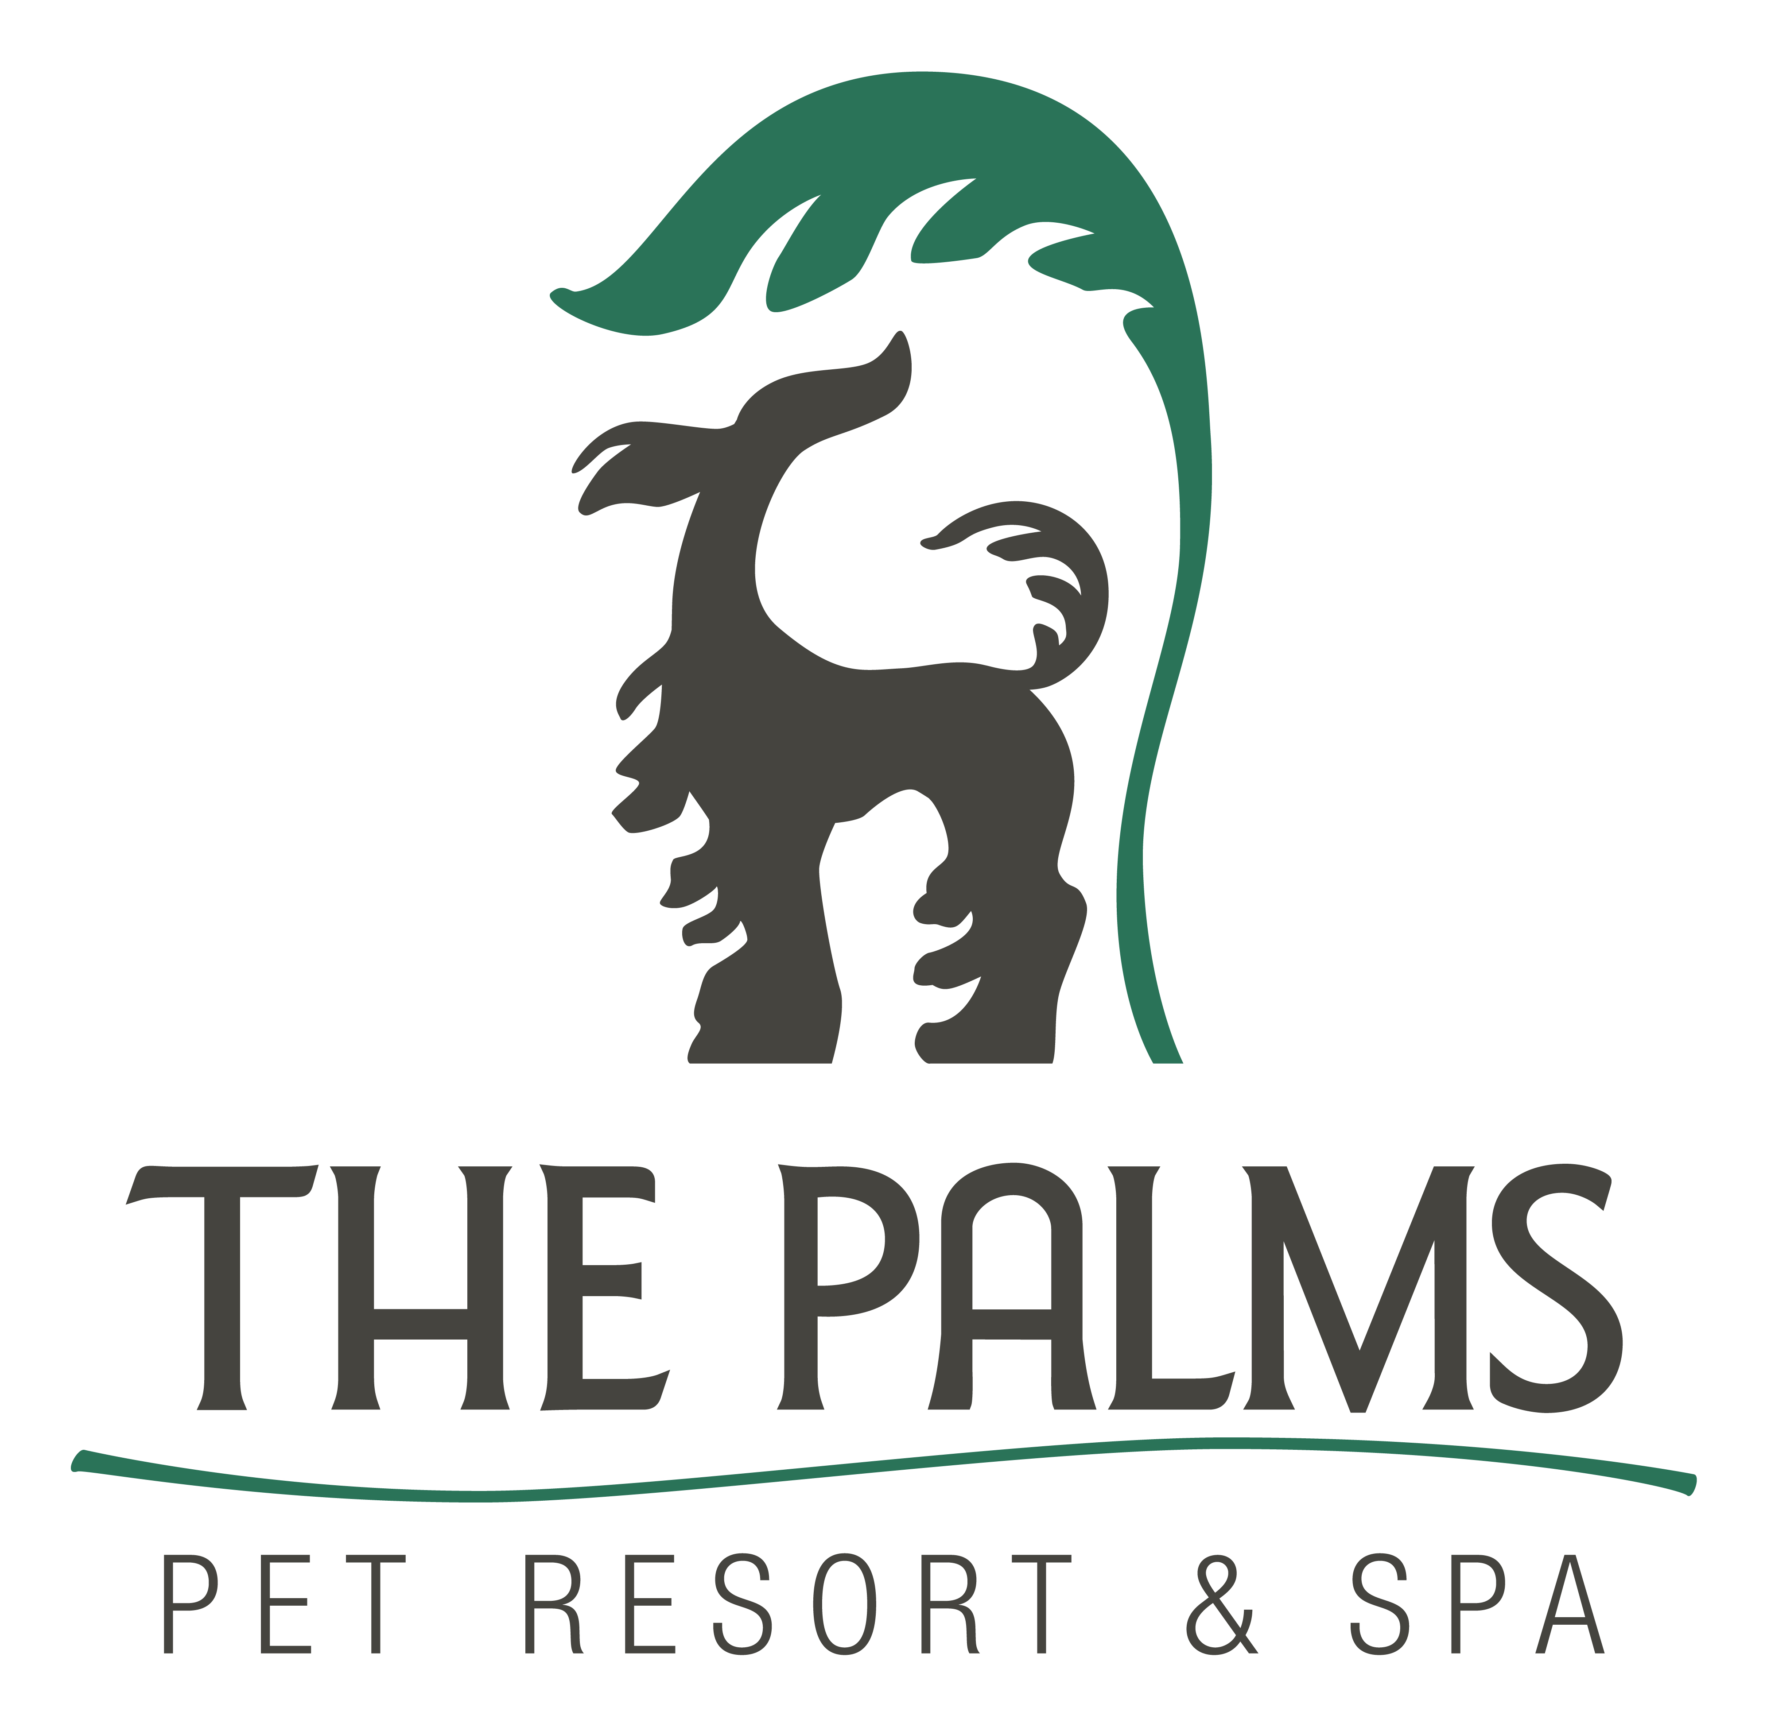
Phone 210-695-1166
Fax 210-695-1578
www.thepalmspetresort.com

Trick Classes Start Thursday September 18, at 8:00 pm

Trick Class- This Class will build the bond with your dog as you learn to guide and motivate in a fun way. Trick class offers a great way to interact with your dog and teach alternate behaviors. Teach your dog how to learn. Interested Students can test for the AKC Novice and Intermediate Trick dog titles at the end of the class.

Some examples of tricks that we will work on are:

~Rollover ~Sit Pretty
~Close Door ~Shake
~Roll over ~Spin
~Jump ~Take a selfie
~Weave and more

Class Pricing-Six weeks for $200.
Pre-requisite- “Pet Manners”

Class Schedule (Thursday)
Sept 18 | 8pm-9pm
Sept 25 | 8pm-9pm
Oct 2 | 8pm-9pm
Oct 9 | 8pm-9pm
Oct 16 | 8pm-9pm
Oct 23 | 8pm-9pm

