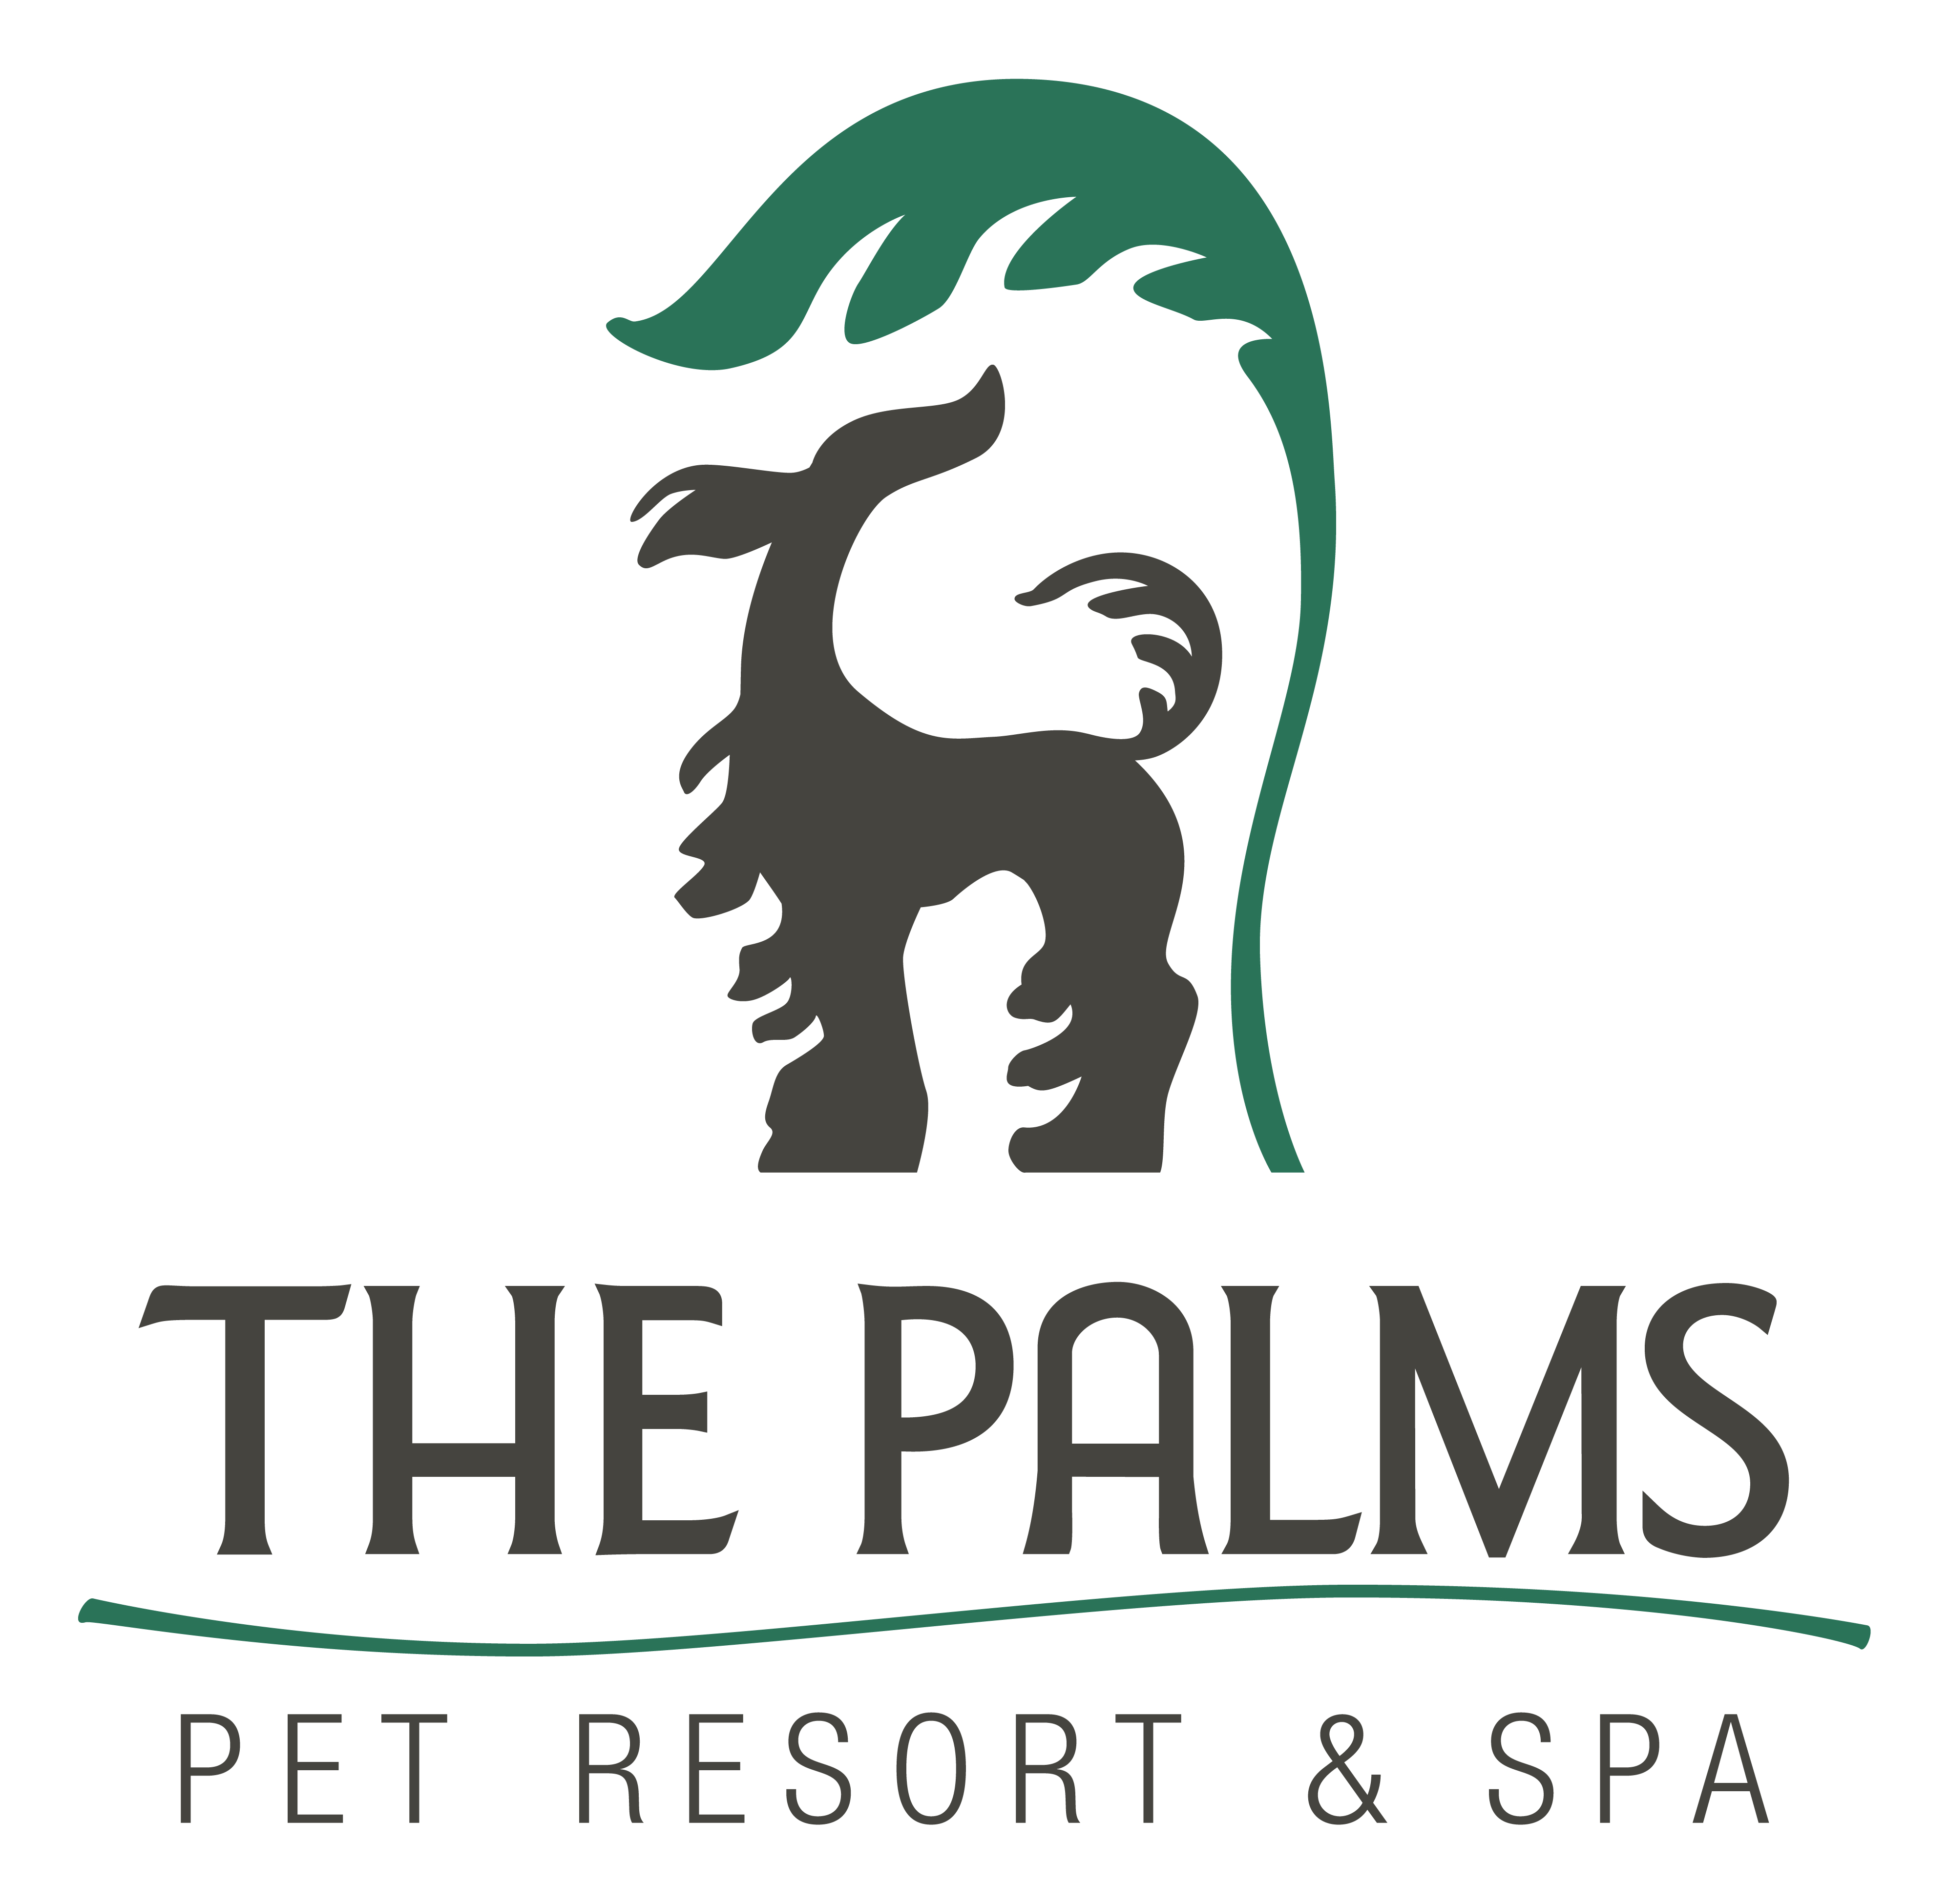
Phone 210-695-1166
Fax 210-695-1578
www.thepalmspetresort.com

Intro to Scent Work (1) Class Starts Monday, Sept 8th, at 7pm

Intro to Scent Work- Scent work is a great way to develop your dog’s natural scenting ability: Dogs are individually challenged to discover hidden treats. This class will provide both physical and mental stimulation for your dog and is a great way to boost their confidence. This class is a great fit for almost any dog! No previous training experience required. It is recommended that you feed your dog a reduced meal/snack prior to class so they are motivated to search for food.

Items Needed for Class:

- 6 Foot Leash or longer | - Buckle Collar or back connecting harness
- Moist/Meaty High value Treats in a tight container

Class Pricing-Six weeks for $200.00
Pre-requisite- “None”

Class Schedule (Monday)
Sept 8 7pm to 8pm
Sept 15 7pm to 8pm
Sept 22 7pm to 8pm
Sept 29 7pm to 8pm
Oct 6 7pm to 8pm
Oct 13 7pm to 8pm

