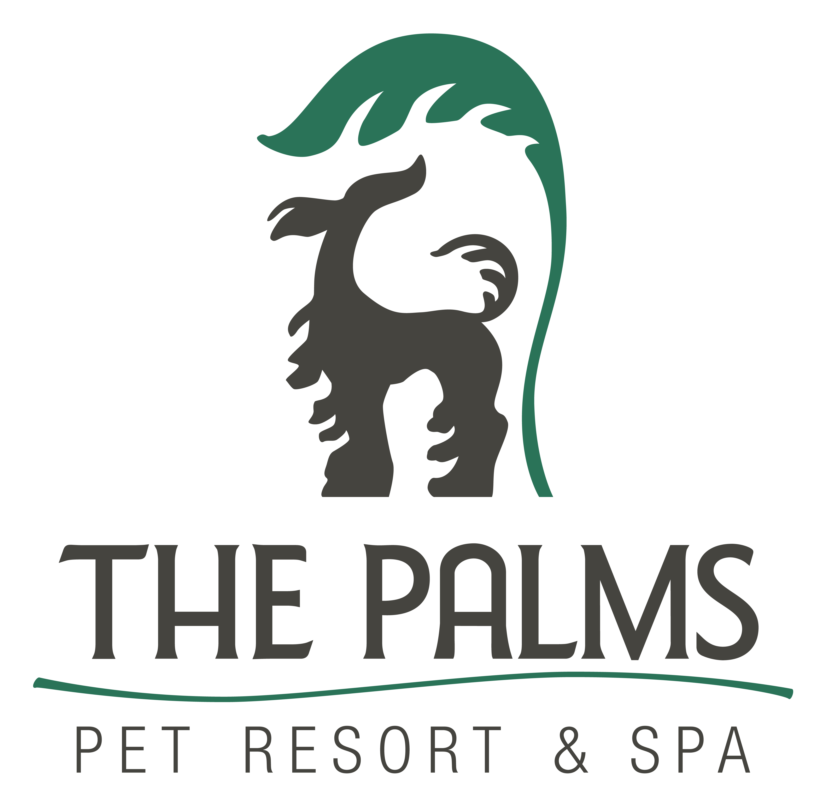
Phone 210-695-1166
Fax 210-695-1578
www.thepalmspetresort.com

Canine Good Citizen Classes Start Thursday, September 18, at 7:00 pm

Canine Good Citizen- CGC is an AKC sponsored program designed to recognize and award the CGC title to dogs that have good manners at home and in the community. This is a two-part program that stresses responsible pet ownership for owners and good manners for dogs. This course will prepare you and your dog for the 10-part test. Dogs do not have to be registered with AKC to earn a CGC nor do they have to be pure bred. Owners are instructed to send in one copy of the test form with a recording fee of $8.00 to receive the certificate from AKC.

Class Pricing-Six weeks for $200.
Pre-requisite- “Pet Manners or Previous Obedience”

Test Items on the CGC test are:
- Accepting a friendly stranger
- Sitting politely for petting
- Appearance and grooming
- Out for a walk (walking in loose lead)
- Walking through a crowd
- Sit and down on command and staying in place
- Coming when called
- Reaction to another dog
- Reaction to distraction
- Supervised separation
All tests must be performed on leash with dogs wearing a well-fitting buckle or slip collar.

Class Schedule (Thursdays)

Sept 18 | 7:00pm-8:00pm
Sept 25 | 7:00pm-8:00pm
Oct 2 | 7:00pm-8:00pm
Oct 9 | 7:00pm-8:00pm
Oct 16 | 7:00pm-8:00pm
Oct 23 | 7:00pm-8:00pm

