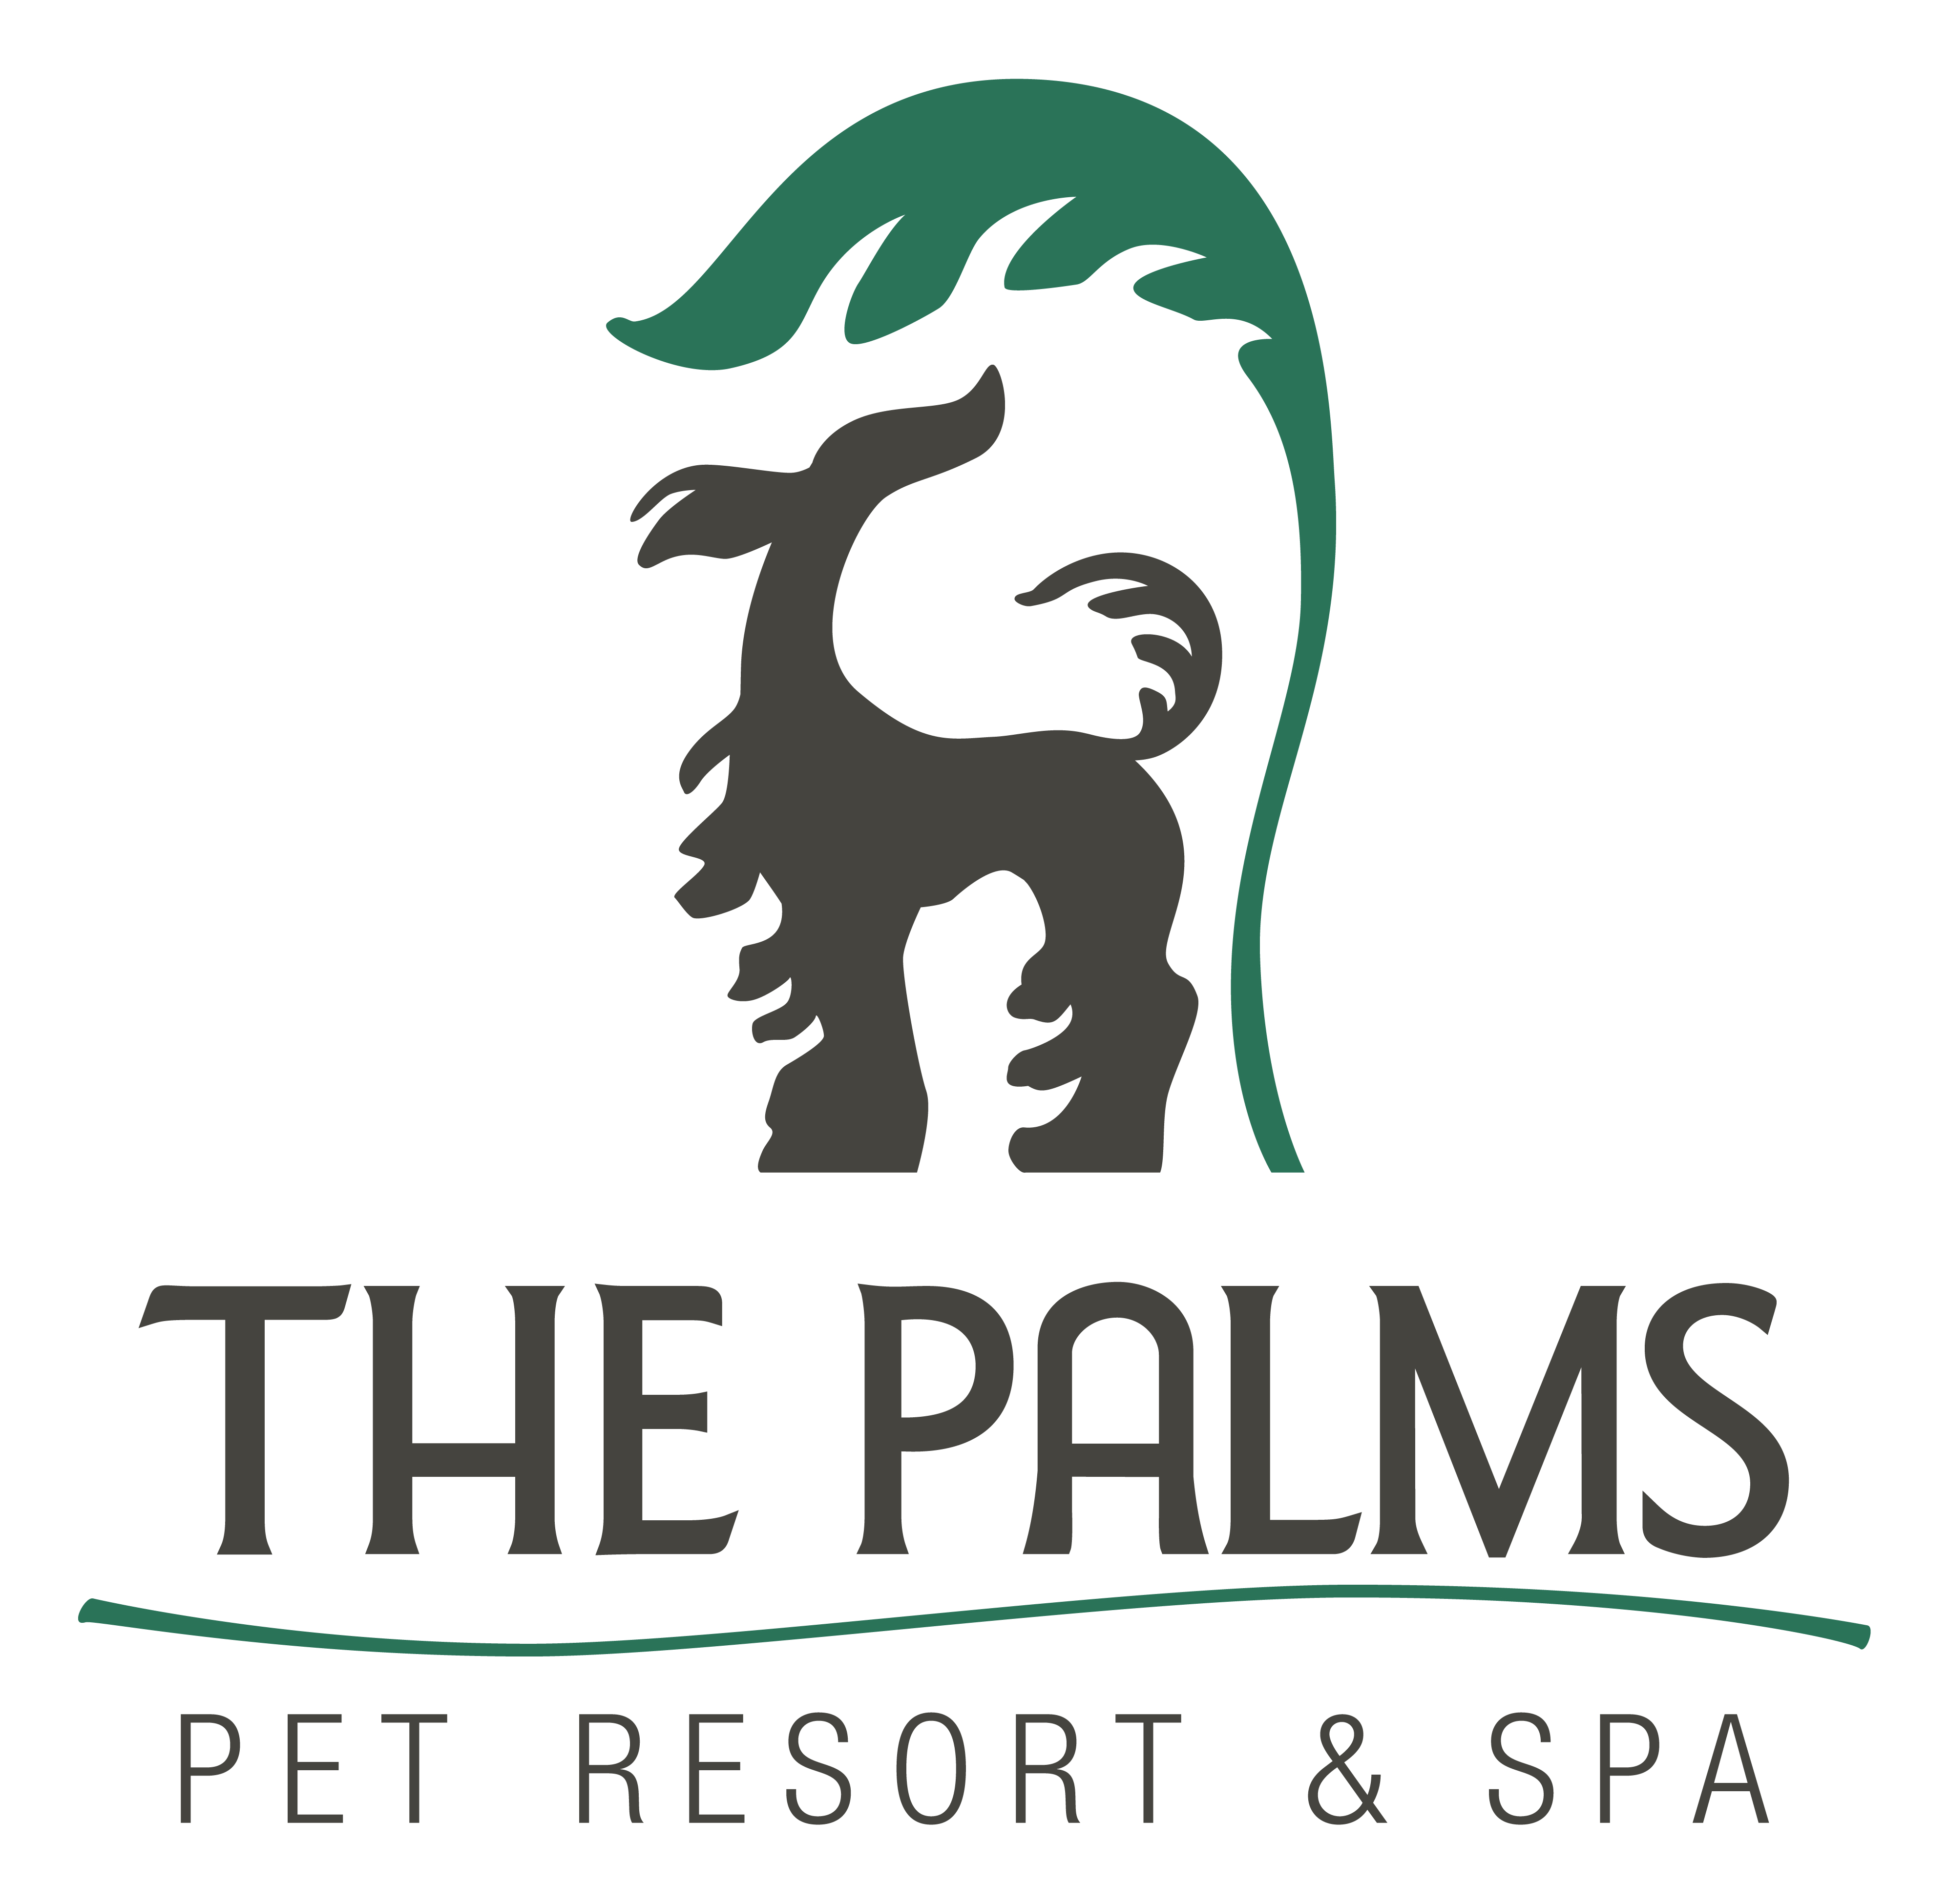
Phone 210-695-1166
Fax 210-695-1578
www.thepalmspetresort.com

Scent Work (3)
Class Starts Monday September 8, at 8pm

4 Odors Scent Work- 4 odors Scent Work is a great way to continue developing your dog’s natural scenting ability: Dogs are individually challenged to discover hidden competition Birch, Anise, Clove and Cypress. This class will provide both physical and mental stimulation for your dog and is a great way to keep boosting their confidence. It is recommended that you do not feed your dog prior to class so they are motivated to search. Scent kit is included.

Items Needed for Class:

- 6 Foot Leash or Longer | - Buckle Collar or Back Connecting Harness
- Moist/Meaty High Value Treats in sealed container | 10” to 15’Line for Larger Searches

Class Pricing-Six weeks for $200.00
Pre-requisite- Birch Scent

Class Schedule (Monday)
Sept 8 | 8:00 pm – 9:00 pm
Sept 15 | 8:00 pm – 9:00 pm
Sept 22 | 8:00 pm – 9:00 pm
Sept 29 | 8:00 pm – 9:00 pm
Oct 6 | 8:00 pm – 9:00 pm
Oct 13 | 8:00 pm – 9:00 pm

