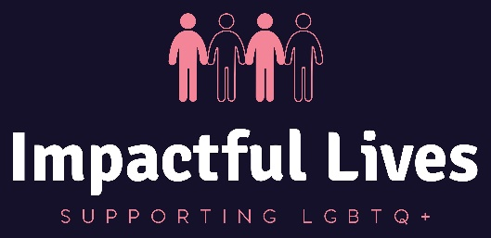
Pre-interview questionnaire

Learning difficulties or disabilities
Do you consider yourself to have any of the following? |  |  | ☐ Yes ☐ No
If Yes, please tick one or more of the following boxes:
Disability, Learning Disability/Difficulty or Autism
Visual Impairment | ☐ | Asperger’s Syndrome |  | ☐
Hearing Impairment | ☐ | Temporary disability after illness or accident |  | ☐
Disability affecting Mobility | ☐ | Speech, Language and Communication Needs |  | ☐
Profound Complex Disabilities | ☐ | Other Physical disability |  | ☐
Social and Emotional Difficulties | ☐ | Other specific learning difficulty (e.g. Dyspraxia) |  | ☐
Mental Health Difficulty | ☐ | Other medical condition (e.g. epilepsy, asthma, diabetes |  | ☐
Moderate Learning Disability | ☐ | Other Learning Difficulty |  | ☐
Severe Learning Disability | ☐ | Other Disability |  | ☐
Dyslexia | ☐ | Prefer not to say |  | ☐
Dyscalculia | ☐ | Not provided |  | ☐
Autism Spectrum Conditions | ☐ |  |  | ☐
Which of the ABOVE learning disability, learning difficulty or health issue do you consider to be your main disability, learning difficulty or health issue:
……………………………………………………………………………………….
……………………………………………………………………………………….
……………………………………………………………………………………….
……………………………………………………………………………………….

Do you have an Education, Health and Care Plan? | ☐ Yes ☐ No
Do you have a Learning Disability/Difficulty Assessment? LLDD | ☐ Yes ☐ No
Do you consider yourself to require any support? | ☐ Yes ☐ No
If Yes, what support do you require?

Your Name: ……………………………………………………………………………………….

Position Applied for: Trustee

Date:


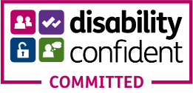

Person Specification:

Essential Criteria | Desirable Criteria
- Working at Board level/Chief Executive and within either statutory or third sector organisations. | - Experience working with LGBTQ+ client groups that have multiple barriers.
- Have lived experience as someone who identifies as LGBTQ+ and has real life experience of some of the challenges. | - Without direction be able to tackle Trustee tasks and responsibilities.
- To be an ambassador of the charity and promoting it to social, business and community connections. | - Own Home/office internet capability with min 50MB download and 10MB upload speed to avoid freeze-screen or drop-out during meetings and presentations.
- Undertake or provide evidence of a clear enhanced DBS check (one will be completed for you if you do not have a transportable DBS) | - Self-starter and able to use initiative to seek-out information.
- Good at speaking with people within our wider community. Promoting the values and benefits of engaging with Impactful Lives. | - Ability to schedule Zoom meetings, sending invites and producing attendance reports and downloading video recordings as evidence.
- Be aware of the ongoing Charity Commission requirements to be an effective Trustee. | - Able to be patient with individuals or groups that have specific issues that may need a higher level of empathy.
- Be empathetic to the LGBTQ+ community and see different perspectives. | - A transportable (online) clean enhanced DBS clearance before commencing any in-person work.
- Organised, punctual and reliable. | - Current understanding of the various structures and models for community partnerships.
- Attend quarterly meetings either in-person or remotely using zoom. | - Understanding of the constraints of Charity Law.
- Must be able to commit to attend our Annual General Meeting (AGM) once a year as a Trustee to support, organize and represent the Board. | - Business acumen to bring decision-making about in the interests of Funding collaborations and partnerships.
- A personable disposition and demonstrable interpersonal skills. | - Some understanding of the Charity Commission Governance Code.
- Write reports and make recommendations in collaboration with the Chair of Trustees.
- Strong ethos for complete inclusion, Equality and diversity (i.e. disability, ethnicity & LGBTQ+)
- Creating partnerships where this can be used as a vehicle to gain greater funding income.

Evidence of how you meet the Person Specification:

Essential Criteria | Desirable Criteria
 | 1
 | 2
 | 3
 | 4
 | 5

Email:ceo@il-org.uk Office: 01923 231660 Website: www.il-org.uk
Registered Office Address: The Old Free School, George Street, Watford, Hertfordshire WD18 0BX
Registered Charity Number: 1203136

