
 |  | The Review | Month/Year
 |  | An Executive Summary of Book Title, written by Author’s name
Author Biography
Put the Author’s bio here. Why should someone read this book?

Reviewer’s Biography
Include a little information about yourself..
Contact information is permitted as well.
  Produced for |  | Main Points Here  Subheading works well on this line.  Newsletters are periodicals used to advertise or update your subscribers with information about your product or blog. They can be printed or emailed and are an excellent way to maintain regular contact with your subscribers and drive traffic to your site. Type the content of your newsletter here. Bullet points can be used sparingly.  Newsletters are periodicals used to advertise or update your subscribers with information about your product or blog. They can be printed or emailed and are an excellent way to maintain regular contact with your subscribers and drive traffic to your site. Type the content of your newsletter here.  Newsletters are periodicals used to advertise or update your subscribers with information about your product or blog. They can be printed or emailed and are an excellent way to maintain regular contact with your subscribers and drive traffic to your site. Type the content of your newsletter here.  Newsletters are periodicals used to advertise or update your subscribers with information about your product or blog. They can be printed or emailed and are an excellent way to maintain regular contact with your subscribers and drive traffic to your site. Type the content of your newsletter here.


The Review
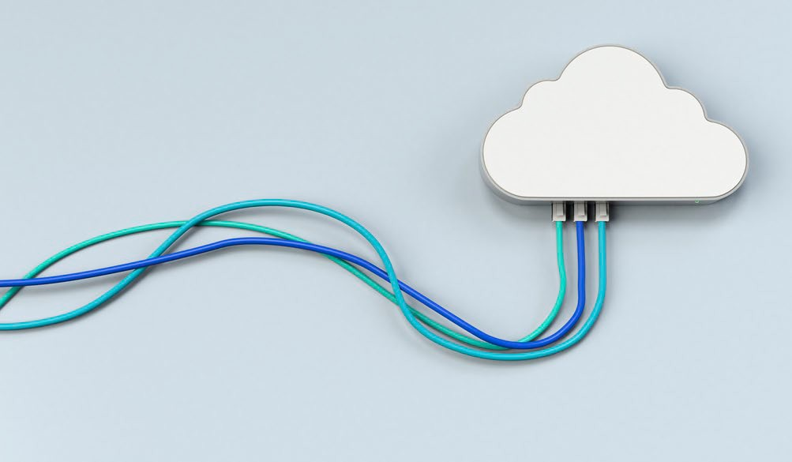  Ministry Application  Critical Thought in line (provide practical ideas and suggestions)  Newsletters are periodicals used to advertise or update your subscribers with information about your product or blog. They can be printed or emailed and are an excellent way to maintain regular contact with your subscribers and drive traffic to your site. Type the content of your newsletter here.  Newsletters are periodicals used to advertise or update your subscribers with information about your product or blog.  Newsletters are periodicals used to advertise or update your subscribers with information about your product or blog. They can be printed or emailed and are an excellent way to maintain regular contact with your subscribers and drive traffic to your site. Type the content of your newsletter here. |  |  | Give brief review of the book Here  Summarize in one phrase.  Newsletters are periodicals used to advertise or update your subscribers with information about your product or blog. They can be printed or emailed and are an excellent way to maintain regular contact with your subscribers and drive traffic to your site. Type the content of your newsletter here.  Newsletters are periodicals used to advertise or update your subscribers with information about your product or blog. Type the content of your newsletter here.  Newsletters are periodicals used to advertise or update your subscribers with information about your product or blog. They can be printed or emailed and are an excellent way to maintain regular contact with your subscribers and drive traffic to your site. Type the content of your newsletter here.
 | Final Thoughts  Subtitle might work here as well  Newsletters are periodicals used to advertise or update your subscribers with information about your product or blog. They can be printed or emailed and are an excellent way to maintain regular contact with your subscribers and drive traffic to your site. Type the content of your newsletter here.  Newsletters are periodicals used to advertise or update your subscribers with information about your product or blog. They are an excellent way to maintain regular contact with your subscribers.

