

Saltmarsh Sparrow Conservation in the Face of Climate Change
Unit Plan: 2-4 weeks depending on weekly class schedule
Target grade band: HS-college
Overview:
The film Stories to Save Us: The Saltmarsh Sparrow concludes with a simple question: Where do we go from here? The activities in this unit help students develop answers to that question. Two main factors have combined to put the saltmarsh sparrow at risk. The first is sea level rise and the second is saltmarsh degradation. Each of those, in turn, have multiple causes and therefore present a range of potential opportunities for mitigation interventions.
To complete a nesting cycle, which includes laying, incubation, hatching, development, and fledging, a saltmarsh sparrow nest requires a window of about 23 days between tidal floods. Saltmarsh sparrows place their nests in high marsh, which is the portion of a saltmarsh that does not flood during daily high tides. Rather, high marsh floods approximately monthly due to spring tides (driven by the full/new moon cycle), and less frequently due to unpredictable storm-surge tides. Human activity has reduced high marsh availability, increased the likelihood of storm surges, and increased the duration of high-mash inundation. Mitigation strategies explored in this unit touch on short term measures (intervene to reduce nest failures), medium term measures (intervene to protect and expand high marsh habitat), and long term (intervene to limit sea level rise).
The unit is comprised of three activities
- Activity 1: Model population growth/decline using a spreadsheet
One lab period
- Activity 2: Exploring conservation measures to rescue salt marshes
Multiple lab periods
- Activity 3: Investigating tidal patterns and exploring species-level conservation measures.
Two lab periods
The activities can be completed as a unit. Alternatively, activities or selected parts of activities can be completed as stand-alone lessons.

Student Learning Outcomes (SLOs)

At the end of this unit students will be able to:

Model population growth and decline
Change model parameters and evaluate impacts
Describe a range of salt marsh restoration actions
Explain tidal dynamics at daily, monthly, and decadal scales
Explain the impacts of climate change on tide dynamics
Differentiate between predictable and stochastic climate-change impacts
Explain the connection(s) between climate-change-related sea-level rise and saltmarsh sparrow persistence
Explain the process of salt marsh accretion
Explain the connection between accretion and saltmarsh sparrow persistence
Propose and evaluate a range of potential conservation efforts aimed at saltmarsh sparrow preservation
Evaluate the social context of conservation actions
Differentiate between species-level and ecosystem-level interventions
Differentiate between proximate and ultimate drivers of extinction

Activity 1: Modeling change in a population over time
Time required:
One long class period or lab
Materials and resources:
Excel or comparable spreadsheet.
Field et al. (2016) High resolution tide projections reveal extinction threshold in response to sea-level rise. Global Change Biology. DOI 10.1111/gcb. 13519

Pre-lab reading assignment:
Cornell Lab, All About Birds, “Saltmarsh Sparrow Life History.” Make sure to read the “Conservation Tipping Point” section. (https://www.allaboutbirds.org/guide/Saltmarsh_Sparrow/lifehistory#habitat)
National Ocean Service, “What is a salt marsh?” (https://oceanservice.noaa.gov/facts/saltmarsh.html)

Activity:
Using spreadsheet functions, address the following questions:
If the population of saltmarsh sparrows declined by 9% per year between 1998 and 2012, and the estimated overall population size in 2012 was 60,000, how large would the population have been in 1998?
If the population continues to decline at 9% per year, how large will it be in 2060?
If we can intervene to slow the rate of decline, how much would 9% per year need to change to ensure that the saltmarsh sparrow would persist beyond 2060?
Instructions:
1. Open a spreadsheet and create three columns titled: Year, Rate, and Size.
2. Fill the “Year” column with years starting with 1998 progressing to 2060.
3. Fill the Rate column with the number -0.09. This will allow you to reduce the population by that amount each year.
4. Start the Size column with a rough estimate of how large you think the population may have been in 1998 (take a guess). Type your guess into the Excel cell for Size in the row where Year = 1998. (For this example I start with a guess of 100, which is obviously not correct, but it is a guess.)
5. Fill the rest of the cells in the size column with a formula that will calculate a population each year that is 9% smaller than it was in the previous year. There are a wide variety of ways that you can do this, the method presented here is just one of those ways.
In this example, population size in 1998 was guessed to be 100. Population size in 1999 is that value (the orange arrow shows the value in Column D, Row 2, referred to as cell “D2”) reduced by 9% (in the formula, C2*D2 multiplies -0.09 x 100 and that value will be subtracted from 100). After typing the formula and hitting Return, the spreadsheet looks like this:
Next, drag the formula down so that it copies into each cell in the column:
Continue this process so that you model population decline through the year 2060.
6. Based on your guess for the population size in 1998, how large would the population have been in 2012? In my example, starting with 100, there would have been ~27 individuals in 2012.

7. Adjust the starting population size (the guess you made for size in 1998), until the size in 2012 is ~60,000.

Discussion and reflection questions:
How many saltmarsh sparrows did we likely have in 1998? Do you and your fellow students all get the same estimate?
Does your simulation of saltmarsh sparrow population size support the statement from All About Birds that the cumulative change between 1998-2012 was a reduction of 75%?
Based on your simulation, how many saltmarsh sparrows will remain in year 2035 and in year 2060?
Research by Field et al. (2017) suggested that the saltmarsh sparrow would not persist beyond 2060, and that it could be extinct as early as 2035. How many saltmarsh sparrows did your simulation suggest would exist in those years? Does your simulation generally agree with the findings of Field et al.? If not, what assumptions might be different between the two analyses. (HINT: Our spreadsheet simulation assumed that the rate of decline, 9% per year estimate from early 2000s data, would not change.)

Extension:
What if we wanted to ensure that in 2060 we would have at least 5000 saltmarsh sparrows. (The number 5000 is often cited as the minimum size of a population to ensure persistence without inbreeding or other issues related to small populations. It is a general rule of thumb that has been useful for some species.)
Starting with your estimate for the current population size (Year 2025), what rate of decline would result in at least 5000 birds in 2060? Adjust the -0.09 to a different value, e.g. -0.08, for Year 2025-2060. Keep adjusting until the estimated size in 2060 is >5000.
Actual extinction is when a species declines to 0 individuals. However, prior to that a population can fall below a threshold that conservationists call the minimum viable population (MVP). The MVP is a flexible concept that is applied differently for different species. For example, for the saltmarsh sparrow, we might say that the MVP is a size that would give the species a 90% chance of not going extinct in the next 50 years in its natural habitat. (The ability to keep organisms alive in a zoo, for example, is generally not included in MVP calculations.) The California condor gives us an example of a species that fell below what ecologists considered to be its MVP. Research the California condor recovery program and summarize the measures were taken to keep condors from going extinct (https://www.fws.gov/program/california-condor-recovery).
Do you think anything similar could be done with the saltmarsh sparrow?
In 1982 there were 23 California condors. How many are there today? Build a spreadsheet model and estimate the average annual growth rate of the California condor between 1982 and today.

Activity 2. Exploring conservation measures at the ecosystem level.
Time required:
Three class periods, three different days. In the first period students will need to go outside to collect soil samples, ~45 minutes, depending on proximity to a location where they can collect soil. In the second period students will set up accretion simulations in a laboratory, ~2 hours. In the third period students will take final measurements, clean up, and discuss their findings, ~45 minutes.
Materials and resources:
Jars, clear, with lids, 1.5 liters is a good size target, Mason jars work well.
Spades
Plastic bins
Carpet remnants, mats, old clothing, tee-shirts, blankets, etc, that can be cut into rectangles.
Dish detergent
Sharpies
Rulers
Soil triangle printout

Pre-lab reading assignment:
USFWS “Nature-Based Solutions: Salt Marsh Habitat Restoration” (https://www.fws.gov/project/nature-based-solutions-salt-marsh-habitat-restoration)
Correll et al. (2017) Predictors of specialist avifaunal decline in coastal marshes. Conservation Biology 13 (1) 172-181)

Activity:
Test the ability of vegetation to trap sediments.
Instructions:
Day 1 - Soil sample in a jar.
In a nutshell, students fill a clear jar 1/3-1/2 full with a soil sample, add a drop of dish detergent, fill the jar nearly to the top with water, shake it well, and let it settle for at least a couple of days. The exact protocol is not important here, but it is important that you use the same protocol for each part of this activity.
Each lab group will need three soil samples, as similar in size and composition as possible.
There are many online resources, both print and video, that cover the jar test for soil texture. Choose one that you like.
Suggested video instruction (https://www.youtube.com/watch?v=3g2nro1EWGE)
Suggested print instruction (https://hgic.clemson.edu/factsheet/soil-texture-analysis-the-jar-test/).

Day 2 - Sediment retention simulation.
Before beginning this activity, students should make predictions about what types of fabric will have the greatest ability to trap sediment. Factors like thickness, tightness of weave/knit, thread count, thickness of fiber, and ability of the fiber to absorb moisture are some examples of variables that might matter. What is most important here is not that they intuit the “right” answer, but that they articulate what they think. Students should be rewarded for creativity and thinking outside the box. After all, someone had to be the first person to imagine that a molecule could behave like a virus or a bacterium, and thus we learned about prion diseases, and that earned a Nobel Prize. We should not forget that our current understanding of many important concepts in science started with ideas that, at the time, most learned people thought were nutso.

1. Obtain rectangular, plastic bins, the bigger the better, three per group.
2. Prop one end of each bin on a book, a piece of wood, or a pile of papers. A paper pile had the advantage that you can very easily adjust the angle by adding or removing sheets. The angle against horizontal should be very shallow, just a few degrees.
3. Cut two rug or fabric rectangles that will cover the about half of the rectangular bin. Place them in the upper (high side) of the bins and secure with a small piece of duct tape (or waterproof first aid tape). Choose rugs/fabrics that differ in some way, such as thickness, tightness of the weave/knit, etc. The third bin will have no fabric.
4. Label each bin, e.g. “Bin A,” Bin B,” and “Bin C,” or “Door Mat,” “Sweatshirt,” and “Control.” Pair each bin with a soil sample jar, and label the jars to match the bins.
5. Record the depth of sand, slit, and clay for each jar. Taking a photo with a ruler for reference is also a good idea.
6. Shake each jar well, and then slowly pour the contents onto the fabric at the top end of the appropriate bin. Add more water to the jar, mix well again, and again slowly pour the contents onto the fabric. At this point the jar should be relatively clean.
7. Clean each jar to remove any soil remnants that got left behind.
8. Wait about 30 minutes.
9. Scoop up all of the soil that has collected in the bottom of each bin and return it to the appropriate jar. Add fresh water until the jar is nearly full, shake well, and leave it to settle for a couple of days.

Day 3 - Compare the results.
1. What were the major differences between the before and after soil samples? Did the overall amount of soil change dramatically? Did the composition of the soil change dramatically? What does that imply about the process by which salt marshes retain soil?

Extension:
Correll et al. (2017) suggest that changes to the way that water enters, lingers, and exits a salt marsh, (processes covered by terms such as “salt marsh restriction” and “salt marsh accretion”), have had more dramatic effects on saltmarsh sparrow nest success than has sea level rise per se. Is this good news or bad news for saltmarsh sparrow conservation? What does that tell us about our ability to mitigate or reverse the decline of the saltmarsh sparrow? Of the nature-based-solutions covered in the USFWS reading, which seem to have the greatest potential? How do the results of your experiment, and the findings of Correll et al. support your opinion?
The film BirdStory: Saltmarsh Sparrow, included information on saltmarsh degradation and restoration. The end of the film posed the question “Where do we go from here?” How did you feel about that question when you watched the film? How would you rate your degree of hope on a scale of 0 (it’s hopeless) to 10 (we can save saltmarshes) then vs. now? After studying sedimentation and its potential effects are you more hopeful?
Listen to the podcast Bringing Wetlands to Market: The Power of Coastal Blue Carbon in a Changing Climate. Could you craft a proposal that would benefit (1) a corporation looking to offset its carbon emissions, (2) the planet’s carbon budget, (3) employment opportunities and the economy of a coastal town, (4) a saltmarsh ecosystem, and (5) the saltmarsh sparrow? In what ways could what you’ve leaned about saltmarsh accretion benefit each of the five entities listed above?
The film BirdStory: Saltmarsh Sparrow, highlighted a series of negative perspectives on marshes, including “drain the swamp” metaphors, swamp monsters in media, swamps as capsules of racism, and swamps as places to dump waste. What stories could you now start to tell that would paint swamps in a positive light? Which vision seems more accurate?

Activity 3. Conservation at the species level.
Time required:
About 2 hours
Materials and resources:
Computers and web access
Pre-lab reading assignment:
New England Aquarium, King Tides: A Glimpse Into Boston’s Future Shorelines (https://www.neaq.org/king-tides-bostons-future-shorelines/)
NOAA, Tide & Currents, Tidal Datums. (https://tidesandcurrents.noaa.gov/datum_options.html#:~:text=A%20tidal%20datum%20is%20a,oceanographic%20characteristics%20without%20substantiating%20measurements.)
Activity:
The film BirdStory: Saltmarsh Sparrow highlighted the very immediate impact of tidal flooding on saltmarsh sparrow nestlings. In this activity students will learn about different aspects of tidal variation, explore data on historic trends in high tides, and examine a solution that had been developed recently.
Instructions:
Day/Part 1: Explore tidal patterns at different scales
1. Navigate to NOAA’s webpage for Tides and Currents (https://tidesandcurrents.noaa.gov/)
2. Click on one of the states in the northeastern USA.

3. Choose a monitoring station that has data for water level. Markers for each data station are color coded to indicate which types of data they record, and the key is on the lower right part of the screen. Red in the marker flag indicates a stations that records water level.
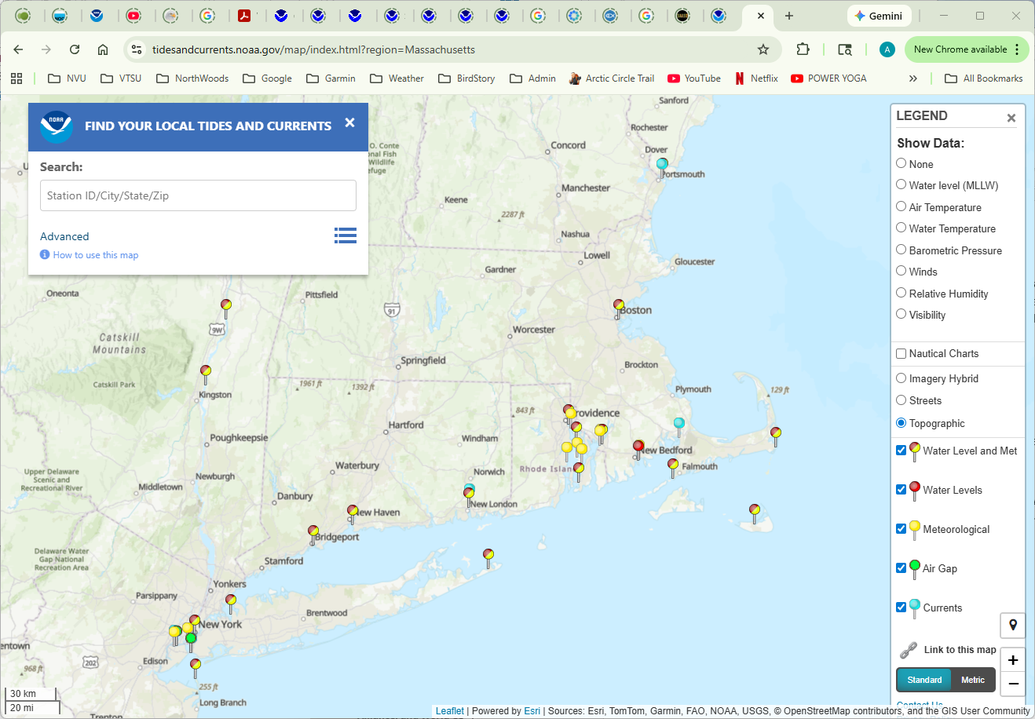

4. Select a station by clicking on its marker flag.
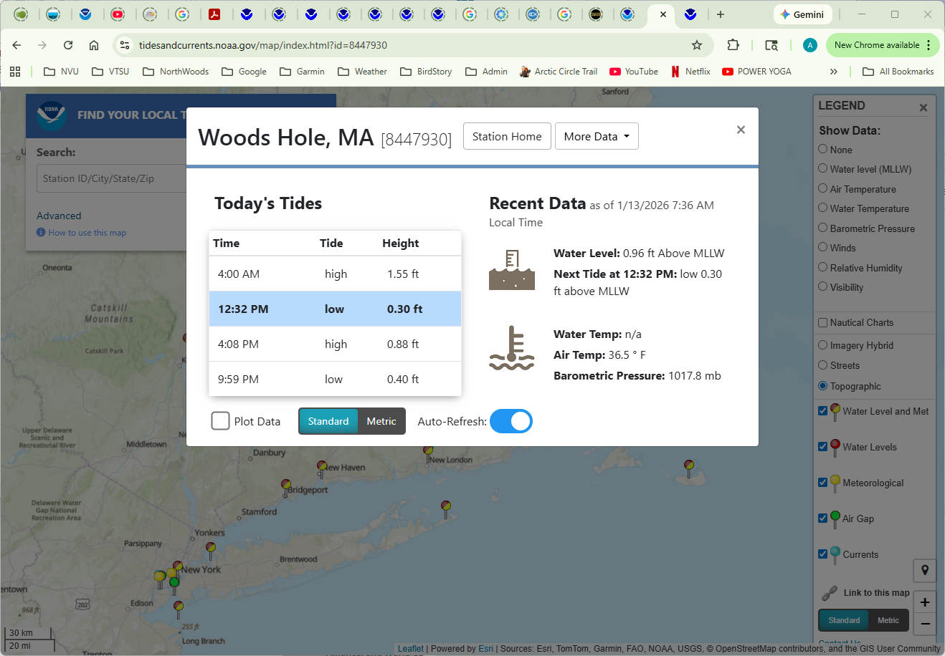
In this example I clicked on “Woods Hole, MA.” Note that there are two high tides and two low tides per day, and that one high tide is higher than the other, while one low tide is lower than the other.
Why are there two cycles of high and low tide per day?

5. Use the “More Data” menu and select “Water Levels.”
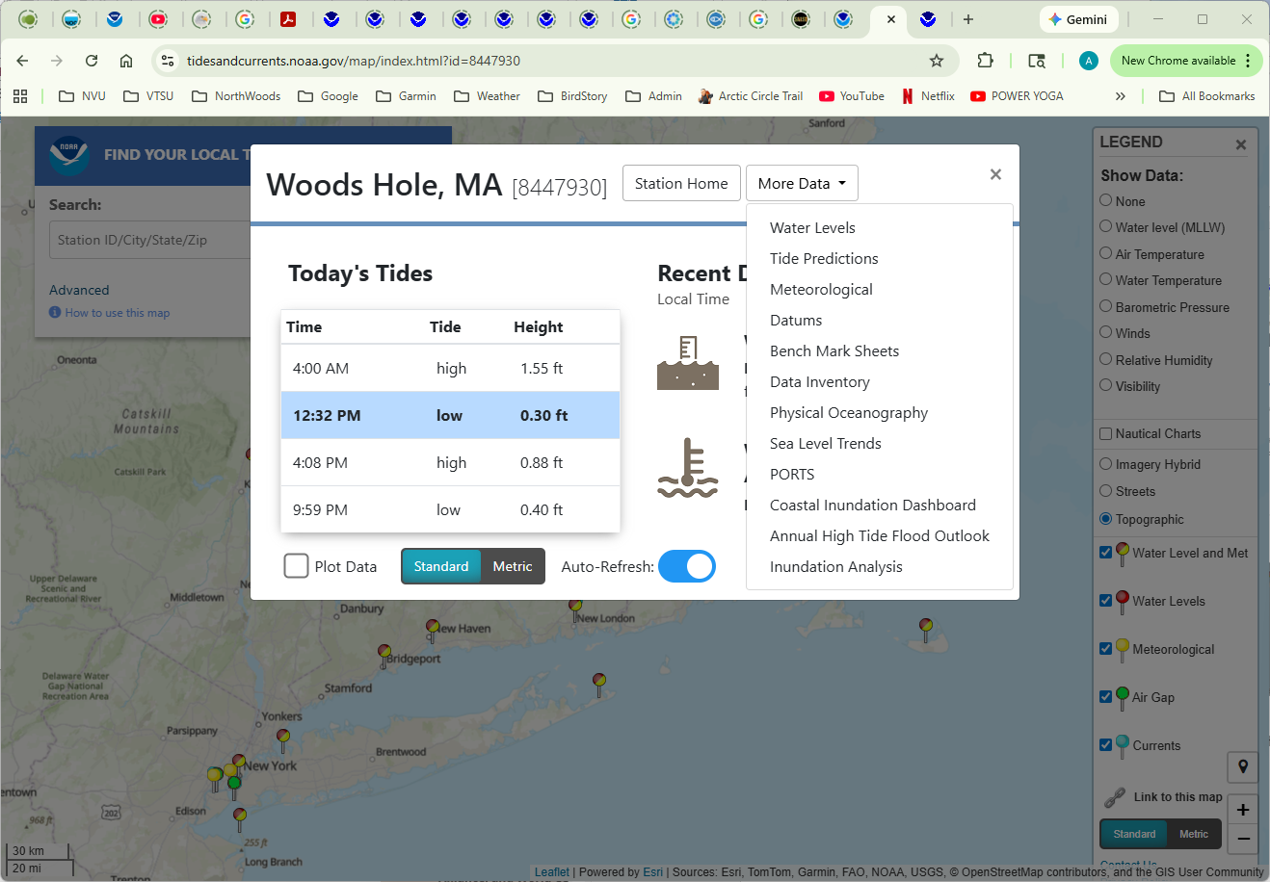
The “Water Levels” page will open with a display of data for the current day. Note that the blue line for predicted water level and the red line for actual water level are not identical.
What factors are used to create the predicted levels, and what factors might cause the actual levels to be different?
6. Use the “Options” window to view data for the past several months.
a. Set the “From” date to be a few months prior to the current data
b. Set the Interval to “1 hr.”
c. In Update, click “Plot.”
d. To simplify the graph, click on “Verified.” Clicking on this will toggle the verified data on and off. (You can also toggle the predicted data on and off.)
Notice the monthly patterns. Periodically we see high and low tides that are not too different from each other (the graphed line contracts vertically) while we also see times when high and low tides diverge from each other (the graphed line expands vertically). The times when the high tides are the highest are called spring or king tides.
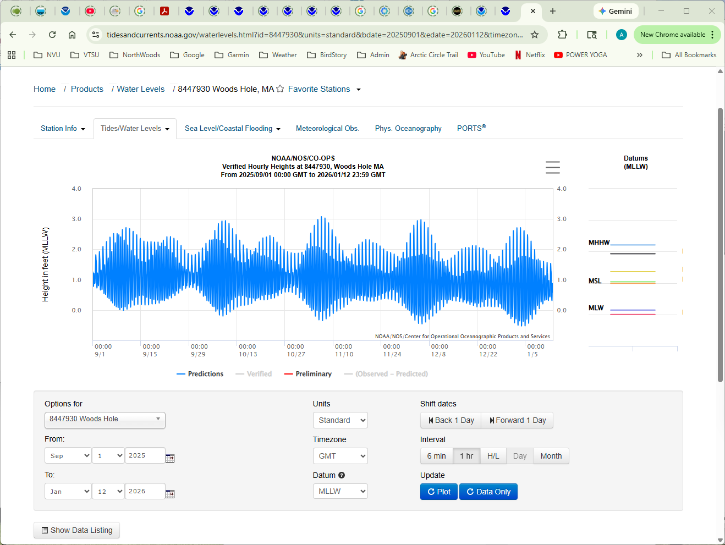
What causes the level of high tide to be at its highest each month at exactly the same time as the low tide is at its lowest each month?

7. Look at 20 years of data (if the station that you chose does not have data going back that far, you might need to pick a different station).
a. Set the “To” year to be 20 years earlier than the current year.
b. Set the “Interval” to “Month.”
c. Click “Plot.”
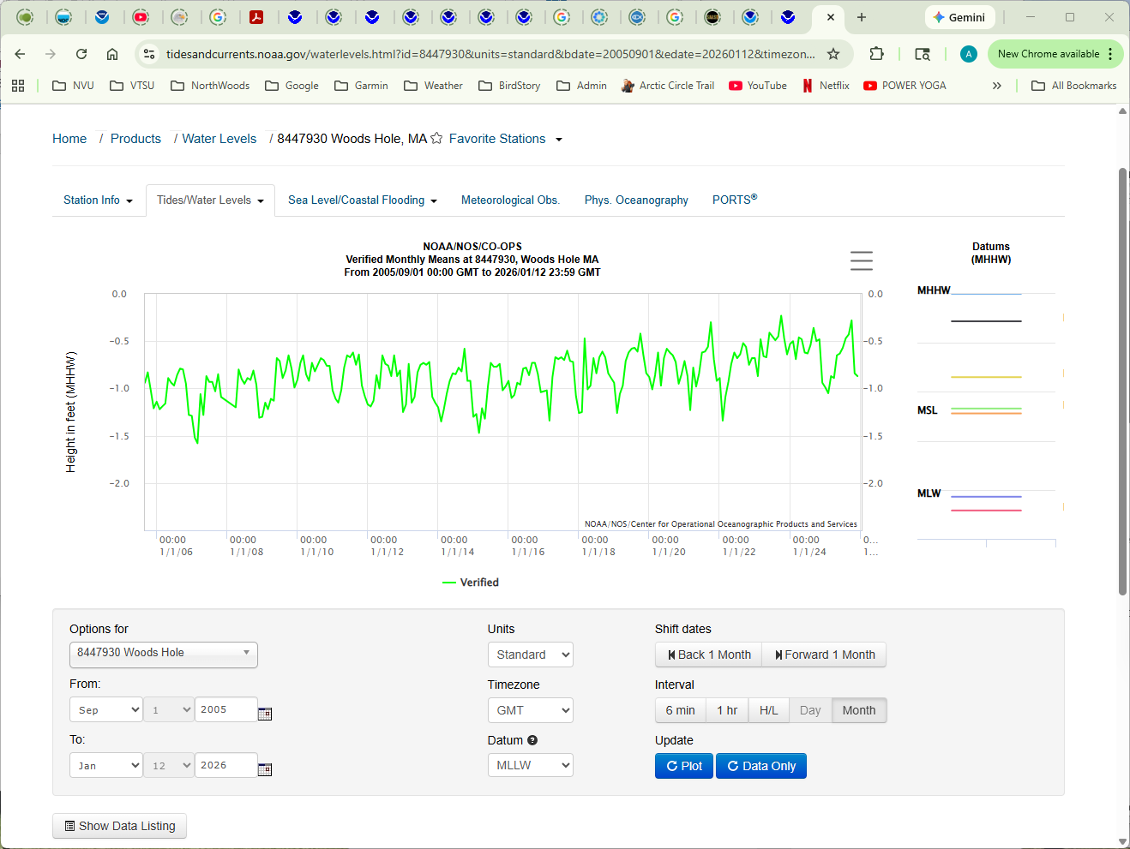
Note that across years tides cycle between periods of relative high and relative low. The cycles here are not as clear and predictable as in the previous graph, but you can still see peaks and valleys.
Across 20 years of data, how many cycles do you see in your graph? )You will have to make some judgement calls here on what constitutes a cycle. In the screen shot above, one fluctuation circled in orange clearly constitutes a cycle, while a second group circled in blue do not.)
What factors cause tidal magnitudes to change at the scale of years?
What is the magnitude of change at this scale? Are the highest high tides large enough to present potential problems for saltmarsh sparrow nest success?
If you drag your mouse/cursor along the graphed line, you can see the date on which each tide occurred. Do the highest highs happen during months of the nesting season? Does this appear to be regular, or random?

8. Note that for each of the plots we have examined, the data are available. To access the data, click the button at the bottom left that says “Show Data Listing.” You can then download the data by clicking in the bottom right on the button that says “Export to csv.” this will create a file that can be opened in a spreadsheet application.
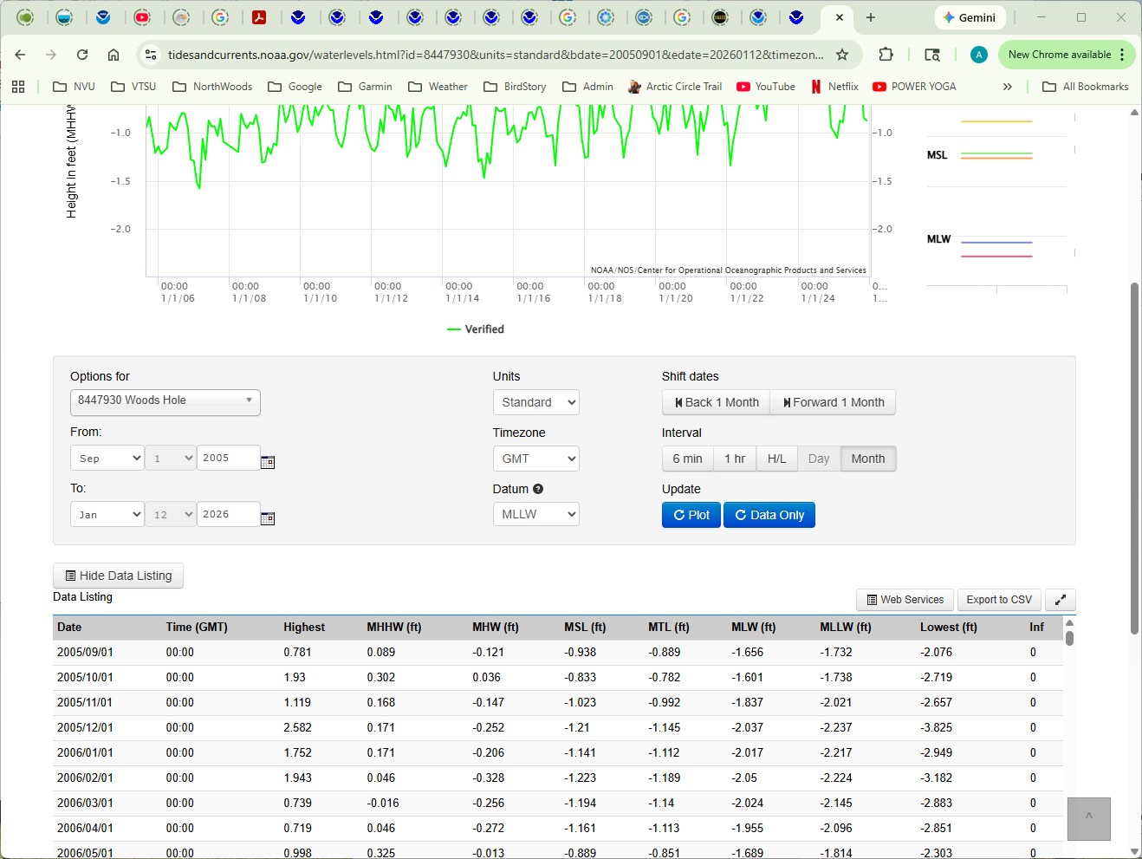

9. Let’s take a closer look at what we’ve been viewing. Tidal data are presented against some reference value, and those reference values are called “Datums.” Note that in the examples presented here, the Datum field was set to “MLLW.” This stands for Mean Lower Low Water. Recall that each day there were two high tides and two low tides. The MLLW averages all of the values for the lower of the two low tides over a 19-year period. Next, each data point in our graph is plotted compared to that 19-year average. So on the graph above, a value of 1.0 ft on the y-axis means that the measured level of the tide was 1.0 ft higher than MLLW. Change the Datum field to MHHW (Mean Higher High Water) and note that your graph will then consist of all negative numbers. That is because monthly averages including highs and lows will be smaller than a benchmark based on the highest highs.
You can see all of the different options for datum in the NOAA Tidal Datums page (https://tidesandcurrents.noaa.gov/datum_options.html#:~:text=A%20tidal%20datum%20is%20a,oceanographic%20characteristics%20without%20substantiating%20measurements.)
10. Switch from the “Tides/Water Levels” page to the “Sea Level/Coastal Flooding” page and select the “Coastal Inundation Dashboard.”
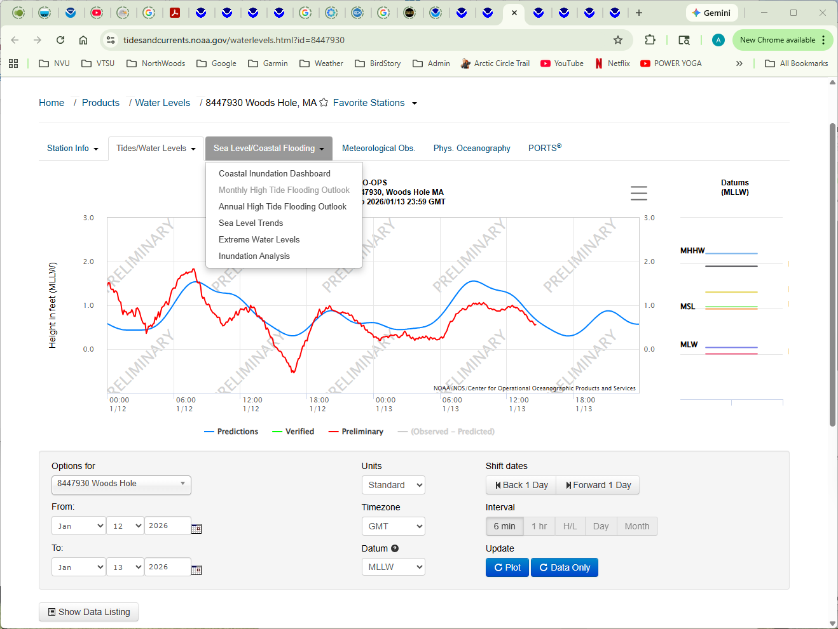
In the window that opens, select “Historical Flood Days.”
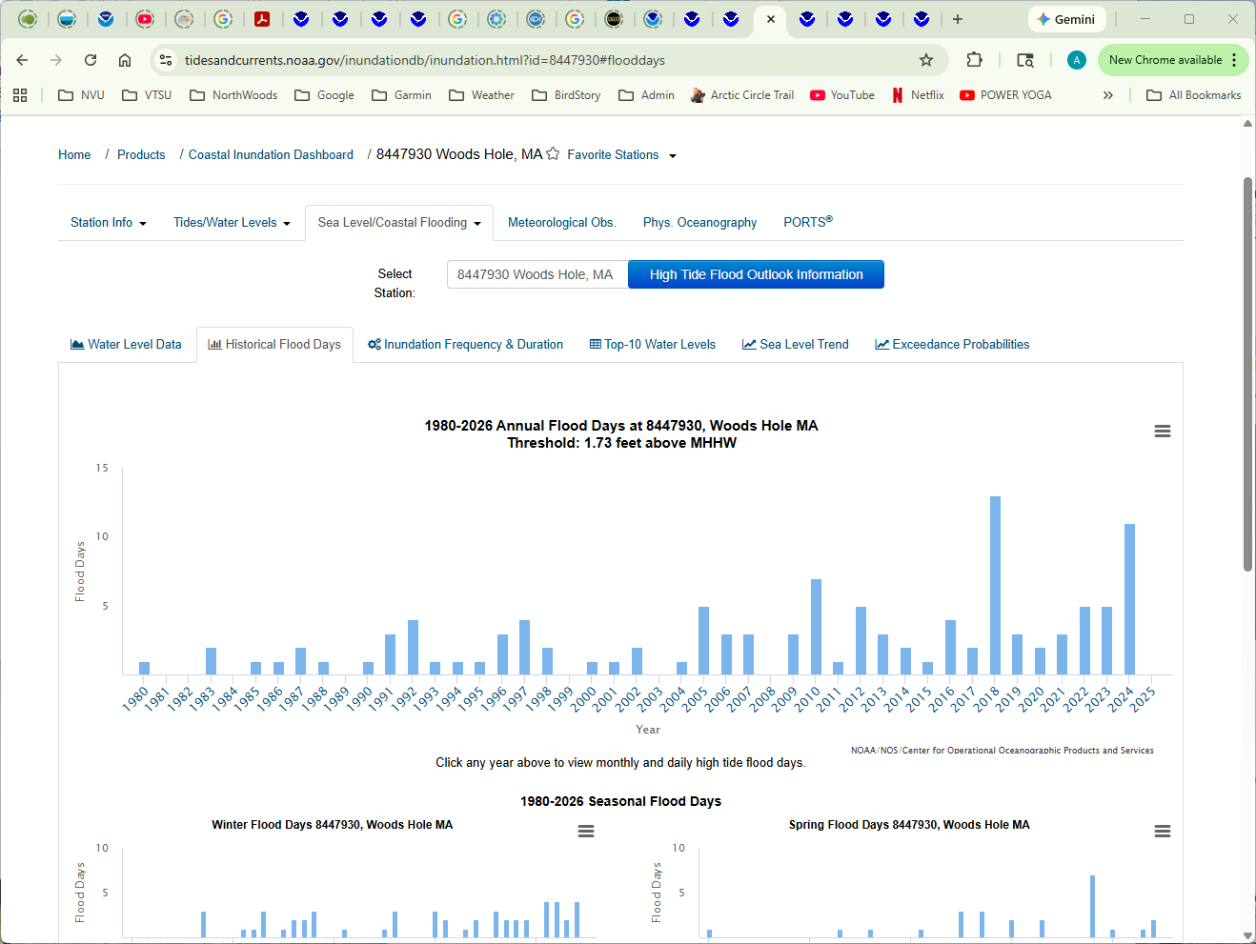
What does this graph suggest about the future of the saltmarsh sparrow?

Day/Part 1: Potential responses to inundation
1. Watch the film “Citizen scientists hacking nature to save the saltmarsh sparrow” (https://www.youtube.com/watch?v=WM17urvrrKE). The film presents two hopeful scenarios for the saltmarsh sparrow. One is that the species will evolve to nest in slightly different habitat. The second is that humans can intervene nest-by-nest.
Does it seem reasonable to conserve this species with a nest-by-nest approach? Is what we stand to gain worth the effort that would be required?
Does it seem reasonable to expect that saltmarsh sparrow nest site selection will evolve? Does the timeline required seem like it might work, or is sea level rising too fast?
If a nest-by-nest approach could save the saltmarsh sparrow from extinction for 30 years, would that be enough time for ecosystem-level interventions to kick in and save salt marshes? Or in 30 years, is it possible that global solutions will have adequately addressed sea level rise?

