

Easter Meditations
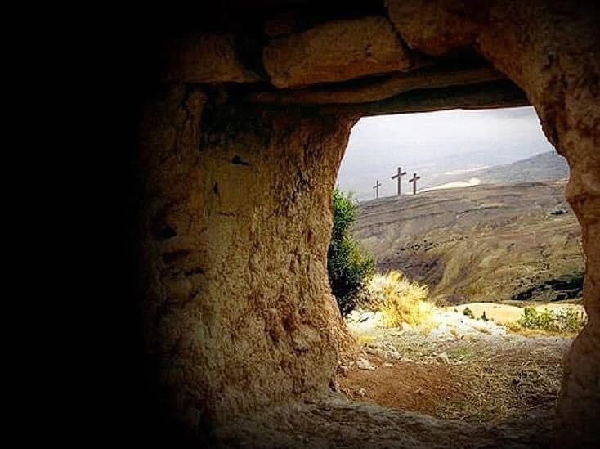
2026

Taken from the Gospel of John

Early in John’s Gospel we read these unforgettable words: ‘For God so loved the world that he gave his only Son, that whoever believes in him should not perish but have eternal life’ (3:16). As the Gospel reaches its final chapters we see what is meant by God giving his only Son. It is not only that he came into the world as one of us, but that he died for us and was resurrected. As a consequence of his death there is eternal life for all who trust him. All this comes from the love of God. What wonderful news!

- ‘Father the hour has come. Glorify your Son, that your Son may glorify you’ (John 17:1)
This is what Jesus prays on the night of his arrest and crucifixion. ‘The hour’ is when he will be lifted up in death (12:27-33). This is why he has come, to save the world. And so, he prays for glory for himself and for the Father. His obedience to God will lead to glory, the glory of the cross. As we realise that Jesus died for us, we thank God for what he has done for us in Jesus, and our hearts are filled with wonder at his grace.
Response:
Our Father, we thank you that you glorified your Son in his death for us on the cross. Help me to glorify you, by trusting you, thanking you and praising you all my days. Amen.

- ‘Caiaphas was the one who had advised the Jewish leaders that it would be good if one man died for the people’ (John 18:14)
Jesus had been arrested. Now he was brought before Caiaphas, the High Priest. John reminds us that some time before, Caiaphas had recommended the death of Jesus. He little knew how significant his words would be. His plan to kill Jesus was evil. But from such evil would come the salvation of all who put their trust in Jesus, the forgiveness we all need. We are called to meditate on this, that God so loved the world that Jesus bore our sins in his body on the tree. We bow before the Lord, asking for forgiveness and thanking him for his mercy.
Response:
Lord God, I confess before you that I am a sinner and do not deserve your love. I know that Jesus died for me and so in his name I ask for your forgiveness now and always. Amen.

- ‘They clothed him in a purple robe and went up to him again and again, saying, “Hail, King of the Jews!” And they slapped him on the face (John 19:3)
What did Jesus suffer for you? Before the crucifixion, he was betrayed by a friend, abandoned by his disciples, unjustly found guilty, and terribly mistreated by the soldiers. They made a crown of thorns, they dressed him as a king, they mocked him and hit him. In all this we can see God’s truth. Jesus is the King of God’s kingdom, the ruler of all people. His kingdom was not established by warfare, but his love. This is the eternal kingdom into which we are invited. We need to ask ourselves, ‘Is Jesus my King?’
Response:
Our Father in heaven, help me to remember every day that Jesus is our Lord and help me to make it my aim to please him in thought and word and deed, for His Name’s sake, Amen.

- ‘When Jesus saw his mother there, and the disciple whom he loved standing nearby, he said to her, “Woman, here is your son,” and to the disciple, “Here is your mother” (John 19:26).
We are confronted with a scene of unspeakable agony and torture. The pain of crucifixion would have been so awful that the victim could think only of himself. How great must have been the pain and grief of his Mother. But here we have our Lord, crucified because of the love he had for us, showing that love by thinking of his Mother and caring for her. No wonder the Apostle Paul prays that we will, ‘grasp how wide and long and high and deep is the love of Christ’ (Ephesians 3:19). Jesus will never fail you.
Response:
Dear Lord, please help us to grasp how wide and long and high and deep is the love of Christ and to dwell in it all my days, for His sake, Amen.

- ‘Later, Joseph of Arimathea asked Jesus for the body of Jesus’ (John 19:38)
Joseph was a secret disciple of Jesus, fearful of what the leaders would say if he was open. He and Nicodemus, the man who had visited Jesus at night, took care of the body of Jesus and laid it in a tomb in a garden near where the crucifixion took place. As we know from Matthew, the tomb was then guarded by soldiers, in case the disciples came and stole the body away. In other words, at every point from his death to his resurrection, the body of Jesus was secure. It was secured by love and guarded by fear. How astonishing, then, that when the women came to anoint the body, the tomb was empty. The resurrection is a reality.
Response:
Almighty God, I thank you that in your power and might you raised the Lord Jesus from the dead, and I thank you that you have promised to raise us also, so that we may have eternal life. Amen.

- ‘Jesus said to her, “Mary”’ (John 20:16)
When Mary Magdalene saw that the tomb was empty, her first reaction was to say that the authorities had removed his body. She was not thinking of a resurrection. On meeting Jesus in the garden, she was so distraught and so convinced that enemies had removed the body, that she mistook him for the gardener. It was not until Jesus said her name that she recognised him and fell at his feet. Once more we see the reality of the resurrection. Once more we see the love of Jesus for us as individuals, for just the single word of her name was enough to open her eyes to the truth. And this woman is the first to meet the resurrected Saviour.
Response:
Gracious God, thank you for your love of the whole world. Thank you for your love of individual persons. Thank you that in your love you reveal yourself to us and open our eyes that we may see the glorious face of our Saviour Jesus Christ. Amen.

- ‘Thomas said to him, “My Lord and my God!”’ (John 20:28)
Thomas the doubter is quite a useful person for us. He puts into words the doubts that many feel about the resurrection. But even Thomas was convinced that he had not encountered a ghost but a real person. And, he gave us the words to say when we encounter Jesus by faith: ‘My Lord and my God’. For God so loved the world that he did not merely send an angel, he sent his Son, true God and true Man. Thomas helps us to turn our doubts into the faith which opens our heart to the risen Lord.
Response:
Heavenly Father, I thank you for your promise that by the power of the Holy Spirit your Son dwells within me as I have opened my heart to Jesus by repentance and faith. Help me to worship you, Father, Son and Holy Spirit, the God of love, now and always. In Christ’s name, Amen.

AMUA Prayer and Spirituality Coordinator
Christine Jensen OAM
prayer@muaustralia.org.au

