Devotions for Advent 2025

The Names and Titles of Jesus
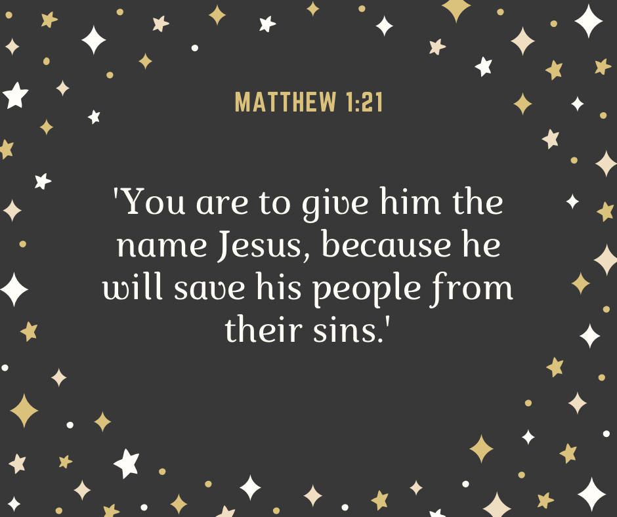

The Bible gives us a variety of names and titles of Jesus. This aids our understanding of who he is and why he came among us. A number of these names and titles are revealed in the Christmas story. As we meditate on them, we are gazing at the real Jesus and why we worship him with all our hearts.

Day 1
Matthew 1:21 ‘She will bear a son, and you shall call his name Jesus for he will save his people form their sins.’
Jesus must surely be the best-known name in all the world. In Hebrew it is the name ‘Joshua’ after the leader of the people of Israel who took God’s people to the Promised Land. The name means ‘Saviour’. The angel tells Joseph that the baby is to be called that because he is to be the Saviour. But Jesus will not be a military commander. He has a bigger task. He is to be the Saviour from sin, the one through whose death comes forgiveness for our sins and eternal life. This is what we all need most of all. No wonder his name is so well-known!
Prayer Gracious and loving heavenly Father, we thank you for the coming into the world of Jesus and for the death he dies to secure our forgiveness. Please make us grateful all our days as we rest in him as our Saviour. Amen
Day 2
Matthew 1:23 ‘And they shall call his name Immanuel (which means God with us)
Immanuel may simply mean that God is with us, at our side. Perhaps that is what Jesus and Mary first thought. But as time passed, an even more wonderful truth about Jesus was revealed. He is not merely a sign of God’s presence. He is God himself, who has come among us. There can be no more wonderful assurance of the love of God than that his Son became one of us and lived, taught and died for us and then was resurrected. Because of our sin we do not deserve any of this, but God is the God of love and grace.
Prayer Loving God, Thank you so much that Jesus became one of us in order to save us. Help us always, we pray, to live for him, in whose name we pray, Amen.

Day 3
Matthew 2:2 ‘Where is he who has been born king of the Jews?’
This was the question of the Wise Men from the East addressed to King Herod. Naturally, he was deeply troubled, seeing the birth of Jesus as a threat to his own rule. He was advised that Bethlehem would be the place to find Jesus, since the prophet Micah had foretold it. This was no accident, for Bethlehem was where David came from and the promises of God to David were that there would always be a king from his lineage on the throne. But this baby was destined to be a king without an army. He was to be the king of God’s kingdom and so the king of all people everywhere. He still invites us to make him the king of our lives.
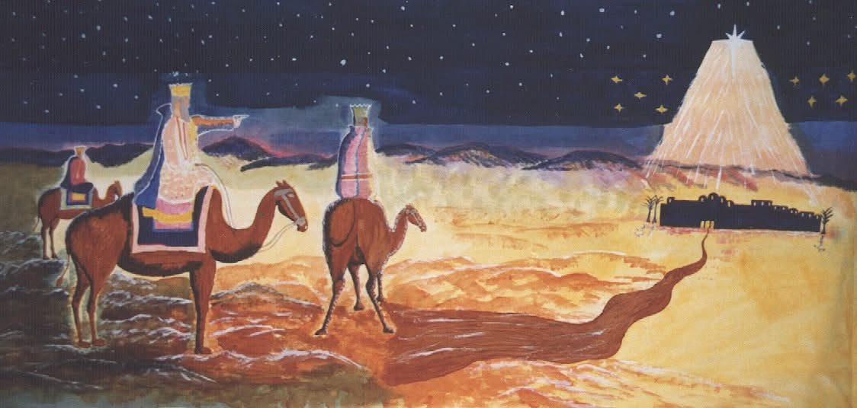
Prayer Heavenly Father, we thank you for the wonder and love of the Lord Jesus. Please help us to make him our King and strive to please him in all things. Amen
Day 4
Luke 1:32 ‘He will be great and will be called “the Son of the Most High”’
God sent many prophets and kings to his people. We can think of Moses and Elijah and Solomon for example. As Luke begins the Christmas story, we hear of the birth of John the Baptist another of the great prophets of God, a man eventually murdered because he confronted the then king with his sins. But John the Baptist, great at he was, said that he was not worthy of untying the shoes of Jesus. He was never called ‘the Son of the Most High’ as Jesus is here. That is why we rejoice at his coming, not only at Christmas, but every day.
Prayer Almighty God, we worship you as our Creator and Redeemer. Thank you for the coming into the world of your beloved Son and thank you that through him we are your adopted sons and daughters, through Jesus Christ our Lord. Amen

Day 5
Luke 1:43 ‘And why is it granted that the mother of my Lord should come to me?’
These are the words of Elizabeth when she saw Mary and exclaimed that the baby in her own womb (John the Baptist) leapt for joy. How wonderful it is that Jesus did not simply appear among us. He had mother, whose name we know, a mother who we honour to this day for her trust in the Lord and her obedience to his word. Now Elizabeth proclaims the name of Jesus as ‘my Lord’ a name in context which again tells us that Mary is the mother of God, making it clear that when the Son of God comes among us he does so by the process of birth as truly man and truly God. Here is the beginning of the greatest revolution in the history of the world.
Prayer Gracious God, we worship you as we remember that our Lord Jesus is both truly man and truly God, one with you and one with us, and the one true Mediator between us. Help us, we pray, to entrust ourselves to him, in whose name we pray. Amen.

Day 6
Luke 2:11 ‘For unto you is born this day in the city of David a Saviour who is Christ the Lord’
Of course, Jesus is most familiarly known as Jesus Christ. The first is his name, the second his title, Christ. Christ is the Messiah, a title again with royal connotations. But it reminds us in particular that Jesus did not simply appear unexpectedly. All the way through the Old Testament, God made promises. He promised a prophet greater than Moses, a priest greater than Aaron and a king greater than David. And so Jesus the Messiah can be identified because all the promises of God find their ‘Yes!’ in him. Our God is a faithful promise-keeping God, and he sends Jesus the Saviour, the King, the Lord, the Son of God, in order to save us, although we do not deserve it. Praise the Lord this Christmas!
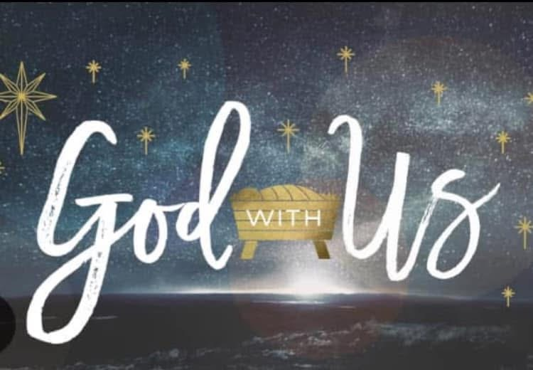
Prayer Dear Lord, we thank you that all your promises are fulfilled in our Saviour, Jesus Christ. Help us always to trust in your promises and live by this faith. Amen.

AMUA Prayer and Spirituality Coordinator
Christine Jensen OAM
prayer@muaustralia.org.au

