DISTRICT L CABINET MEETING

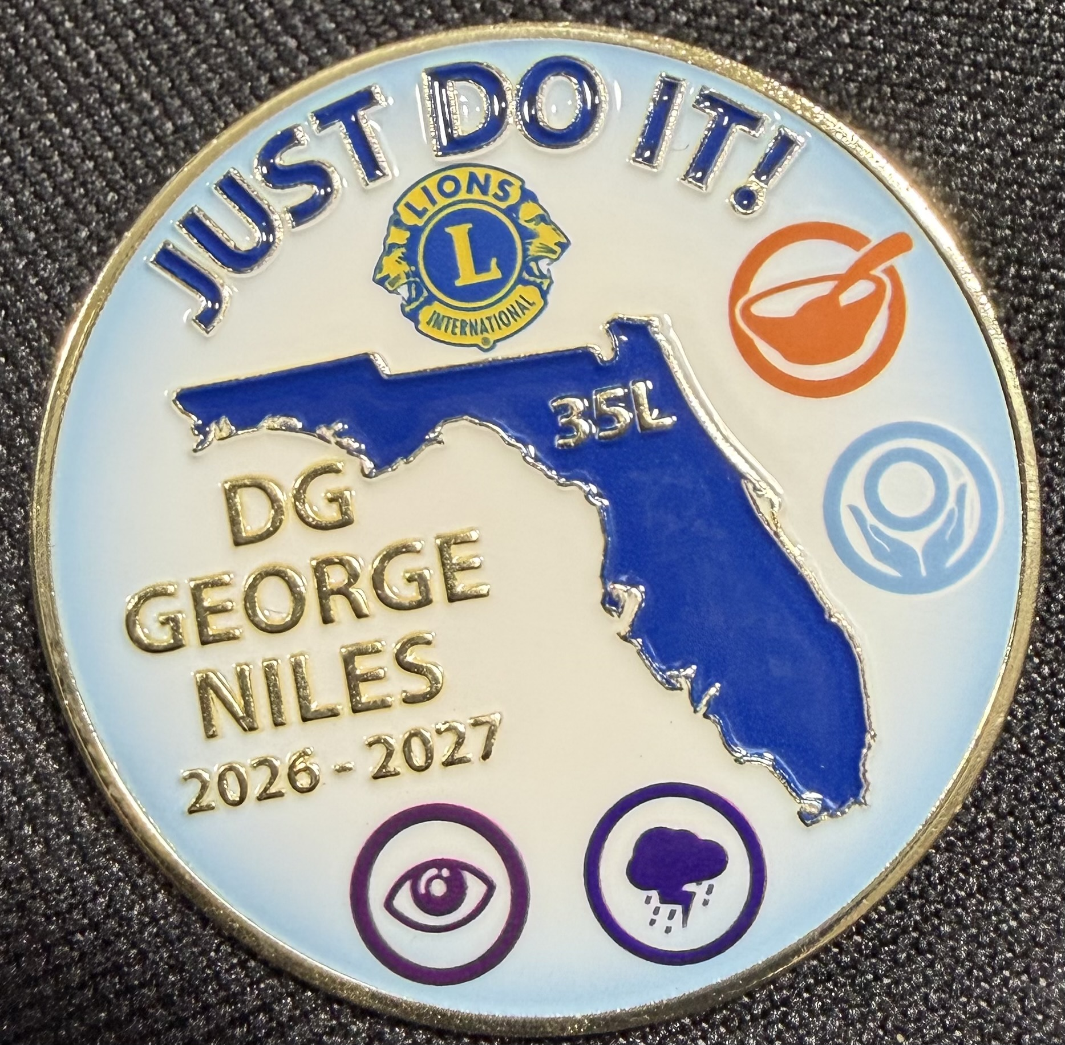
Join us for our second Cabinet meeting!
When: Saturday October 31, 2026
Where: High Springs Lions Club
26900 W US Highway 27
High Springs FL 32655

Time: 8am-1:30pm Cabinet Mtg
8am breakfast / 8:30am pre-Cabinet meeting (Cabinet
members and PDGs)
10:30am- Cabinet meeting starts for all Lions
12noon-1:00pm LUNCH
1pm-1:30 Cabinet meeting ends
2pm-4pm-Guiding Lion Training (for all Lions who wish to be
considered as a Guiding Lion for a new Lions club).

Breakfast & Lunch- Total Cost $18.00 per person

Doors open at 8am
BREAKFAST MENU 8am
SCRAMBLED EGGS
BACON/SAUSAGE
PANCAKES
MEAL RESERVATIONS MUST BE RECEIVED NO LATER THAN 10/26 for accurate head count.
RSVP: MARVIN BRANDT 386 324 2445 OR EMAIL: brandtem09@gmail.com
SEND TO HIGH SPPRINGS LIONS CLUB PO BOX 2444 HIGH SPRINGS FL 32655 OR PAYMENT CAN BE MADE AT THE DOOR. CASH OR CHECKS ONLY.

FRUIT CUP
COFFEE/TEA/JUICE

LUNCH MENU 12 noon
CHICKEN GNOCCHI SOUP
½ CHICKEN CAESAR WRAP
BREADSTICK
DESSERT (TO BE DETERMINED)
TEA/SODA/WATER
For any questions or clarifications, please contact Lion Judi Seltzer, District L Cabinet Secretary Email lionseltzerjudi@gmail.com or call 443-910-7604

