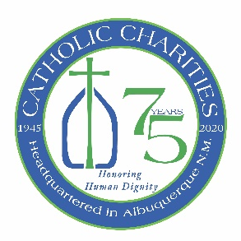
Archbishop Wester calls for a Second Collection to benefit the programs and services of Catholic Charities in the Archdiocese of Santa Fe
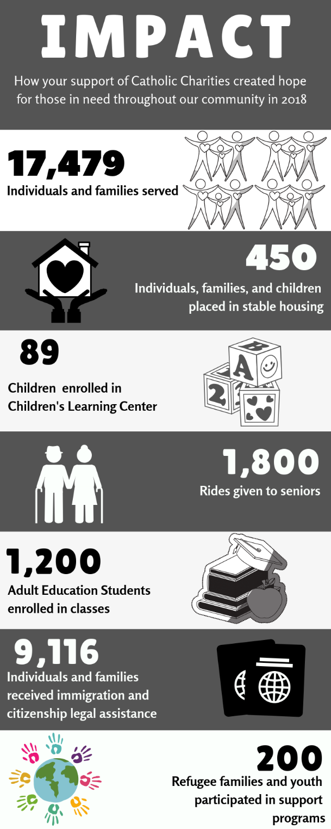
Archbishop John C. Wester has approved an annual Second Collection to benefit the programs and services of Catholic Charities of the Archdiocese of Santa Fe on the weekend of August 15 and 16.

Watch Archbishop Wester’s message here:
https://youtu.be/-bH5stA1AQA

Funding from this important second collection will support vital, ongoing programs serving our community through a wide spectrum of services including bilingual early childhood education, adult basic education classes, refugee support, low-cost immigration and citizenship legal services, self-sufficiency and housing assistance, free senior transportation, and a food pantry.

Because of your generosity, this year Catholic Charities in the Archdiocese of Santa Fe will celebrate our 75th year of finding solutions to some of the most pressing social challenges. Our mission is to put faith in action to improve the lives of those in need.

Ways to give:
- Catholic Charities Annual 2nd Collection Envelopes should be provided with your parish envelopes
- Write Catholic Charities in the memo field of your check
- Drop it in the collection basket or mail it to your parish office
- Make an online donation on your parish website-indicate that you are giving to Catholic Charities
- Go to Catholic Charities website, www.ccasfnm.org, and give there!
To learn more about the programs and services of Catholic Charities, go to our website.

